Project Source Backup Tool Help

With the Project Source Backup Tool, you can backup your source code using Windows Compression routines. You will not need to include a third-party tool such as WinRar or WinZip. The Project Source Backup Tool does everything for you, except add a password.
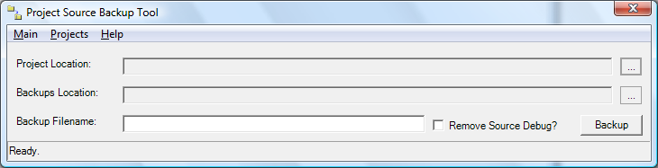
Figure 1: The main interface of the Project Source Backup Tool.

