Project Location
The first step in using the tool is to locate your source folder. You can do this by clicking the Project Location ellipsis button. See below for the location.
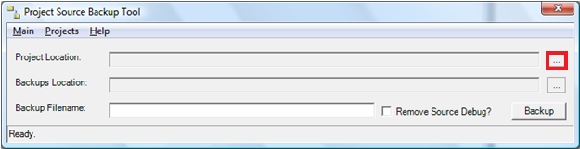
Figure 2: The Project Location button of the Project Source Backup Tool.
Clicking this button will bring up a ‘Browse for Folder’ dialog that will enable you to locate your source folder. Click the ‘OK’ button to continue. If at any time you realize you’ve made a mistake, click Main | Clear to clear the form and start over.
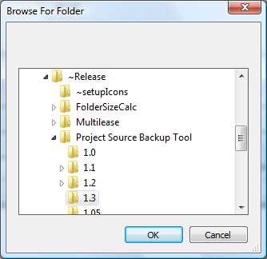
Figure 3: The Browse for Folder dialog.

