Saving a Profile

The main feature of Project Source Backup Tool is the ability to save your project location, backup location, and filename to a ‘Profile’ in your registry. This will allow a less time consuming process the next time you’d like to backup your source. In order to do this, simply follow the steps above, but before you click the backup button, select ‘Projects’ from the Main Menu, and the option ‘Save Profile...’ The following screen will show up, to allow you to name your project profile.
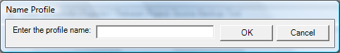
Figure 7: The profile name form of the Project Source Backup Tool.
To continue, enter the desired name of the profile and click the ‘OK’ button. Your project information will be recorded in your registry, and will become available under Projects | Profiles, as a menu option. Clicking that new option will populate the interface with the values you had in the locations when you saved it. Once loaded you can then double-click the Backup Filename textbox to rename the file, and click ‘Backup’ to start the process.

