The Big Race Quiz

Comparing Equation/Function Types

Fill in the blank below to correctly label the equation. Then complete the table below the equation to correctly represent the data from the equation.

__________ Equation : y = 2x+1

|  |  |  |
| --- | --- | --- |
| x | y=x | y |
| -5 |  |  |
| -4 |  |  |
| -3 |  |  |
| -2 |  |  |
| -1 |  |  |
| 0 |  |  |
| 1 |  |  |
| 2 |  |  |
| 3 |  |  |
| 4 |  |  |
| 5 |  |  |

Fill in the data table below with the data generated by the equation below.

Quadratic Equation : y = x2

|  |  |  |
| --- | --- | --- |
| x | y = x2 | y |
| -5 |  |  |
| -4 |  |  |
| -3 |  |  |
| -2 |  |  |
| -1 |  |  |
| 0 |  |  |
| 1 |  |  |
| 2 |  |  |
| 3 |  |  |
| 4 |  |  |

Fill in blanks to correctly represent the graph below. Then fill in the table below the graph with the correct data from the graph.

________ Function : f(x) = ____

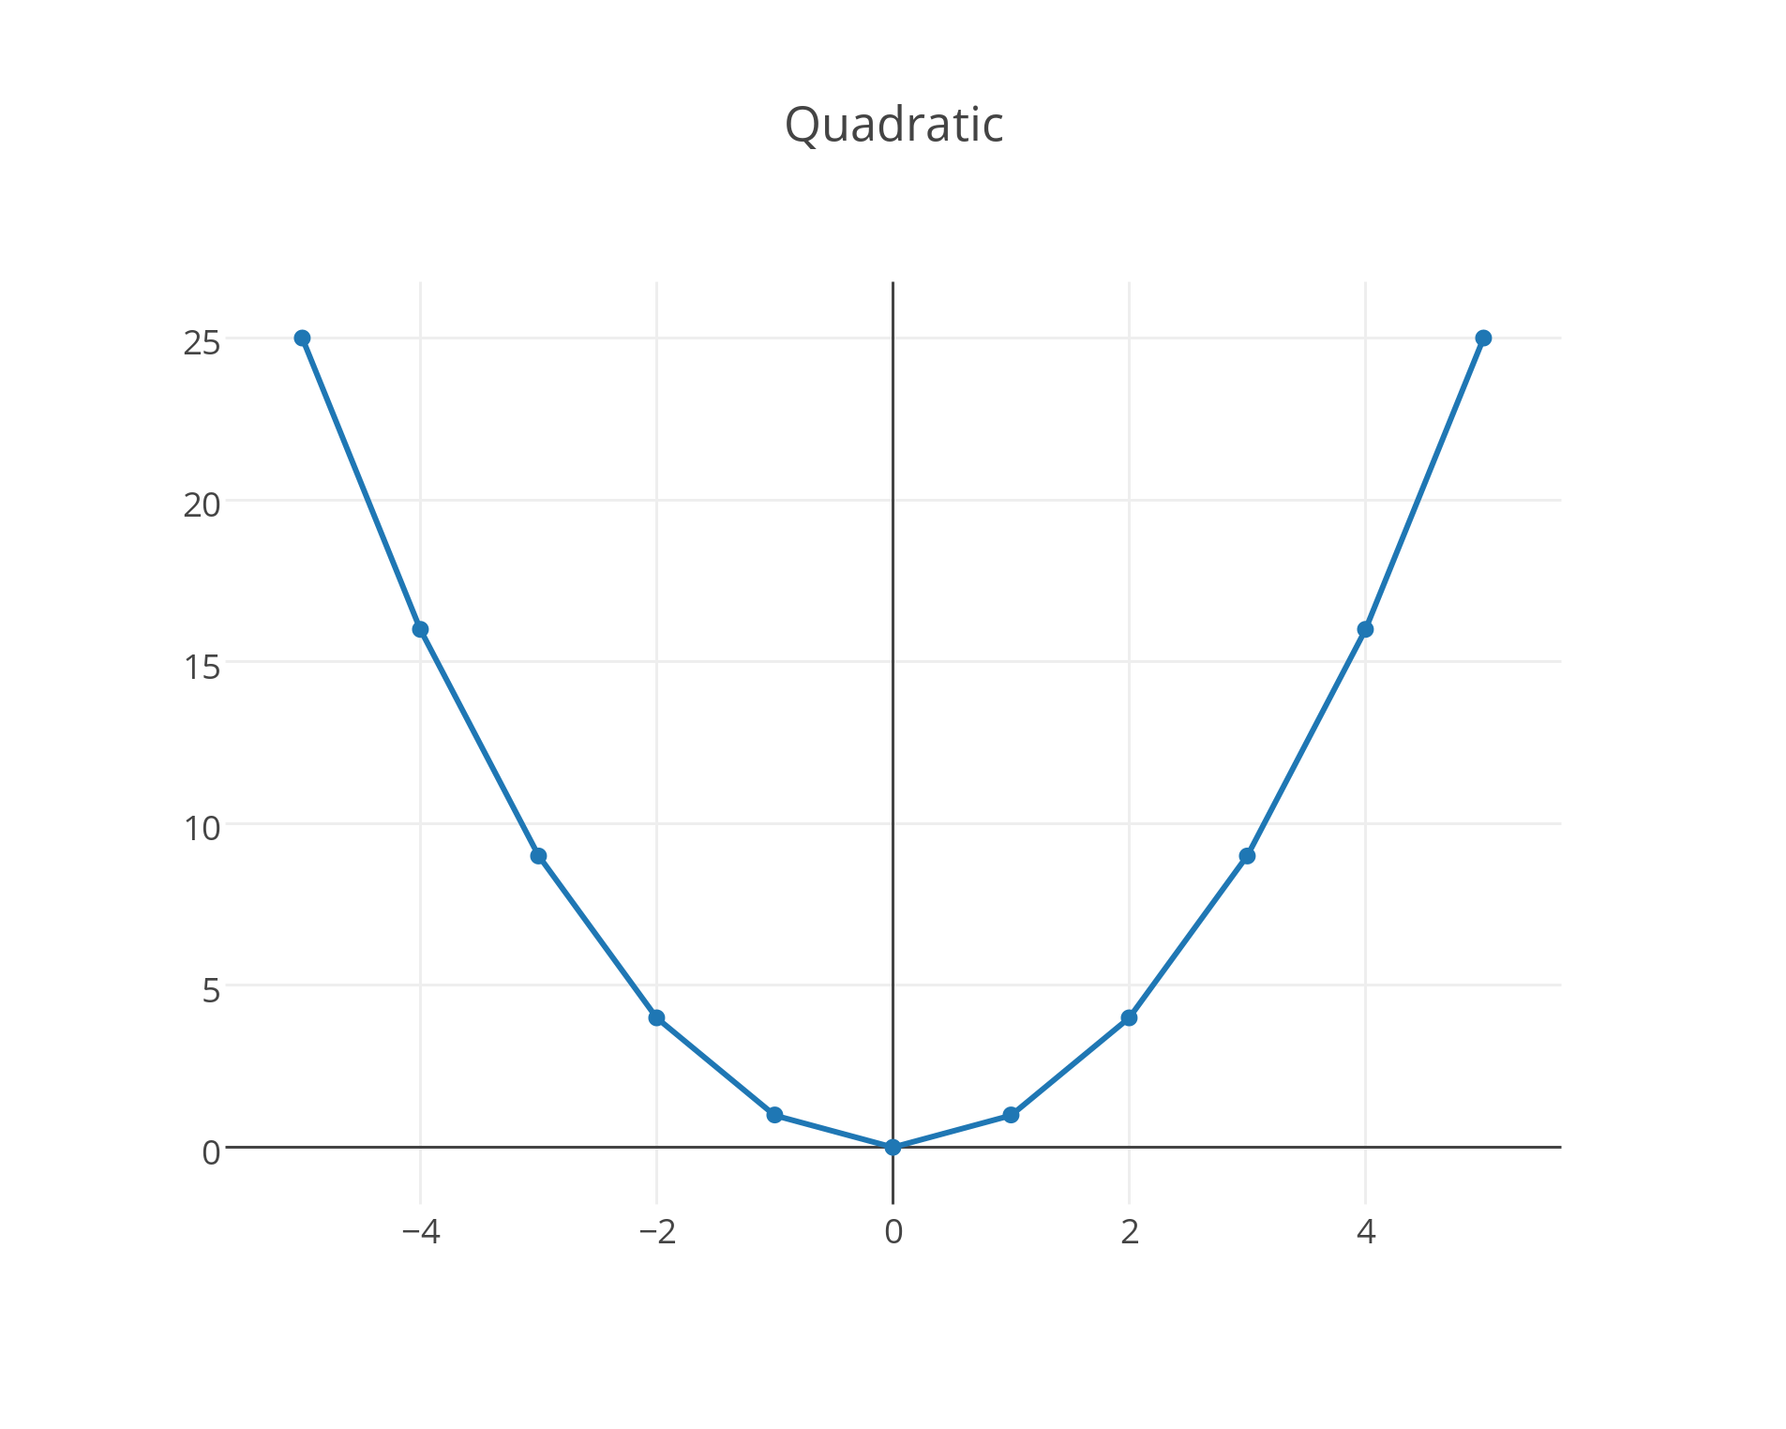

|  |  |  |
| --- | --- | --- |
| x |  | y |
| -5 |  |  |
| -4 |  |  |
| -3 |  |  |
| -2 |  |  |
| -1 |  |  |
| 0 |  |  |
| 1 |  |  |
| 2 |  |  |
| 3 |  |  |
| 4 |  |  |

Label the function type below based on the graph below. Then fill in the data table.

___________ Function f(x) = x

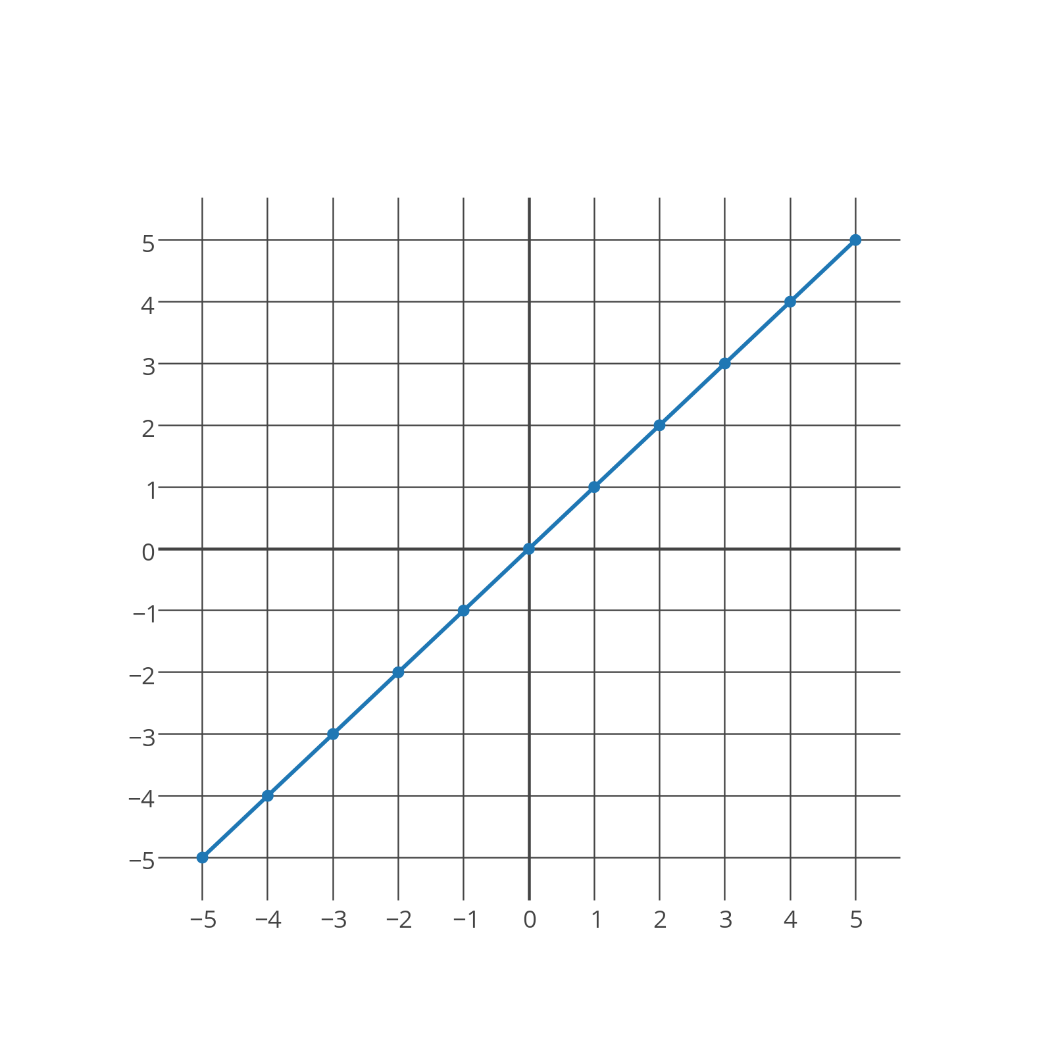

|  |  |  |
| --- | --- | --- |
| x |  | y |
| -5 |  |  |
| -4 |  |  |
| -3 |  |  |
| -2 |  |  |
| -1 |  |  |
| 0 |  |  |
| 1 |  |  |
| 2 |  |  |
| 3 |  |  |
| 4 |  |  |

Label the equation type below. Then fill in the table and the graph based on the equation.

____________ Equation : y = 2x

|  |  |  |
| --- | --- | --- |
| x | y = 2x | y |
| -5 |  |  |
| -4 |  |  |
| -3 |  |  |
| -2 |  |  |
| -1 |  |  |
| 0 |  |  |
| 1 |  |  |
| 2 |  |  |
| 3 |  |  |
| 4 |  |  |
| 5 |  |  |

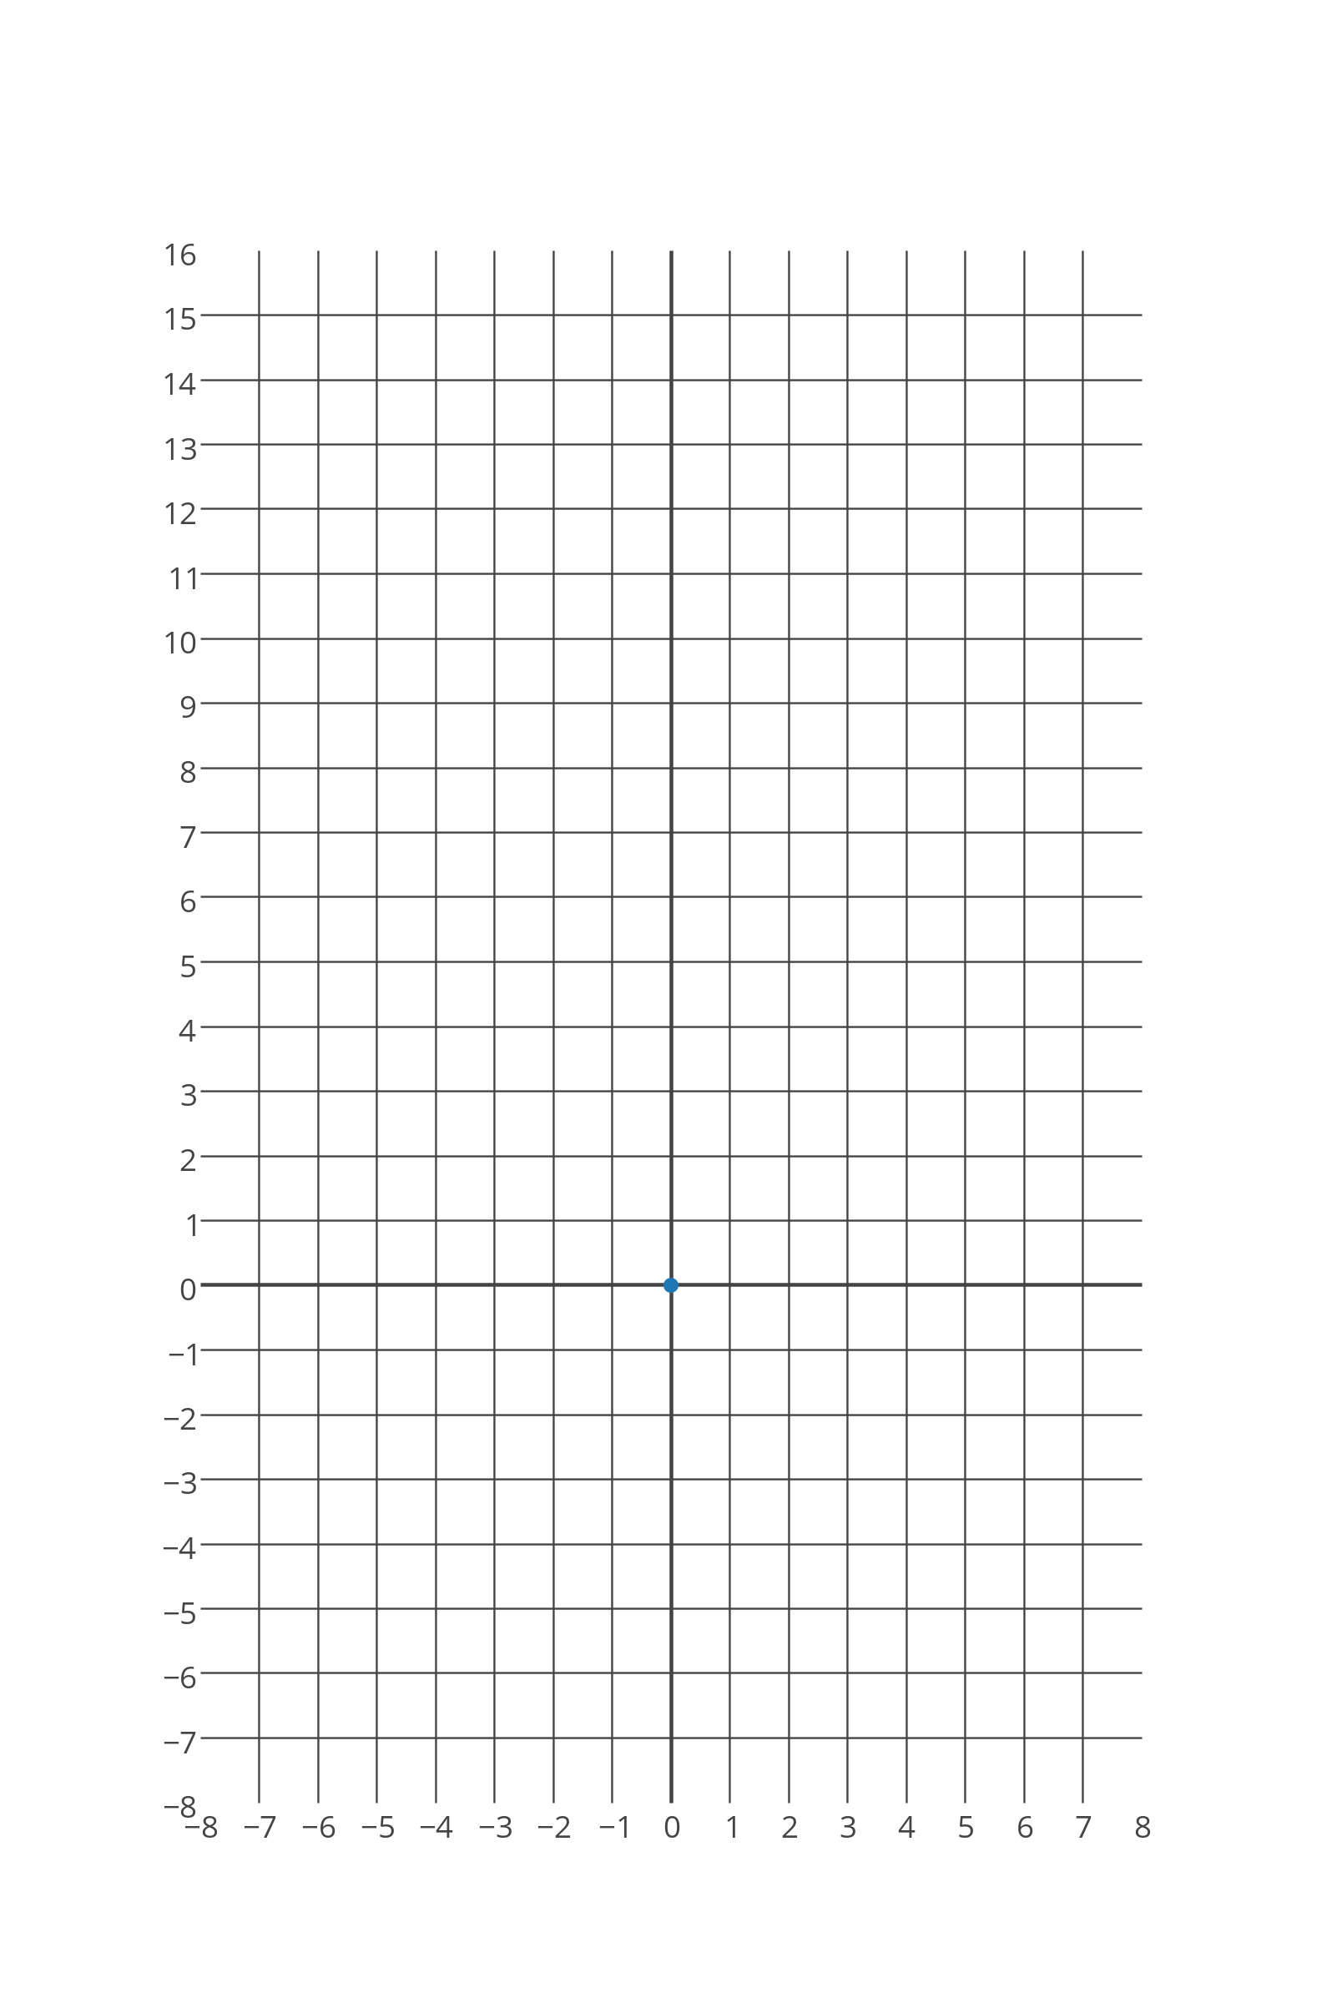

Create your own function of any type then label the function, fill in the data table below and graph the function on the graph below.

___________ Function ________

|  |  |  |
| --- | --- | --- |
| x |  | y |
|  |  |  |
|  |  |  |
|  |  |  |
|  |  |  |
|  |  |  |
|  |  |  |
|  |  |  |
|  |  |  |
|  |  |  |
|  |  |  |

