Lesson 2

Objective: Reason abstractly using place value understanding to relate adjacent base ten units from millions to thousandths.

Suggested Lesson Structure

|  |  |
| --- | --- |
|  | A NOTE ON  STANDARDS ALIGNMENT: |
| Fluency tasks are included not only as warm-ups for the current lesson, but also as opportunities to retain past number understandings and to sharpen those understandings needed for coming work. Skip-counting in Grade 5 provides support for the common multiple work covered in Module 3.  Additionally, returning to a familiar and well-understood fluency can provide a student with a feeling of success before tackling a new body of work.  Consider including body movements to accompany skip-counting exercises (e.g., jumping jacks, toe touches, arm stretches, or dance movements like the *Macarena*). | |

 Fluency Practice (12 minutes)

 Application Problem (10 minutes)

 Concept Development (28 minutes)

 Student Debrief (10 minutes)

**Total Time (60 minutes)**

Fluency Practice (12 minutes)

* Skip-Counting **3.OA.4–6** (3 minutes)
* Take Out the Tens **2.NBT.1** (2 minutes)
* Bundle Ten and Change Units **4.NBT.1** (2 minutes)
* Multiply and Divide by 10 **5.NBT.1**  (5 minutes)

Skip-Counting (3 minutes)

Note: Practicing skip-counting on the number line builds a foundation for accessing higher order concepts throughout the year.

Direct students to count forward and backward by threes to 36, emphasizing the transitions of crossing the ten. Direct students to count forward and backward by fours to 48, emphasizing the transitions of crossing the ten.

Take Out the Tens (2 minutes)

Materials: (S) Personal white board

Note: Decomposing whole numbers into different units lays a foundation to do the same with decimal fractions.

T: (Write 83 ones = ____ tens ____ ones.) Write the number sentence.

S: (Write 83 ones = 8 tens 3 ones.)

Repeat the process for 93 ones, 103 ones, 113 ones, 163 ones, 263 ones, 463 ones, and 875 ones.

Bundle Ten and Change Units (2 minutes)

Note: Reviewing this fluency area helps students work toward mastery of changing place value units in the base ten system.

T: (Write 10 hundreds = 1 ____.) Say the number sentence, filling in the blank.

S: 10 hundreds = 1 thousand.

Repeat the process for 10 tens = 1 ____, 10 ones = 1 ____, 10 tenths = 1 ____, 10 thousandths = 1 ____, and 10 hundredths = 1 ____.

Multiply and Divide by 10 (5 minutes)

Materials: (T) Millions through thousandth place value chart (Lesson 1 Template) (S) Personal white board, millions through thousandths place value chart (Lesson 1 Template)

Note: Reviewing this skill from Lesson 1 helps students work toward mastery.

T: (Project the place value chart from millions to thousandths.) Draw three ones disks, and write the total value of the disks below it.

S: (Draw three disks in the ones column. Below it, write 3.)

T: Multiply by 10. Cross out each disk and the number 3 to show that you’re changing its value.

S: (Cross out each disk in the ones column and the 3. Draw arrows to the tens column, and draw three disks in the tens column. Below it, write 3 in the tens column and 0 in the ones column.)

Repeat the process for 2 hundredths, 3 tenths 2 hundredths, 3 tenths 2 hundredths 4 thousandths, 2 tenths   
4 hundredths 5 thousandths, and 1 tenth 3 thousandths. Repeat the process for dividing by 10 for this possible sequence: 2 ones, 3 tenths, 2 ones 3 tenths, 2 ones 3 tenths 5 hundredths, 5 tenths 2 hundredths, and 1 ten 5 thousandths.

Application Problem (10 minutes)

|  |  |
| --- | --- |
|  | A NOTE ON  APPLICATION PROBLEMS: |
| Application Problems are designed to reach back to the learning in the prior day’s lesson. Today’s problem requires students to show thinking using the concrete–pictorial approach used in Lesson 1 to find the product and quotient. This will act as an anticipatory set for today’s lesson. | |

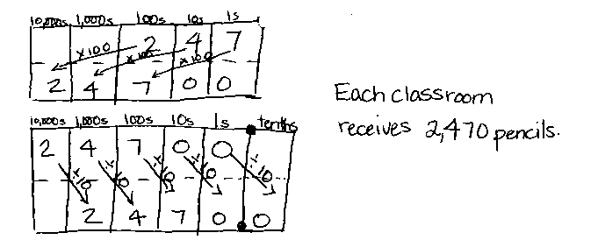A school district ordered 247 boxes of pencils. Each box contains 100 pencils. If the pencils are to be shared evenly among 10 classrooms, how many pencils will each class receive? Draw a place value chart to show your thinking.

Concept Development (28 minutes)

Materials: (S) Millions through thousandths place value chart (Lesson 1 Template), personal white board

T: Turn and share with your partner. What do you remember from yesterday’s lesson about how adjacent units on the place value chart are related?

S: (Share.)

|  |  |
| --- | --- |
|  | NOTES ON  MULTIPLE MEANS OF ACTION AND EXPRESSION: |
| Although students are being encouraged toward more abstract reasoning in the lesson, it is important to keep concrete materials like place value charts and place value disks accessible to students while these place value relationships are being solidified. Giving students the freedom to move between levels of abstraction on a task-by-task basis can decrease anxiety when working with more difficult applications. | |

T: Moving one position to the left on the place value chart makes units 10 times larger. Conversely, moving one position to the right makes units 1 tenth the size.

As students move through the sequence of problems, encourage a move away from the concrete–pictorial representations of the products and quotients and, instead, move toward reasoning about the patterns of the number of zeros in the products and quotients and the placement of the decimal.

Problem 1

367 × 10

367 ÷ 10

4,367 × 10

4,367 ÷ 10

T: Work with your partner to solve these problems. Write two complete number sentences on your board.

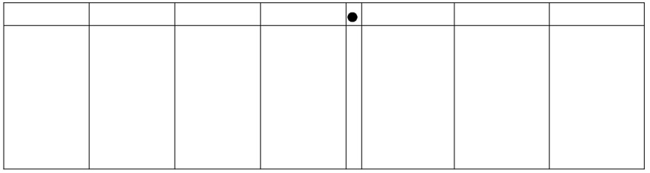

3 6 7

3 6 7 0

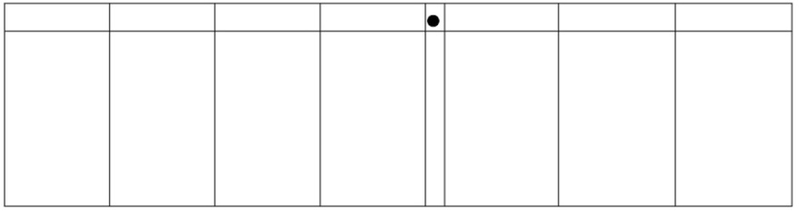

3 6 7

3 6 7

S: 367 × 10 = 3,670. 🡪 367 ÷ 10 = 36.7.

T: Explain how you got your answers. What are the similarities and differences between the two answers?

**MP.3**

S: The digits are the same, but their values have changed. Their position in the number is different. 🡪 The 3 is 10 times larger in the product than in the factor. It was 3 hundreds. Now, it is 3 thousands. 🡪 The six started out as 6 tens, but once it was divided by 10, it is now 1 tenth as large because it is 6 ones.

T: What patterns do you notice in the number of zeros in the product and the placement of the decimal in the quotient? What do you notice about the number of zeros in your factors and the shift in places in your product? What do you notice about the number of zeros in your divisor and the shift in places in your quotient?

**MP.2**

S: (Share.)

Repeat this sequence with the last pair of expressions (4,367 10 and 4,367 10). Encourage students to visualize the place value chart and attempt to find the product and quotient without drawing the chart. Circulate. Watch for misconceptions and students who are not ready to work on an abstract level. As students share thinking, encourage the use of the language *10 times as large* and *1 tenth as large*.

Problem 2

**MP.3**

215.6 × 100

215.6 ÷ 100

3.7 × 100

3.7 ÷ 100

T: Now, solve with your partner by visualizing your place value chart and recording only your products and quotients. You may check your work using a place value chart. (Circulate. Look for students who may still need the support of the place value chart.)

S: (Solve.)

**MP.7**

T: Compare your work with your partner’s. Do you agree? How many times did the digits shift in each problem, and why? Share your thinking with your partner.

S: The digits shifted two places to the left when we multiplied and two places to the right when we divided. 🡪 This time the digits each shifted two places because there are 2 zeros in 100. 🡪 The values of the products are 100 times as large, so the digits had to shift to larger units.

**Problem 3**

**MP.3**

**MP.3**

**MP.3**

**MP.3**

0.482 × 1,000

482 ÷ 1,000

Follow a similar sequence for these expressions.

Problem Set (10 minutes)

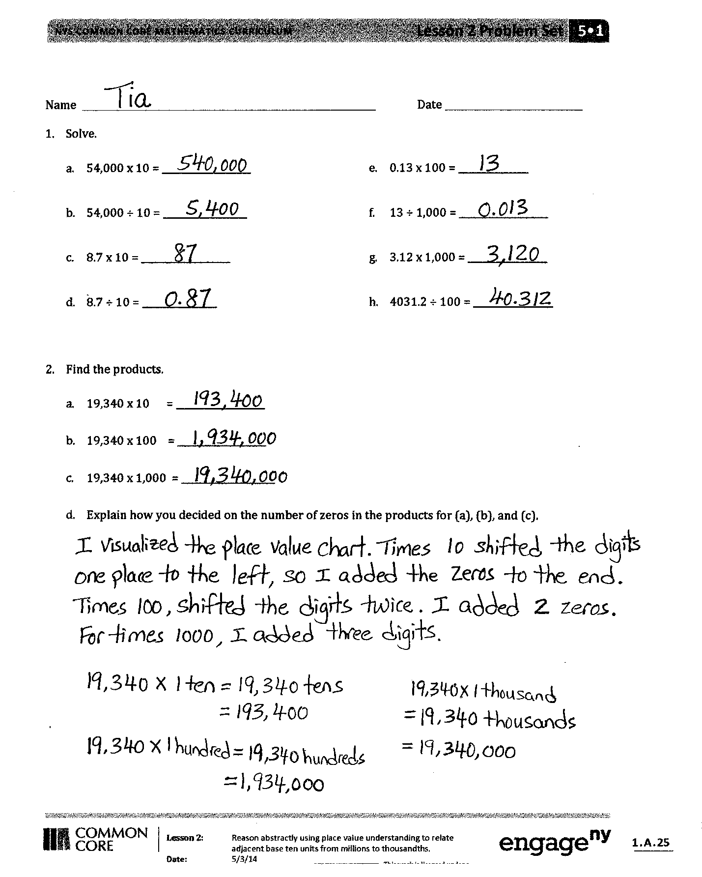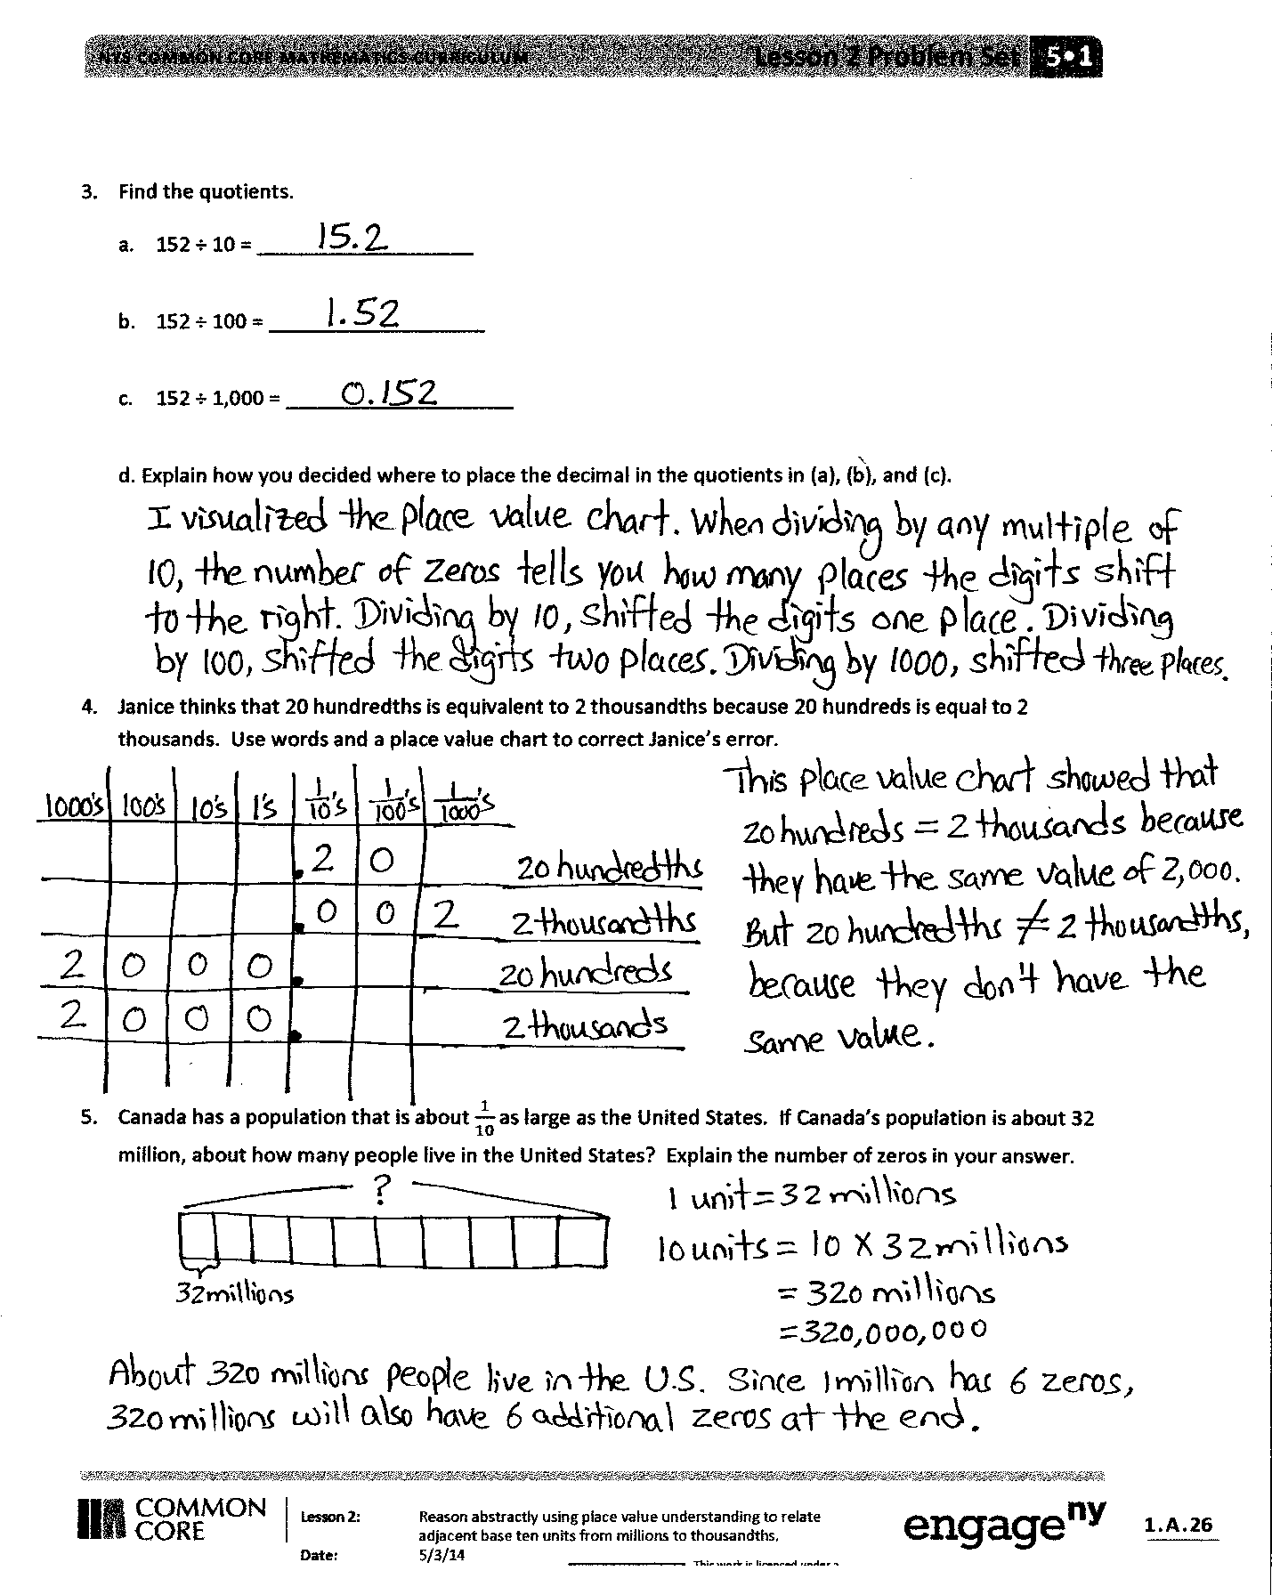

Students should do their personal best to complete the Problem Set within the allotted 10 minutes. For some classes, it may be appropriate to modify the assignment by specifying which problems they work on first. Some problems do not specify a method for solving. Students solve these problems using the RDW approach used for Application Problems.

Student Debrief (10 minutes)

**Lesson Objective:** Reason abstractly using place value understanding to relate adjacent base ten units from millions to thousandths.

The Student Debrief is intended to invite reflection and active processing of the total lesson experience.

Invite students to review their solutions for the Problem Set. They should check work by comparing answers with a partner before going over answers as a class. Look for misconceptions or misunderstandings that can be addressed in the Debrief. Guide students in a conversation to debrief the Problem Set and process the lesson.

Any combination of the questions below may be used to lead the discussion.

* Compare and contrast answers in Problem 1(a) and (b) or 1(c) and (d).
* What is similar about the process you used to solve Problem 1(a), (c), (e), and (g)?
* What is similar about the process you used to solve Problem 1(b), (d), (f), and (h)?
* When asked to find the number 1 tenth as large as another number, what operation would you use? Explain how you know.
* When solving Problem 2, how did the number of zeros in the factors help you determine the product?
* Give an example of a time when there will be a different number of zeros in the factors and the product? (If students have difficulty answering, give them the example of 4 × 5, 4 × 50, 40 × 50. Then, ask students to give other examples.)
* When dividing by 10, what happens to the digits in the quotient? When multiplying by 100, what happens to the digits in the product?
* Be prepared for students to make mistakes when answering Problem 4. (Using a place value chart to solve this problem may reduce the errors. Encourage discussion about the relative size of the units in relation to a whole and why hundredths are larger than thousandths.)

Exit Ticket (3 minutes)

After the Student Debrief, instruct students to complete the Exit Ticket. A review of their work will help with assessing students’ understanding of the concepts that were presented in today’s lesson and planning more effectively for future lessons. The questions may be read aloud to the students.

Name Date

1. Solve.
   1. 54,000 × 10 = ___________________
   2. 54,000 ÷ 10 = ___________________
   3. 8.7 × 10 = ___________________
   4. 8.7 ÷ 10 = ___________________
   5. 0.13 × 100 = ___________________
   6. 13 ÷ 1,000 = ___________________
   7. 3.12 × 1,000 = ___________________
   8. 4,031.2 ÷ 100 = ___________________
2. Find the products.
   1. 19,340 × 10 = ___________________
   2. 19,340 × 100 = ___________________
   3. 19,340 × 1,000 = ___________________
   4. Explain how you decided on the number of zeros in the products for (a), (b), and (c).
3. Find the quotients.

a. 152 ÷ 10 = ___________________

b. 152 ÷ 100 = ___________________

c. 152 ÷ 1,000 = ___________________

1. Explain how you decided where to place the decimal in the quotients for (a), (b), and (c).
2. Janice thinks that 20 hundredths is equivalent to 2 thousandths because 20 hundreds is equal to 2 thousands. Use words and a place value chart to correct Janice’s error.
3. Canada has a population that is about as large as the United States. If Canada’s population is about 32 million, about how many people live in the United States? Explain the number of zeros in your the answer.

Name Date

1. Solve.
   1. 32.1 × 10 = ___________________
   2. 3632.1 ÷ 10 = ___________________
2. Solve.
   1. 455 × 1,000 = ___________________
3. 455 ÷ 1,000 = ___________________

Name Date

1. Solve.
   1. 36,000 × 10 = ___________________
   2. 36,000 ÷ 10 = ___________________
   3. 4.3 × 10 = ___________________
   4. 4.3 ÷ 10 = ___________________
   5. 2.4 x 100 = ___________________
   6. 24 ÷ 1,000 = ___________________
   7. 4.54 × 1,000 = ___________________
   8. 3,045.4 ÷ 100 = ___________________
2. Find the products.
3. 14,560 × 10 = ___________________
4. 14,560 × 100 = ___________________
5. 14,560 × 1,000 = ___________________

Explain how you decided on the number of zeros in the products for (a), (b), and (c).

1. Find the quotients.
   1. 16.5 ÷ 10 = ___________________
   2. 16.5 ÷ 100 = ___________________
   3. Explain how you decided where to place the decimal in the quotients for (a) and (b).
2. Ted says that 3 tenths multiplied by 100 equals 300 thousandths. Is he correct? Use a place value chart to explain your answer.
3. Alaska has a land area of about 1,700,000 square kilometers. Florida has a land area the size of Alaska. What is the land area of Florida? Explain how you found your answer.