Lesson 3

Objective: Use exponents to name place value units, and explain patterns in the placement of the decimal point.

Suggested Lesson Structure

 Fluency Practice (15 minutes)

 Application Problem (7 minutes)

 Concept Development (28 minutes)

 Student Debrief (10 minutes)

**Total Time (60 minutes)**

Fluency Practice (15 minutes)

* Sprint: Multiply by 3 **3.OA.7** (8 minutes)
* State the Unit as a Decimal—Choral Response **5.NBT.2** (4 minutes)
* Multiply and Divide by 10, 100, and 1000 **5.NBT.2** (3 minutes)

Sprint: Multiply by 3 (8 minutes)

Materials: (S) Multiply by 3 Sprint.

Note: This Sprint reviews foundational skills learned in Grades 3 and 4.

State the Unit as a Decimal—Choral Response (4 minutes)

Note: Reviewing these skills helps students work toward mastery of decimal place value, which assists them in applying their place value skills to more difficult concepts.

T: (Write 9 tenths = ____.) Complete the number sentence by saying the unknown value as a decimal.

S: 0.9

T: (Write 10 tenths = ____.)

S: 1.0

T: (Write 11 tenths = ____.)

S: 1.1

T: (Write 12 tenths = ____.)

S: 1.2

T: (Write 18 tenths = ____.)

|  |  |
| --- | --- |
|  | NOTES ON  MULTIPLE MEANS  OF ACTION AND EXPRESSION: |
| Very large numbers like one million and beyond easily capture the imagination of students. Consider allowing students to research and present to classmates the origin of number names like *googol* and *googleplex.* Connections to literacy can also be made with books about large numbers, such as *How Much is a Million* by Steven Kellogg, *A Million Dots* by Andrew Clements, or *Big Numbers and Pictures That Show Just How Big They Are* by Edward Packard and Sal Murdocca.  The following benchmarks may help students appreciate just how large a googolis.   * There are approximately 1024 stars in the observable universe. * There are approximately 1080 atoms in the observable universe. * A stack of 70 numbered cards can be ordered in approximately 1 googol different ways. That means that the number of ways a stack of only 70 cards can be shuffled is more than the number of atoms in the observable universe. | |

S: 1.8

T: (Write 28 tenths = ____.)

S: 2.8

T: (Write 58 tenths = ____.)

S: 5.8

Repeat the process for 9 hundredths, 10 hundredths, 20 hundredths, 60 hundredths, 65 hundredths, 87 hundredths, and 118 tenths. (The last item is an extension.)

Multiply and Divide by 10, 100, and 1000 (3 minutes)

Materials: (S) Millions through thousandths place value chart (Lesson 1 Template)

Note: This fluency drill reviews concepts taught in Lesson 2.

T: (Project the place value chart from millions through thousandths.) Draw two disks in the thousandths place, and write the value below it.

S: (Draw two disks in the thousandths column. Below it, write 0.002 in the appropriate place value columns.)

T: Multiply by 10. Cross out each disk and the number 2 to show that you’re changing its value.

S: (Cross out each 1 thousandths disk and the 2. Draw arrows to the hundredths column, and draw two disks there. Below it, they write 2 in the hundredths column and 0 in the ones and tenths column.)

Repeat the process for the following possible sequence:   
0.004 × 100, 0.004 × 1000, 1.004 × 1000, 1.024 × 100,   
1.324 × 100, 1.324 × 10, and 1.324 × 1000.

Repeat the process for dividing by 10, 100, and 1000 for the following possible sequence: 4 ÷ 1, 4.1 ÷ 10, 4.1 ÷ 100,   
41 ÷ 1000, and 123 ÷ 1000.

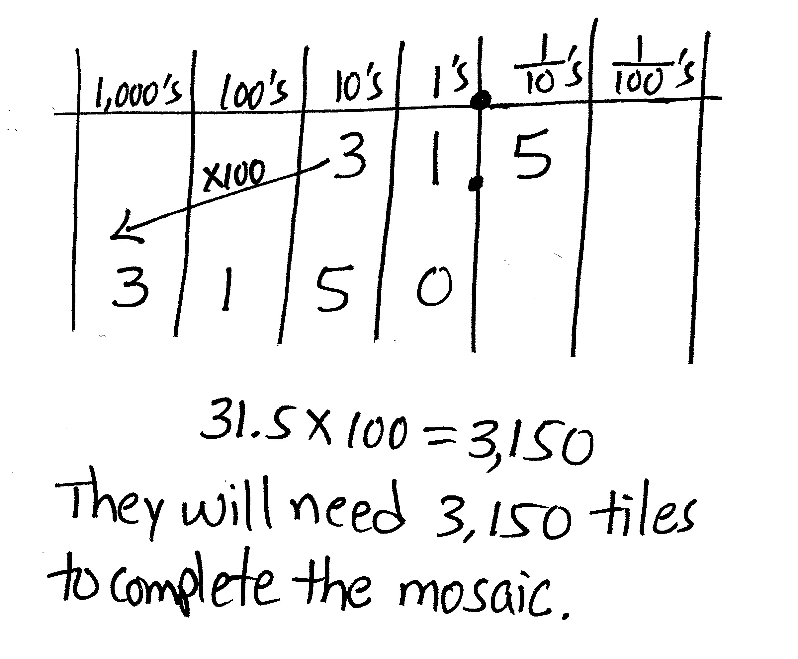Application Problem (7 minutes)

Jack and Kevin are creating a mosaic for art class by using fragments of broken tiles. They want the mosaic to have 100 sections. If each section requires 31.5 tiles, how many tiles will they need to complete the mosaic? Explain your reasoning with a place value chart.

Note: This Application Problem provides an opportunity for students to reason about the value of digits after being multiplied by 100.

Concept Development (28 minutes)

Materials: (S) Powers of 10 chart (Template), personal white board

Problem 1

**MP.7**

T: (Draw or project the powers of 10 chart, adding numerals as the discussion unfolds.)

|  |  |  |  |  |  |
| --- | --- | --- | --- | --- | --- |
|  |  |  |  | 100 | 10 |
|  |  |  |  | 10 x 10 | 10 x 1 |
|  |  |  |  |  |  |
|  |  |  |  |  |  |

T: (Write 10 × ____ = 10 on the board.) On your personal board, fill in the unknown factor to complete this number sentence.

S: 10 × 1 = 10.

T: (Write 10 × ____ = 100 on the board.) Fill in the unknown factor to complete this number sentence.

S: 10 × 10 = 100.

T: This time, using only 10 as a factor, how could you multiply to get a product of 1,000? Write the multiplication sentence on your personal board.

S: 10 × 10 × 10 = 1,000.

T: Work with your partner. What would the multiplication sentence be for 10,000 using only 10 as a factor? Write it on your personal board.

S: (Write.)

T: How many factors of 10 did we have to multiply to get to 1,000?

S: 3.

T: How many factors of 10 do we have to multiply to get 10,000?

S: 4.

T: Say the number sentence.

S: 10 × 10 × 10 × 10 = 10,000.

T: How many zeros are in our product of 10,000?

S: 4 zeros.

T: What patterns do you notice? Turn and share with your partner.

S: The number of zeros is the same on both sides of the equation. 🡪 The number of zeros in the product is the same as the total number of zeros in the factors. 🡪 I see three zeros on the left side, and there are three zeros on the right side for 10 × 10 × 10 = 1,000. 🡪 The 1 moves one place to the left every time we multiply by 10. 🡪 It’s like a place value chart. Each number is 10 times as much as the last one.

T: Using this pattern, how many factors of 10 do we have to multiply to get 1 million? Work with your partner to write the multiplication sentence.

**MP.7**

S: (Write.)

T: How many factors of 10 did you use?

S: 6.

T: Why did we need 6 factors of 10?

S: 1 million has 6 zeros.

T: (Write the term ***exponent*** on the board.) We can use an **exponent** to represent how many times we use 10 as a factor. We can write 10 × 10 as 102. (Add to the chart.) We say, “Ten to the second power.” The 2 (point to exponent) is the exponent, and it tells us how many times to use 10 as a factor.

T: How do you express 1000 using exponents? Turn and share with your partner.

S: We multiply 10 × 10 × 10, which is three times, so the answer is 103. 🡪 There are three zeros in 1,000, so it’s ten to the third power.

T: Working with your partner, complete the chart using the exponents to represent each value on the place value chart.

|  |  |  |  |  |  |
| --- | --- | --- | --- | --- | --- |
| 1,000,000 | 100,000 | 10,000 | 1,000 | 100 | 10 |
| (10 × 10 × 10) × (10 × 10 × 10) | 10 × 10 × (10 × 10 × 10) | 10 × (10 × 10 × 10) | (10 × 10 × 10) | 10 × 10 | 10 × 1 |
| 106 | 105 | 104 | 103 | 102 | 101 |

After reviewing the chart with the students, challenge them to multiply 10 one hundred times. As some start to write it out, others may write 10100, a googol, with exponents.

|  |  |
| --- | --- |
|  | NOTES ON  MULTIPLE MEANS OF REPRESENTATION: |
| Providing non-examples is a powerful way to clear up mathematical misconceptions and generate conversation around the work. Highlight those examples such as 105 pointing out its equality to 10 × 10 × 10 × 10 × 10 but not to 10 × 5 or even 510.  Allowing students to explore with a calculator and highlighting the functions used to calculate these expressions (e.g., 105 versus 10 × 5) can be valuable. | |

T: Now, look at the place value chart. Let’s read our powers of 10 and the equivalent values.

S: Ten to the second power equals 100. Ten to the third power equals 1,000. (Continue to read chorally up to 1 million.)

T: A googol has 100 zeros. Write it using an exponent on your personal board.

S: (Write 10100.)

Problem 2

105

T: Write *ten to the fifth power* as a product of tens.

S: 105 = 10 × 10 × 10 × 10 × 10.

T: Find the product.

S: 105 = 100,000.

Repeat with more examples as needed.

Problem 3

10 × 100

T: Work with your partner to write this expression using an exponent on your personal board. Explain your reasoning.

S: I multiply 10 × 100 to get 1,000, so the answer is ten to the third power. 🡪 There are 3 factors of 10. 🡪 There are three tens. I can see one 10 in the first factor and two more tens in the second factor.

Repeat with 100 × 1000 and other examples as needed.

Problem 4

3 × 102

3.4 × 103

T: Compare these expressions to the ones we’ve already talked about.

S: These have factors other than 10.

T: Write 3 × 102 without using an exponent. Write it on your personal board.

S: 3 × 100.

T: What’s the product?

S: 300.

T: If you know that 3 × 100 equals 300, then what is 3 × 102? Turn and explain to your partner.

S: The product is also 300. 102 and 100 are the same amount, so the product will be the same.

T: Use what you learned about multiplying decimals by 10, 100, and 1,000 and your new knowledge about exponents to solve 3.4 × 103 with your partner.

S: 3.4 103 = 3,400.

Repeat with 4.021 × 102 and other examples as needed.

Have students share their solutions and reasoning about multiplying decimal factors by powers of 10. In particular, students should articulate the relationship between the exponent, how the values of the digits change, and the placement of the decimal in the product.

Problem 5

700 ÷ 102

7.1 ÷ 102

T: Write 700 ÷ 102 without using an exponent, and find the quotient. Write it on your personal board.

S: 700 ÷ 100 = 7.

T: If you know that 700 ÷ 100 equals 7, then what is 700 ÷ 102? Turn and explain to your partner.

S: The quotient is 7 because 102 = 100. 🡪 7 hundreds divided by 1 hundred equals 7.

T: Use what you know about dividing decimals by multiples of 10 and your new knowledge about exponents to solve 7.1 ÷ 102 with your partner.

S: (Work.)

T: Tell your partner what you notice about the relationship between the exponents and how the values of the digits change. Discuss how you decided where to place the decimal.

Repeat with more examples as needed.

Problem 6

Complete this pattern: 0.043 4.3 430 _________ _________ __________

T: (Write the pattern on the board.) Turn and talk with your partner about the pattern on the board. How is the value of the 4 changing as we move to the next term in the sequence? Draw a place value chart to explain your ideas as you complete the pattern, and use an exponent to express the relationships.

S: The 4 shifted two places to the left. 🡪 Each number is being multiplied by 100 to get the next one. 🡪 Each number is multiplied by 10 twice. 🡪 Each number is multiplied by 102.

Repeat with 6,300,000; ____; 630; 6.3; _____ and other patterns as needed.

T: As you work on the Problem Set, be sure you are thinking about the patterns that we’ve discovered today.

Problem Set (10 minutes)

Students should do their personal best to complete the Problem Set within the allotted 10 minutes. For some classes, it may be appropriate to modify the assignment by specifying which problems they work on first. Some problems do not specify a method for solving. Students solve these problems using the RDW approach used for Application Problems.

Student Debrief (10 minutes)

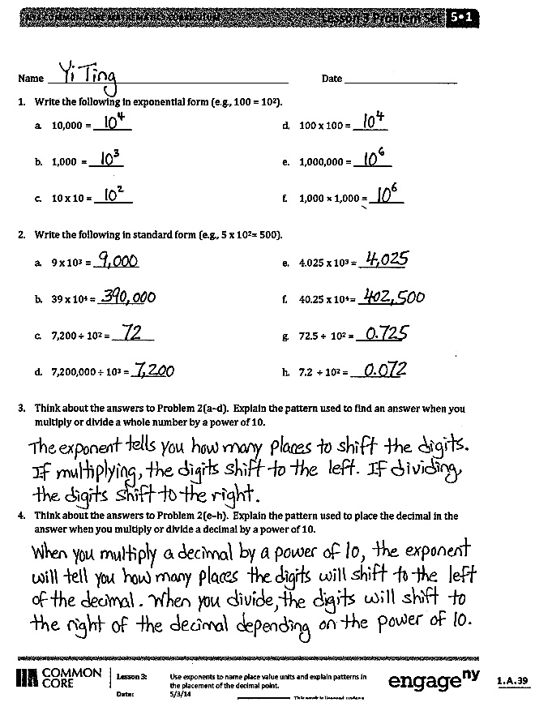Lesson Objective: Use exponents to name place value units, and explain patterns in the placement of the decimal point.

The Student Debrief is intended to invite reflection and active processing of the total lesson experience.

Invite students to review their solutions for the Problem Set. They should check work by comparing answers with a partner before going over answers as a class. Look for misconceptions or misunderstandings that can be addressed in the Debrief. Guide students in a conversation to debrief the Problem Set and process the lesson.

Any combination of the questions below may be used to lead the discussion.

* What is an **exponent**, and how can exponents be useful in representing numbers? (This question could also serve as a prompt for math journals. Journaling about new vocabulary throughout the year can be a powerful way for students to solidify their understanding of new terms.)
* 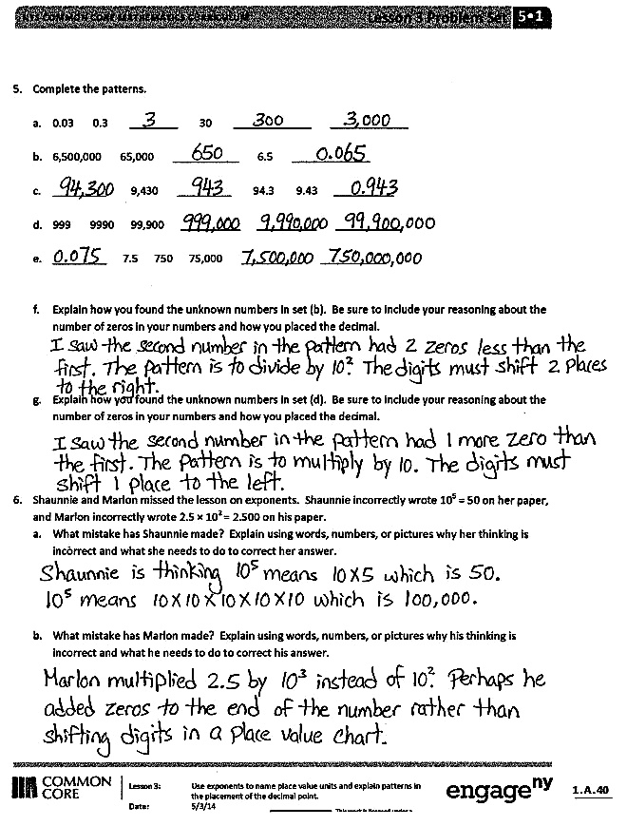How would you write 1,000 using exponents? How would you write it as a multiplication sentence using only 10 as a factor?
* Explain to your partner the relationship we saw between the exponents and the number of places the digits shift when you multiplied or divided by a power of 10.
* How are the patterns you discovered in Problems 3 and 4 of the Problem Set alike?
* Give students plenty of opportunity to discuss the error patterns in Problems 6(a) and 6(b). These are the most common misconceptions students hold when dealing with exponents, so it is worth the time to see that they do not become firmly held.

Exit Ticket (3 minutes)

After the Student Debrief, instruct students to complete the Exit Ticket. A review of their work will help with assessing students’ understanding of the concepts that were presented in today’s lesson and planning more effectively for future lessons. The questions may be read aloud to the students.

Number Correct: _______

**A**

Multiply by 3

|  |  |  |  |  |  |  |
| --- | --- | --- | --- | --- | --- | --- |
|  | 1 × 3 = |  |  |  | 10 × 3 = |  |
|  | 3 × 1 = |  |  |  | 9 × 3 = |  |
|  | 2 × 3 = |  |  |  | 4 × 3 = |  |
|  | 3 × 2 = |  |  |  | 8 × 3 = |  |
|  | 3 × 3 = |  |  |  | 5 × 3 = |  |
|  | 4 × 3 = |  |  |  | 7 × 3 = |  |
|  | 3 × 4 = |  |  |  | 6 × 3 = |  |
|  | 5 × 3 = |  |  |  | 3 × 10 = |  |
|  | 3 × 5 = |  |  |  | 3 × 5 = |  |
|  | 6 × 3 = |  |  |  | 3 × 6 = |  |
|  | 3 × 6 = |  |  |  | 3 × 1 = |  |
|  | 7 × 3 = |  |  |  | 3 × 9 = |  |
|  | 3 × 7 = |  |  |  | 3 × 4 = |  |
|  | 8 × 3 = |  |  |  | 3 × 3 = |  |
|  | 3 × 8 = |  |  |  | 3 × 2 = |  |
|  | 9 × 3 = |  |  |  | 3 × 7 = |  |
|  | 3 × 9 = |  |  |  | 3 × 8 = |  |
|  | 10 × 3 = |  |  |  | 11 × 3 = |  |
|  | 3 × 10 = |  |  |  | 3 × 11 = |  |
|  | 3 × 3 = |  |  |  | 12 × 3 = |  |
|  | 1 × 3 = |  |  |  | 3 × 13 = |  |
|  | 2 × 3 = |  |  |  | 13 × 3 = |  |

**B**

**[KEY]**

Number Correct: _______

Improvement: _______

Multiply by 3

|  |  |  |  |  |  |  |
| --- | --- | --- | --- | --- | --- | --- |
|  | 3 × 1 = |  |  |  | 9 × 3 = |  |
|  | 1 × 3 = |  |  |  | 3 × 3 = |  |
|  | 3 × 2 = |  |  |  | 8 × 3 = |  |
|  | 2 × 3 = |  |  |  | 4 × 3 = |  |
|  | 3 × 3 = |  |  |  | 7 × 3 = |  |
|  | 3 × 4 = |  |  |  | 5 × 3 = |  |
|  | 4 × 3 = |  |  |  | 6 × 3 = |  |
|  | 3 × 5 = |  |  |  | 3 × 5 = |  |
|  | 5 × 3 = |  |  |  | 3 × 10 = |  |
|  | 3 × 6 = |  |  |  | 3 × 1 = |  |
|  | 6 × 3 = |  |  |  | 3 × 6 = |  |
|  | 3 × 7 = |  |  |  | 3 × 4 = |  |
|  | 7 × 3 = |  |  |  | 3 × 9 = |  |
|  | 3 × 8 = |  |  |  | 3 × 2 = |  |
|  | 8 × 3 = |  |  |  | 3 × 7 = |  |
|  | 3 × 9 = |  |  |  | 3 × 3 = |  |
|  | 9 × 3 = |  |  |  | 3 × 8 = |  |
|  | 3 × 10 = |  |  |  | 11 × 3 = |  |
|  | 10 × 3 = |  |  |  | 3 × 11 = |  |
|  | 1 × 3 = |  |  |  | 13 × 3 = |  |
|  | 10 × 3 = |  |  |  | 3 × 13 = |  |
|  | 2 × 3 = |  |  |  | 12 × 3 = |  |

Name Date

1. Write the following in exponential form (e.g., 100 = 102).
2. 10,000 = __________
3. 1,000 = _________
4. 10 × 10 = __________
5. 100 × 100 = _________
6. 1,000,000 = __________
7. 1,000 × 1,000 = _________
8. Write the following in standard form (e.g., 5 × 102 = 500).
9. 9 × 103 = ____________
10. 39 × 104 = ____________
11. 7,200 ÷ 102 = ___________
12. 7,200,000 ÷ 103 = _________
13. 4.025 × 103 = ____________
14. 40.25 × 104 = ____________
15. 72.5 ÷ 102 = ____________
16. 7.2 ÷ 102 = _____________
17. Think about the answers to Problem 2(a–d). Explain the pattern used to find an answer when you multiply or divide a whole number by a power of 10.
18. Think about the answers to Problem 2(e–h). Explain the pattern used to place the decimal in the answer when you multiply or divide a decimal by a power of 10.
19. Complete the patterns.
20. 0.03 0.3 _______________ 30 _______________ _______________
21. 6,500,000 65,000 _______________ 6.5 _______________
22. _______________ 9,430 _______________ 94.3 9.43 _______________
23. 999 9990 99,900 _______________ _______________ _______________
24. _______________ 7.5 750 75,000 _______________ _______________
25. Explain how you found the unknown numbers in set (b). Be sure to include your reasoning about the number of zeros in your numbers and how you placed the decimal.
26. Explain how you found the unknown numbers in set (d). Be sure to include your reasoning about the number of zeros in your numbers and how you placed the decimal.
27. Shaunnie and Marlon missed the lesson on exponents. Shaunnie incorrectly wrote 105 = 50 on her paper, and Marlon incorrectly wrote 2.5 × 102 = 2.500 on his paper.
    1. What mistake has Shaunnie made? Explain using words, numbers, or pictures why her thinking is incorrect and what she needs to do to correct her answer.
    2. What mistake has Marlon made? Explain using words, numbers, or pictures why his thinking is incorrect and what he needs to do to correct his answer.

Name Date

1. Write the following in exponential form and as a multiplication sentence using only 10 as a factor   
   (e.g., 100 = 102 = 10 × 10).
2. 1,000 = ______________ = ______________
3. 100 × 100 = ______________ = ______________
4. Write the following in standard form (e.g., 4 × 102 = 400).
5. 3 × 102 = ______________
6. 2.16 × 104 = ______________
7. 800 ÷ 103 = ______________
8. 754.2 ÷ 102 = ______________

Name Date

1. Write the following in exponential form (e.g., 100 = 102).
2. 1000 = __________
3. 10 × 10 = _________
4. 100,000 = __________
5. 100 × 10 = _________
6. 1,000,000 = __________
7. 10,000 × 10 = _________
8. Write the following in standard form (e.g., 4 × 102 = 400).
9. 4 × 103 = ____________
10. 64 × 104 = ____________
11. 5,300 ÷ 102 = ___________
12. 5,300,000 ÷ 103 = _________
13. 6.072 × 103 = ____________
14. 60.72 × 104 = ____________
15. 948 ÷ 103 = ____________
16. 9.4 ÷ 102 = _____________
17. Complete the patterns.
    1. 0.02 0.2 __________ 20 __________ __________
    2. 3,400,000 34,000 __________ 3.4 __________
    3. __________ 8,570 __________ 85.7 8.57 __________
    4. 444 4440 44,400 __________ __________ __________
    5. __________ 9.5 950 95,000 __________ __________
18. After a lesson on exponents, Tia went home and said to her mom, “I learned that 104 is the same as 40,000.” She has made a mistake in her thinking. Use words, numbers, or a place value chart to help Tia correct her mistake.
19. Solve 247 ÷ 102 and 247 × 102.
    1. What is different about the two answers? Use words, numbers, or pictures to explain how the digits shift.
    2. Based on the answers from the pair of expressions above, solve 247 ÷ 103 and 247 × 103.

|  |  |  |
| --- | --- | --- |
| 10 | 10 ____ |  |
|  |  |  |
|  |  |  |
|  |  |  |
|  |  |  |
|  |  |  |

[1]

1. powers of 10 chart