Lesson 4

Objective: Use exponents to denote powers of 10 with application to metric conversions.

Suggested Lesson Structure

 Fluency Practice (12 minutes)

 Application Problem (8 minutes)

 Concept Development (30 minutes)

 Student Debrief (10 minutes)

**Total Time (60 minutes)**

Fluency Practice (12 minutes)

* Multiply and Divide Decimals by 10, 100, and 1000 **5.NBT.2** (5 minutes)
* Write the Unit as a Decimal **5.NBT.1** (2 minutes)
* Write in Exponential Form **5.NBT.2** (3 minutes)
* Convert Units **4.MD.1** (2 minutes)

Multiply and Divide Decimals by 10, 100, and 1000 (5 minutes)

Materials: (S) Millions through thousandths place value chart (Lesson 1 template), personal white board

Note: This fluency activity reviews concepts taught in earlier lessons and helps students work toward mastery in multiplying and dividing decimals by 10, 100, and 1000.

T: (Project the place value chart from millions to thousandths. Draw 3 disks in the tens place, 2 disks in the ones place, and 4 disks in the tenths place.) Say the value as a decimal.

S: 32.4 (thirty-two and four tenths).

T: Write the number on your personal boards, and multiply it by 10.

S: (Write 32.4 on their place value charts, cross out each digit, and shift the number one place value to the left to show 324.)

T: Show 32.4 divided by 10.

S: (Write 32.4 on their place value charts, cross out each digit, and shift the number one place value to the right to show 3.24.)

Repeat the process and sequence for 32.4 × 100, 32.4 ÷ 100, 837 ÷ 1000, and 0.418 × 1000.

Write the Unit as a Decimal (2 minutes)

Materials: (S) Personal white board

Note: Reviewing these skills helps students work toward mastery of decimal place value. This, in turn, helps them apply their place value skills to more difficult concepts.

T: (Write 9 tenths on the board.) Show this unit form as a decimal.

S: 0.9.

T: (Write 10 tenths on the board.)

S: 1.0.

Repeat the process for 20 tenths, 30 tenths, 70 tenths, 9 hundredths, 10 hundredths, 11 hundredths, 17 hundredths, 57 hundredths, 42 hundredths, 9 thousandths, 10 thousandths, 20 thousandths, 60 thousandths, 64 thousandths, and 83 thousandths.

Write in Exponential Form (3 minutes)

Materials: (S) Personal white board

Note: Reviewing this skill in isolation lays a foundation for students to apply it when multiplying during the lesson.

T: (Write 100 = 10?.) Write 100 in exponential form.

S: (Write 100 = 102.)

Repeat the process for 1,000, 10,000, and 1,000,000.

Convert Units (2 minutes)

Materials: (S) Personal white board

Note: Reviewing conversions in isolation lays a foundation for students to apply it when multiplying and dividing during the lesson.

Use this quick fluency drill to activate prior knowledge of these familiar equivalents.

T: (Write 1 km = ____ m.) Fill in the unknown number.

S: (Write 1 km = 1,000 m.)

Repeat the process and procedure for 1 kg = ____ g, 1 liter = ____ mL, 1 m = ____ cm.

Application Problem (8 minutes)

Materials: (S) Meter strip (Template)

T: Here is a place value chart. (Show the place value chart from thousands to thousandths without other headings.)

|  |  |  |  |  |  |  |
| --- | --- | --- | --- | --- | --- | --- |
| thousands | hundreds | tens | ones | tenths | hundredths | thousandths |
| 1000 meters  kilometer | 100 meters  (hectometer) | 10 meters  (dekameter) | 1 meter | meter (decimeter) | meter centimeter | meter **millimeter** |
|  |  |  | 0  0 | 0  0 | 1  0 | 1 |

T: Here is a set of column headings based on metric length related to our place value chart, designating one meter as the base unit, or the ones place.

|  |  |
| --- | --- |
|  | NOTES ON  MULTIPLE MEANS  OF ACTION AND ENGAGEMENT: |
| The place value chart can be used throughout the coming lesson to help students think through whether they are renaming from small to large units or large to small units. Throughout the school day, take the opportunity to extend thinking by asking students to make a conversion to the unit that is  1 tenth as large as a meter (decimeter) and the unit 10 times as large (dekameter). Students can do research about these and other metric units that are less commonly used or investigate industry applications for the less familiar units. For example, decameters are often used to measure altitude in meteorology, and decimeters are commonly used in physical chemistry. | |

T: Use your meter strip to show and explain to your partner the lengths that relate to the tenths, hundredths, and thousandths places. (Move through the tenths, hundredths, and thousandths until identifying and naming meter as 1 **millimeter**.)

Have students then explain to their partner lengths that relate to the tens, hundreds, and thousands places. For example, 10 meters would be about the length of the classroom, 100 meters about the length of a football field, and 1,000 meters is a kilometer, which may be conceived in relation to the distance to their home from school.

Note: Be sure to establish the following, which is essential to the Concept Development lesson:

1 **millimeter** (mm) = meter (m) = 0.001 meter

1 centimeter (cm) = meter (m) = 0.01 meter.

The relationship of metric lengths to the place value chart will also help students to realize when they are moving from smaller to larger or larger to smaller units. Consider reviewing the multiplicative relationships between the units.

Concept Development (30 minutes)

Materials: (S) Meter strip (Template), personal white board

Each problem below includes conversions from both large units to smaller units and small to larger units. Allow students the time to reason about how the change in the size of the unit will affect the *quantity* and *size* of the units needed to express an equivalent measure.

Problem 1

Rename or convert large units as smaller units using multiplication equations with exponents.

|  |  |
| --- | --- |
|  | NOTES ON  MULTIPLE MEANS  OF REPRESENTATION: |

The drawing of the 2-meter,   
200-centimeter, and 2,000-millimeter line supports student understanding, especially when plotting 1.37 meters. Butcher paper can be used if there is insufficient space on the class board or other surface normally used. This also promotes student success with plotting decimal fractions on the number line.

T: (Draw and label a line 2 meters long on the board.)

T: How many centimeters equal 2 meters?

S: 200 centimeters. (Label the same 2 meter point as 200 centimeters. Fill in the first row of the t-chart.)

T: Tell me a multiplication equation multiplying by 2 to get 200.

S: 2 100 = 200.

T: Restate the equation renaming 100 with an exponent.

S: 2 102 = 200.

T: With your partner, determine how many centimeters are equal to 1.37 meter. Use your meter strip if it helps you.

|  |  |  |
| --- | --- | --- |
| meters | centimeters | millimeters |
| 2 | 200 | 2,000 |
| 1.37 | 137 | 1,370 |
| 2.6 | 260 | 2,600 |
| To rename meters as centimeters, multiply by 102.  To rename meters as millimeters, multiply by 103. | | |

S: It’s 1 meter and 37 centimeters. 🡪 It’s more than 1 meter and less than 2 meters. 🡪 37 hundredths of a meter is 37 centimeters.   
100 cm + 37 cm = 137 cm.

T: What is the equivalent measure in centimeters?

S: 137 centimeters. (On the board, label the same 1.37 meter point as 137 centimeters. Fill in the second row of the chart.)

T: On your boards, show this conversion using a multiplication equation with an exponent.

S: 1.37 100 = 137. 🡪 1.37 102 = 137.

T: What must we do to the number of meters to rename them as centimeters?

S: Multiply the number of meters by 100 or 102. (Record the rule on the chart. Repeat with   
2.6 meters.)

T: How can we use multiplication to rename a meter as millimeters? Discuss with your partner.

S: Multiply the number of meters by 1,000 or by 103.

T: Take a moment to write multiplication equations with exponents to find the number of millimeters to complete the third column of our chart.

T: Show me your boards.

S: (Show 2 103 = 2,000, 1.37 103 = 1,370, and 2.6 103 = 2,600.)

T/S: (Fill in the equivalent millimeter measures together.)

T: Explain the difference between A and B to your partner.

*Problem A*  *Problem B*

2 meters 103  = 2,000 meters 2 103 = 2,000 2 meters = 2,000 millimeters

S: Problem A is not renaming or converting, but multiplying 2 *meters* by 103, so the answer is   
2,000 *meters.* That’s more than 2 miles! 🡪 Problem B is renaming by multiplying 1,000 by 2 because each meter has a thousand millimeters in it. After we multiply, then we can name the unit. That is the exact same measurement as 2 meters.

T: Yes, we are multiplying the number of meters by 103. Explain why we multiply to rename large units as small units. (Point to the 2-meter line drawn on the board.)

S: 1 meter = 1,000 millimeters, 2 meters = 2,000 millimeters. It’s the *number* of meters that is being multiplied, not the meters. 🡪 Multiplying didn’t make 2 meters into more *meters*, but renamed the 2 meters as 2,000 millimeters. 🡪 One meter got chopped up into 1,000 millimeters, so we multiply the number of meters by 1,000. 🡪 The length stays the same because we’re making more units by decomposing a meter, not by making more copies of a meter.

Problem 2

|  |  |  |
| --- | --- | --- |
| millimeters | centimeters | meters |
| 2,000 | 200 | 2 |
| 1,370 | 137 | 1.37 |
| 2,600 | 260 | 2.6 |
| To rename centimeters to meters, divide by 102.  To rename millimeters to meters, divide by 103. | | |

Rename millimeters and centimeters as meters using division equations with exponents.

Again, using the 2-meter line and chart, reverse Problem 1’s sequence, and convert from smaller to larger units, dividing by 102 to rename, or convert, centimeters as meters, dividing by 103 to rename, or convert, millimeters as meters.

Culminate with the same reflection:

T: We are dividing the number of meters by 102 orby 103. That is a method for renaming centimeters as meters and millimeters as meters. Explain the difference between C and D with your partner.

*Problem C*  *Problem D*

2,000 mm ÷ 103 = 2 mm 2,000 ÷ 103 = 2 2,000 mm = 2 m

S: 1,000 millimeters = 1 meter, 2,000 millimeters = 2 meters. It’s the *number* of millimeters that is being divided, not the millimeters. 🡪 Division renamed the 2,000 mm as 2 meters. How many groups of 1,000 are in 2 thousands? 🡪 1,000 millimeters got grouped together as 1 meter, so we divide or make groups of 1,000.

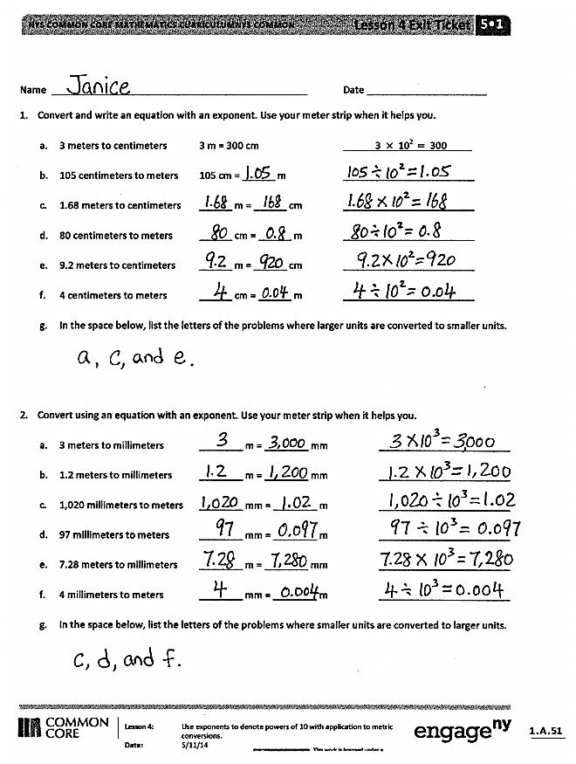Problem 3

A ribbon measures 4.5 meters. Convert its length to centimeters.  
A wire measures 67 millimeters. Convert its length to meters.

Note: The most important concept is the equivalence of the two measurements—that is, the length did not change, which becomes very apparent when conversions are contextualized. The ribbon and wire are not getting longer or shorter. Clarify this understanding before moving on to finding the conversion equation by asking, “How can 4.5 and 4,500 represent the same length?” (While the numeric values differ, the unit size is also different. 4.5 is meters. 4,500 is millimeters. Meters are 1,000 times as large as millimeters. Therefore, it takes fewer meters to represent the same amount as something measured in millimeters.) Lead students to articulate that when converting the number of large units to a number of smaller units, they multiplied, and when converting from small units to larger units, they divided.

Problem Set (10 minutes)

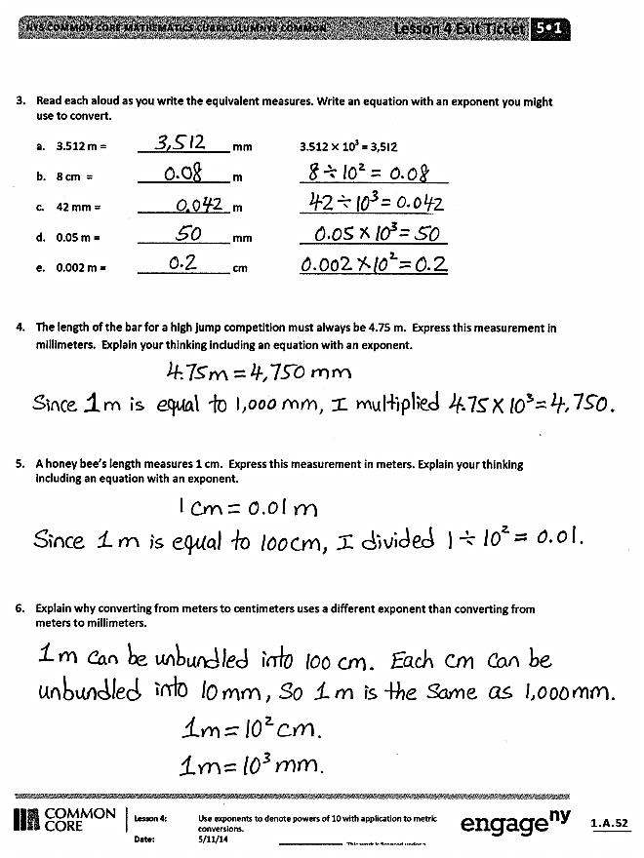Students should do their personal best to complete the Problem Set within the allotted 10 minutes. For some classes, it may be appropriate to modify the assignment by specifying which problems they work on first. Some problems do not specify a method for solving. Students solve these problems using the RDW approach used for Application Problems.

In this Problem Set, we suggest all students begin with Problem 1 and leave Problem 6 for the end, if they have time.

Student Debrief (10 minutes)

**Lesson Objective:**  Use exponents to denote powers of 10 with application to metric conversions.

The Student Debrief is intended to invite reflection and active processing of the total lesson experience.

Invite students to review their solutions for the Problem Set. They should check work by comparing answers with a partner before going over answers as a class. Look for misconceptions or misunderstandings that can be addressed in the Debrief. Guide students in a conversation to debrief the worksheet and process the lesson.

Any combination of the questions below may be used to lead the discussion.

* Which of the following statements is false? Explain your thinking to your partner.

1. 2 m 103 = 2,000 m
2. 2 m 103 = 2,000 mm
3. 2 103 = 2,000
4. 2 m = 2,000 mm

* Is it easier for you to think about converting from large units to smaller units or small units to larger units? Why? What is the difference in both the thinking and the operation required?
* 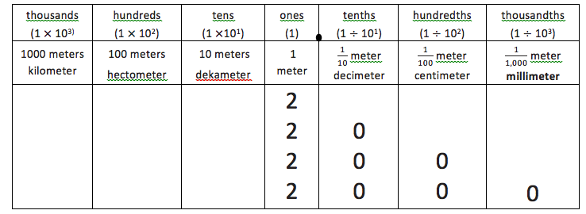Let’s look at the place value chart. Explain to your partner the way the equivalence of 2 meters, 20 tenth meters, 200 centimeters, and 2,000 **millimeters** is shown.
* How can we use what we know about renaming meters to millimeters to rename kilograms to grams and liters to milliliters?

Exit Ticket (3 minutes)

After the Student Debrief, instruct students to complete the Exit Ticket. A review of their work will help with assessing students’ understanding of the concepts that were presented in today’s lesson and planning more effectively for future lessons. The questions may be read aloud to the students.

Name Date

1. Convert and write an equation with an exponent. Use your meter strip when it helps you.
2. 3 meters to centimeters 3 m = 300 cm 3 102 300
3. 105 centimeters to meters 105 cm = ______ m ________________________
4. 1.68 meters to centimeters ______ m = ______ cm ________________________
5. 80 centimeters to meters ______ cm = ______ m ________________________
6. 9.2 meters to centimeters ______ m = ______ cm ________________________
7. 4 centimeters to meters ______ cm = ______ m ________________________
8. In the space below, list the letters of the problems where larger units are converted to smaller units.
9. Convert using an equation with an exponent. Use your meter strip when it helps you.
10. 3 meters to millimeters ________ m = ________ mm ________________________
11. 1.2 meters to millimeters ________ m = ________ mm ________________________
12. 1,020 millimeters to meters ________ mm = ________ m ________________________
13. 97 millimeters to meters ________ mm = ________ m ________________________
14. 7.28 meters to millimeters ________ m = ________ mm ________________________
15. 4 millimeters to meters ________ mm = ________ m ________________________
16. In the space below, list the letters of the problems where smaller units are converted to larger units.
17. Read each aloud as you write the equivalent measures. Write an equation with an exponent you might use to convert.
18. 3.512 m = _______________ mm 3.512 103 = 3,512
19. 8 cm = _______________ m ________________________
20. 42 mm = _______________ m ________________________
21. 0.05 m = _______________ mm ________________________
22. 0.002 m = _______________ cm ________________________
23. The length of the bar for a high jump competition must always be 4.75 m. Express this measurement in millimeters. Explain your thinking. Include an equation with an exponent in your explanation.
24. A honey bee’s length measures 1 cm. Express this measurement in meters. Explain your thinking. Include an equation with an exponent in your explanation.
25. Explain why converting from meters to centimeters uses a different exponent than converting from meters to millimeters.

Name Date

1. Convert using an equation with an exponent.
2. 2 meters to centimeters 2 m = ________ cm _________________________
3. 40 millimeters to meters 40 mm = ________ m _________________________
4. Read each aloud as you write the equivalent measures.
5. A piece of fabric measures 3.9 meters. Express this length in centimeters.
6. Ms. Ramos’s thumb measures 4 centimeters. Express this length in meters.

Name Date

1. Convert and write an equation with an exponent. Use your meter strip when it helps you.
2. 2 meters to centimeters 2m = 200 cm 2 102 200
3. 108 centimeters to meters 108 cm = ______ m ________________________
4. 2.49 meters to centimeters ______ m = ______ cm ________________________
5. 50 centimeters to meters ______ cm = ______ m ________________________
6. 6.3 meters to centimeters ______ m = ______ cm ________________________
7. 7 centimeters to meters ______ cm = ______ m ________________________
8. In the space below, list the letters of the problems where smaller units are converted to larger units.
9. Convert using an equation with an exponent. Use your meter strip when it helps you.
10. 4 meters to millimeters ________ m = ________ mm ________________________
11. 1.7 meters to millimeters ________ m = ________ mm ________________________
12. 1,050 millimeters to meters ________ mm = ________ m ________________________
13. 65 millimeters to meters ________ mm = ________ m ________________________
14. 4.92 meters to millimeters ________ m = ________ mm ________________________
15. 3 millimeters to meters ________ mm = ________ m ________________________
16. In the space below, list the letters of the problems where larger units are converted to smaller units.
17. Read each aloud as you write the equivalent measures. Write an equation with an exponent you might use to convert.
18. 2.638 m = ______________ mm 2.638 103 = 2,638
19. 7 cm = ______________ m ________________________
20. 39 mm = ______________ m ________________________
21. 0.08 m = _______________ mm ________________________
22. 0.005 m = ______________ cm ________________________
23. Yi Ting’s height is 1.49 m. Express this measurement in millimeters. Explain your thinking. Include an equation with an exponent in your explanation.
24. A ladybug’s length measures 2 cm. Express this measurement in meters. Explain your thinking. Include an equation with an exponent in your explanation.
25. The length of a sticky note measures 77 millimeters. Express this length in meters. Explain your thinking. Include an equation with an exponent in your explanation.

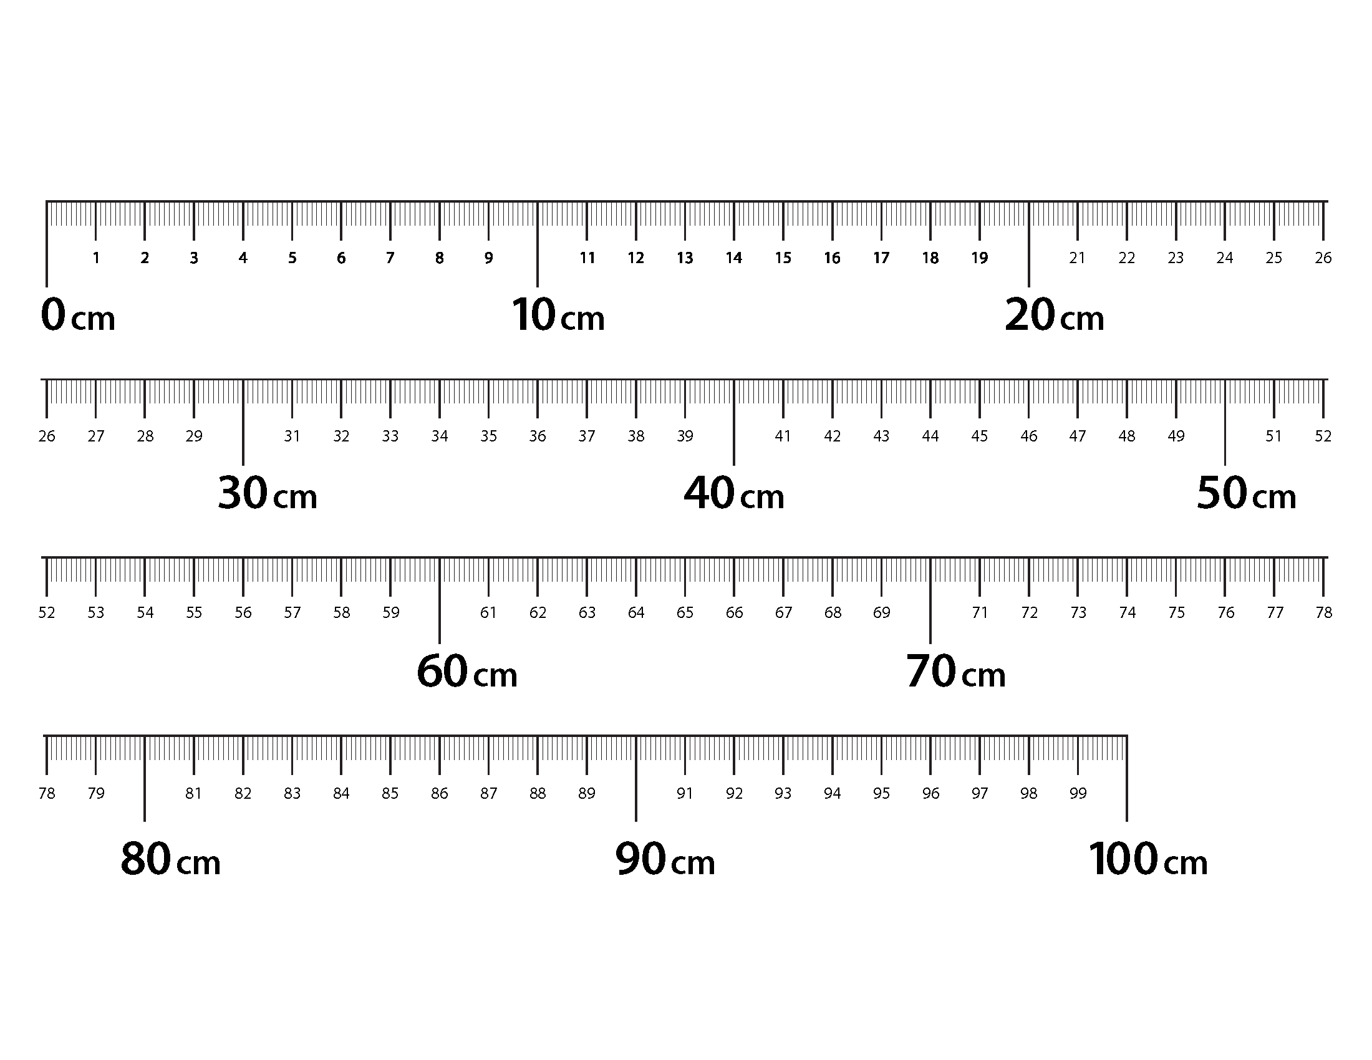[1]

1. meter strip