Lesson 6

Objective: Compare decimal fractions to the thousandths using like units, and express comparisons with >, <, =.

Suggested Lesson Structure

  Fluency Practice (12 minutes)

  Application Problem (8 minutes)

  Concept Development (30 minutes)

  Student Debrief (10 minutes)

**Total Time (60 minutes)**

Fluency Practice (12 minutes)

* Find the Midpoint **5.NBT.4** (5 minutes)
* Rename the Units **5.NBT.1** (2 minutes)
* Multiply by Decimal Fractions **5.NBT.3a** (5 minutes)

Find the Midpoint (5 minutes)

Materials: (S) Personal white board

Note: Practicing this skill in isolation helps students conceptually understand rounding decimals in Lesson 12.

T: (Draw a 0 on the left side of a number line and 10 on the right side of the number line.) What’s halfway between 0 ones and 10 ones?

S: 5 ones.

T: (Write 5 ones halfway between the 0 and 10. Draw a second number line directly beneath the first. Write 0 on the left side and 1 on the right side.) How many tenths is 1?

S: 1 is 10 tenths.

T: (Write 10 tenths below the 1.) On your boards, write the decimal that is halfway between 0 and 1 or 10 tenths.

S: (Write 0.5 approximately halfway between 0 and 1 on their number lines.)

Repeat the process for these possible sequences: 0 and 0.1, 0 and 0.01, 10 and 20, 1 and 2, 0.1 and 0.2, 0.01 and 0.02, 0.7 and 0.8, 0.7 and 0.71, 9 and 10, 0.9 and 1, and 0.09 and 0.1.

Rename the Units (2 minutes)

Note: Reviewing unit conversions helps students work toward mastery of decomposing common units into compound units.

T: (Write 100 cm = ____ m.) Rename the units.

S: 100 cm = 1 meter.

T: (Write 200 cm = ____ m.) Rename the units.

S: 200 centimeters = 2 meters.

T: 700 centimeters.

S: 7 meters.

T: (Write 750 cm = ____ m ____ cm.) Rename the units.

S: 7 meters 50 centimeters.

Repeat the process for 450 cm, 630 cm, and 925 cm.

Multiply by Decimal Fractions (5 minutes)

Materials: (S) Personal white board, millions to thousandths place value chart (Lesson 1 Template)

Note: Reviewing the concept helps students work toward mastery of this skill introduced in previous lessons.

T: (Project a place value chart from tens to thousandths. Beneath the chart, write 3 × 10 = ____.) Say the multiplication sentence.

S: 3 × 10 = 30.

T: (Write 3 in the tens column. Below the multiplication sentence, write 30. To the right of 3 × 10, write 4 × 1 = ____.) Say the multiplication sentence.

S: 4 × 1 = 4.

T: (Write 4 in the ones column, and fill in the addition sentence so that it reads 30 + 4.)

Repeat the process with each of the expressions below so that, in the end, the number 34.652 will be written in the place value chart and 30 + 4 + 0.6 + 0.05 + 0.002 is written underneath it:

6 5 2

T: Say the addition sentence.

S: 30 + 4 + 0.6 + 0.05 + 0.002 = 34.652.

T: (Write 75.614 on the place value chart.) Write the number in expanded form.

Repeat with the following possible sequence: 75.604, 20.197, and 40.803.

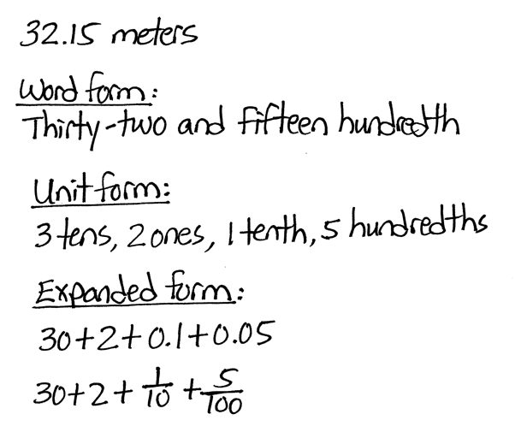Application Problem (8 minutes)

Ms. Meyer measured the edge of her dining table to the hundredths of a meter. The edge of the table measured 32.15 meters. Write her measurement in word form, unit form, and expanded form using fractions and decimals.

Encourage students to name the decimal by decomposing it into various units (e.g., 3,215 hundredths; 321 tenths 5 hundredths; 32 ones 15 hundredths).

Concept Development (30 minutes)

Materials: (S) Millions to thousands place value chart (Lesson 1 Template), personal white board

Problem 1

**MP.2**

Compare 13,196 and 13,296.

T: (Point to 13,196.) Read the number.

S: 13 thousand, 1 hundred ninety-six.

T: (Point to 13,296.) Read the number.

S: 13 thousand, 2 hundred ninety-six.

T: Which number is greater? How can you tell?

S: 13,296 is greater than 13,196 because the digit in the hundreds place is one greater. 🡪 13,296 is 100 more than 13,196. 🡪 13,196 has 131 hundreds and 13,296 has 132 hundreds, so 13,296 is greater.

T: Use a symbol to show which number is greater.

S: 13,196 < 13,296.

Problem 2

Compare 0.012 and 0.002.

T: Write 2 thousandths in standard form on your place value chart. (Write 2 thousandths on the board.)

S: (Write.)

T: Say the digits that you wrote on your chart.

S: Zero point zero zero two.

T: Write 12 thousandths in standard form underneath 0.002 on your chart. (Write 12 thousandths on the board.)

S: (Write.)

T: Say the digits that you wrote on your chart.

S: Zero point zero one two.

T: Say this number in unit form.

S: 1 hundredth 2 thousandths.

T: Which number is greater? Turn and talk to your partner about how you can tell.

S: 0.012 is bigger than 0.002. 🡪 In 0.012, there is a one in the hundredths place, but 0.002 has a zero in the hundredths, so that means 0.012 is greater than 0.002. 🡪 12 of something is greater than 2 of the same thing. Just like 12 apples are more than 2 apples.

T: Write an expression comparing these two values.

S: 0.002 < 0.012.

Problem 3

|  |  |
| --- | --- |
|  | NOTES ON  MULTIPLE MEANS  OF ENGAGEMENT: |
| Help students deepen their understanding of comparing decimals by returning to concrete materials. Some students may not see that 0.4 > 0.399 because they are focusing on the number of digits to the right of the decimal rather than their value. Comparison of like units becomes a concrete experience when students' attention is directed to comparisons of largest to smallest place value on the chart and when they are encouraged to make trades to the smaller unit using disks. | |

Compare and

T: Write 3 tenths in standard form on your place value chart.

S: (Write.)

T: Write 299 thousandths in standard form on your place value chart under 3 tenths.

S: (Write.)

T: Which decimal has more tenths?

S: 0.3.

T: If we traded 3 tenths for thousandths, how many thousandths would we need? Turn and talk to your partner.

S: 300 thousandths.

T: Name these decimals using unit form and compare.

**MP.4**

Tell your partner which is greater.

S: 299 thousandths. 300 thousandths is more.

|  |  |
| --- | --- |
|  | NOTES ON  MULTIPLE MEANS  OF ENGAGEMENT: |
| Provide an extension by including fractions along with decimals to be ordered.  Order from least to greatest: 29.5, 27.019, and 27. | |

T: Show this relationship with a symbol.

S: 0.299 < 0.3.

Repeat the sequence with and and 15.203 and 15.21.

Encourage students to name the fractions and decimals using like units as above (e.g., 15 ones 20 tenths 3 thousandths and 15 ones 21 tenths 0 hundredths or 15,203 thousandths and 15,210 thousandths). Be sure to have students express the relationships using <, >, and =.

Problem 4

Order from least to greatest: 0.413, 0.056, 0.164, and 0.531.

Have students order the decimals and then explain their strategy (e.g., renaming in unit form, using a place value chart to compare largest to smallest units looking for differences in value).

Repeat with the following in ascending and descending order: 27.005, 29.04, 27.019, and 29.5; 119.177, 119.173, 119.078, and 119.18.

Problem Set (10 minutes)

Students should do their personal best to complete the problem set within the allotted 10 minutes. For some classes, it may be appropriate to modify the assignment by specifying which problems they work on first. Some problems do not specify a method for solving. Students solve these problems using the RDW approach used for Application Problems.

On this Problem Set, it is suggested that all students begin with Problems 1, 2, and 5 and possibly leave Problems 3 and 6 for the end, if time allows.

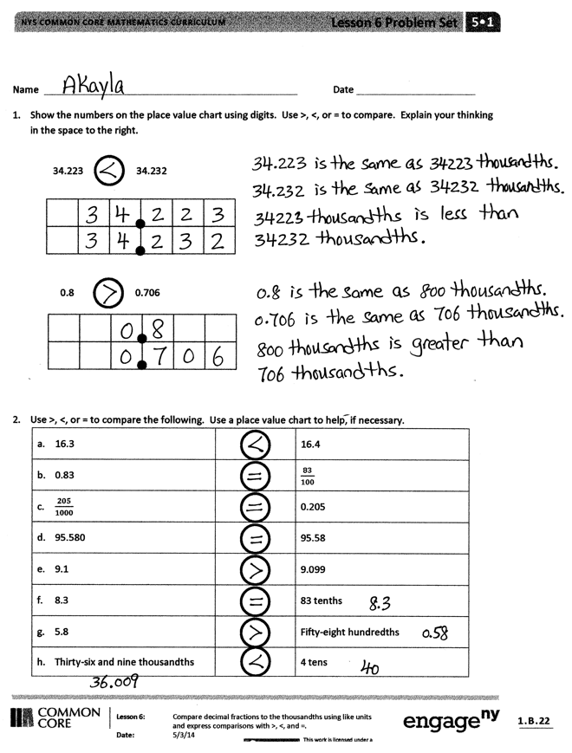Student Debrief (10 minutes)

**Lesson Objective:** Compare decimal fractions to the thousandths using like units, and express comparisons with >, <, =.

The Student Debrief is intended to invite reflection and active processing of the total lesson experience.

Invite students to review their solutions for the Problem Set. They should check work by comparing answers with a partner before going over answers as a class. Look for misconceptions or misunderstandings that can be addressed in the Debrief. Guide students in a conversation to debrief the Problem Set and process the lesson. Any combination of the questions below may be used to lead the discussion.

* How is comparing whole numbers like comparing decimal fractions? How is it different?
* 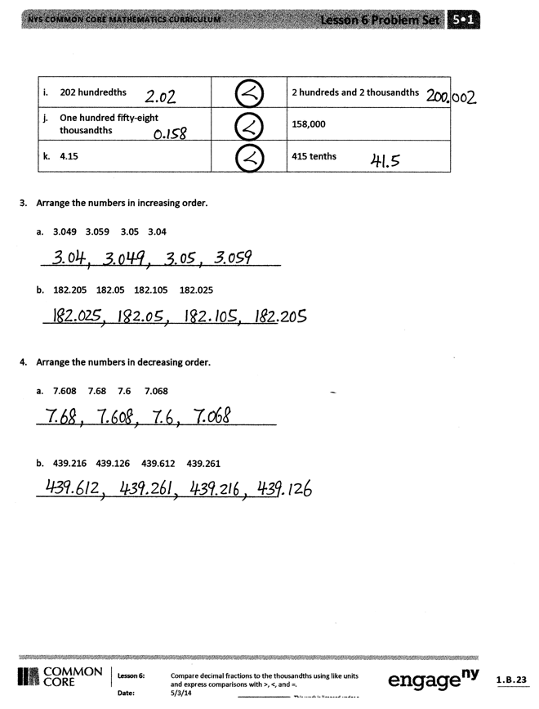You learned two strategies to help you compare numbers (finding a common unit and looking at the place value chart). Which strategy do you like best? Explain.
* Allow sufficient time for an in-depth discussion of Problem 5. As these are commonly held misconceptions when comparing decimals, it is   
  worthy of special attention. Ask the following series of questions. What is the mistake that Lance is making? (He’s not using like units to compare the numbers. He’s forgetting that decimals are named by their smallest units.) How could Angel have named his quantity of water so that the units were the same as Lance’s? How would using the same units have helped Lance to make a correct comparison? How is renaming these decimals in the same unit like changing fractions to like denominators?
* Compare 7 tens and 7 tenths. How are they alike? How are they different? (Encourage students to notice that both quantities are 7, but the units have different values.) Also, encourage students to notice that they are placed symmetrically in relation to the ones place on place value chart. Tens are 10 times greater than ones while tenths are 1 tenth as much. Repeat with other values, (e.g., 2000, 0.002), or ask students to generate values that are symmetrically placed on the chart.

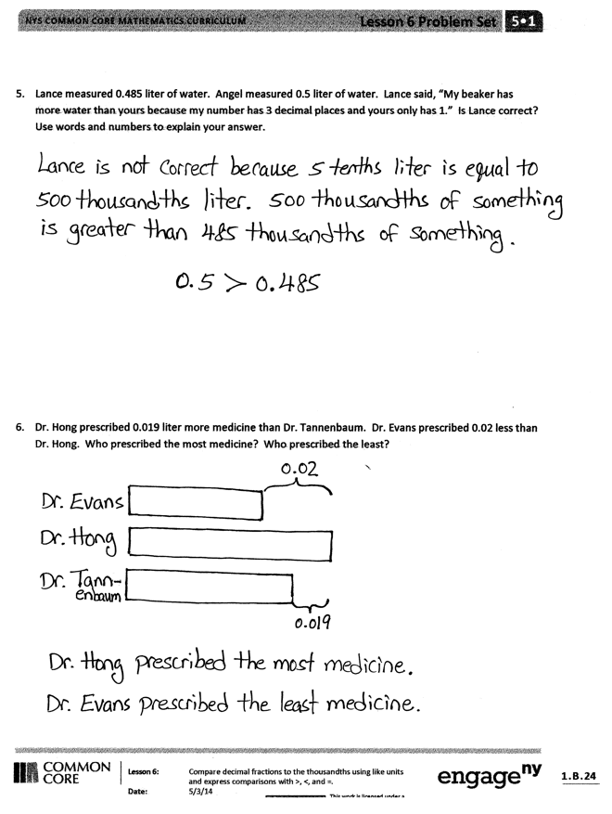Exit Ticket (3 minutes)

After the Student Debrief, instruct students to complete the Exit Ticket. A review of their work will help with assessing students’ understanding of the concepts that were presented in today’s lesson and planning more effectively for future lessons. The questions may be read aloud to the students.

Name Date

1. Show the numbers on the place value chart using digits. Use >, <, or = to compare. Explain your thinking in the space to the right.

|  |  |  |  |  |  |
| --- | --- | --- | --- | --- | --- |
|  |  |  |  |  |  |
|  |  |  |  |  |  |

34.223 34.232

|  |  |  |  |  |  |  |
| --- | --- | --- | --- | --- | --- | --- |
|  |  |  |  |  |  |  |
|  |  |  |  |  |  |  |

0.8 0.706

1. Use >, <, or = to compare the following. Use a place value chart to help, if necessary.

|  |  |  |
| --- | --- | --- |
| 1. 16.3 |  | 16.4 |
| 1. 0.83 |  |  |
|  |  | 0.205 |
| 1. 95.580 |  | 95.58 |
| 1. 9.1 |  | 9.099 |
| 1. 8.3 |  | 83 tenths |
| 1. 5.8 |  | Fifty-eight hundredths |
| 1. Thirty-six and nine thousandths |  | 4 tens |
| 1. 202 hundredths |  | 2 hundreds and 2 thousandths |
| 1. One hundred fifty-eight thousandths |  | 158,000 |
| 1. 4.15 |  | 415 tenths |

1. Arrange the numbers in increasing order.
2. 3.049 3.059 3.05 3.04

_______________________________________________

1. 182.205 182.05 182.105 182.025

______________________________________________

1. Arrange the numbers in decreasing order.
2. 7.608 7.68 7.6 7.068

_______________________________________________

1. 439.216 439.126 439.612 439.261

_______________________________________________

1. Lance measured 0.485 liter of water. Angel measured 0.5 liter of water. Lance said, “My beaker has more water than yours because my number has three decimal places and yours only has one.” Is Lance correct? Use words and numbers to explain your answer.
2. Dr. Hong prescribed 0.019 liter more medicine than Dr. Tannenbaum. Dr. Evans prescribed 0.02 less than Dr. Hong. Who prescribed the most medicine? Who prescribed the least?

Name Date

1. Show the numbers on the place value chart using digits. Use >, <, or = to compare. Explain your thinking in the space to the right.

|  |  |  |  |  |  |
| --- | --- | --- | --- | --- | --- |
|  |  |  |  |  |  |
|  |  |  |  |  |  |

167.4 167.462

1. Use >, <, and = to compare the numbers.

32.725 32.735

1. Arrange the numbers in decreasing order.

76.342 76.332 76.232 76.343

_______________________________________________

Name Date

1. Use >, <, or = to compare the following.

|  |  |  |
| --- | --- | --- |
| 1. 16.45 |  | 16.454 |
| 1. 0.83 |  |  |
|  |  | 0.205 |
| 1. 95.045 |  | 95.545 |
| 1. 419.10 |  | 419.099 |
| 1. Five ones and eight tenths |  | Fifty-eight tenths |
| 1. Thirty-six and nine thousandths |  | Four tens |
| 1. One hundred four and twelve hundredths |  | One hundred four and two thousandths |
| 1. One hundred fifty-eight thousandths |  | 0.58 |
| 1. 703.005 |  | Seven hundred three and five hundredths |

1. Arrange the numbers in increasing order.
2. 8.08 8.081 8.09 8.008

_______________________________________________

1. 14.204 14.200 14.240 14.210

_______________________________________________

1. Arrange the numbers in decreasing order.
2. 8.508 8.58 7.5 7.058

_______________________________________________

1. 439.216 439.126 439.612 439.261

_______________________________________________

1. James measured his hand. It was 0.17 meter. Jennifer measured her hand. It was 0.165 meter. Whose hand is bigger? How do you know?
2. In a paper airplane contest, Marcel’s plane travels 3.345 meters. Salvador’s plane travels 3.35 meters. Jennifer’s plane travels 3.3 meters. Based on the measurements, whose plane traveled the farthest distance? Whose plane traveled the shortest distance? Explain your reasoning using a place value chart.