Lesson 7

Objective: Round a given decimal to any place using place value understanding and the vertical number line.

Suggested Lesson Structure

|  |  |
| --- | --- |
|  | NOTES ON  MULTIPLE MEANS  OF REPRESENTATION: |

Vertical number lines may be a novel representation for students. Their use offers an important scaffold for students’ understanding of rounding in that numbers are quite literally rounded up and down to the nearest multiple rather than left or right as in a horizontal number line. Consider showing both a horizontal and vertical line and comparing their features so that students can see the parallels and gain comfort in the use of the vertical line.

 Fluency Practice (12 minutes)

 Application Problem (8 minutes)

 Concept Development (30 minutes)

 Student Debrief (10 minutes)

**Total Time (60 minutes)**

Fluency Practice (12 minutes)

* Sprint: Find the Midpoint **5.NBT.4** (7 minutes)
* Compare Decimal Fractions **5.NBT.3b** (2 minutes)
* Rename the Units  **5.NBT.2** (3 minutes)

Sprint: Find the Midpoint (7 minutes)

Materials: (S) Find the Midpoint Sprint

Note: Practicing this skill in isolation helps students conceptually understand the rounding of decimals.

Compare Decimal Fractions (2 minutes)

|  |  |
| --- | --- |
|  | NOTES ON  MULTIPLE MEANS  OF ENGAGEMENT: |
| Fluency activities like Compare Decimal Fractions may be made more active by allowing students to stand and use their arms to make the >, <, and = signs in response to questions on the board. | |

Materials: (S) Personal white board

Note: This review fluency activity helps students work toward mastery of comparing decimal numbers, a topic introduced in Lesson 6.

T: (Write 12.57 ___ 12.75.) On your personal boards, compare the numbers using the greater than, less than, or equal sign.

S: (Write 12.57 < 12.75 on boards.)

Repeat the process and procedure:

0.67 __ __ 0.084 328.2 __ 328.099

4.07 __ forty-seven tenths twenty-four and 9 thousandths___ 3 tens

Rename the Units (3 minutes)

Note: Renaming decimals using various units strengthens student understanding of place value and provides an anticipatory set for rounding decimals in Lessons 7 and 8.

T: (Write 1.5 = ____ tenths.) Fill in the blank.

S: 15 tenths.

T: (Write 1.5 = 15 tenths. Below it, write 2.5 = ____ tenths.) Fill in the blank.

S: 25 tenths.

T: (Write 2.5 = 25 tenths. Below it, write 12.5 = ____ tenths.) Fill in the blank.

S: 125 tenths.

Repeat the process for 17.5, 27.5, 24.5, 24.3, and 42.3.

Application Problem (8 minutes)

Craig, Randy, Charlie, and Sam ran in a 5K race on Saturday. They were the top 4 finishers. Here are their race times:

Craig: 25.9 minutes Randy: 32.2 minutes

Charlie: 32.28 minutes Sam: 25.85 minutes

Who won first place? Who won second place? Third? Fourth?

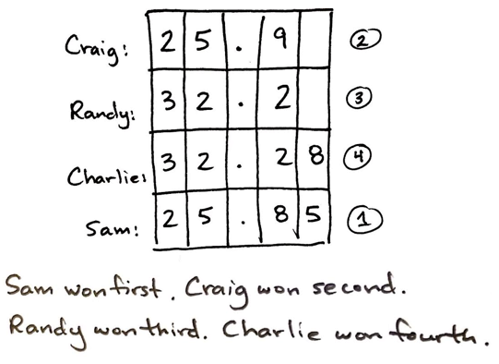

Note: This Application Problem offers students a quick review of yesterday’s concept before moving toward the rounding of decimals. Students may need reminding that in a race, the lowest number indicates the fastest time.

Concept Development (30 minutes)

Materials: (S) Personal white board, hundreds to thousandths place value chart (Template)

Problem 1

Strategically decompose 155 using multiple units to round to the nearest ten and nearest hundred.

T: Work with your partner to name 155 in unit form. Next, rename 155 using the greatest number of tens possible. Finally, rename 155 using only ones. Record your ideas on your place value chart.

|  |  |  |  |
| --- | --- | --- | --- |
| **Hundreds** | **Tens** | **Ones** | **Tenths** |
| 1 | 5 | 5 |  |
|  | 15 | 5 |  |
|  |  | 155 |  |

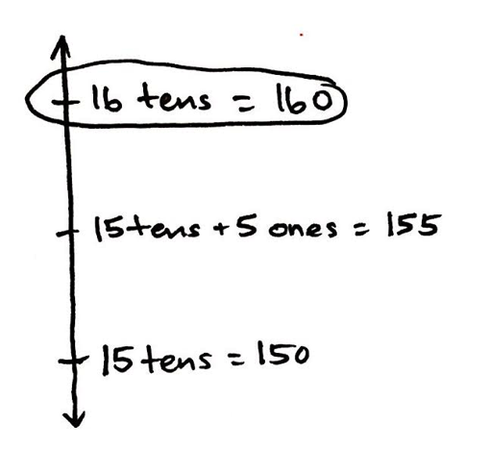T: Which decomposition of 155 helps you round this number to the nearest ten? Turn and talk.

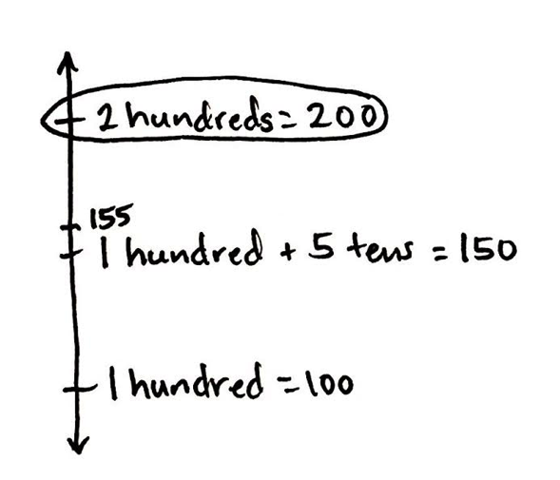S: 15 tens and 5 ones. 🡪 The one that shows 15 tens. This helps me see that 155 is between 15 tens and 16 tens on the number line. It is exactly halfway, so 155 would round to the next greater ten, which is 16 tens, or 160.

T: Let’s record that on the number line. (Record both of the nearest multiples of ten, the halfway point, and the number being rounded. Circle the correct rounded figure.)

T: Using your chart, which of these representations helps you round 155 to the nearest 100? Turn and talk to your partner about how you will round.

S: The one that shows 1 hundred. 🡪 I can see that 155 is between 1 hundred and 2 hundred. 🡪 The midpoint between 1 hundred and 2 hundred is 150. 155 is past the midpoint, so 155 is closer to 2 hundreds. It rounds up to 200.

T: Label your number line with the nearest multiples of one hundred, the halfway point, and the number we’re rounding. Then, circle the one to which 155 would round.

Problem 2

**MP.6**

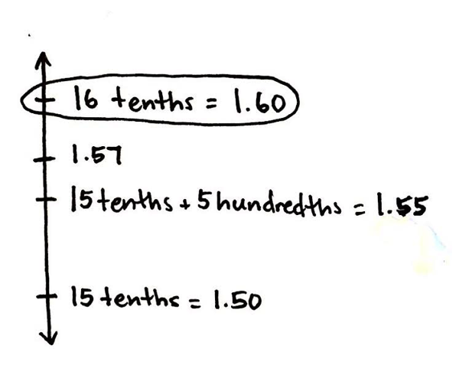Strategically decompose 1.57 to round to the nearest whole and nearest tenth.

T: Work with your partner to name 1.57 in unit form. Next, rename 1.57 using the greatest number of tenths possible. Finally, rename 1.57 using only hundredths. Record your ideas on your place value chart.

S: (Work and share.)

|  |  |  |
| --- | --- | --- |
| **Ones** | **Tenths** | **Hundredths** |
| 1 | 5 | 7 |
|  | 15 | 7 |
|  |  | 157 |

T: Which decomposition of 1.57 best helps you to round this number to the nearest tenth? Turn and talk. Label your number line, and circle your rounded number.

S: (Share.)

Bring to students’ attention that this problem parallels conversions between meters and centimeters since different units are being used to name the same quantity: 1.57 meters = 157 centimeters.

Problem 3

Strategically decompose to round 4.381 to the nearest ten, one, tenth, and hundredth.

T: Work with your partner to decompose 4.381 using as many tens, ones, tenths, and hundredths as possible. Record your work on your place value chart.

S: (Share.)

|  |  |  |  |  |
| --- | --- | --- | --- | --- |
| **Tens** | **Ones** | **Tenths** | **Hundredths** | **Thousandths** |
| 0 | 4 | 3 | 8 | 1 |
|  |  | 43 | 8 | 1 |
|  |  |  | 438 | 1 |
|  |  |  |  | 4381 |

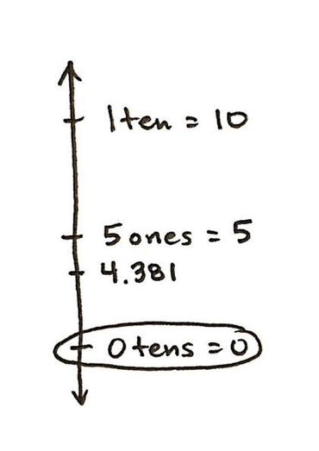T: We want to round this number to the nearest ten first. How many tens did you need to name this number?

S: Zero tens.

T: Between what two multiples of 10 will we place this number on the number line? Turn and talk. Draw your number line, and circle your rounded number.

S: (Share.)

T: Work with your partner to round 4.381 to the nearest one, tenth, and hundredth. Explain your thinking with a number line.

Follow the sequence from above to guide students in realizing that the number 4.381 rounds down to 4 ones, up to 44 tenths (4.4), and down to 438 hundredths (4.38).

Problem 4

Strategically decompose to round 9.975 to the nearest one, ten, tenth, and hundredth.

|  |  |  |  |  |
| --- | --- | --- | --- | --- |
| **Tens** | **Ones** | **Tenths** | **Hundredths** | **Thousandths** |
|  | 9 | 9 | 7 | 5 |
|  |  | 99 | 7 | 5 |
|  |  |  | 997 | 5 |
|  |  |  |  | 9975 |

Follow a sequence similar to the previous problem to lead students in rounding to the given places. This problem can prove to be a problematic rounding case. Naming the number with different units, however, allows students to choose easily between nearest multiples of the given place value.

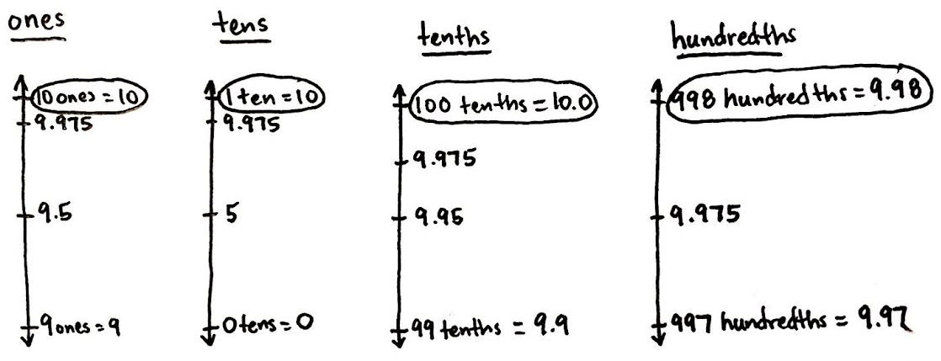

Repeat this sequence with 99.799. Round to the nearest ten, one, tenth, and hundredth.

Problem Set (10 minutes)

Students should do their personal best to complete the Problem Set within the allotted 10 minutes. For some classes, it may be appropriate to modify the assignment by specifying which problems they work on first. Some problems do not specify a method for solving. Students solve these problems using the RDW approach used for Application Problems.

On this Problem Set, it is suggested that all students begin with Problems 1, 2, 3, and 5 and possibly leave Problem 4 until the end if they still have time.

Before circulating while students work, review the Debrief questions relevant to the Problem Set to better guide students to a deeper understanding of, and skill with, the lesson’s objective.

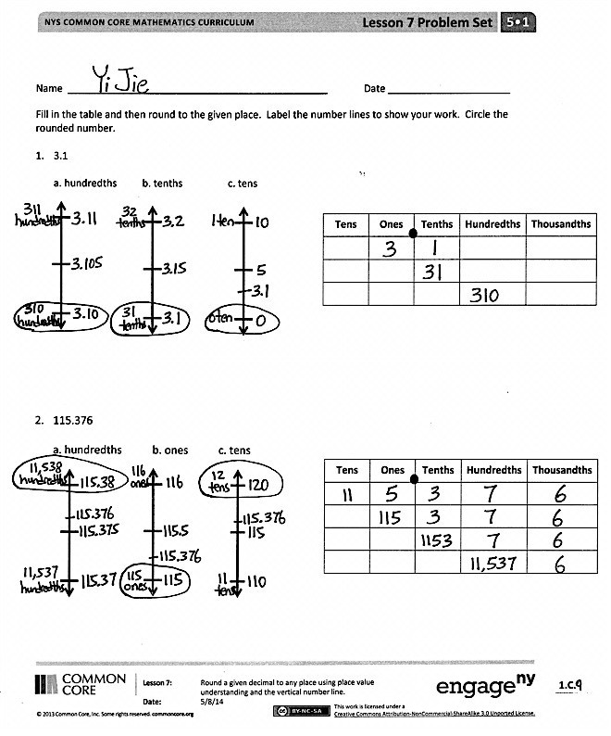Student Debrief (10 minutes)

**Lesson Objective:** Round a given decimal to any place using place value understanding and the vertical number line.

The Student Debrief is intended to invite reflection and active processing of the total lesson experience.

Invite students to review their solutions for the Problem Set. They should check work by comparing answers with a partner before going over answers as a class. Look for misconceptions or misunderstandings that can be addressed in the Debrief. Guide students in a conversation to debrief the Problem Set and process the lesson.

Any combination of the questions below may be used to lead the discussion.

* In Problem 2, which decomposition helps you most if you want to round to the hundredths place? The tens place? Ones place? Why?
* 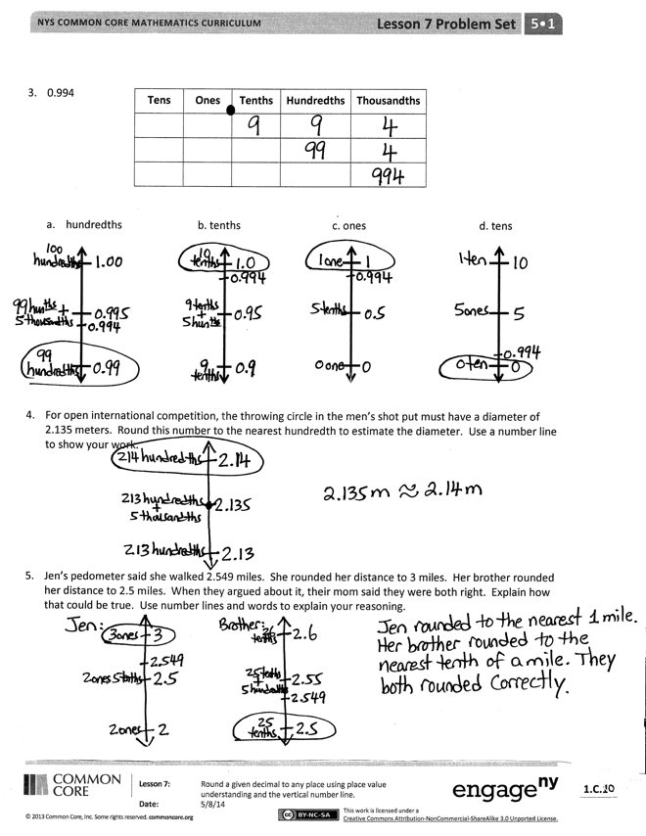How was Problem 1 different from both Problem 2 and 3? (While students may offer many differences, the salient point here is that Problem 1 is already rounded to the nearest hundredth and tenth.)
* Unit choice is the foundation of the current lesson. Problem 3 on the Problem Set offers an opportunity to discuss how the choice of unit affects the result of rounding. Be sure to allow time for these important understandings to be articulated by asking the following: If a number rounds up when rounded to the nearest tenth, does it follow that it will round up when rounded to the nearest hundredth? Thousandth? Why or why not? How do we decide about rounding up or down? How does the unit we are rounding to affect the position of the number relative to the midpoint?
* Problem 3 also offers a chance to discuss how 9-numbers often round to the same number regardless of the unit to which they are rounded. Point out that decomposing to smaller units makes this type of number easier to round. The decompositions make it simpler to identify which numbers to use as endpoints on the number line.

Extension: Problem 5 offers an opportunity to discuss the effect rounding to different places has on the accuracy of a measurement. Which rounded value is closest to the actual measurement? Why? In this problem, does that difference in accuracy matter? In another situation, might those differences in accuracy be more important? What should be considered when deciding to round, and to which place one might round? (For some students, this may lead to an interest in significant digits and their role in measurement in other disciplines.)

Exit Ticket (3 minutes)

After the Student Debrief, instruct students to complete the Exit Ticket. A review of their work will help with assessing students’ understanding of the concepts that were presented in today’s lesson and planning more effectively for future lessons. The questions may be read aloud to the students.

Number Correct: _______

**A**

Find the Midpoint

|  |  |  |  |  |  |  |  |  |
| --- | --- | --- | --- | --- | --- | --- | --- | --- |
|  | 0 |  | 10 |  |  | 8.5 |  | 8.6 |
|  | 0 |  | 1 |  |  | 2.8 |  | 2.9 |
|  | 0 |  | 0.01 |  |  | 0.03 |  | 0.04 |
|  | 10 |  | 20 |  |  | 0.13 |  | 0.14 |
|  | 1 |  | 2 |  |  | 0.37 |  | 0.38 |
|  | 2 |  | 3 |  |  | 80 |  | 90 |
|  | 3 |  | 4 |  |  | 90 |  | 100 |
|  | 7 |  | 8 |  |  | 8 |  | 9 |
|  | 1 |  | 2 |  |  | 9 |  | 10 |
|  | 0.1 |  | 0.2 |  |  | 0.8 |  | 0.9 |
|  | 0.2 |  | 0.3 |  |  | 0.9 |  | 1 |
|  | 0.3 |  | 0.4 |  |  | 0.08 |  | 0.09 |
|  | 0.7 |  | 0.8 |  |  | 0.09 |  | 0.1 |
|  | 0.1 |  | 0.2 |  |  | 26 |  | 27 |
|  | 0.01 |  | 0.02 |  |  | 7.8 |  | 7.9 |
|  | 0.02 |  | 0.03 |  |  | 1.26 |  | 1.27 |
|  | 0.03 |  | 0.04 |  |  | 29 |  | 30 |
|  | 0.07 |  | 0.08 |  |  | 9.9 |  | 10 |
|  | 6 |  | 7 |  |  | 7.9 |  | 8 |
|  | 16 |  | 17 |  |  | 1.59 |  | 1.6 |
|  | 38 |  | 39 |  |  | 1.79 |  | 1.8 |
|  | 0.4 |  | 0.5 |  |  | 3.99 |  | 4 |

**B**

**[KEY]**

Number Correct: _______

Improvement: _______

Find the Midpoint

|  |  |  |  |  |  |  |  |  |
| --- | --- | --- | --- | --- | --- | --- | --- | --- |
|  | 10 |  | 20 |  |  | 0.7 |  | 0.8 |
|  | 1 |  | 2 |  |  | 4.7 |  | 4.8 |
|  | 0.1 |  | 0.2 |  |  | 2.3 |  | 2.4 |
|  | 0.01 |  | 0.02 |  |  | 0.02 |  | 0.03 |
|  | 0 |  | 10 |  |  | 0.12 |  | 0.13 |
|  | 0 |  | 1 |  |  | 0.47 |  | 0.48 |
|  | 1 |  | 2 |  |  | 80 |  | 90 |
|  | 2 |  | 3 |  |  | 90 |  | 100 |
|  | 6 |  | 7 |  |  | 8 |  | 9 |
|  | 1 |  | 2 |  |  | 9 |  | 10 |
|  | 0.1 |  | 0.2 |  |  | 0.8 |  | 0.9 |
|  | 0.2 |  | 0.3 |  |  | 0.9 |  | 1 |
|  | 0.3 |  | 0.4 |  |  | 0.08 |  | 0.09 |
|  | 0.6 |  | 0.7 |  |  | 0.09 |  | 0.1 |
|  | 0.1 |  | 0.2 |  |  | 36 |  | 37 |
|  | 0.01 |  | 0.02 |  |  | 6.8 |  | 6.9 |
|  | 0.02 |  | 0.03 |  |  | 1.46 |  | 1.47 |
|  | 0.03 |  | 0.04 |  |  | 39 |  | 40 |
|  | 0.06 |  | 0.07 |  |  | 9.9 |  | 10 |
|  | 7 |  | 8 |  |  | 6.9 |  | 7 |
|  | 17 |  | 18 |  |  | 1.29 |  | 1.3 |
|  | 47 |  | 48 |  |  | 6.99 |  | 7 |

Name Date

Fill in the table, and then round to the given place. Label the number lines to show your work. Circle the rounded number.

1. 3.1

a. Hundredths b. Tenths c. Tens

|  |  |  |  |  |
| --- | --- | --- | --- | --- |
| **Tens** | **Ones** | **Tenths** | **Hundredths** | **Thousandths** |
|  |  |  |  |  |
|  |  |  |  |  |
|  |  |  |  |  |

1. 115.376

a. Hundredths b. Ones c. Tens

|  |  |  |  |  |
| --- | --- | --- | --- | --- |
| **Tens** | **Ones** | **Tenths** | **Hundredths** | **Thousandths** |
|  |  |  |  |  |
|  |  |  |  |  |
|  |  |  |  |  |
|  |  |  |  |  |

|  |  |  |  |  |
| --- | --- | --- | --- | --- |
| **Tens** | **Ones** | **Tenths** | **Hundredths** | **Thousandths** |
|  |  |  |  |  |
|  |  |  |  |  |
|  |  |  |  |  |

1. 0.994
2. Hundredths b. Tenths c. Ones d. Tens
3. For open international competition, the throwing circle in the men’s shot put must have a diameter of 2.135 meters. Round this number to the nearest hundredth. Use a number line to show your work.
4. Jen’s pedometer said she walked 2.549 miles. She rounded her distance to 3 miles. Her brother rounded her distance to 2.5 miles. When they argued about it, their mom said they were both right. Explain how that could be true. Use number lines and words to explain your reasoning.

Name Date

Use the table to round the number to the given places. Label the number lines, and circle the rounded value.

8.546

|  |  |  |  |  |  |
| --- | --- | --- | --- | --- | --- |
| **Tens** | **Ones** | **•** | **Tenths** | **Hundredths** | **Thousandths** |
|  | 8 | **•** | 5 | 4 | 6 |
|  |  | **•** | 85 | 4 | 6 |
|  |  | **•** |  | 854 | 6 |
|  |  | **•** |  |  | 8546 |

1. Hundredths b. Tens

Name Date

Fill in the table, and then round to the given place. Label the number lines to show your work. Circle the rounded number.

1. 4.3
2. Hundredths b. Tenths c. Ones

|  |  |  |  |  |
| --- | --- | --- | --- | --- |
| **Tens** | **Ones** | **Tenths** | **Hundredths** | **Thousandths** |
|  |  |  |  |  |
|  |  |  |  |  |
|  |  |  |  |  |

1. 225.286

|  |  |  |  |  |
| --- | --- | --- | --- | --- |
| **Tens** | **Ones** | **Tenths** | **Hundredths** | **Thousandths** |
|  |  |  |  |  |
|  |  |  |  |  |
|  |  |  |  |  |
|  |  |  |  |  |

1. Hundredths b. Ones c. Tens

|  |  |  |  |  |
| --- | --- | --- | --- | --- |
| **Tens** | **Ones** | **Tenths** | **Hundredths** | **Thousandths** |
|  |  |  |  |  |
|  |  |  |  |  |
|  |  |  |  |  |
|  |  |  |  |  |

1. 8.984
2. Hundredths b. Tenths c. Ones d. Tens
3. On a Major League Baseball diamond, the distance from the pitcher’s mound to home plate is 18.386 meters.
4. Round this number to the nearest hundredth of a meter. Use a number line to show your work.
5. How many centimeters is it from the pitcher’s mound to home plate?
6. Jules reads that 1 pint is equivalent to 0.473 liters. He asks his teacher how many liters there are in a pint. His teacher responds that there are about 0.47 liters in a pint. He asks his parents, and they say there are about 0.5 liters in a pint. Jules says they are both correct. How can that be true? Explain your answer.

|  |  |  |  |  |  |
| --- | --- | --- | --- | --- | --- |
| **Thousandths** |  |  |  |  |  |
| **Hundredths** |  |  |  |  |  |
| **Tenths** |  |  |  |  |  |
| **•** |  |  |  |  |  |
| **Ones** |  |  |  |  |  |
| **Tens** |  |  |  |  |  |
| **Hundreds** |  |  |  |  |  |

[1]

1. hundreds to thousandths place value chart