**Lesson 8**

Objective: Round a given decimal to any place using place value understanding and the vertical number line.

Suggested Lesson Structure

 Fluency Practice (12 minutes)

 Application Problem (6 minutes)

 Concept Development (32 minutes)

 Student Debrief (10 minutes)

**Total Time (60 minutes)**

Fluency Practice (12 minutes)

|  |  |
| --- | --- |
|  | NOTES ON  MULTIPLE MEANS  OF ACTION AND EXPRESSION: |
| Learners with language differences may have more success in responding to today’s Sprint by writing rather than verbalizing responses. Often, English language learners have receptive language abilities that exceed productive abilities. Therefore, allowing a choice of written response can increase accuracy and allow for more confident participation. | |

* Rename the Units **5.NBT.3** (6 minutes)
* Round to Different Place Values **5.NBT.4** (6 minutes)

Rename the Units (6 minutes)

Note: Decomposing common units as decimals strengthens student understanding of place value.

T: (Write 13 tenths = ____.) Say the decimal.

S: One and 3 tenths.

Repeat the process for 14 tenths, 24 tenths, 124 tenths, and 524 tenths.

T: Name the number of tenths. (Write 2.5.)

S: 25 tenths.

Repeat the process for 17.5, 27.5, 24.5, 24.3, and 42.3. Then, repeat the entire process, but with hundredths.

T: (Write 37 hundredths = ____.) Say the decimal.

S: 0.37.

T: (Write 37 hundredths = 0.37. Below it, write 137 hundredths = ____.) Say the decimal.

S: 1.37.

Repeat the process for 537 hundredths and 296 hundredths.

T: (Write 0.548 = ____ thousandths.) Say the number sentence.

S: 0.548 = 548 thousandths.

T: (Write 0.548 = 548 thousandths. Below it, write 1.548 = ____ thousandths.) Say the number sentence.

S: 1.548 = 1548 thousandths.

Repeat the process for 2.548 and 7.352.

Round to Different Place Values (6 minutes)

Materials: (S) Personal white board

Note: Reviewing this skill introduced in Lesson 7 helps students work toward mastery of rounding decimal numbers to different place values.

Although the approximation sign (≈) is used in Grade 4, a quick review of its meaning may be in order.

|  |  |
| --- | --- |
|  | NOTES ON  MULTIPLE MEANS  OF ENGAGEMENT: |
| *Turn and talk* is a strategy intended to broaden active student participation by offering opportunity for all to speak during a lesson. Spend time in the beginning of the school year helping students understand what turn and talk looks like and sounds like by demonstrating with a student for the whole class. Modeling knee-to-knee, eye-to-eye body posture and active listening expectations (e.g., restating one’s partner’s ideas in one’s own words) make for successful implementation of this powerful strategy. | |

T: (Project 8.735.) Say the number.

S: 8 and 735 thousandths.

T: Draw a vertical number line on your boards with two endpoints and a midpoint.

T: Between what two ones is 8.735?

S: 8 ones and 9 ones.

T: What’s the midpoint for 8 and 9?

S: 8.5.

T: Fill in your endpoints and midpoint.

T: 8.5 is the same as how many tenths?

S: 85 tenths.

T: How many tenths are in 8.735?

S: 87 tenths.

T: Is 87 tenths more than or less than 85 tenths?

S: More than.

T: (Write 8.735 ≈ _______.) Show 8.735 on your number line. Write the number sentence, when rounded to the nearest one.

S: (Write 8.735 between 8.5 and 9 on the number line and write 8.735 ≈ 9.)

Repeat the process for the tenths place and hundredths place. Follow the same process and procedure for 7.458.

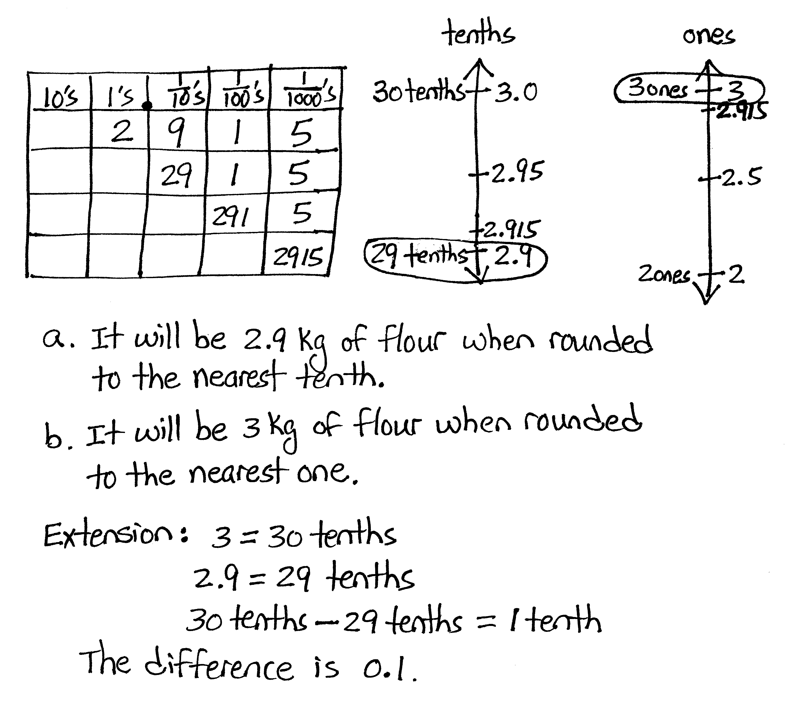Application Problem (6 minutes)

Organic whole wheat flour sells in bags weighing 2.915 kilograms.

1. How much flour is this when rounded to the nearest tenth? Use a place value chart and number line to explain your thinking.
2. How much flour is this when rounded to the nearest one?

Extension: What is the difference of the two answers?

Note: This problem is a review of yesterday’s lesson on rounding. The extension serves as an opportunity for students to recall the work they did in Grade 4 when subtracting fractions.

Concept Development (32 minutes)

Materials: (S) Personal white board, hundreds to thousandths place value chart (Lesson 7 Template)

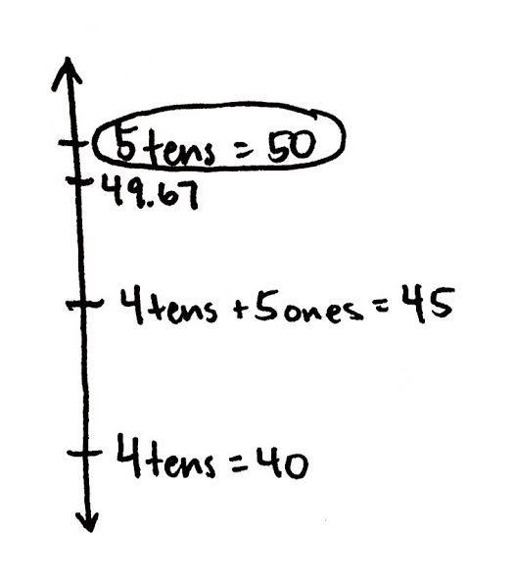Problem 1

Round 49.67 to the nearest ten.

T: Turn and talk to your partner about the different ways 49.67 could be decomposed. On your place value chart, show the decomposition that you think will be most helpful in rounding to the nearest ten.

|  |  |  |  |
| --- | --- | --- | --- |
| **Tens** | **Ones** | **Tenths** | **Hundredths** |
| 4 | 9 | 6 | 7 |
|  | 49 | 6 | 7 |
|  |  | 496 | 7 |

T: Which one of these decompositions did you decide was the most helpful?

S: The decomposition with more tens is most helpful because it helps me identify the two rounding choices: 4 tens or 5 tens.

T: Draw and label a number line, and circle the rounded value. Explain your reasoning to your neighbor.

Repeat this sequence with rounding 49.67 to the nearest one and then to the nearest tenth.

Problem 2

Decompose 9.949 and round to the nearest tenth and hundredth. Show your work on a number line.

|  |  |  |  |
| --- | --- | --- | --- |
| **Ones** | **Tenths** | **Hundredths** | **Thousandths** |
| 9 | 9 | 4 | 9 |
|  | 99 | 4 | 9 |
|  |  | 994 | 9 |

T: What decomposition of 9.949 best helps to round this number to the nearest tenth?

S: The one using the most tenths to name the decimal fraction. I knew I would round to either 99 tenths or 100 tenths. I looked at the hundredths. Four hundredths is not past the midpoint, so I rounded to 99 tenths. Ninety-nine tenths is the same as 9.9.

T: Which digit made no difference when you rounded to the nearest tenth? Explain your thinking.

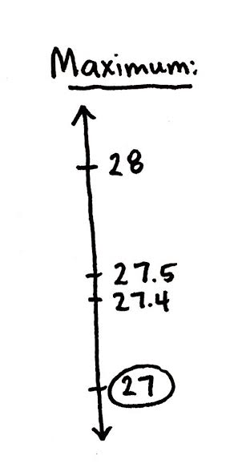S: The thousandths, because the hundredths decided which direction to round. Since there are not 5 hundredths, I rounded to the lesser number.

Repeat the process, rounding to the nearest hundredth.

Problem 3

A decimal number has 1 digit to the right of the decimal point. If we round this number to the nearest whole number, the result is 27. What are the maximum and minimum possible values of these two numbers? Use a number line to show your reasoning. Include the midpoint on the number line.

T: (Draw a vertical number line with 3 points.)

T: What do we know about the unknown number?

S: It has a digit in the tenths place but nothing else beyond the tenths place. 🡪 We know that it has been rounded to 27.

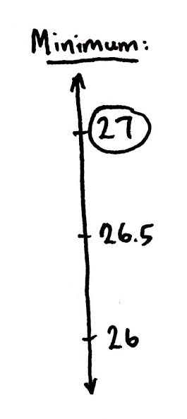T: (Write 27 at the bottom point on the number line and circle it.) Why did I place 27 as the lesser rounded value?

S: We are looking for the largest number that will round down to 27. That number will be greater than 27 but less than the midpoint between 27 and 28.

T: What is the midpoint between 27 and 28?

S: 27.5.

T: (Place 27.5 on the number line.)

T: If we look at numbers that have exactly 1 digit to the right of the decimal point, what is the greatest one that will round down to 27?

S: 27.4. If we go to 27.5, that would round up to 28.

Repeat the same process to find the minimum value.

Encourage further discussion with the following:

What if our number had exactly 2 digits to the right of the decimal point? Could I find a number larger than 27.4 that would still round down to 27? (Various answers could be expected: 27.41, 27.49, etc.). What is the largest possible value it could have? (27.49.)

A similar discussion can take place in finding the minimum when students discover that 26.5 rounds up to 27. Lead students to discover that something different happens here. Is there a number less than 26.5 with exactly 2 digits to the right of the decimal point that would still round up? (No, nothing less than than 26.50.)

Problem Set (10 minutes)

Students should do their personal best to complete the Problem Set within the allotted 10 minutes. For some classes, it may be appropriate to modify the assignment by specifying which problems they work on first. Some problems do not specify a method for solving. Students solve these problems using the RDW approach used for Application Problems.

On this Problem Set, it is suggested that all students begin with Problems 1 and 3 and possibly leave Problem 2 until the end, if they still have time.

Before circulating while students work, review the Debrief questions relevant to the Problem Set to better guide students to a deeper understanding of a skill with the lesson’s objective.

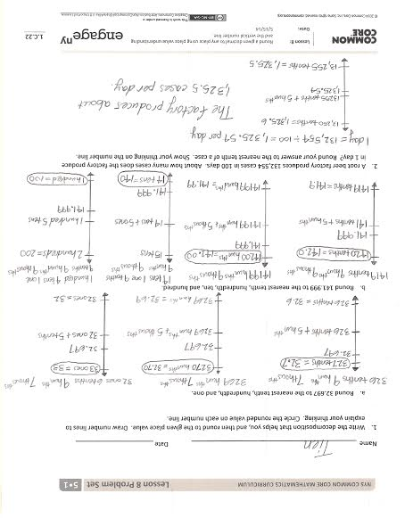Student Debrief (10 minutes)

**Lesson Objective:** Round a given decimal to any place using place value understanding and the vertical number line.

The Student Debrief is intended to invite reflection and active processing of the total lesson experience.

Invite students to review their solutions for the Problem Set. They should check work by comparing answers with a partner before going over answers as a class. Look for misconceptions or misunderstandings that can be addressed in the Debrief. Guide students in a conversation to debrief the Problem Set and process the lesson.

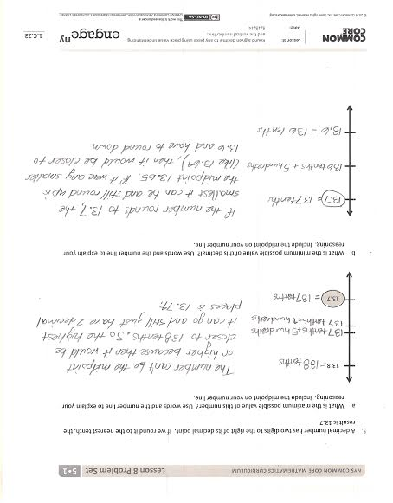Any combination of the questions below may be used to lead the discussion.

* Compare our approach to rounding in today’s lesson and in Lesson 7. How are they alike? How are they different? (Students will likely offer many accurate responses. Lead the discussion, however, toward the notion of only choosing specific decompositions to round in today’s lesson as opposed to naming every decomposition in Lesson 7. Explore which units, or place values, are worthy of attention and which are not when rounding to a specific place value. Are there patterns to these choices?)
* Once a number rounds up at one place value, does it follow then that every place value will round up? Why or why not? (Encourage students to reference their Problem Sets as evidence of their reasoning. Problem 1(b) provides an example of differing unit choices resulting in differences in rounding up and down.)
* How does the place value chart help organize your thinking when rounding?
* Finding the maximum and minimum values poses a significant increase in cognitive load and an opportunity to build excitement! Make time to deeply discuss ways of reasoning about these tasks, as they are sure to be many and varied. Consider a discussion of Problem 3 that mirrors the one in the lesson. What if our number has exactly 3 digits to the right of the decimal? Can we find a value larger than 13.74 that would round down to 13.7? (13.749.) What about 4 places or 5 places to the right of the decimal? (13.7499, 13.74999.) Encourage students to generalize that we can get infinitely close to 13.5 with a decimal that has an infinite number of nines, yet that decimal will still round down to 13.7. We can find points on the number line as close as we like, and yet they will not be equal to 13.75. Follow the discussion with the discovery that this is not true for our minimum value. There is nothing less than 13.750 that will round up to 13.8. Math journals offer a venue for students to continue to explore maximum and minimum tasks beyond today’s lesson.

Exit Ticket (3 minutes)

After the Student Debrief, instruct students to complete the Exit Ticket. A review of their work will help with assessing students’ understanding of the concepts that were presented in today’s lesson and planning more effectively for future lessons. The questions may be read aloud to the students.

Name Date

1. Write the decomposition that helps you, and then round to the given place value. Draw number lines to explain your thinking. Circle the rounded value on each number line.
2. Round 32.697 to the nearest tenth, hundredth, and one.
3. Round 141.999 to the nearest tenth, hundredth, ten, and hundred.
4. A root beer factory produces 132,554 cases in 100 days. About how many cases does the factory produce in 1 day? Round your answer to the nearest tenth of a case. Show your thinking on the number line.
5. A decimal number has two digits to the right of its decimal point. If we round it to the nearest tenth, the result is 13.7.
6. What is the maximum possible value of this number? Use words and the number line to explain your reasoning. Include the midpoint on your number line.

13.7

13.8

1. What is the minimum possible value of this decimal? Use words and the number line to explain your reasoning. Include the midpoint on your number line.

Name Date

Round the quantity to the given place value. Draw number lines to explain your thinking. Circle the rounded value on the number line.

1. 13.989 to the nearest tenth
2. 382.993 to nearest hundredth

Name Date

1. Write the decomposition that helps you, and then round to the given place value. Draw number lines to explain your thinking. Circle the rounded value on each number line.
2. 43.586 to the nearest tenth, hundredth, and one.
3. 243.875 to nearest tenth, hundredth, ten, and hundred.
4. A trip from New York City to Seattle is 2,852.1 miles. A family wants to make the drive in 10 days, driving the same number of miles each day. About how many miles will they drive each day? Round your answer to the nearest tenth of a mile.
5. A decimal number has two digits to the right of its decimal point. If we round it to the nearest tenth, the result is 18.6.
6. What is the maximum possible value of this number? Use words and the number line to explain your reasoning. Include the midpoint on your number line.

18.7 (1870 hundredths)

18.6

1. What is the minimum possible value of this decimal? Use words, pictures, or numbers to explain your reasoning.

18.6

18.5