Lesson 10

Objective: Subtract decimals using place value strategies, and relate those strategies to a written method.

Suggested Lesson Structure

 Fluency Practice (10 minutes)

 Application Problem (5 minutes)

 Concept Development (35 minutes)

 Student Debrief (10 minutes)

**Total Time (60 minutes)**

Fluency Practice (10 minutes)

* Take Out the Unit **5.NBT.1** (3 minutes)
* Add Decimals **5.NBT.7** (3 minutes)
* One Less Unit **5.NBT.7** (4 minutes)

Take Out the Unit (3 minutes)

Materials: (S) Personal white board

Note: Decomposing common units as decimals strengthens student understanding of place value.

T: (Project 76.358 = .) Say the number.

S: 76 and 358 thousandths.

T: (Write 76.358 = 7 tens thousandths.) On your personal white board, fill in the blank.

S: (Write 76.358 = 7 tens 6358 thousandths.)

Repeat the process for tenths and hundredths. 76.358 = 763 tenths thousandths, 76.358 = hundredths 8 thousandths.

Add Decimals (3 minutes)

Materials: (S) Personal white board

Note: Reviewing this skill introduced in Lesson 9 helps students work toward mastery of adding common decimal units.

T: (Write 3 tenths + 2 tenths = .) Write the addition sentence in standard form.

S: 0.3 + 0.2 = 0.5.

Repeat the process for 5 hundredths + 4 hundredths and 35 hundredths + 4 hundredths.

One Unit Less (4 minutes)

Materials: (S) Personal white board

Note: This anticipatory fluency drill lays a foundation for the concept taught in this lesson.

T: (Write 5 tenths.) Say the decimal that is 1 tenth less than the given unit.

S: 0.4.

Repeat the process for 5 hundredths, 5 thousandths, 7 hundredths, and 9 tenths.

T: (Write 0.029.) On your board, write the decimal that is one less thousandth.

S: (Write 0.028.)

Repeat the process for 1 tenth less than 0.61, 1 thousandth less than 0.061, and 1 hundredth less than 0.549.

Note: This fluency is a review of skills learned in Lesson 9.

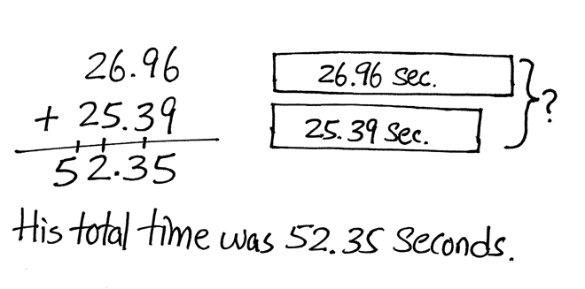Application Problem (5 minutes)

At the 2012 London Olympics, Michael Phelps won the gold medal in the men’s 100-meter butterfly. He swam the first   
50 meters in 26.96 seconds. The second 50 meters took him 25.39 seconds. What was his total time?

Note: Adding decimal numbers is a skill learned in Lesson 9.

Concept Development (35 minutes)

Materials: (S) Hundreds to thousandths place value chart (Lesson 7 Template), personal white board

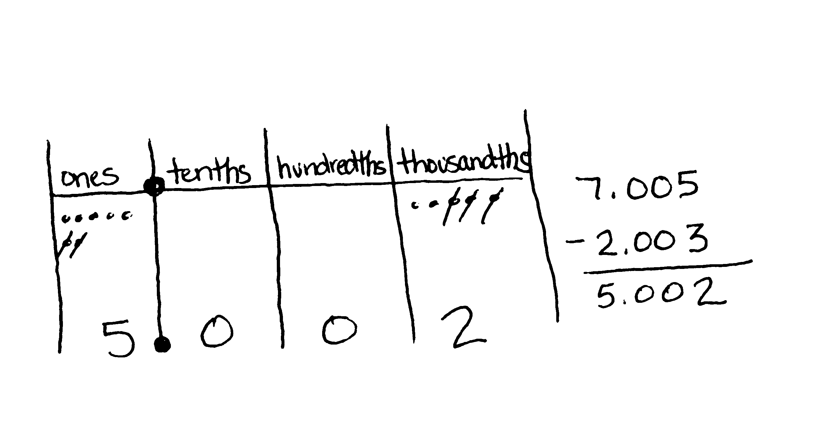Problem 1

5 tenths – 3 tenths

7 ones 5 thousandths – 2 ones 3 thousandths

9 hundreds 5 hundredths – 3 hundredths

T: (Write 5 tenths – 3 tenths on the board.) Let’s read this expression aloud together. Turn and tell your partner how you’ll solve this problem, and then find the difference using your place value chart and disks.

T: Explain your reasoning when solving this subtraction expression.

S: Since the units are alike, we can just subtract. 5 – 3 = 2. 🡪 This problem is very similar to 5 ones minus 3 ones, or 5 people minus 2 people. The units may change, but the basic fact 5 – 2 = 3 is the same.

T: (Write 7 ones 5 thousandths – 2 ones 3 thousandths on the board.) Find the difference. Solve this problem with the place value chart and disks. Record your thinking vertically, using the algorithm.

S: (Solve.)

T: What did you have to think about as you wrote the problem vertically?

|  |  |
| --- | --- |
|  | NOTES ON  MULTIPLE MEANS OF ENGAGEMENT: |
| Support oral or written responses with sentence frames, such as _____ *is* _______ *hundredths*. Allow the use of place value charts and the sentence frames to scaffold the process of converting units in subtraction. Some students need concrete materials to support their learning, as renaming in various units may not yet be an abstract construct for them. | |

S: Like units are being subtracted, so my work should also show that. Ones with ones and thousandths with thousandths.

T: (Write 9 hundreds 5 hundredths – 3 hundredths on board.) Solve 9 hundreds 5 hundredths – 3 hundredths. Read carefully, and then tell your neighbor how you’ll solve this problem.

S: In word form, these units look similar, but they’re not. I’ll just subtract 3 hundredths from 5 hundredths.

T: Use your place value chart to help you solve, and record your thinking vertically.

Problems 2–3

83 tenths – 6.4

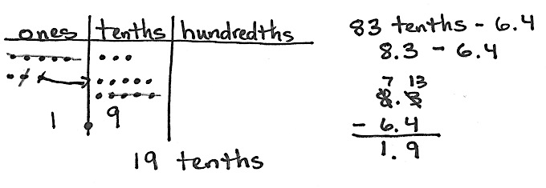9.2 – 6 ones 4 tenths

T: (Write 83 tenths – 6.4 = on the board.) How is this problem different from the problems we’ve seen previously?

S: This problem involves regrouping.

S: (Solve using disks, recording their work in the standard algorithm.)

T: Share how you solved.

S: We had to regroup before we could subtract tenths from tenths. Then, we subtracted ones from ones using the same process as with whole numbers.

Repeat the sequence with 9.2 – 6 ones 4 tenths. Students may use various strategies to solve. Comparison of strategies makes for interesting discussion.

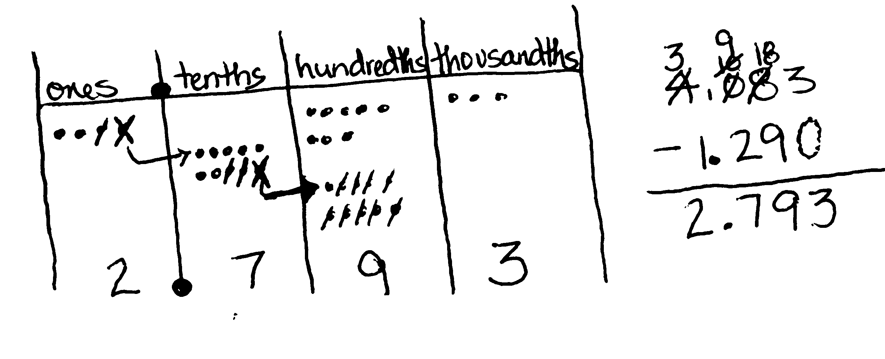Problems 4–5

0.831 – 0.292

4.083 – 1.29

6 – 0.48

T: (Write 0.831 – 0.292 on the board.) Use your disks to solve. Record your work vertically using the standard algorithm.

|  |  |
| --- | --- |
|  | NOTES ON:  MULTIPLE MEANS  OF ENGAGEMENT: |
| Students may be more engaged with the concept of adding and subtracting decimal fractions when reminded that these are the same skills needed for managing money. | |

S: (Write and share.)

T: (Write 4.083 – 1.29 on the board.) What do you notice about the thousandths place? Turn and talk.

S: There is no digit in the thousandths place in 1.29. 🡪 We can think of 29 hundredths as 290 thousandths. In this case, I don’t have to change units because there are no thousandths that must be subtracted.

T: Solve with your disks and record.

Repeat the sequence with 6 – 0.48. While some students may use a mental strategy to find the difference, others will use disks to regroup in order to subtract. Continue to stress the alignment based on like unitswhen recording vertically. When the ones place is aligned, students will recognize that there are not as many digits in the minuend of 6 wholes as in the subtrahend of 48 hundredths. Ask, “How can we think about 6 wholes in the same units as 48 hundredths?” Then, lead students to articulate the need to record 6 ones as 600 hundredths or 6.00 in order to subtract vertically. Ask, “By decomposing 6 wholes into 600 hundredths, have we changed its value?” (No, we just converted it to smaller units—similar to exchanging six dollars for 600 pennies.)

Problem Set (10 minutes)

Students should do their personal best to complete the Problem Set within the allotted 10 minutes. For some classes, it may be appropriate to modify the assignment by specifying which problems they work on first. Some problems do not specify a method for solving. Students solve these problems using the RDW approach used for Application Problems.

With this Problem Set, it is suggested that students begin with Problems 1–4 and possibly leave Problem 5 until the end, if they still have time. Alternatively, be selective about which items from Problems 2 and 3 are required. This lends time for all to complete Problem 5.

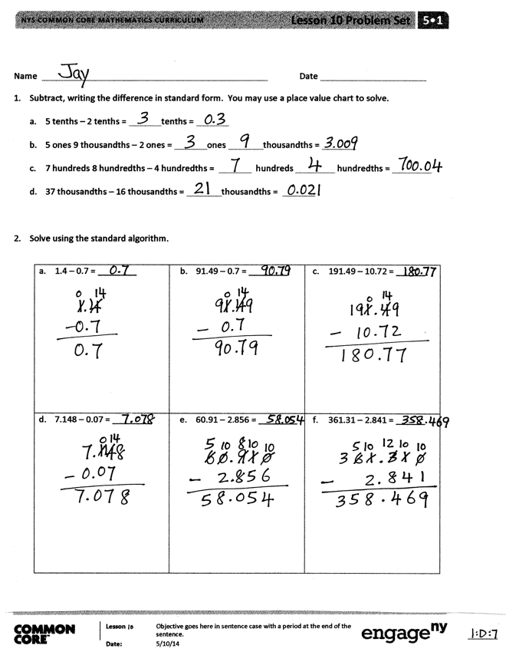Student Debrief (10 minutes)

**Lesson Objective:** Subtract decimals using place value strategies, and relate those strategies to a written method.

The Student Debrief is intended to invite reflection and active processing of the total lesson experience.

Invite students to review their solutions for the Problem Set. They should check work by comparing answers with a partner before going over answers as a class. Look for misconceptions or misunderstandings that can be addressed in the Debrief. Guide students in a conversation to debrief the Problem Set and process the lesson.

Any combination of the questions below may be used to lead the discussion.

* How is subtracting decimal fractions the same as subtracting whole numbers? How is it different?
* 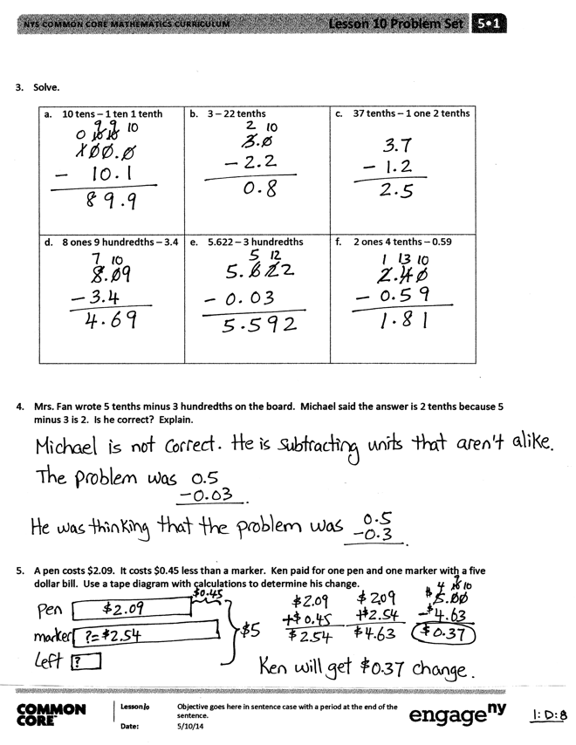Look at Problem 2(a), (b), and (c). What process did you use to find the difference in each of these problems?
* Did you have to use the standard algorithm to solve each of the problems in Problem 3? Look at Problem 3(b) and (c). Which was more challenging? Why?
* In Problem 3(f), how did you think about finding the difference between 59 hundredths and   
  2 ones 4 tenths? Explain your approach.
* How could you change Mrs. Fan’s question in Problem 4 so that Michael’s answer is correct?
* Take time during the Debrief to explore any miscues in Problem 5 with the phrase *less than.*

Exit Ticket (3 minutes)

After the Student Debrief, instruct students to complete the Exit Ticket. A review of their work will help with assessing students’ understanding of the concepts that were presented in today’s lesson and planning more effectively for future lessons. The questions may be read aloud to the students.

Name Date

1. Subtract, writing the difference in standard form. You may use a place value chart to solve.
2. 5 tenths – 2 tenths = tenths =
3. 5 ones 9 thousandths – 2 ones = ones thousandths =
4. 7 hundreds 8 hundredths – 4 hundredths = hundreds hundredths =
5. 37 thousandths – 16 thousandths = thousandths =

1. Solve using the standard algorithm.

|  |  |  |
| --- | --- | --- |
| 1. 1.4 – 0.7 = | 1. 91.49 – 0.7 = | 1. 191.49 – 10.72 = |
| 1. 7.148 – 0.07 = | 1. 60.91 – 2.856 = | 1. 361.31 – 2.841 = |

1. Solve.

|  |  |  |
| --- | --- | --- |
| 1. 10 tens – 1 ten 1 tenth | 1. 3 – 22 tenths | 1. 37 tenths – 1 one 2 tenths |
| 1. 8 ones 9 hundredths – 3.4 | 1. 5.622 – 3 hundredths | 1. 2 ones 4 tenths – 0.59 |

1. Mrs. Fan wrote *5 tenths minus 3 hundredths* on the board. Michael said the answer is 2 tenths because   
   5 minus 3 is 2. Is he correct? Explain.
2. A pen costs $2.09. It costs $0.45 less than a marker. Ken paid for one pen and one marker with a   
   five-dollar bill. Use a tape diagram with calculations to determine his change.

Name Date

1. Subtract.
   1. – 0.8 = tenths – tenths = tenths =
2. Subtract vertically, showing all work.
   1. 84.637 – 28.56 =
   2. 7 – 0.35 =

Name Date

1. Subtract. You may use a place value chart.
   1. 9 tenths – 3 tenths = tenths
   2. 9 ones 2 thousandths – 3 ones = ones thousandths
   3. 4 hundreds 6 hundredths – 3 hundredths = hundreds hundredths
   4. 56 thousandths – 23 thousandths = thousandths = hundredths thousandths
2. Solve using the standard algorithm.

|  |  |  |
| --- | --- | --- |
| 1. 1.8 – 0.9 = | 1. 41.84 – 0.9 = | 1. 341.84 – 21.92 = |
| 1. 5.182 – 0.09 = | 1. 50.416 – 4.25 = | 1. 741 – 3.91 = |

1. Solve.

|  |  |  |
| --- | --- | --- |
| 1. 30 tens – 3 tens 3 tenths | 1. 5 – 16 tenths | 1. 24 tenths – 1 one 3 tenths |
| 1. 6 ones 7 hundredths – 2.3 | 1. 8.246 – 5 hundredths | 1. 5 ones 3 tenths – 0.53 |

1. Mr. House wrote *8 tenths minus 5 hundredths* on the board. Maggie said the answer is 3 hundredths because 8 minus 5 is 3. Is she correct? Explain.
2. A clipboard costs $2.23. It costs $0.58 more than a notebook. Lisa bought two clipboards and one notebook. She paid with a ten-dollar bill. How much change does Lisa get? Use a tape diagram to show your thinking.