Lesson 9

Objective: Add decimals using place value strategies, and relate those strategies to a written method.

Suggested Lesson Structure

 Fluency Practice (14 minutes)

 Application Problem (5 minutes)

 Concept Development (31 minutes)

 Student Debrief (10 minutes)

**Total Time (60 minutes)**

Fluency Practice (14 minutes)

* Sprint: Round to the Nearest One **5.NBT.4** (8 minutes)
* Decompose the Unit **5.NBT.1** (2 minutes)
* Round to Different Place Values **5.NBT.4** (2 minutes)
* One Unit More **5.NBT.7** (2 minutes)

Sprint: Round to the Nearest One (8 minutes)

Materials: (S) Round to the Nearest One Sprint

Note: This Sprint helps students build mastery of rounding to the nearest whole number.

Decompose the Unit (2 minutes)

Materials: (S) Personal white board

Note: Decomposing common units as decimals strengthens student understanding of place value.

T: (Project 6.358.) Say the number.

S: 6 and 358 thousandths.

T: How many tenths are in 6.358?

S: 63 tenths.

T: (Write 6.358 = 63 tenths ____ thousandths.) On your boards, write the number separating the tenths.

S: (Write 6.358 = 63 tenths 58 thousandths.)

Repeat the process for hundredths. Follow the same process for 7.354.

Round to Different Place Values (2 minutes)

Materials: (S) Personal white board

Note: Reviewing this skill introduced in Lesson 8 helps students work toward mastery of rounding decimal numbers to different place values.

T: (Project 2.475.) Say the number.

S: 2 and 475 thousandths.

T: On your board, round the number to the nearest tenth.

S: (Write 2.475 ≈ 2.5.)

Repeat the process, rounding 2.457 to the nearest hundredth. Follow the same process for 2.987, but vary the sequence.

One Unit More (2 minutes)

Materials: (S) Personal white board

Note: This anticipatory fluency drill lays a foundation for the concept taught in this lesson.

T: (Write 5 tenths.) Say the decimal that’s one-tenth more than the given value.

S: Six-tenths.

Repeat the process for 5 hundredths, 5 thousandths, 8 hundredths, 3 tenths, and 2 thousandths. Specify the unit to increase by.

T: (Write 0.052.) On your board, write one more thousandth.

S: (Write 0.053.)

Repeat the process for 1 tenth more than 35 hundredths, 1 thousandth more than 35 hundredths, and 1 hundredth more than 438 thousandths.

Application Problem (5 minutes)

Ten baseballs weigh 1,417.4 grams. About how much does 1 baseball weigh? Round your answer to the nearest tenth of a gram. Round your answer to the nearest gram. Which answer would you give if someone asked, “About how much does a baseball weigh?” Explain your choice.

Note: The Application Problem requires students to divide by powers of ten and round. These are skills learned in the first part of this module.

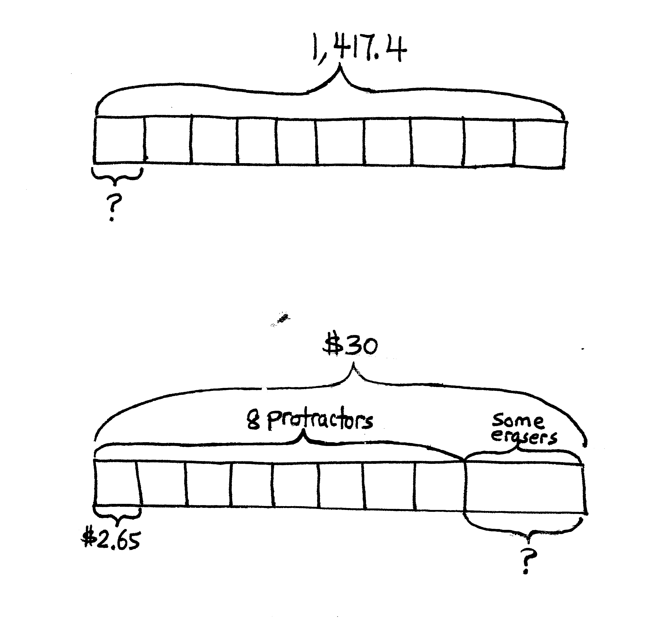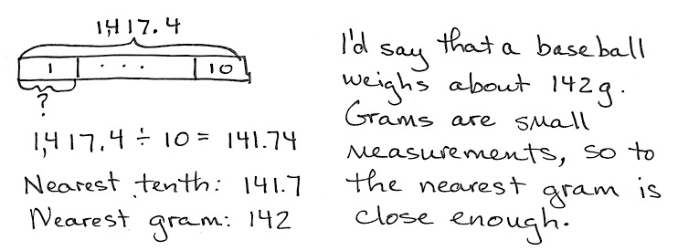

Concept Development (31 minutes)

Materials: (S) Hundreds to thousandths place value chart (Lesson 7 Template), personal white board

Problems 1–3

2 tenths + 6 tenths

2 ones 3 thousandths + 6 ones 1 thousandth

2 tenths 5 thousandths + 6 hundredths

T: (Write 2 tenths + 6 tenths on the board.) Solve 2 tenths plus 6 tenths using disks on your place value chart.

S: (Solve.)

T: Say the sentence using unit form.

|  |  |
| --- | --- |
|  | NOTES ON  Multiple means of representation: |
| Understanding the meaning of *tenths*, *hundredths*, and *thousandths* is essential. Proportional manipulatives, such as base ten blocks, can be used to ensure understanding of the vocabulary. Students should eventually move to concrete place value disks or drawing, which are more efficient. | |

S: 2 tenths + 6 tenths = 8 tenths.

T: How is this addition problem the same as a whole-number addition problem? Turn and share with your partner.

S: In order to find the sum, I added like units—tenths with tenths. 🡪 2 tenths plus 6 tenths equals 8 tenths, just like 2 apples plus 6 apples equals 8 apples.   
🡪 Since the sum is 8 tenths, we don’t need to bundle or regroup.

T: (On the board, write Problems 2 and 3.) Work with your partner, and solve the next two problems with place value disks on your place value chart.

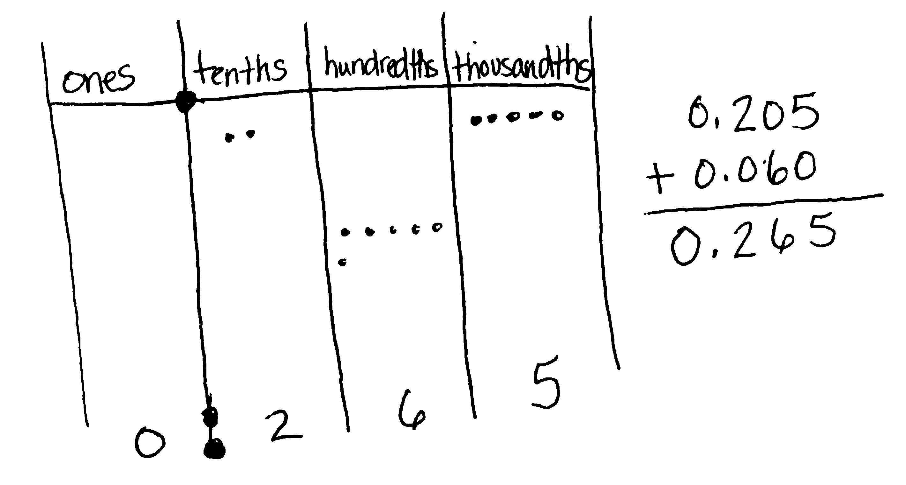

S: (Solve.)

T: Let’s record our last problem vertically. (Write 0.205 and the plus sign underneath on the board.) What do I need to think about when I write my second addend?

Lead students to see that the vertical written method mirrors the placement of disks on the chart. Like units should be aligned with like units. Avoid procedural language like *line up the decimals*. Students should justify alignment of digits based on place value units.

Problems 4–6

1.8 + 13 tenths

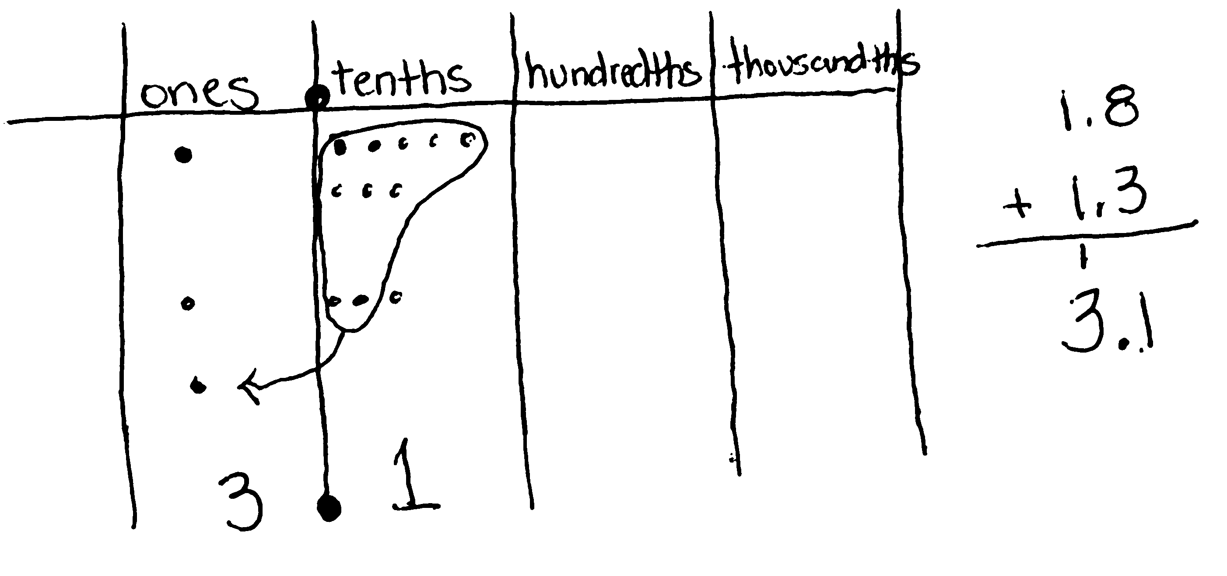1 hundred 8 hundredths + 2 ones 4 hundredths

148 thousandths + 7 ones 13 thousandths

T: (Write 1.8 + 13 tenths on the board.) Use your place value chart and draw disks to show the addends of our next problem.

S: (Show.)

T: Tell how you represented these addends.

Some students may represent 13 tenths by drawing 13 disks in the tenths column or as 1 disk in the ones column and 3 disks in the tenths column. Others may represent 1.8 using mixed units or only tenths.

S: (Share.)

T: Which way of composing these addends requires the fewest number of disks? Why?

|  |  |
| --- | --- |
|  | NOTES ON  Multiple means  OF Action and expression: |
| Some students may struggle when asked to turn and talk to another student because they need more time to compose their thoughts. Math journals can be used in conjunction with Turn and Talk as journals provide a venue in which students can use a combination of graphics, symbols, and words to help them communicate their thinking. | |

S: Using ones and tenths because each ones disk is worth 10 tenths disks.

T: Will your choice of units on your place value chart affect your answer (sum)?

S: No! Either is OK. It will still give the same answer.

T: Add. Share your thinking with your partner.

S: 1.8 + 13 tenths = 1 one and 21 tenths. There are 10 tenths in one whole. I can compose 2 wholes and 11 tenths from 21 tenths, so the answer is 3 and 1 tenth. 🡪 13 tenths is the same as 1 one 3 tenths. 1 one 3 tenths + 1 one 8 tenths = 2 ones 11 tenths, which is the same as 3 ones 1 tenth.

T: Let’s record what we did on our charts. (Lead students to articulate the need to align like units in the vertical algorithm.)

T: What do you notice that was different about this problem? What was the same? Turn and talk.

S: We needed to rename in this problem because 8 tenths and 3 tenths is 11 tenths. 🡪 We added ones with ones and tenths with tenths—like units, just like before.

T: (On the board, write Problems 5 and 6.) Work with your partner to solve the next two problems on your place value chart, and record your thinking vertically.

T: (As students work 148 thousandths + 7 ones 13 thousandths, discuss which composition of 148 thousandths is the most efficient.)

Problems 7−9

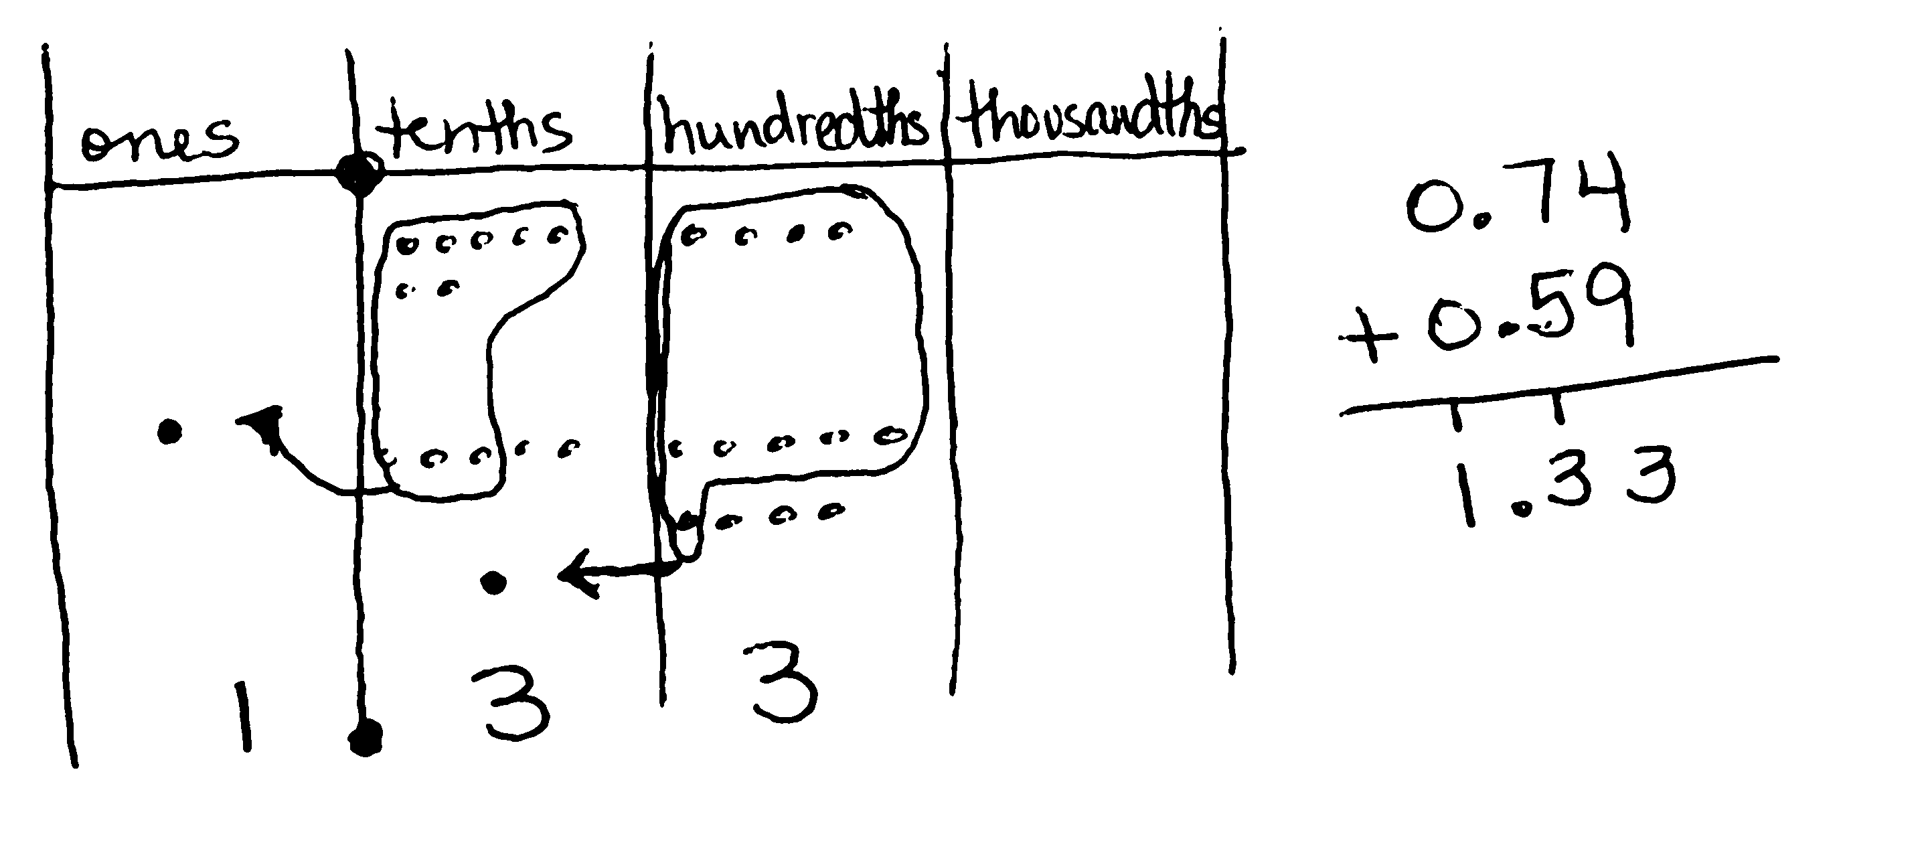0.74 + 0.59

7.048 + 5.196

7.44 + 0.774

T: (Write 0.74 + 0.59 horizontally on the board.) Using disks and the place value chart, find the sum of 0.74 and 0.59. Record your work.

S: (Solve.)

T: How was this problem like others we’ve solved? How was it different?

S: We still add by combining like units—ones with ones, tenths with tenths, hundredths with hundredths—­­but this time we had to bundle in two place value units. We still record our thinking the same way we do with whole numbers—aligning like units.

T: Solve the next two problems using the written method. You may also use your disks to help you. (Write 7.048 + 5.196 and 7.44 + 0.774 on the board horizontally.)

S: (Solve.)

T: How is 7.44 + 0.704 different from the other problems we’ve solved? Turn and talk.

S: One addend had hundredths, and the other had thousandths. We still had to add like units. 🡪 We could think of 44 hundredths as 440 thousandths. 🡪 One addend did not have a zero in the ones place. I could leave it like that or include the zero. The missing zero did not change the quantity.

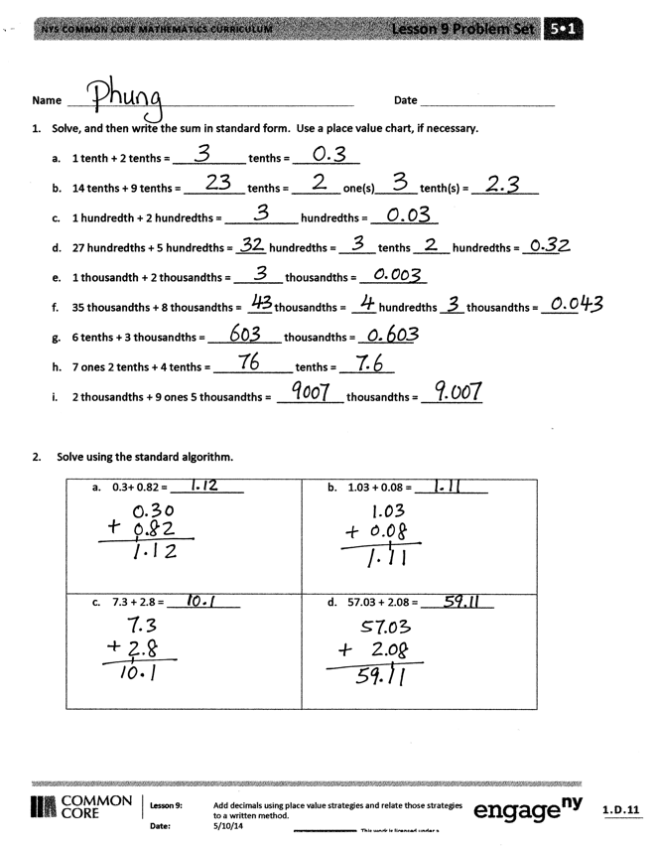Problem Set (10 minutes)

Students should do their personal best to complete the Problem Set within the allotted 10 minutes. For some classes, it may be appropriate to modify the assignment by specifying which problems they work on first. Some problems do not specify a method for solving. Students solve these problems using the RDW approach used for Application Problems.

On this Problem Set, we suggest all students work directly through all problems. Please note that Problem 4 includes the word *pedometer,* which may need explanation for some students.

Student Debrief (10 minutes)

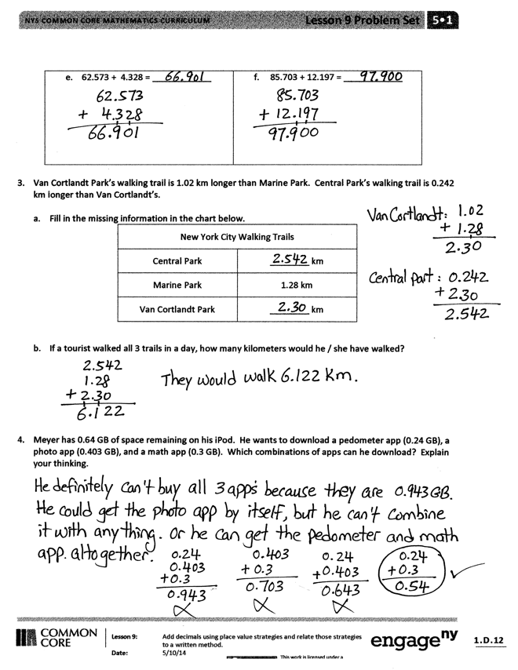**Lesson Objective:** Add decimals using place value strategies, and relate those strategies to a written method.

The Student Debrief is intended to invite reflection and active processing of the total lesson experience.

Invite students to review their solutions for the Problem Set. They should check work by comparing answers with a partner before going over answers as a class. Look for misconceptions or misunderstandings that can be addressed in the Debrief. Guide students in a conversation to debrief the Problem Set and process the lesson.

Any combination of the questions below may be used to lead the discussion.

* How is adding decimal fractions the same as adding whole numbers? How is it different?
* What are some different words you have used through the grades for changing 10 smaller units for 1 of the next larger units or changing 1 unit for 10 of the next smaller units?
* What do you notice about the addends in Problems 1(b), (d), and (f)? Explain the thought process in solving these problems.
* Did you recognize a pattern in the digits used in Problem 2? Look at each row and column.
* What do you notice about the sum in Problem 2(f)? What are some different ways to express the sum? (Encourage students to name the sum using thousandths, hundredths, and tenths.) How is this problem different from adding whole numbers?
* Ask early finishers to generate addition problems that have 2 decimal place values, but add up to specific sums like 1 or 2 (e.g., 0.74 + 0.26).

Exit Ticket (3 minutes)

After the Student Debrief, instruct students to complete the Exit Ticket. A review of their work will help with assessing students’ understanding of the concepts that were presented in today’s lesson and planning more effectively for future lessons. The questions may be read aloud to the students.

Number Correct: _______

**A**

Round to the Nearest One

|  |  |  |  |  |  |  |
| --- | --- | --- | --- | --- | --- | --- |
|  | 3.1 ≈ |  |  |  | 12.51 ≈ |  |
|  | 3.2 ≈ |  |  |  | 16.61 ≈ |  |
|  | 3.3 ≈ |  |  |  | 17.41 ≈ |  |
|  | 3.4 ≈ |  |  |  | 11.51 ≈ |  |
|  | 3.5 ≈ |  |  |  | 11.49 ≈ |  |
|  | 3.6 ≈ |  |  |  | 13.49 ≈ |  |
|  | 3.9 ≈ |  |  |  | 13.51 ≈ |  |
|  | 13.9 ≈ |  |  |  | 15.51 ≈ |  |
|  | 13.1 ≈ |  |  |  | 15.49 ≈ |  |
|  | 13.5 ≈ |  |  |  | 6.3 ≈ |  |
|  | 7.5 ≈ |  |  |  | 7.6 ≈ |  |
|  | 8.5 ≈ |  |  |  | 49.5 ≈ |  |
|  | 9.5 ≈ |  |  |  | 3.45 ≈ |  |
|  | 19.5 ≈ |  |  |  | 17.46 ≈ |  |
|  | 29.5 ≈ |  |  |  | 11.76 ≈ |  |
|  | 89.5 ≈ |  |  |  | 5.2 ≈ |  |
|  | 2.4 ≈ |  |  |  | 12.8 ≈ |  |
|  | 2.41 ≈ |  |  |  | 59.5 ≈ |  |
|  | 2.42 ≈ |  |  |  | 5.45 ≈ |  |
|  | 2.45 ≈ |  |  |  | 19.47 ≈ |  |
|  | 2.49 ≈ |  |  |  | 19.87 ≈ |  |
|  | 2.51 ≈ |  |  |  | 69.51 ≈ |  |

Number Correct: _______

Improvement: _______

**B**

**[KEY]**

Round to the Nearest One

|  |  |  |  |  |  |  |
| --- | --- | --- | --- | --- | --- | --- |
|  | 4.1 ≈ |  |  |  | 13.51 ≈ |  |
|  | 4.2 ≈ |  |  |  | 17.61 ≈ |  |
|  | 4.3 ≈ |  |  |  | 18.41 ≈ |  |
|  | 4.4 ≈ |  |  |  | 12.51 ≈ |  |
|  | 4.5 ≈ |  |  |  | 12.49 ≈ |  |
|  | 4.6 ≈ |  |  |  | 14.49 ≈ |  |
|  | 4.9 ≈ |  |  |  | 14.51 ≈ |  |
|  | 14.9 ≈ |  |  |  | 16.51 ≈ |  |
|  | 14.1 ≈ |  |  |  | 16.49 ≈ |  |
|  | 14.5 ≈ |  |  |  | 7.3 ≈ |  |
|  | 7.5 ≈ |  |  |  | 8.6 ≈ |  |
|  | 8.5 ≈ |  |  |  | 39.5 ≈ |  |
|  | 9.5 ≈ |  |  |  | 4.45 ≈ |  |
|  | 19.5 ≈ |  |  |  | 18.46 ≈ |  |
|  | 29.5 ≈ |  |  |  | 12.76 ≈ |  |
|  | 79.5 ≈ |  |  |  | 6.2 ≈ |  |
|  | 3.4 ≈ |  |  |  | 13.8 ≈ |  |
|  | 3.41 ≈ |  |  |  | 49.5 ≈ |  |
|  | 3.42 ≈ |  |  |  | 6.45 ≈ |  |
|  | 3.45 ≈ |  |  |  | 19.48 ≈ |  |
|  | 3.49 ≈ |  |  |  | 19.78 ≈ |  |
|  | 3.51 ≈ |  |  |  | 59.51 ≈ |  |

Name Date

1. Solve, and then write the sum in standard form. Use a place value chart if necessary.
2. 1 tenth + 2 tenths = ____________ tenths = ___________
3. 14 tenths + 9 tenths = __________ tenths = ________ one(s) _______ tenth(s) = ___________
4. 1 hundredth + 2 hundredths = ____________ hundredths = ___________
5. 27 hundredths + 5 hundredths = _____ hundredths = ______ tenths ______ hundredths = ______
6. 1 thousandth + 2 thousandths = ________ thousandths = ___________
7. 35 thousandths + 8 thousandths = ____ thousandths = ____ hundredths ____ thousandths = ______
8. 6 tenths + 3 thousandths = ____________ thousandths = _________
9. 7 ones 2 tenths + 4 tenths = _____________ tenths = _________
10. 2 thousandths + 9 ones 5 thousandths = ___________ thousandths = __________
11. Solve using the standard algorithm.

|  |  |
| --- | --- |
| 1. 0.3 + 0.82 = ____________ | 1. 1.03 + 0.08 = ____________ |
| 1. 7.3 + 2.8 = ____________ | 1. 57.03 + 2.08 = ____________ |
| 1. 62.573 + 4.328 = ____________ | 1. 85.703 + 12.197 = ____________ |

1. Van Cortlandt Park’s walking trail is 1.02 km longer than Marine Park’s. Central Park’s walking trail is 0.242 km longer than Van Cortlandt’s.
2. Fill in the missing information in the chart below.

|  |  |
| --- | --- |
| **New York City Walking Trails** | |
| Central Park | ________ km |
| Marine Park | 1.28 km |
| Van Cortlandt Park | ________ km |

1. If a tourist walked all 3 trails in a day, how many kilometers would he or she have walked?
2. Meyer has 0.64 GB of space remaining on his iPod. He wants to download a pedometer app (0.24 GB), a photo app (0.403 GB), and a math app (0.3 GB). Which combinations of apps can he download? Explain your thinking.

Name Date

1. Solve.
   1. 4 hundredths + 8 hundredths = ______ hundredths = ______ tenth(s) _______ hundredths
2. 64 hundredths + 8 hundredths = ______ hundredths = ______ tenths _______ hundredths
3. Solve using the standard algorithm.

|  |  |
| --- | --- |
| 1. 2.40 + 1.8 = ____________ | 1. 36.25 + 8.67 = ____________ |

Name Date

* + 1. Solve.

1. 3 tenths + 4 tenths = ____________ tenths
2. 12 tenths + 9 tenths = ____________ tenths = ____________ one(s) ____________ tenth(s)
3. 3 hundredths + 4 hundredths = ____________ hundredths
4. 27 hundredths + 7 hundredths = ______ hundredths = ______ tenths _______ hundredths
5. 4 thousandths + 3 thousandths = ____________ thousandths
6. 39 thousandths + 5 thousandths = ____ thousandths = ____ hundredths ____ thousandths
7. 5 tenths + 7 thousandths = ____________ thousandths
8. 4 ones 4 tenths + 4 tenths = ____________ tenths
9. 8 thousandths + 6 ones 8 thousandths = ____________ thousandths
10. Solve using the standard algorithm.

|  |  |
| --- | --- |
| 1. 0.4 + 0.7 = ____________ | 1. 2.04 + 0.07 = ____________ |
| 1. 6.4 + 3.7 = ____________ | 1. 56.04 + 3.07 = ____________ |
| 1. 72.564 + 5.137 = ____________ | 1. 75.604 + 22.296 = ____________ |

1. Walkway Over the Hudson, a bridge that crosses the Hudson River in Poughkeepsie, is 2.063 kilometers long. Anping Bridge, which was built in China 850 years ago, is 2.07 kilometers long.
   1. What is the total span of both bridges? Show your thinking.
   2. Leah likes to walk her dog on the Walkway Over the Hudson. If she walks across and back, how far will she and her dog walk?
2. For his parents’ anniversary, Danny spends $5.87 on a photo. He also buys a balloon for $2.49 and a box of strawberries for $4.50. How much money does he spend all together?