Lesson 11

Objective: Multiply a decimal fraction by single-digit whole numbers, relate to a written method through application of the area model and place value understanding, and explain the reasoning used.

Suggested Lesson Structure

 Fluency Practice (10 minutes)

 Application Problem (5 minutes)

 Concept Development (35 minutes)

 Student Debrief (10 minutes)

**Total Time (60 minutes)**

Fluency Practice (10 minutes)

* Take Out the Unit **5.NBT.1**  (4 minutes)
* Add and Subtract Decimals **5.NBT.7** (6 minutes)

Take Out the Unit (4 minutes)

Materials: (S) Personal white board

Note: Decomposing common units as decimals strengthens student understanding of place value.

T: (Project 1.234 = _____ thousandths.) Say the number. Think about how many thousandths are in 1.234.

T: (Project 1.234 = 1234 thousandths.) How much is one thousand thousandths?

S: One thousand thousandths is the same as 1.

T: (Project 65.247 = ____.) Say the number in unit form.

S: 65 ones 247 thousandths.

T: (Write 76.358 = 7 tens _____ thousandths.) On your personal white board, fill in the blank.

S: (Write 76.358 = 7 tens 6358 thousandths.)

Repeat the process for 76.358 = 763 tenths _____ thousandths and 76.358 = ____ hundredths 8 thousandths.

Add and Subtract Decimals (6 minutes)

Materials: (S) Personal white board

Note: Reviewing these skills introduced in Lessons 9 and 10 helps students work toward mastery of adding and subtracting common decimal units.

T: (Write 7258 thousandths + 1 thousandth = ____.) Write the addition sentence in standard form.

S: 7.258 + 0.001 = 7.259.

Repeat the process for 7 ones 258 thousandths + 3 hundredths, 7 ones 258 thousandths + 4 tenths, 6 ones 453 thousandths + 4 hundredths, 2 ones 37 thousandths + 5 tenths, and 6 ones 35 hundredths + 7 thousandths.

T: (Write 4 ones 8 hundredths – 2 ones = ___ ones ___ hundredths.) Write the subtraction sentence in standard form.

S: (Write 4.08 – 2 = 2.08.)

Repeat the process for 9 tenths 7 thousandths – 4 thousandths, 4 ones 582 thousandths – 3 hundredths,   
9 ones 708 thousandths – 4 tenths, and 4 ones 73 thousandths – 4 hundredths.

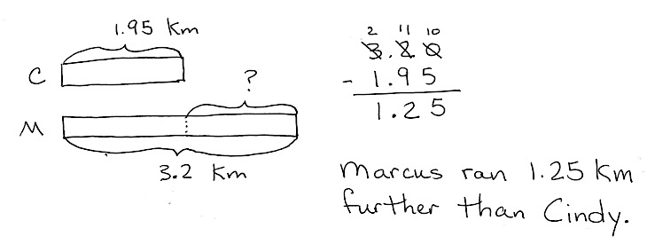Application Problem (5 minutes)

After school, Marcus ran 3.2 km, and Cindy ran 1.95 km. Who ran farther? How much farther?

Note: This Application Problem requires students to subtract decimal numbers, as studied in Lesson 10.

Concept Development (35 minutes)

Materials: (S) Hundreds to thousandths place value chart (Lesson 7 Template), personal white board

**Problems 1–3**

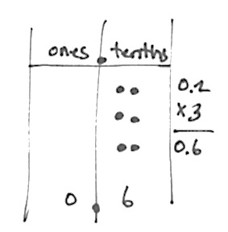3 0.2 = 0.6

3 0.3 = 0.9

4 0.3 = 1.2

T: Draw 2 tenths on your place value chart.

**MP.7**

S: (Draw.)

T: Make 3 copies of 2 tenths. How many tenths do you have in all?

S: 6 tenths.

T: With your partner, write the algorithm showing 6 tenths.

S: I wrote 0.2 + 0.2 + 0.2 = 0.6 because I added 2 tenths three times to get 6 tenths. 🡪 I multiplied   
2 tenths by 3 and got 6 tenths. So, I wrote 3 0.2 = 0.6.

T: (On the board, write 3 copies of 2 tenths is _____.) Complete the sentence. Say the equation in   
unit form.

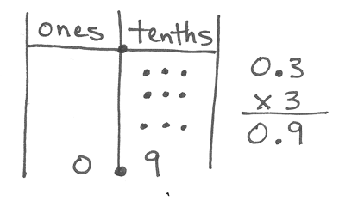S: 6 tenths; 3 2 tenths = 6 tenths.

T: Work with your partner to find the values of 3 0.3 and 4 0.3.

S: (Work to solve.)

T: How was 4 3 tenths different from 3 3 tenths?

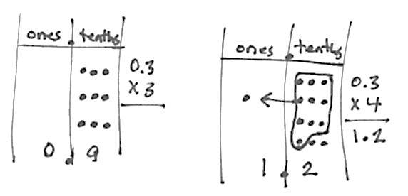S: I had to bundle the 10 tenths. I made 1 one, and I had 2 tenths left.   
I didn’t do this before. 🡪 We made a number greater than 1 whole.

T: 4 copies of 3 tenths is 12 tenths. (Show on the place value chart.)   
12 tenths is the same as ______.

S: 1 one and 2 tenths.

Problems 4–6

2 0.43 = 0.86

2 0.423 = 0.846

4 0.423 = 1.692

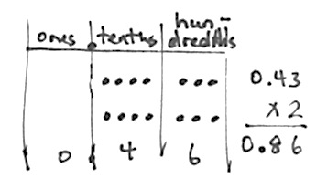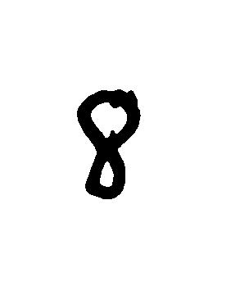

T: (On the board, write 2 0.43 = ________.) How can we use our knowledge from the previous problems to solve this problem?

S: We can make copies of hundredths like we made copies of tenths. 🡪 A hundredth is a different unit, but we can multiply it just like a tenth.

T: Use your place value chart to find the product of   
2 0.43. Complete the sentence, “2 copies of   
43 hundredths is _____________.”

|  |  |
| --- | --- |
|  | NOTES ON  MULTIPLE MEANS  OF ACTION AND  EXPRESSION: |
| The area model can be considered a graphic organizer. It organizes the partial products. Some students may need support in order to remember which product goes in each cell of the area model, especially as the model becomes more complex. The organizer can be modified by writing the expressions in each cell. This might eliminate the need for some students to visually track the product into the appropriate cell. | |

S: (Work.)

T: Read what your place value chart shows.

S: I have 2 groups of 4 tenths and 2 groups of   
3 hundredths. I need to combine tenths with tenths and hundredths with hundredths.

T: (Draw an area model.) Let me record what I hear you saying. Discuss with your partner the difference between these two models.

4 tenths + 3 hundredths

2 8 tenths 6 hundredths

0.8 + 0.06 = 0.86

S: (Share observations.)

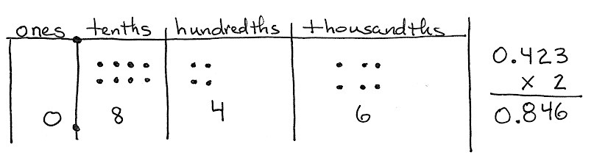T: (On the board, write 2 0.423 =______.) What is different about this problem?

S: There is a digit in the thousandths place.   
🡪 We are multiplying thousandths.

T: Use your place value chart to solve this problem. (Allow students time to work.)

T: Read what your place value chart shows.

0.8 + 0.04 + 0.006 = 0.846

8 tenths 4 hundredths 6 thousandths

2

4 tenths + 2 hundredths + 3 thousandths dthshundredths

S: 846 thousandths.

T: Now, draw an area model, and write an equation with the partial products to show how you found the product. (Allow students time to draw.)

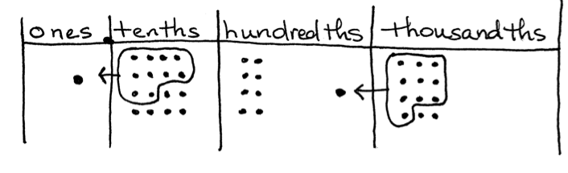T: (Write 4 0.423 = _______ on the board.) Solve by drawing on your place value chart.

S: (Solve.)

T: Read the number that is shown on your chart.

S: 1 and 692 thousandths.

T: How was this problem different from the last?

16 tenths 8 hundredths 12 thousandths

4

4 tenths + 2 hundredths + 3 thousandths

1.6 + 0.08 + 0.012 = 1.692

S: 4 times 3 thousandths is 12 thousandths, so we had to bundle 10 thousandths to make 1 hundredth.

T: Did any other units have to be regrouped?

S: The units in the tenths place. Four times 4 tenths is   
16 tenths, so we had to regroup 10 tenths to make   
1 whole.

T: Let’s record what happened using an area model and an equation showing the partial products.

|  |  |
| --- | --- |
|  | NOTES ON  MULTIPLE MEANS  OF ENGAGEMENT: |
| It can be highly motivating for students to recognize their progress. Teachers can help students do this by creating a list of skills and concepts students will master in this module. Students can keep track as the module and their skills progress. | |

Problems 7–9

Use the area model to represent the distributive property.

61.21

7 2.41

8 2.34

T: (On the board, write 6 1.21 = ____________.) Let’s imagine our disks but use an area model to represent our thinking as we find the product of 6 times 1 and   
21 hundredths.

T: (On the board, draw a rectangle for the area model.) On our area model, how many sections do we have?

S: 3. We have one for each place.

T: (Divide the rectangle into three sections and label the area model.) I have a section for 1 whole,   
2 tenths, and 1 hundredth. I am multiplying each by what number?

S: 6.

T: With a partner, solve the equation using an area model and an equation that shows the partial products.

S: (Work with partners to solve.)

Have students solve the last two expressions using area models and recording equations. Circulate. Look for any misconceptions.

Problem Set (10 minutes)

Students should do their personal best to complete the Problem Set within the allotted 10 minutes. For some classes, it may be appropriate to modify the assignment by specifying which problems they work on first. Some problems do not specify a method for solving. Students solve these problems using the RDW approach used for Application Problems.

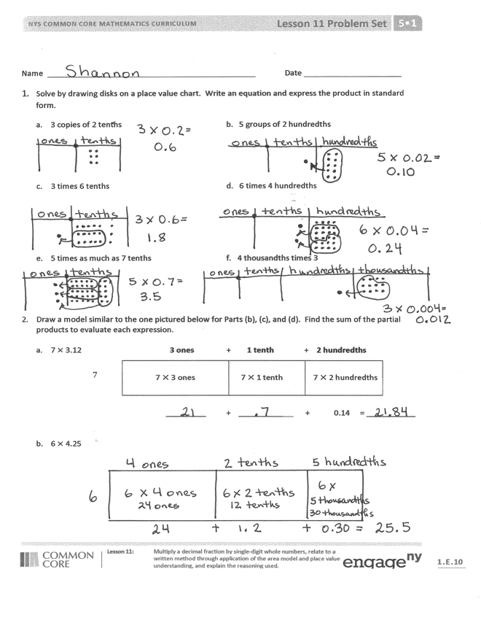Student Debrief (10 minutes)

**Lesson Objective:** Multiply a decimal fraction by single-digit whole numbers, relate to a written method through application of the area model and place value understanding, and explain the reasoning used**.**

The Student Debrief is intended to invite reflection and active processing of the total lesson experience.

Invite students to review their solutions for the Problem Set. They should check work by comparing answers with a partner before going over answers as a class. Look for misconceptions or misunderstandings that can be addressed in the Debrief. Guide students in a conversation to debrief the Problem Set and process the lesson.

Any combination of the questions below may be used to lead the discussion.

* 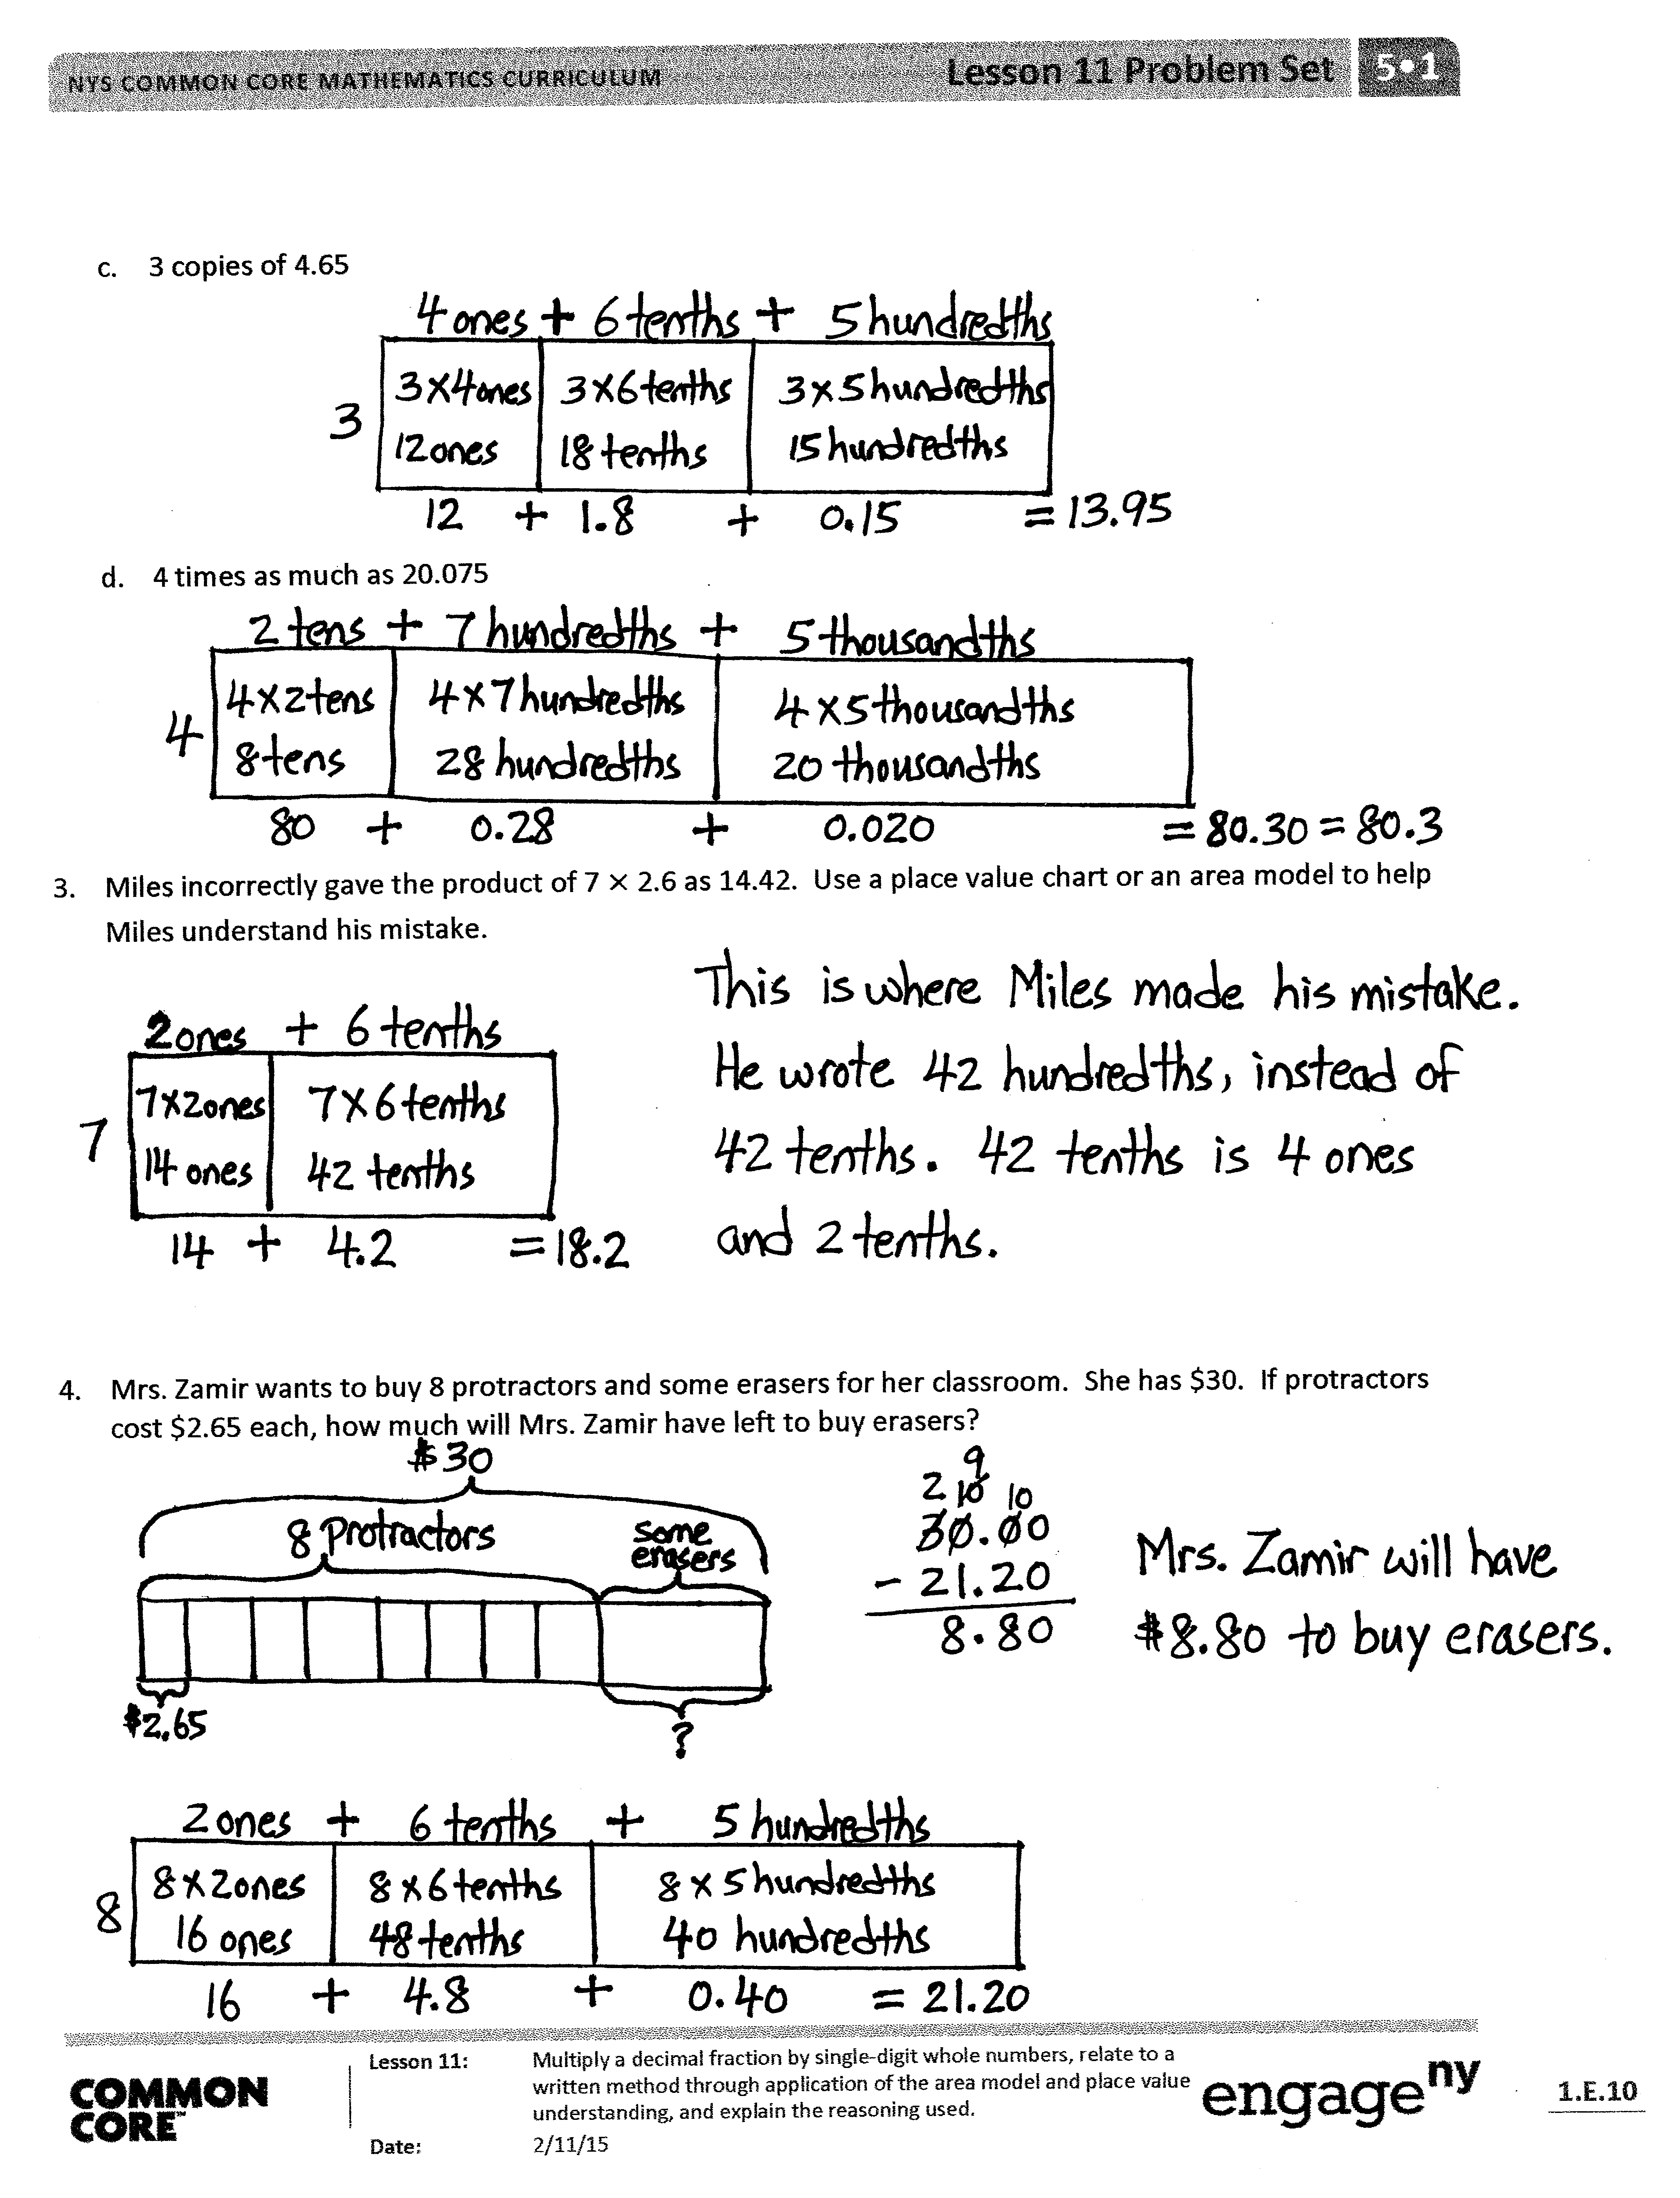Compare student work in Problems 1(c) and 1(d), as some students may regroup units while others may not. Give an opportunity for students to discuss the equality of the various unit decompositions. Give other examples (e.g., 6 0.25), asking students to defend the equality of 1.50, 150 hundredths, and 1.5 with words, models, and numbers.
* Problem 3 points out a common error in student thinking when multiplying decimals by whole numbers. Allow students to share their models for correcting Miles’s error. Students should be able to articulate which units are being multiplied and composed into larger ones.
* Problem 3 also offers an opportunity to extend understanding. Ask students to find the expression that has 14.42 as the product and 7 as the multiplicand. Ask students to show their work using an area model.

Exit Ticket (3 minutes)

After the Student Debrief, instruct students to complete the Exit Ticket. A review of their work will help with assessing students’ understanding of the concepts that were presented in today’s lesson and planning more effectively for future lessons. The questions may be read aloud to the students.

Name Date

1. Solve by drawing disks on a place value chart. Write an equation, and express the product in standard form.
2. 3 copies of 2 tenths b. 5 groups of 2 hundredths
3. 3 times 6 tenths d. 6 times 4 hundredths
4. 5 times as much as 7 tenths f. 4 thousandths times 3
5. Draw a model similar to the one pictured below for Parts (b), (c), and (d). Find the sum of the partial products to evaluate each expression.
6. 7 3.12  3 ones + 1 tenth + 2 hundredths

|  |  |  |
| --- | --- | --- |
| 7 3 ones | 7 1 tenth | 7 2 hundredths |

7

_________ + _________ + 0.14 = _________

1. 6 4.25
2. 3 copies of 4.65
3. 4 times as much as 20.075
4. Miles incorrectly gave the product of 7 2.6 as 14.42. Use a place value chart or an area model to help Miles understand his mistake.
5. Mrs. Zamir wants to buy 8 protractors and some erasers for her classroom. She has $30. If protractors cost $2.65 each, how much will Mrs. Zamir have left to buy erasers?

Name Date

1. Solve by drawing disks on a place value chart. Write an equation, and express the product in standard form.

4 copies of 3 tenths

1. Complete the area model, and then find the product.

3 9.63

_______ _______ _______

_______

|  |  |  |
| --- | --- | --- |
| 3 ____ ones | 3 ____ tenths | 3 _____ hundredths |

Name Date

1. Solve by drawing disks on a place value chart. Write an equation, and express the product in standard form.
2. 2 copies of 4 tenths b. 4 groups of 5 hundredths
3. 4 times 7 tenths d. 3 times 5 hundredths
4. 9 times as much as 7 tenths f. 6 thousandths times 8
5. Draw a model similar to the one pictured below. Find the sum of the partial products to evaluate each expression.
6. 4 6.79 6 ones + 7 tenths + 9 hundredths

4

|  |  |  |
| --- | --- | --- |
| 4 6 ones | 4 7 tenths | 4 9 hundredths |

___________ + __________ + __________ = ___________

1. 6 7.49
2. 9 copies of 3.65
3. 3 times 20.175
4. Leanne multiplied 8 4.3 and got 32.24. Is Leanne correct? Use an area model to explain your answer.
5. Anna buys groceries for her family. Hamburger meat is $3.38 per pound, sweet potatoes are $0.79 each, and hamburger rolls are $2.30 a bag. If Anna buys 3 pounds of meat, 5 sweet potatoes, and 1 bag of hamburger rolls, what will she pay in all for the groceries?