Lesson 12

Objective: Multiply a decimal fraction by single-digit whole numbers, including using estimation to confirm the placement of the decimal point.

Suggested Lesson Structure

 Fluency Practice (12 minutes)

 Application Problem (8 minutes)

 Concept Development (30 minutes)

 Student Debrief (10 minutes)

**Total Time (60 minutes)**

Fluency Practice (12 minutes)

* Sprint: Add Decimals **5.NBT.7** (9 minutes)
* Find the Product **5.NBT.7** (3 minutes)

**MP.3**

Sprint: Add Decimals (9 minutes)

Materials: (S) Add Decimals Sprint

Note: This Sprint helps students build automaticity in adding decimals without renaming.

Find the Product (3 minutes)

Materials: (S) Personal white board

Note: Reviewing this skill introduced in Lesson 11 helps students work toward mastery of multiplying single-digit numbers times decimals.

T: (Write 4 2 ones = __.) Write the multiplication sentence.

S: 4 2 = 8.

T: Say the multiplication sentence in unit form.

S: 4 2 ones = 8 ones.

Repeat the process for 4 0.2, 4 0.02, 5 3, 5 0.3, 5 0.03, 3 0.2, 3 0.03, 3 0.23, and 2 0.14.

Application Problem (8 minutes)

Patty buys 7 juice boxes a month for lunch. If one juice box costs $2.79, how much money does Patty spend on juice each month? Use an area model to solve.

Extension: How much will Patty spend on juice in 10 months? In 12 months?

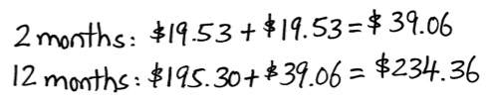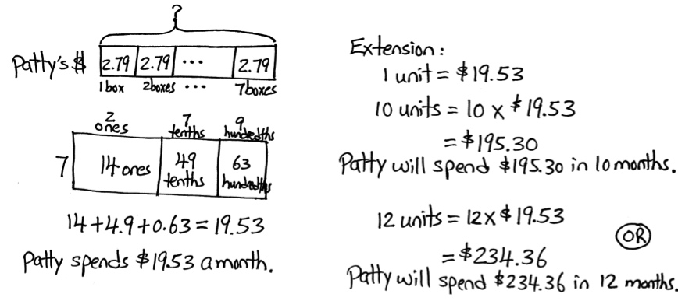

Note: The first part of this Application Problem asks students to multiply a number with two decimal digits by a single-digit whole number. This skill, taught in Lesson 11, provides a bridge to today’s topic, which involves reasoning about such problems on a more abstract level. The extension problem looks back to Topic A and requires multiplication by powers of 10. Although students have not multiplied a decimal number by a two-digit number, they can solve 12 2.79 by using the distributive property: (10 2.79) + (2 2.79).

Concept Development (30 minutes)

Materials: (S) Personal white board

Problems 1–3

31 4 = 124

**MP.8**

3.1 4= 12.4

0.31 4 = 1.24

T: (Write all three problems on the board.) How are these three problems alike?

S: They are alike because they all have 3, 1, and 4 as part of the problem.

T: Use an area model to find the products.

S: (Draw.)

3 tenths + 1 hundredth

4

4 hundredths

12 tenths

1.2 + 0.04

= 1.24

3 ones + 1 tenth

4

4 tenths

12 ones

12 + 0.4

= 12.4

3 tens + 1 one

4

4 ones

12 tens

120 + 4

= 124

T: How are the products of all three problems alike?

|  |  |
| --- | --- |
|  | NOTES ON  MULTIPLE MEANS  OF ACTION AND  EXPRESSION: |
| Web-based applications like Number Navigator offer assistance to those whose fine motor skills may prevent them from being able to set out columnar arithmetic with ease. Such applications preclude the need for complicated spreadsheets, making them an ideal scaffold for the classroom. | |

S: Every product has the digits 1, 2, and 4, and they are always in the same order.

T: If the products have the same digits and those digits are in the same order, do the products have the same value? Why or why not? Turn and talk.

S: The decimal is not in the same place in every product. 🡪 No. The values are different because the units that we multiplied are different. 🡪 The digits that we multiplied are the same, but you have to think about the units to make sure the answer is right.

T: So, let me repeat what I hear you saying. I can multiply the numerals first and then think about the units to help place the decimal.

Problems 4–6

5.1 6 = 30.6

11.4 4 = 45.6

7.8 3 = 23.4

T: (Write 5.1 6 on the board.) What is the smallest unit in 5.1?

S: Tenths.

T: Multiply 5.1 by 10 to convert it to tenths. How many tenths is the same as 5.1?

|  |  |  |
| --- | --- | --- |
| 5 | 1 | tenths |
|  | 6 |  |
| 3 0 | 6 | tenths |

S: 51 tenths.

T: Suppose our multiplication sentence was 51 6. Multiply and record your multiplication vertically. What is the product?

S: 306.

T: We know that our product will contain these digits, but is 306 a reasonable product for our actual problem of 5.1 6? Turn and talk.

S: We have to think about the units. 306 ones is not reasonable, but 306 tenths is. 🡪 5.1 is close to 5, and 5 6 = 30, so the answer should be around 30. 🡪 306 tenths is the same as 30 ones and 6 tenths.

T: Using this reasoning, where does it make sense to place the decimal in 306? What is the product of 5.1 6?

S: Between the zero and the six. The product is 30.6.

T: (Write 11.4 4 = _______ on the board.) What is the smallest unit in 11.4?

S: Tenths.

T: What power of 10 must I use to convert 11.4 to tenths? How many tenths are the same as 11 ones 4 tenths? Turn and talk.

S: 101. 🡪 We have to multiply by 10. 🡪 11.4 is the same as 114 tenths.

T: Multiply vertically to find the product of 114 tenths 4.

S: 456 tenths.

T: We know that our product will contain these digits. How will we determine where to place our decimal?

|  |  |  |  |
| --- | --- | --- | --- |
| 1 | 1 | 4 | tenths |
|  |  | 4 |  |
| 4 | 5 | 6 | tenths |

S: We can estimate. 11.4 is close to 11, and 11 4 is 44. The only place that makes sense for the decimal is between the five and six. The actual product is 45.6. 🡪 456 tenths is the same as 45 ones and 6 tenths.

Repeat the sequence with 7.8 3. Elicit from students the similarities and differences between this problem and others. (Must compose tenths into ones.)

Problems 7–9

3.12 4 = 12.48

3.22 5 = 16.10

|  |  |
| --- | --- |
|  | NOTES ON  MULTIPLE MEANS  OF ENGAGEMENT: |
| Once students are able to determine the reasonable placement of decimals through estimation, by composition of smaller units to larger units, and by using the area model, teachers should have students articulate which strategy they might choose first. Students who have choices develop self-determination and feel more connected to their learning. | |

3.42 6 = 20.52

T: (Write 3.12 4 on the board.) Use hundredths to name 3.12 and multiply vertically by 4. What is the product?

S: 1248 hundredths.

T: I will write four possible products for 3.12 4 on my board. Turn and talk to your partner about which of these products is reasonable. Then, confirm the actual product using an area model. Be prepared to share your thinking. (Write 1248, 1.248, 12.48, and 124.8 on the board.)

S: (Work and share.)

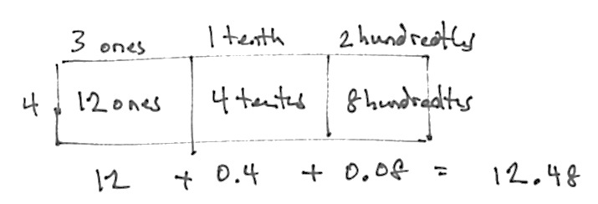

Repeat this sequence for the other problems in this set. Write possible products, and allow students to reason about decimal placement both from an estimation-based strategy and from a composition of smaller units into larger units (e.g., 2,052 hundredths is the same as 20 ones and 52 hundredths). Students should also find the products using an area model and then compare the two methods for finding products.

Problems 10–12

0.733 4 = 2.932

10.733 4 = 42.932

5.733 4 = 22.932

T: (Write 0.733 4 on the board.) Rename 0.733 using its smallest units, and multiply vertically by 4. What is the product?

S: 2,932 thousandths.

T: (Write 2.932, 29.32, 293.2, and 2,932 on the board.) Which of these is the most reasonable product for 0.733 4? Why? Turn and talk.

S: 2.932. 0.733 is close to one whole, and 1 4 = 4. None of the other choices make sense. 🡪 I know that 2,000 thousandths make 2 wholes, so 2,932 thousandths is the same as 2 ones 932 thousandths.

T: Solve 0.733 4 using an area model. Compare your products using these two different strategies.

Repeat this sequence for 10.733 4, and allow independent work for 5.733 4. Require students to decompose to smallest units to reason about decimal placement and the area model so that products and strategies may be compared.

Problem Set (10 minutes)

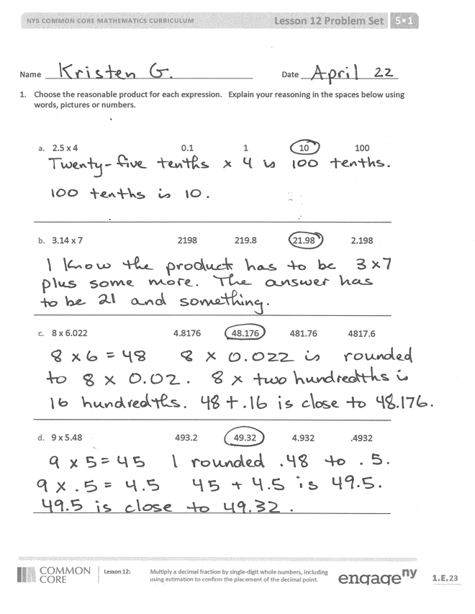Students should do their personal best to complete the Problem Set within the allotted 10 minutes. For some classes, it may be appropriate to modify the assignment by specifying which problems they work on first. Some problems do not specify a method for solving. Students solve these problems using the RDW approach used for Application Problems.

Student Debrief (10 minutes)

**Lesson Objective:** Multiply a decimal fraction by single-digit whole numbers, including using estimation to confirm the placement of the decimal point.

The Student Debrief is intended to invite reflection and active processing of the total lesson experience.

Invite students to review their solutions for the Problem Set. They should check work by comparing answers with a partner before going over answers as a class. Look for misconceptions or misunderstandings that can be addressed in the Debrief. Guide students in a conversation to debrief the Problem Set and process the lesson. Any combination of the questions below may be used to lead the discussion.

* 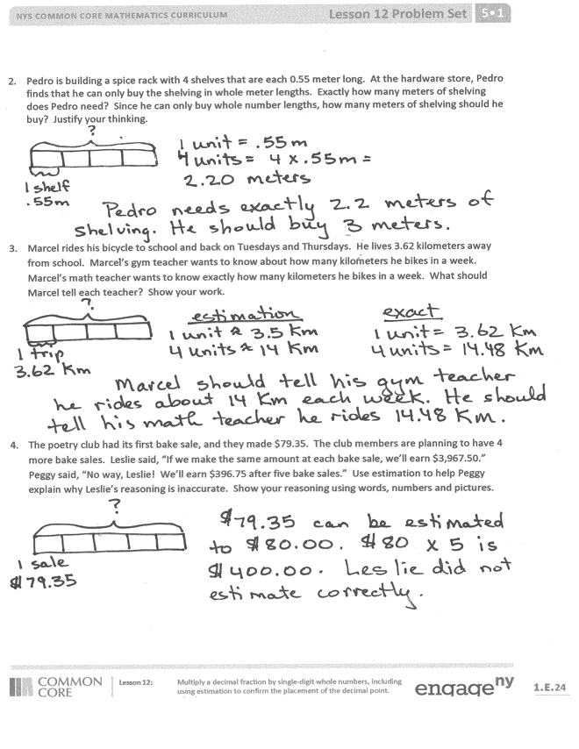How can whole-number multiplication help you with decimal multiplication? (Elicit from students that the digits in a product can be found through whole-number multiplication. The actual product can be deduced through estimation-based logic or composing smaller units into larger units.)
* How does the area model help you to justify the placement of the decimal point for the product in 1(b)?
* Problem 3 offers an excellent opportunity to discuss purposes of estimation because multiple answers are possible for the estimate Marcel gives his gym teacher. For example, Marcel could round to 4 km and estimate that he bikes about 16 miles. Another way to estimate is to round each leg of the trip to 3.5 km. The estimated total distance is then 14 km. Allow time for students to defend their thoughts. It may also be fruitful to compare their thoughtful estimates with the exact answer. Which estimate is closer to the actual distance? In which cases would it matter?

Exit Ticket (3 minutes)

After the Student Debrief, instruct students to complete the Exit Ticket. A review of their work will help with assessing students’ understanding of the concepts that were presented in today’s lesson and planning more effectively for future lessons. The questions may be read aloud to the students.

Number Correct: _______

**A**

Add Decimals

|  |  |  |  |  |  |  |
| --- | --- | --- | --- | --- | --- | --- |
|  | 3 + 1 = |  |  |  | 5 + 0.1 = |  |
|  | 3.5 + 1 = |  |  |  | 5.7 + 0.1 = |  |
|  | 3.52 + 1 = |  |  |  | 5.73 + 0.1 = |  |
|  | 0.3 + 0.1 = |  |  |  | 5.736 + 0.1 = |  |
|  | 0.37 + 0.1 = |  |  |  | 5.736 + 1 = |  |
|  | 5.37 + 0.1 = |  |  |  | 5.736 + 0.01 = |  |
|  | 0.03 + 0.01 = |  |  |  | 5.736 + 0.001 = |  |
|  | 0.83 + 0.01 = |  |  |  | 6.208 + 0.01 = |  |
|  | 2.83 + 0.01 = |  |  |  | 3 + 0.01 = |  |
|  | 30 + 10 = |  |  |  | 3.5 + 0.01 = |  |
|  | 32 + 10 = |  |  |  | 3.58 + 0.01 = |  |
|  | 32.5 + 10 = |  |  |  | 3.584 + 0.01 = |  |
|  | 32.58 + 10 = |  |  |  | 3.584 + 0.001 = |  |
|  | 40.789 + 1 = |  |  |  | 3.584 + 0.1 = |  |
|  | 4 + 1 = |  |  |  | 3.584 + 1 = |  |
|  | 4.6 + 1 = |  |  |  | 6.804 + 0.01 = |  |
|  | 4.62 + 1 = |  |  |  | 8.642 + 0.001 = |  |
|  | 4.628 + 1 = |  |  |  | 7.65 + 0.001 = |  |
|  | 4.628 + 0.1 = |  |  |  | 3.987 + 0.1 = |  |
|  | 4.628 + 0.01 = |  |  |  | 4.279 + 0.001 = |  |
|  | 4.628 + 0.001 = |  |  |  | 13.579 + 0.01 = |  |
|  | 27.048 + 0.1 = |  |  |  | 15.491 + 0.01 = |  |

**B**

**[KEY]**

Number Correct: _______

Improvement: _______

Add Decimals

|  |  |  |  |  |  |  |
| --- | --- | --- | --- | --- | --- | --- |
|  | 2 + 1 = |  |  |  | 4 + 0.1 = |  |
|  | 2.5 + 1 = |  |  |  | 4.7 + 0.1 = |  |
|  | 2.53 + 1 = |  |  |  | 4.73 + 0.1 = |  |
|  | 0.2 + 0.1 = |  |  |  | 4.736 + 0.1 = |  |
|  | 0.27 + 0.1 = |  |  |  | 4.736 + 1 = |  |
|  | 5.27 + 0.1 = |  |  |  | 4.736 + 0.01 = |  |
|  | 0.02 + 0.01 = |  |  |  | 4.736 + 0.001 = |  |
|  | 0.82 + 0.01 = |  |  |  | 5.208 + 0.01 = |  |
|  | 4.82 + 0.01 = |  |  |  | 2 + 0.01 = |  |
|  | 20 + 10 = |  |  |  | 2.5 + 0.01 = |  |
|  | 23 + 10 = |  |  |  | 2.58 + 0.01 = |  |
|  | 23.5 + 10 = |  |  |  | 2.584 + 0.01 = |  |
|  | 23.58 + 10 = |  |  |  | 2.584 + 0.001 = |  |
|  | 30.789 + 1 = |  |  |  | 2.584 + 0.1 = |  |
|  | 3 + 1 = |  |  |  | 2.584 + 1 = |  |
|  | 3.6 + 1 = |  |  |  | 5.804 + 0.01 = |  |
|  | 3.62 + 1 = |  |  |  | 7.642 + 0.001 = |  |
|  | 3.628 + 1 = |  |  |  | 6.75 + 0.001 = |  |
|  | 3.628 + 0.1 = |  |  |  | 2.987 + 0.1 = |  |
|  | 3.628 + 0.01 = |  |  |  | 3.279 + 0.001 = |  |
|  | 3.628 + 0.001 = |  |  |  | 12.579 + 0.01 = |  |
|  | 37.048 + 0.1 = |  |  |  | 14.391 + 0.01 = |  |

Name Date

1. Choose the reasonable product for each expression. Explain your reasoning in the spaces below using words, pictures, or numbers.

|  |  |  |  |  |
| --- | --- | --- | --- | --- |
| 1. 2.5 4 | 0.1 | 1 | 10 | 100 |
| 1. 3.14 7 | 2198 | 219.8 | 21.98 | 2.198 |
| 1. 8 6.022 | 4.8176 | 48.176 | 481.76 | 4817.6 |
| 1. 9 5.48 | 493.2 | 49.32 | 4.932 | 0.4932 |

1. Pedro is building a spice rack with 4 shelves that are each 0.55 meter long. At the hardware store, Pedro finds that he can only buy the shelving in whole meter lengths. Exactly how many meters of shelving does Pedro need? Since he can only buy whole-number lengths, how many meters of shelving should he buy? Justify your thinking.
2. Marcel rides his bicycle to school and back on Tuesdays and Thursdays. He lives 3.62 kilometers away from school. Marcel’s gym teacher wants to know about how many kilometers he bikes in a week. Marcel’s math teacher wants to know exactly how many kilometers he bikes in a week. What should Marcel tell each teacher? Show your work.
3. The poetry club had its first bake sale, and they made $79.35. The club members are planning to have   
   4 more bake sales. Leslie said, “If we make the same amount at each bake sale, we’ll earn $3,967.50.” Peggy said, “No way, Leslie! We’ll earn $396.75 after five bake sales.” Use estimation to help Peggy explain why Leslie’s reasoning is inaccurate. Show your reasoning using words, numbers, or pictures.

Name Date

1. Use estimation to choose the correct value for each expression.
2. 5.1 2 0.102 1.02 10.2 102
3. 4 8.93 3.572 35.72 357.2 3572
4. Estimate the answer for 7.13 × 6. Explain your reasoning using words, pictures, or numbers.

Name Date

* + - 1. Choose the reasonable product for each expression. Explain your thinking in the spaces below using words, pictures, or numbers.

|  |  |  |  |  |
| --- | --- | --- | --- | --- |
| 1. 2.1 3 | 0.63 | 6.3 | 63 | 630 |
| 1. 4.27 6 | 2562 | 256.2 | 25.62 | 2.562 |
| 1. 7 6.053 | 4237.1 | 423.71 | 42.371 | 4.2371 |
| 1. 9 4.82 | 4.338 | 43.38 | 433.8 | 4338 |

* + - 1. Yi Ting weighs 8.3 kg. Her older brother is 4 times as heavy as Yi Ting. How much does her older brother weigh in kilograms?
      2. Tim is painting his storage shed. He buys 4 gallons of white paint and 3 gallons of blue paint. Each gallon of white paint costs $15.72, and each gallon of blue paint is $21.87. How much will Tim spend in all on paint?
      3. Ribbon is sold at 3 yards for $6.33. Jackie bought 24 yards of ribbon for a project. How much did she pay?