Lesson 13

Objective: Divide decimals by single-digit whole numbers involving easily identifiable multiples using place value understanding and relate to a written method.

Suggested Lesson Structure

 Fluency Practice (15 minutes)

 Application Problem (7 minutes)

 Concept Development (28 minutes)

 Student Debrief (10 minutes)

**Total Time (60 minutes)**

Fluency Practice (15 minutes)

* Sprint: Subtract Decimals **5.NBT.7** (9 minutes)
* Find the Product **5.NBT.7** (3 minutes)
* Compare Decimal Fractions **3.NF.3d** (3 minutes)

Sprint: Subtract Decimals (9 minutes)

Materials: (S) Subtract Decimals Sprint

Note: This Sprint helps students build automaticity in subtracting decimals without renaming.

Find the Product (3 minutes)

Materials: (S) Personal white board

Note: Reviewing this skill introduced in Lessons 11–12 helps students work toward mastery of multiplying single-digit numbers times decimals.

T: (Write 4 3 = .) Say the multiplication sentence in unit form.

S: 4 3 ones = 12 ones.

T: (Write 4 0.2 = .) Say the multiplication sentence in unit form.

S: 42 tenths = 8 tenths.

T: (Write 4 x 3.2 = .) Say the multiplication sentence in unit form.

S: 4 3 ones 2 tenths = 12 and 8 tenths.

T: Write the multiplication sentence.

S: (Write 4 3.2 = 12.8.)

Repeat the process for 4 3.21, 9 2, 9 0.1, 9 0.03, 9 2.13, 4.012 4, and 5 3.237.

Compare Decimal Fractions (3 minutes)

Materials: (S) Personal white board

Note: This review fluency helps solidify student understanding of place value in the decimal system.

T: (Write 13.78 13.86.) On your personal white boards, compare the numbers using the greater than, less than, or equal sign.

S: (Write 13.78 13.86.)

Repeat the process and procedure for 0.78 , 439.3 4.39, 5.08 fifty-eight tenths, thirty-five and   
9 thousandths 4 tens.

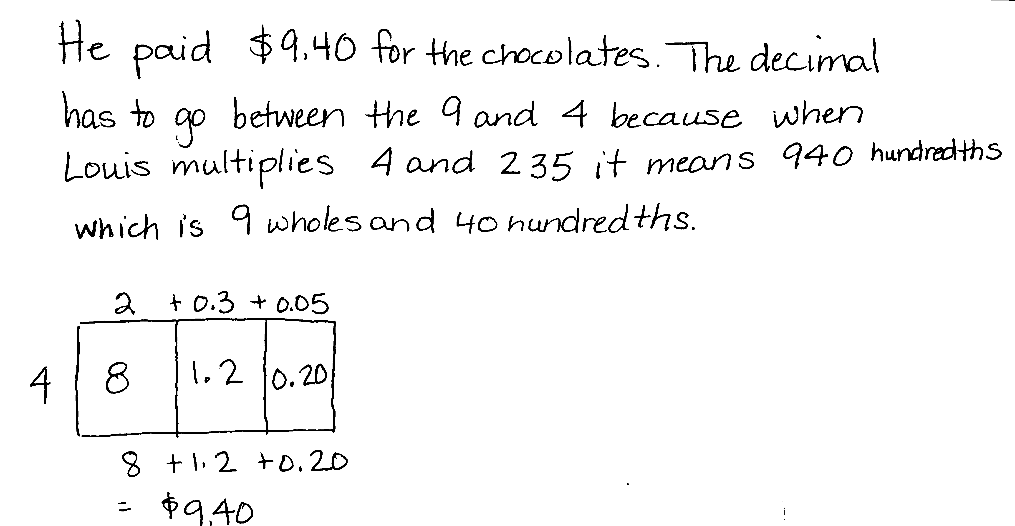Application Problem (7 minutes)

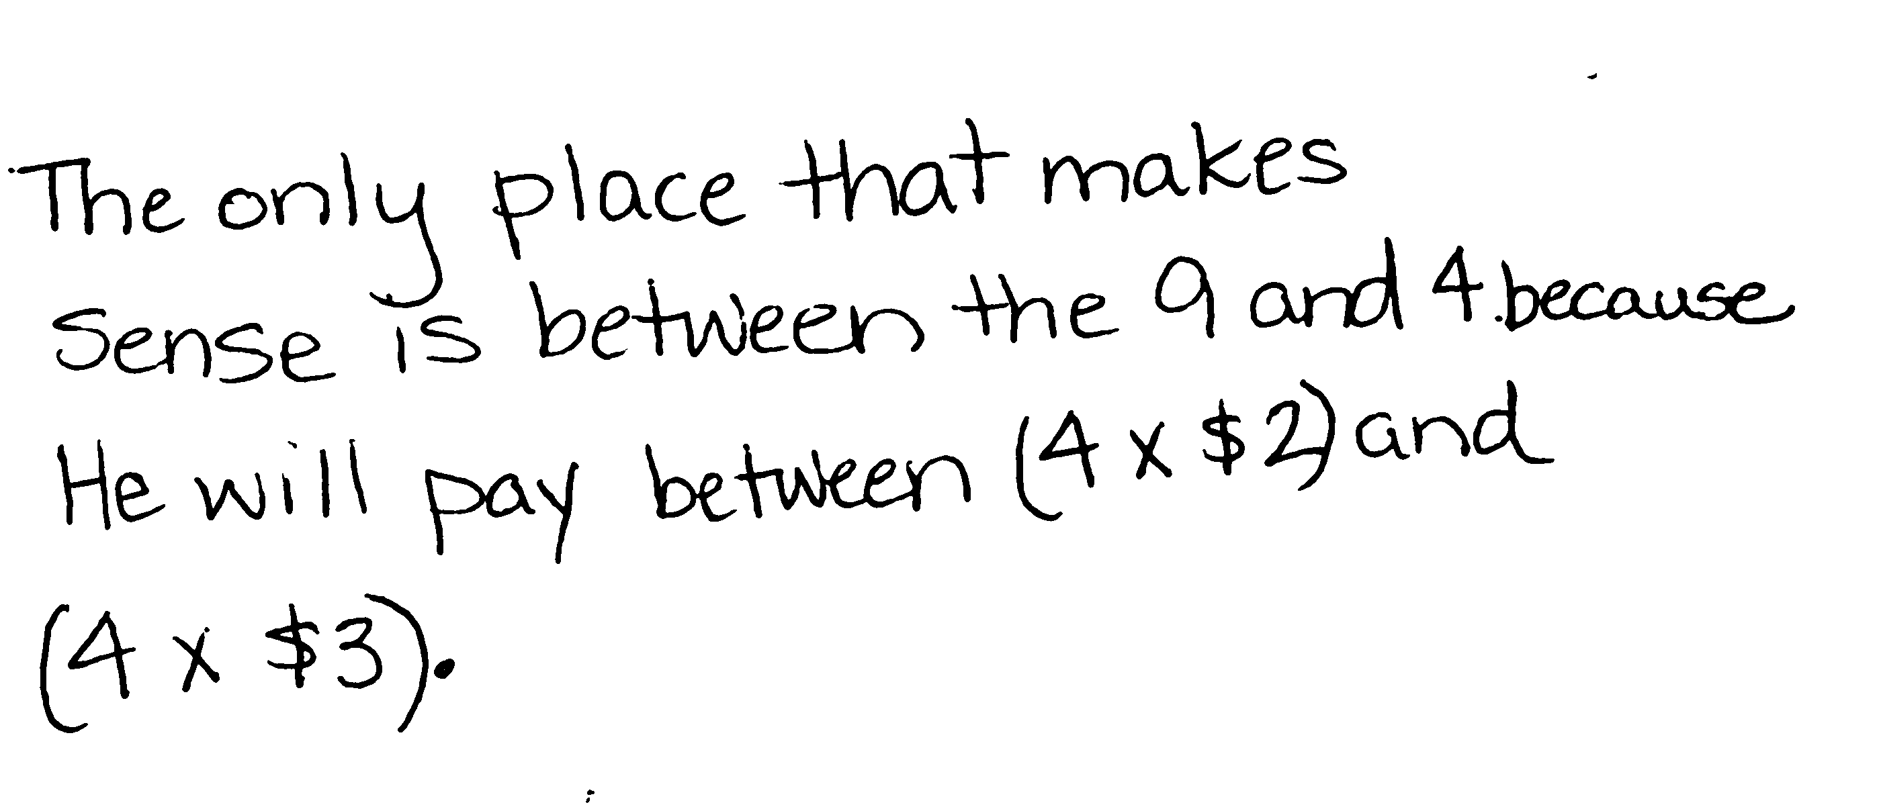Louis buys 4 chocolates. Each chocolate costs $2.35. Louis multiplies 4 235 and gets 940. Place the decimal to show the cost of the chocolates, and explain your reasoning using words, numbers, and pictures.

Note: This Application Problem requires students to estimate 4 $2.35 in order to place the decimal point in the product. This skill was taught in Lesson 12.

Concept Development (28 minutes)

Materials: (S) Hundreds to thousandths place value chart (Lesson 7 Template), personal white board

Problems 1–3

0.9 ÷ 3 = 0.3

0.24 ÷ 4 = 0.06

0.032 ÷ 8 = 0.004

T: Draw disks to show 9 tenths on your hundreds to thousandths place value chart.

S: (Show.)

T: Divide 9 tenths into 3 equal groups.

S: (Make 3 groups of 3 tenths.)

T: How many tenths are in each group?

S: There are 3 tenths in each group.

T: (Write 0.9 ÷ 3 = 0.3 on the board.) Read the number sentence using unit form.

S: 9 tenths divided by 3 equals 3 tenths.

T: How does unit form help us divide?

S: When we identify the units, then it’s just like dividing 9 apples into 3 groups. 🡪 If you know what unit you are sharing, then it’s just like whole-number division. You can just think about the basic fact.

T: (Write 3 groups of = 0.9 on the board.) What is the unknown in our number sentence?

S: 3 tenths (0.3).

Repeat this sequence with 0.24 ÷ 4 = 0.06 (24 hundredths divided by 4 equals 6 hundredths) and   
0.032 ÷ 8 = 0.004 (32 thousandths divided by 8 equals 4 thousandths).

Problems 4–6

|  |  |
| --- | --- |
|  | NOTES ON  MULTIPLE MEANS  OF ENGAGEMENT: |
| Students can also be challenged to use a compensation strategy to make another connection to whole-number division. The dividend is multiplied by a power of ten, which converts it to its smallest units. Once the dividend is shared among the groups, it must be converted back to the original units by dividing it by the same power of ten. For example:  1.5 ÷ 5🡪(1.5 10) ÷ 5🡪  15 ÷ 5 = 3🡪 3 **÷** 10= 0.3 | |

1.5 ÷ 5 = 0.3

1.05 ÷ 5 = 0.21

3.015 ÷ 5 = 0.603

T: (Write on the board 1.5 ÷ 5.) Read the equation stating the whole in unit form.

S: Fifteen tenths divided by 5.

T: What is useful about reading the decimal as 15 tenths?

S: When you say the units, it’s like a basic fact.

T: What is 15 tenths divided by 5?

S: 3 tenths.

T: (On the board, complete the equation 1.5 ÷ 5 = 0.3.)

T: (On the board, write 1.05 ÷ 5.) Read the expression using unit form for the dividend.

S: 105 hundredths divided by 5.

T: Is there another way to decompose (name or group) this quantity?

S: 1 one and 5 hundredths. 🡪 10 tenths and 5 hundredths.

T: Which way of naming 1.05 is most useful when dividing by 5? Why? Turn and talk, and then solve.

S: 10 tenths and 5 hundredths because they are both multiples of 5. This makes it easy to use basic facts to divide mentally. The answer is 2 tenths and 1 hundredth. 🡪 105 hundredths is easier for me because I know 100 is 20 fives, so 105 is 1 more: 21. 21 hundredths. 🡪 I just used the algorithm from Grade 4 and got 21. I knew it was hundredths.

Repeat this sequence with 3.015 ÷ 5. Have students decompose the decimal several ways and then reason about which is the most useful for division. It is also important to draw parallels among the next three problems. Lead students by asking questions such as “How does the answer to the second set of problems help you find the answer to the third?” if necessary.

Problems 7–9

|  |  |
| --- | --- |
|  | NOTES ON  MULTIPLE MEANS  OF REPRESENTATION: |
| Unfamiliar vocabulary can slow down the learning process or even confuse students. Reviewing key vocabulary, such as *dividend, divisor,* or *quotient,* may benefit all students. Displaying the words in a familiar mathematical sentence may serve as a useful reference for students. For example, display:  Dividend **÷** Divisor = Quotient. | |

Compare the relationships between:

4.8 ÷ 6 = 0.8 and 48 ÷ 6 = 8

4.08 ÷ 8 = 0.51 and 408 ÷ 8 = 51

63.021 ÷ 7 = 9.003 and 63,021 ÷ 7 = 9,003

T: (Write 4.8 ÷ 6 = 0.8 and 48 ÷ 6 = 8 on the board.) What relationships do you notice between these two equations? How are they alike?

S: 8 is 10 times greater than 0.8. 🡪 48 is 10 times greater than 4.8. 🡪 The digits are the same in both equations, but the decimal points are in different places.

T: How can 48 ÷ 6 help you with 4.8 ÷ 6? Turn and talk.

S: If you think of the basic fact first, then you can get a quick answer. Then, you just have to remember what units were really in the problem. This one was really 48 tenths. 🡪 The division is the same; the units are the only difference.

Repeat the process for 4.08 ÷ 8 = 0.51 and 408 ÷ 8 = 51, 63.021 ÷ 7 = 9.003, and 63,021 ÷ 7 = 9,003.

T: When completing the Problem Set, remember to use what you know about whole numbers to help you divide the decimal numbers.

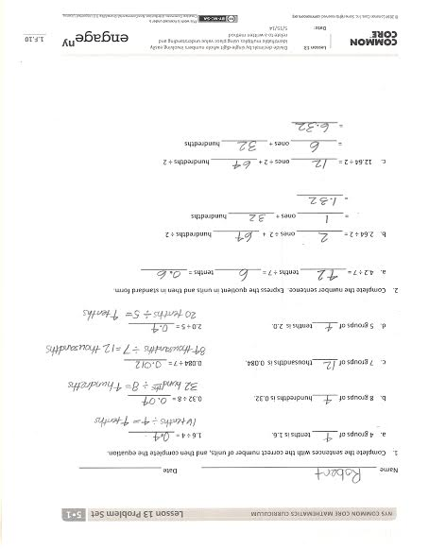Problem Set (10 minutes)

Students should do their personal best to complete the Problem Set within the allotted 10 minutes. For some classes, it may be appropriate to modify the assignment by specifying which problems they work on first. Some problems do not specify a method for solving. Students solve these problems using the RDW approach used for Application Problems.

Student Debrief (10 minutes)

**Lesson Objective:**  Divide decimals by single-digit whole numbers involving easily identifiable multiples using place value understanding and relate to a written method.

The Student Debrief is intended to invite reflection and active processing of the total lesson experience.

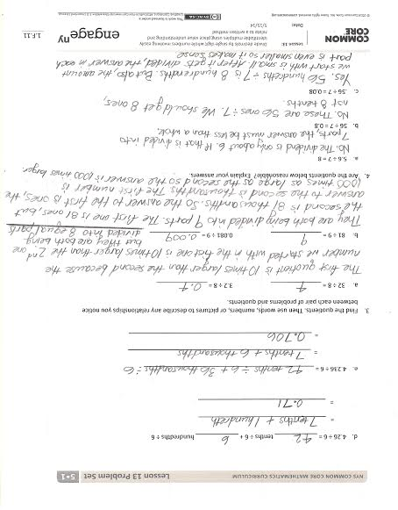Invite students to review their solutions for the Problem Set. They should check work by comparing answers with a partner before going over answers as a class. Look for misconceptions or misunderstandings that can be addressed in the Debrief. Guide students in a conversation to debrief the Problem Set and process the lesson.

Any combination of the questions below may be used to lead the discussion.

* In Problem 2(a), how does your understanding of whole-number division help you solve the equation with a decimal?
* Is there another decomposition of the dividend in Problem 2(c) that could have been useful in dividing by 2? What about in Problem 2(d)? Why or why not?
* When decomposing decimals in different ways, how can you tell which is the most useful? (We are looking for easily identifiable multiples of the divisor.)
* 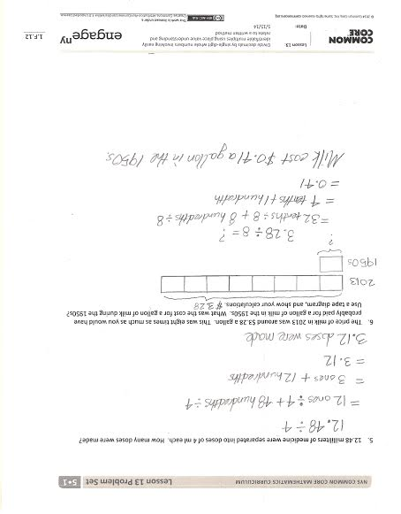In Problem 4(a), what mistake is being made that would produce 5.6 ÷ 7 = 8?
* Change the dividends in Problem 4 so that all of the quotients are correct. Is there a pattern to the changes that you must make?
* 4.221 ÷ 7 = . Explain how you would decompose 4.221 so that you only need knowledge of basic facts to find the quotient.

Exit Ticket (3 minutes)

After the Student Debrief, instruct students to complete the Exit Ticket. A review of their work will help with assessing students’ understanding of the concepts that were presented in today’s lesson and planning more effectively for future lessons. The questions may be read aloud to the students.

Number Correct: _______

**A**

Subtract Decimals

|  |  |  |  |  |  |  |
| --- | --- | --- | --- | --- | --- | --- |
|  | 5 – 1 = |  |  |  | 7.985 – 0.002 = |  |
|  | 5.9 – 1 = |  |  |  | 7.985 – 0.004 = |  |
|  | 5.93 – 1 = |  |  |  | 2.7 – 0.1 = |  |
|  | 5.932 – 1 = |  |  |  | 2.785 – 0.1 = |  |
|  | 5.932 – 2 = |  |  |  | 2.785 – 0.5 = |  |
|  | 5.932 – 4 = |  |  |  | 4.913 – 0.4 = |  |
|  | 0.5 – 0.1 = |  |  |  | 3.58 – 0.01 = |  |
|  | 0.53 – 0.1 = |  |  |  | 3.586 – 0.01 = |  |
|  | 0.539 – 0.1 = |  |  |  | 3.586 – 0.05 = |  |
|  | 8.539 – 0.1 = |  |  |  | 7.982 – 0.04 = |  |
|  | 8.539 – 0.2 = |  |  |  | 6.126 – 0.001 = |  |
|  | 8.539 – 0.4 = |  |  |  | 6.126 – 0.004 = |  |
|  | 0.05 – 0.01 = |  |  |  | 9.348 – 0.006 = |  |
|  | 0.057 – 0.01 = |  |  |  | 8.347 – 0.3 = |  |
|  | 1.057 – 0.01 = |  |  |  | 9.157 – 0.05 = |  |
|  | 1.857 – 0.01 = |  |  |  | 6.879 – 0.009 = |  |
|  | 1.857 – 0.02 = |  |  |  | 6.548 – 2 = |  |
|  | 1.857 – 0.04 = |  |  |  | 6.548 – 0.2 = |  |
|  | 0.005 – 0.001 = |  |  |  | 6.548 – 0.02 = |  |
|  | 7.005 – 0.001 = |  |  |  | 6.548 – 0.002 = |  |
|  | 7.905 – 0.001 = |  |  |  | 6.196 – 0.06 = |  |
|  | 7.985 – 0.001 = |  |  |  | 9.517 – 0.004 = |  |

**B**

**[KEY]**

Number Correct: _______

Improvement: _______

Subtract Decimals

|  |  |  |  |  |  |  |
| --- | --- | --- | --- | --- | --- | --- |
|  | 6 – 1 = |  |  |  | 7.986 – 0.002 = |  |
|  | 6.9 – 1 = |  |  |  | 7.986 – 0.004 = |  |
|  | 6.93 – 1 = |  |  |  | 3.7 – 0.1 = |  |
|  | 6.932 – 1 = |  |  |  | 3.785 – 0.1 = |  |
|  | 6.932 – 2 = |  |  |  | 3.785 – 0.5 = |  |
|  | 6.932 – 4 = |  |  |  | 5.924 – 0.4 = |  |
|  | 0.6 – 0.1 = |  |  |  | 4.58 – 0.01 = |  |
|  | 0.63 – 0.1 = |  |  |  | 4.586 – 0.01 = |  |
|  | 0.639 – 0.1 = |  |  |  | 4.586 – 0.05 = |  |
|  | 8.639 – 0.1 = |  |  |  | 6.183 – 0.04 = |  |
|  | 8.639 – 0.2 = |  |  |  | 7.127 – 0.001 = |  |
|  | 8.639 – 0.4 = |  |  |  | 7.127 – 0.004 = |  |
|  | 0.06 – 0.01 = |  |  |  | 1.459 – 0.006 = |  |
|  | 0.067 – 0.01 = |  |  |  | 8.457 – 0.4 = |  |
|  | 1.067 – 0.01 = |  |  |  | 1.267 – 0.06 = |  |
|  | 1.867 – 0.01 = |  |  |  | 7.981 – 0.001 = |  |
|  | 1.867 – 0.02 = |  |  |  | 7.548 – 2 = |  |
|  | 1.867 – 0.04 = |  |  |  | 7.548 – 0.2 = |  |
|  | 0.006 – 0.001 = |  |  |  | 7.548 – 0.02 = |  |
|  | 7.006 – 0.001 = |  |  |  | 7.548 – 0.002 = |  |
|  | 7.906 – 0.001 = |  |  |  | 7.197 – 0.06 = |  |
|  | 7.986 – 0.001 = |  |  |  | 1.627 – 0.004 = |  |

Name Date

1. Complete the sentences with the correct number of units, and then complete the equation.
2. 4 groups of tenths is 1.6. 1.6 ÷ 4 =
3. 8 groups of hundredths is 0.32. 0.32 ÷ 8 =

1. 7 groups of thousandths is 0.084. 0.084 ÷ 7 =
2. 5 groups of tenths is 2.0. 2.0 ÷ 5 =
3. Complete the number sentence. Express the quotient in units and then in standard form.
4. 4.2 ÷ 7 = tenths ÷ 7 = tenths =
5. 2.64 ÷ 2 = ones ÷ 2 + hundredths ÷ 2

= ones + hundredths

=

1. 12.64 ÷ 2 = ones ÷ 2 + hundredths ÷ 2

= ones + hundredths

=

1. 4.26 ÷ 6 = tenths ÷ 6 + hundredths ÷ 6

=

=

1. 4.236 ÷ 6 =

=

=

1. Find the quotients. Then, use words, numbers, or pictures to describe any relationships you notice between each pair of problems and quotients.
2. 32 ÷ 8 = 3.2 ÷ 8 =
3. 81 ÷ 9 = 0.081 ÷ 9 =
4. Are the quotients below reasonable? Explain your answers.
   1. 5.6 ÷ 7 = 8
   2. 56 ÷ 7 = 0.8
   3. 0.56 ÷ 7 = 0.08
5. 12.48 milliliters of medicine were separated into doses of 4 mL each. How many doses were made?
6. The price of milk in 2013 was around $3.28 a gallon. This was eight times as much as you would have probably paid for a gallon of milk in the 1950s. What was the cost for a gallon of milk during the 1950s? Use a tape diagram, and show your calculations.

Name Date

1. Complete the sentences with the correct number of units, and then complete the equation.
2. 2 groups of tenths is 1.8. 1.8 ÷ 2 =
3. 4 groups of hundredths is 0.32. 0.32 ÷ 4 =
4. 7 groups of thousandths is 0.021. 0.021 ÷ 7 =
5. Complete the number sentence. Express the quotient in unit form and then in standard form.
6. 4.5 ÷ 5 = tenths ÷ 5 = tenths =
7. 6.12 ÷ 6 = ones ÷ 6 + hundredths ÷ 6

= ones + hundredths

=

Name Date

1. Complete the sentences with the correct number of units, and then complete the equation.
2. 3 groups of tenths is 1.5. 1.5 ÷ 3 =
3. 6 groups of hundredths is 0.24. 0.24 ÷ 6 =
4. 5 groups of thousandths is 0.045. 0.045 ÷ 5 =
5. Complete the number sentence. Express the quotient in units and then in standard form.
6. 9.36 ÷ 3 = ones ÷ 3 + hundredths ÷ 3

= ones + hundredths

=

1. 36.012 ÷ 3 = ones ÷ 3 + thousandths ÷ 3

= ones + thousandths

=

1. 3.55 ÷ 5 = tenths ÷ 5 + hundredths ÷ 5

=

=

1. 3.545 ÷ 5 =

=

=

1. Find the quotients. Then, use words, numbers, or pictures to describe any relationships you notice between each pair of problems and quotients.
2. 21 ÷ 7 = 2.1 ÷ 7 =
3. 48 ÷ 8 = 0.048 ÷ 8 =
4. Are the quotients below reasonable? Explain your answers.
   1. 0.54 ÷ 6 = 9
   2. 5.4 ÷ 6 = 0.9
   3. 54 ÷ 6 = 0.09
5. A toy airplane costs $4.84. It costs 4 times as much as a toy car. What is the cost of the toy car?
6. Julian bought 3.9 liters of cranberry juice, and Jay bought 8.74 liters of apple juice. They mixed the two juices together and then poured them equally into 2 bottles. How many liters of juice are in each bottle?