Lesson 14

Objective: Divide decimals with a remainder using place value understanding and relate to a written method.

Suggested Lesson Structure

 Fluency Practice (12 minutes)

 Application Problem (8 minutes)

 Concept Development (30 minutes)

 Student Debrief (10 minutes)

**Total Time (60 minutes)**

Fluency Practice (12 minutes)

* Multiply and Divide by Exponents **5.NBT.2** (3 minutes)
* Round to Different Place Values **5.NBT.4** (3 minutes)
* Find the Quotient **5.NBT.5** (6 minutes)

Multiply and Divide by Exponents (3 minutes)

Materials: (T) Millions to thousandths place value chart (Lesson 1 Template 2) (S) Millions to thousandths place value chart (Lesson 1 Template 2), personal white board

Note: This review fluency helps solidify student understanding of multiplying by 10, 100, and 1,000 in the decimal system.

T: (Project the place value chart from millions to thousandths.) Using the place value chart, write   
65 tenths as a decimal.

S: (Write 6 in the ones column and 5 in the tenths column.)

T: Say the decimal.

S: 6.5

T: Multiply it by 102.

S: (Cross out 6.5 and write 650.)

Repeat the process and sequence for 0.7 102, 0.8 ÷ 102, 3.895 103, and 5,472 ÷ 103.

Round to Different Place Values (3 minutes)

Materials: (S) Personal white board

Note: This review fluency helps solidify student understanding of rounding decimals to different place values.

T: (Project 6.385.) Say the number.

S: 6 and 385 thousandths.

T: On your personal white boards, round the number to the nearest tenth.

S: (Write 6.385 ≈ 6.4.)

Repeat the process, rounding 6.385 and 37.645 to the nearest hundredth.

Find the Quotient (6 minutes)

Materials: (S) Personal white board

Note: Reviewing these skills introduced in Lesson 13 helps students work toward mastery of dividing decimals by single-digit whole numbers.

T: (Write 14 ÷ 2 = ___.) Write the division sentence.

S: 14 ÷ 2 = 7.

T: Say the division sentence in unit form.

S: 14 ones ÷ 2 = 7 ones.

Repeat the process for 1.4 ÷ 2, 0.14 ÷ 2, 24 ÷ 3, 2.4 ÷ 3, 0.24 ÷ 3, 30 ÷ 3, 3 ÷ 3, and 0.3 ÷ 3.

Application Problem (8 minutes)

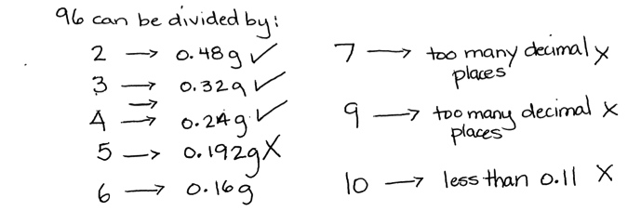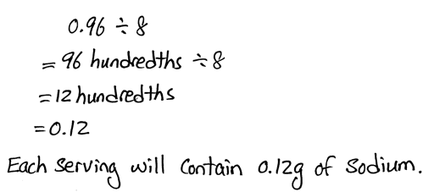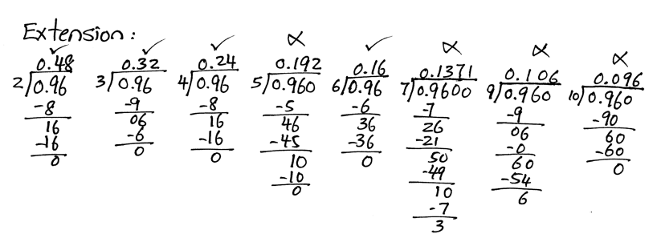

A bag of potato chips contains 0.96 grams of sodium. If the bag is split into 8 equal servings, how many grams of sodium will each serving contain?

Extension: What other ways can the bag be divided into equal servings so that the amount of sodium in each serving has two digits to the right of the decimal and the digits are greater than zero in the tenths and hundredths place?

Note: This Application Problem reviews dividing decimal numbers by a single-digit whole number.

Concept Development (30 minutes)

Materials: (S) Hundreds to thousandths place value chart (Lesson 7 Template), place value disks, personal white board

Problem 1

|  |  |
| --- | --- |
|  | NOTES ON  MULTIPLE MEANS  OF REPRESENTATION: |
| In order to activate prior knowledge, have students solve one or two whole-number division problems using the place value disks. Help them record their work, step by step, in the standard algorithm. This may help students understand that division of whole numbers and the division of decimal fractions are the same concept and process. | |

6.72 ÷ 3 =

5.16 ÷ 4 =

T: (Write 6.72 ÷ 3 = on the board, and draw a place value chart with 3 groups at the bottom.) Show 6.72 on your place value chart using your place value disks. I’ll draw on my chart.

S: (Represent work with the place value disks.)

For the first problem, students show their work with the place value disks. The teacher will represent the work in a drawing and in the algorithm. In Problems 2 and 3 of the Concept Development, students may draw instead of using the disks.

T: Let’s begin with our largest units. We will share 6 ones equally with 3 groups. How many ones are in each group?

S: 2 ones. (Move the place value disks to show the distribution.)

T: (Draw 2 place value disks in each group, and cross off in the dividend as they are shared.) We gave each group 2 ones. (In the algorithm, record 2 in the ones place in the quotient.) How many ones did we share in all?

S: 6 ones.

T: (Show the subtraction in the algorithm.) How many ones are left to share?

S: 0 ones.

T: Let’s share our tenths. 7 tenths divided by 3. How many tenths can we share with each group?

S: 2 tenths.

T: Using your place value disks, share your tenths. I’ll show what we did on my place value chart and in my written work. (Draw to share and cross off in the dividend. Record in the algorithm.)

S: (Move the place value disks.)

T: (Record 2 in the tenths place in the quotient.) How many tenths did we share in all?

S: 6 tenths.

T: (Record subtraction.) Let’s stop here a moment. Why are we subtracting the 6 tenths?

S: We have to take away the tenths we have already shared. 🡪 We distributed the 6 tenths into   
3 groups, so we have to subtract them.

T: Since we shared 6 tenths in all, how many tenths are left to share?

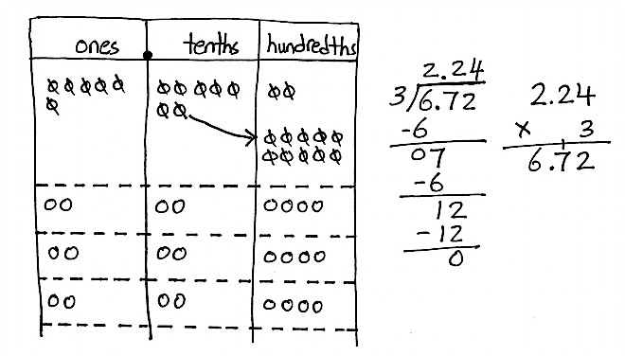S: 1 tenth.

**MP.6**

T: Can we share 1 tenth with 3 groups?

S: No.

T: What can we do to keep sharing?

S: We can change 1 tenth for 10 hundredths.

T: Make that exchange on your place value chart.   
I’ll record.

T: How many hundredths do we have now?

S: 12 hundredths.

T: Can we share 12 hundredths with 3 groups? If so, how many hundredths can we share with each group?

|  |  |
| --- | --- |
|  | NOTES ON  MULTIPLE MEANS  OF ACTION AND EXPRESSION: |
| Students should have the opportunity to use tools that will enhance their understanding. In math class, this often means using manipulatives. Communicate to students that the journey from concrete understanding to representational understanding (drawings) to abstraction is rarely a linear one. Create a learning environment in which students feel comfortable returning to concrete manipulatives when problems are challenging. Throughout this module, the place value disks should be readily available to all learners. | |

S: Yes. We can give 4 hundredths to each group.

T: Share your hundredths, and I’ll record.

T: (Record 4 hundredths in the quotient.) Each group received 4 hundredths. How many hundredths did we share in all?

S: 12 hundredths.

T: (Record subtraction.) Remind me why we subtract these 12 hundredths. How many hundredths are left?

S: We subtract because those 12 hundredths have been shared. 🡪 They are now divided into the groups, so we have to subtract. 12 hundredths minus   
12 hundredths is equal to 0 hundredths.

T: Look at the 3 groups you made. How many are in each group?

S: 2 and 24 hundredths.

T: Do we have any other units to share?

S: No.

T: How is the division we did with decimal units like whole-number division? Turn and talk.

S: It’s the same as dividing whole numbers, except we are sharing units smaller than ones. 🡪 Our quotient has a decimal point because we are sharing fractional units. The decimal shows where the ones place is. 🡪 Sometimes we have to change the decimal units just like we change the whole-number units in order to continue dividing.

T: (Write 5.16 ÷ 4 = ___ on the board.) Let’s switch jobs for this problem. I will use place value disks. You record using the algorithm.

Follow the questioning sequence from above. Students record the steps of the algorithm as the teacher models using the place value disks.

Problem 2

6.72 ÷ 4 =

20.08 ÷ 8 =

T: (Write 6.72 ÷ 4 = on the board.) Using the place value chart, solve this problem with your partner. Partner A will draw the place value disks, and Partner B will record all steps using the standard algorithm.

S: (Work to solve.)

T: Compare the drawing to the algorithm. Match each number to its counterpart in the drawing.

Circulate to ensure that students are using their whole-number experiences with division to share decimal units. Check for misconceptions in recording. For the second problem in the set, partners should switch roles.

Problem 3

6.372 ÷ 6 =

T: (Write 6.372 ÷ 6 = on the board.) Work independently using the standard algorithm to solve.

S: (Work to solve.)

T: Compare your quotient with your partner’s. How is this problem different from the ones in the other Problem Sets? Turn and talk.

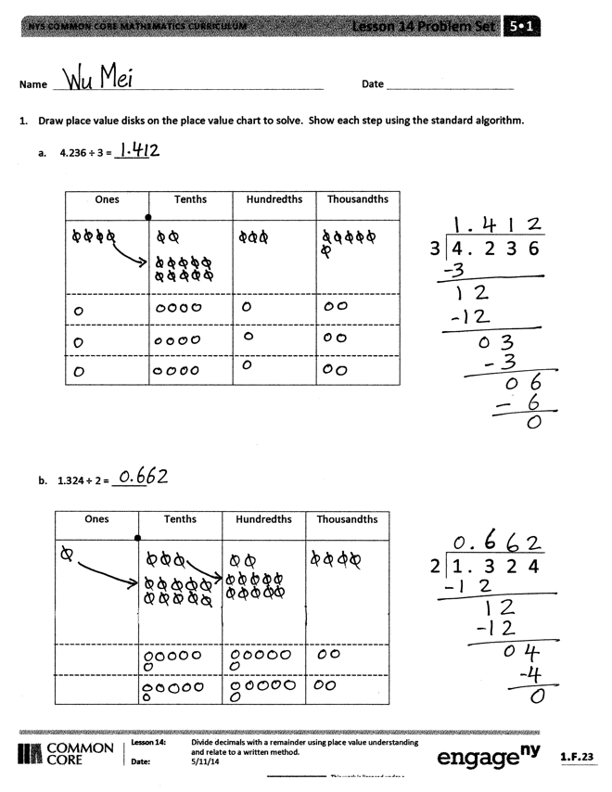Problem Set (10 minutes)

Students should do their personal best to complete the Problem Set within the allotted 10 minutes. For some classes, it may be appropriate to modify the assignment by specifying which problems they work on first. Some problems do not specify a method for solving. Students solve these problems using the RDW approach used for Application Problems.

Student Debrief (10 minutes)

**Lesson Objective:** Divide decimals with a remainder using place value understanding and relate to a written method**.**

The Student Debrief is intended to invite reflection and active processing of the total lesson experience.

Invite students to review their solutions for the Problem Set. They should check work by comparing answers with a partner before going over answers as a class. Look for misconceptions or misunderstandings that can be addressed in the Debrief. Guide students in a conversation to debrief the Problem Set and process the lesson.

Any combination of the questions below may be used to lead the discussion.

* 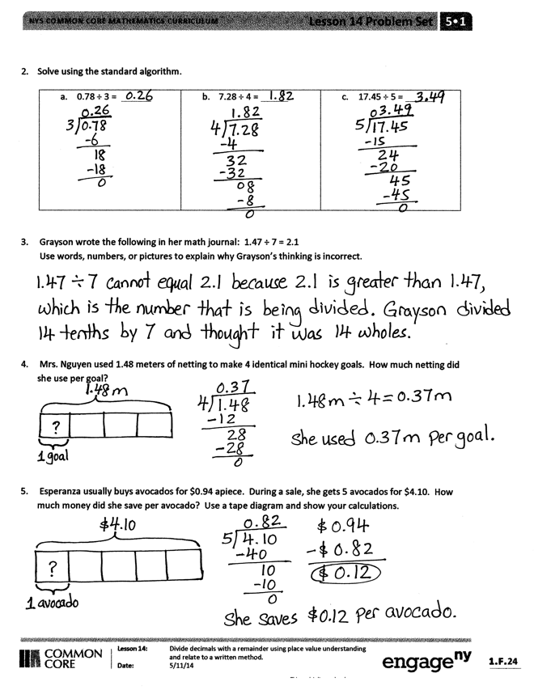How are dividing decimals and dividing whole numbers similar? How are they different?
* Look at the quotients in Problems 1(a) and 1(b). What do you notice about the values in each of the ones places? Explain why Problem 1(b) has a zero in the ones place.
* Explain your approach to Problem 5. (Because this is a multi-step problem, students may have arrived at the solution through different means. Some may have divided $4.10 by 5 and compared the quotient to the regularly priced avocado. Others may first multiply the regular price, $0.94, by 5, subtract $4.10 from that product, and then divide the difference by 5. Both approaches will result in a correct answer of $0.12 saved per avocado.)

Exit Ticket (3 minutes)

After the Student Debrief, instruct students to complete the Exit Ticket. A review of their work will help with assessing students’ understanding of the concepts that were presented in today’s lesson and planning more effectively for future lessons. The questions may be read aloud to the students.

Name Date

1. Draw place value disks on the place value chart to solve. Show each step using the standard algorithm.
2. 4.236 ÷ 3 = ______

|  |  |  |  |
| --- | --- | --- | --- |
| Ones | Tenths | Hundredths | Thousandths |
|  |  |  |  |

|  |  |  |  |  |
| --- | --- | --- | --- | --- |
|  |  |  |  |  |
| 3 | 4 . | 2 | 3 | 6 |
|  |  |  |  |  |

1. 1.324 ÷ 2 = ______

|  |  |  |  |
| --- | --- | --- | --- |
| Ones | Tenths | Hundredths | Thousandths |
|  |  |  |  |

|  |  |  |  |  |
| --- | --- | --- | --- | --- |
|  |  |  |  |  |
| 2 | 1 . | 3 | 2 | 4 |
|  |  |  |  |  |

1. Solve using the standard algorithm.

|  |  |  |
| --- | --- | --- |
| 1. 0.78 ÷ 3 = | 1. 7.28 ÷ 4 = | 1. 17.45 ÷ 5 = |

1. Grayson wrote 1.47 ÷ 7 = 2.1 in her math journal.

Use words, numbers, or pictures to explain why Grayson’s thinking is incorrect.

1. Mrs. Nguyen used 1.48 meters of netting to make 4 identical mini hockey goals. How much netting did she use per goal?
2. Esperanza usually buys avocados for $0.94 apiece. During a sale, she gets 5 avocados for $4.10. How much money did she save per avocado? Use a tape diagram, and show your calculations.

Name Date

1. Draw place value disks on the place value chart to solve. Show each step using the standard algorithm.

5.372 ÷ 2 =

|  |  |  |  |  |
| --- | --- | --- | --- | --- |
|  |  |  |  |  |
| 2 | 5 . | 3 | 7 | 2 |
|  |  |  |  |  |

|  |  |  |  |
| --- | --- | --- | --- |
| Ones | Tenths | Hundredths | Thousandths |
|  |  |  |  |

1. Solve using the standard algorithm.

0.576 ÷ 4 =

Name Date

1. Draw place value disks on the place value chart to solve. Show each step using the standard algorithm.
2. 5.241 ÷ 3 =

|  |  |  |  |
| --- | --- | --- | --- |
| Ones | Tenths | Hundredths | Thousandths |
|  |  |  |  |

|  |  |  |  |  |
| --- | --- | --- | --- | --- |
|  |  |  |  |  |
| 3 | 5 . | 2 | 4 | 1 |
|  |  |  |  |  |

1. 5.372 ÷ 4 =

|  |  |  |  |  |
| --- | --- | --- | --- | --- |
|  |  |  |  |  |
| 4 | 5 . | 3 | 7 | 2 |
|  |  |  |  |  |

|  |  |  |  |
| --- | --- | --- | --- |
| Ones | Tenths | Hundredths | Thousandths |
|  |  |  |  |

1. Solve using the standard algorithm.

|  |  |  |
| --- | --- | --- |
| 1. 0.64 ÷ 4 = | 1. 6.45 ÷ 5 = | 1. 16.404 ÷ 6 = |

1. Mrs. Mayuko paid $40.68 for 3 kg of shrimp. What’s the cost of 1 kilogram of shrimp?
2. The total weight of 6 pieces of butter and a bag of sugar is 3.8 lb. If the weight of the bag of sugar is   
   1.4 lb, what is the weight of each piece of butter?