Lesson 15

Objective: Divide decimals using place value understanding, including remainders in the smallest unit.

Suggested Lesson Structure

 Fluency Practice (12 minutes)

 Application Problem (8 minutes)

 Concept Development (30 minutes)

 Student Debrief (10 minutes)

**Total Time (60 minutes)**

Fluency Practice (12 minutes)

* Sprint: Multiply by Exponents **5.NBT.2** (8 minutes)
* Find the Quotient **5.NBT.7** (4 minutes)

Sprint: Multiply by Exponents (8 minutes)

Materials: (S) Multiply by Exponents Sprint

Note: This Sprint helps students build automaticity in multiplying decimals by 101, 102, 103, and 104.

Find the Quotient (4 minutes)

Materials: (S) Millions to thousandths place value chart (Lesson 1 Template 2), personal white board

Note: This review fluency drill helps students work toward mastery of dividing decimals using concepts introduced in Lesson 14.

T: (Project the place value chart showing ones, tenths, and hundredths. Write 0.48 ÷ 2 = __.) On your place value chart, draw 48 hundredths using place value disks. (Allow students time to draw.)

T: (Write 48 hundredths ÷ 2 = __ hundredths = __ tenths __ hundredths.) Solve the division problem.

S: (Write 48 hundredths ÷ 2 = 24 hundredths = 2 tenths 4 hundredths.)

T: Solve using the standard algorithm.

Repeat the process for 0.42 ÷ 3, 3.52 ÷ 2, and 96 tenths ÷ 8.

Application Problem (8 minutes)

|  |  |
| --- | --- |
|  | NOTES ON  MULTIPLE MEANS  OF REPRESENTATION: |
| Tape diagrams are a form of modeling that offers students a way to organize, prioritize, and contextualize information in story problems. Students create pictures, represented in bars, from the words in the story problems. Once bars are drawn and the unknown identified, students can find viable solutions. | |

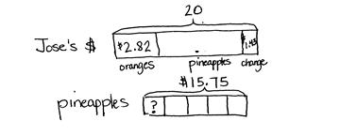Jose bought a bag of 6 oranges for $2.82. He also bought   
5 pineapples. He gave the cashier $20 and received $1.43 change. How much did each pineapple cost?

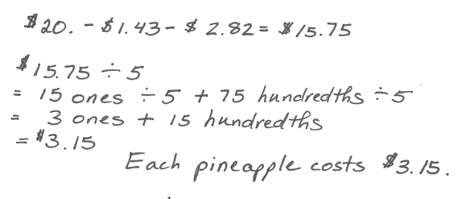

Note: This multi-step problem requires several skills taught in this module, such as multiplying decimal numbers by single-digit whole numbers, subtraction of decimal numbers, and division of decimal numbers. Working with these three operations helps activate prior knowledge and helps scaffold today’s lesson on decimal division. Labeling the tape diagram as a class may be a beneficial scaffold for some learners.

Concept Development (30 minutes)

Materials: (S) Hundreds to thousandths place value chart (Lesson 7 Template), personal white board

|  |  |
| --- | --- |
|  | NOTES ON  MULTIPLE MEANS  OF REPRESENTATION: |
| In this lesson, students will need to know that a number can be written in multiple ways. In order to activate prior knowledge and heighten interest, the teacher may display a dollar bill while writing $1 on the board. The class could discuss that, in order for the dollar to be divided between two people, it must be thought of as tenths: ($1.0). Additionally, if the dollar were to be divided by more than 10 people, it would be thought of as hundredths: $1.00. If students need additional support, this could be demonstrated using concrete materials. | |

Problems 1–2

1.7 ÷ 2

2.6 ÷ 4

T: (Write 1.7 ÷ 2 on the board, and draw a place value chart.) Show 1.7 on your place value chart by drawing place value disks.



For this problem, students are only using the place value chart and drawing the place value disks. However, the teacher should record the standard algorithm and draw the place value disks as each unit is decomposed and shared.

T: Let’s begin with our largest unit. Can 1 one be divided into 2 groups?

S: No.

T: Each group gets how many ones?

S: 0 ones.

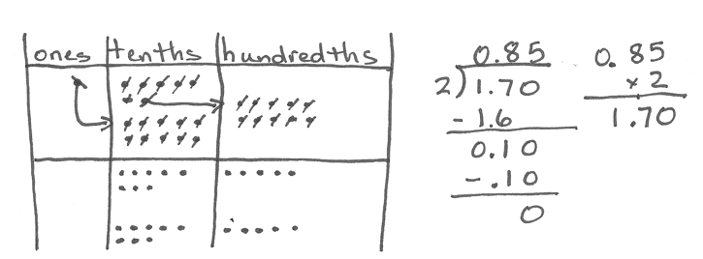T: (Record 0 in the ones place of the quotient in the algorithm.) We need to keep sharing. How can we share this single ones disk?

S: Unbundle it or exchange it for 10 tenths.

T: Draw that unbundling, and tell me how many tenths we have now.

S: 17 tenths.

T: 17 tenths divided by 2. How many tenths can we put in each group?

S: 8 tenths.

T: Cross them off as you divide them into 2 equal groups.

S: (Cross out tenths and share them in 2 groups.)

T: (Record 8 tenths in the quotient in the algorithm.) How many tenths did we share in all?

S: 16 tenths.

T: (Record 16 tenths in the algorithm.) Explain to your partner why we are subtracting the 16 tenths.

S: (Discuss.)

T: How many tenths are left?

S: 1 tenth.

T: (Record the subtraction in the algorithm.) Is there a way for us to keep sharing? Turn and talk.

S: We can make 10 hundredths with 1 tenth. 🡪 Yes. 1 tenth is still equal to 10 hundredths, even though there is no digit in the hundredths place in 1.7. 🡪 We can think about 1 and 7 tenths as   
1 and 70 hundredths. They are equal.

T: Unbundle the 1 tenth to make 10 hundredths.

S: (Unbundle and draw.)

T: Have you changed the value of what we needed to share? Explain.

S: No. It’s the same amount to share, but we are using smaller units. 🡪 The value is the same. 1 tenth is the same as 10 hundredths.

T: I can show this by placing a zero in the hundredths place. (Record the 0 in the hundredths place of the algorithm. 1 tenth becomes 10 hundredths.)

T: Now that we have 10 hundredths, can we divide this between our 2 groups? How many hundredths are in each group?

S: Yes. 5 hundredths are in each group.

T: Let’s cross them off as you divide them into 2 equal groups.

S: (Work.)

T: (Record 5 hundredths in the quotient in the algorithm.) How many hundredths did we share in all?

S: 10 hundredths.

T: (Record 10 hundredths in the algorithm.) How many hundredths are left?

S: 0 hundredths.

T: (Record the subtraction in the algorithm.) Do we have any other units that we need to share?

S: No.

T: Tell me the quotient in unit form and then in standard form.

S: 0 ones 8 tenths 5 hundredths: 85 hundredths. 0.85.

T: (Show 6.72 ÷ 3 = 2.24 recorded in the standard algorithm and 1.7 ÷ 2 = 0.85 recorded in the standard algorithm side by side.) Compare these two problems. How do they differ? Turn and share with your partner.

S: One equation has a divisor of 3, and the other equation has a divisor of 2. 🡪 Both quotients have   
2 decimal places. 6.72 has digits in the tenths and hundredths, and 1.7 only has a digit in the tenths. 🡪 In order to divide 1.7, we have to think about our dividend as 1 and 70 hundredths to keep sharing.

T: That’s right! In today’s problem, we had to record a zero in the hundredths place to show how we unbundled. Did recording that zero change the amount that we had to share—1 and 7 tenths? Why or why not?

S: No, because 1 and 70 hundredths is the same amount as 1 and 7 tenths.

For the next problem (2.6 ÷ 4), repeat this sequence. Model the process on the place value chart while students record the steps of the algorithm. Stop along the way to make connections between the concrete materials and the written method.

Problems 3–4

17 ÷ 4

22 ÷ 8

T: (Write 17 ÷ 4 on the board.) Look at this expression. What do you notice? Turn and share with your partner.

S: When we divide 17 into 4 groups, we have a remainder.

T: In fourth grade, we recorded this remainder as R1. What have we done today that lets us keep sharing this remainder?

S: We can unbundle the ones into tenths or hundredths and continue to divide.

T: With your partner, use the place value chart to solve this problem. Partner A will draw the place value disks, and Partner B will solve using the standard algorithm.

S: (Solve.)

T: Compare your work. Match each number in the algorithm with its counterpart in the drawing.

Circulate to ensure that students are using their whole-number experiences with division to share decimal units. Check for misconceptions in recording. For the second problem in the set, partners should switch roles.

Problem 5

7.7 ÷ 4

T: (Write 7.7 ÷ 4 = _______ on the board.) Solve independently, using the standard algorithm.

S: (Solve.)

T: Compare your answer with your partner’s.

Problem 6

0.84 ÷ 4

T: (Write 0.84 ÷ 4 = _______ on the board.) Solve independently, using the standard algorithm.

S: (Solve.)

T: Compare your answer with your neighbor’s.

Problem Set (10 minutes)

Students should do their personal best to complete the Problem Set within the allotted 10 minutes. For some classes, it may be appropriate to modify the assignment by specifying which problems they work on first. Some problems do not specify a method for solving. Students should solve these problems using the RDW approach used for Application Problems.

Student Debrief (10 minutes)

**Lesson Objective:** Divide decimals using place value understanding, including remainders in the smallest unit.

The Student Debrief is intended to invite reflection and active processing of the total lesson experience.

Invite students to review their solutions for the Problem Set. They should check work by comparing answers with a partner before going over answers as a class. Look for misconceptions or misunderstandings that can be addressed in the Debrief. Guide students in a conversation to debrief the Problem Set and process the lesson.

Any combination of the questions below may be used to lead the discussion.

* 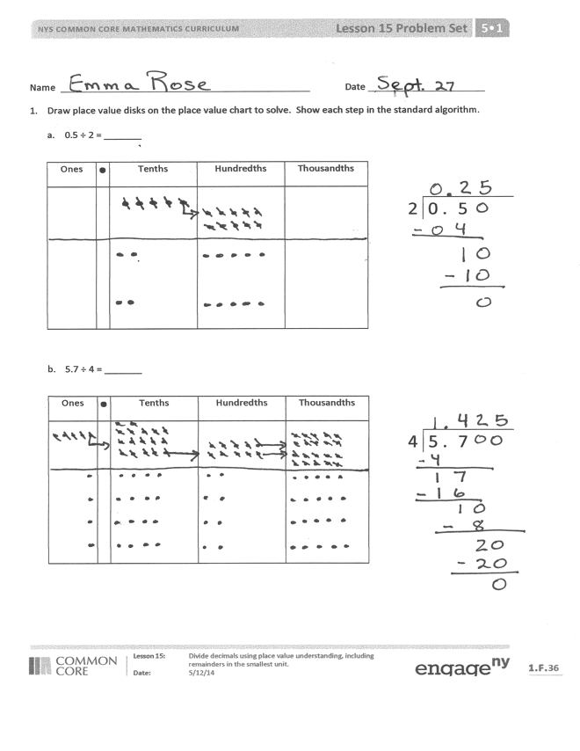In Problems 1(a) and 1(b), which division strategy did you find more efficient­­­—drawing place value disks or using the algorithm?
* How are Problems 2(c) and 2(f) different from the others? Will a whole number divided by a whole number always result in a whole number?
* Explain why these problems resulted in a decimal quotient.
* Take out the Problem Set from Lesson 14. Compare and contrast the first page of each assignment. Talk about what you notice.
* Take a look at Problem 2(f). What was different about how you solved this problem?
* When you solved Problem 4, what did you notice about the units used to measure the juice? (Students may not have recognized that the orange juice was measured in milliliters.) How do we proceed if we have unlike units?

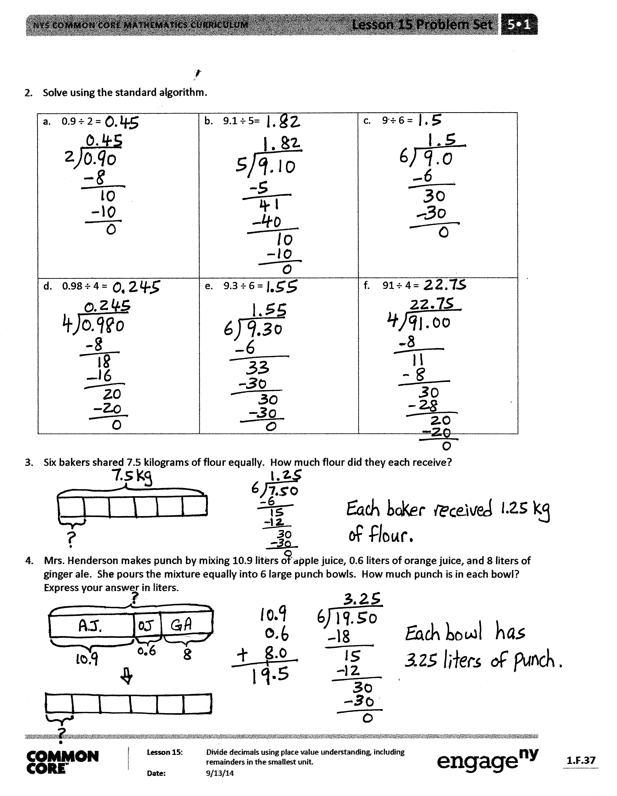Exit Ticket (3 minutes)

After the Student Debrief, instruct students to complete the Exit Ticket. A review of their work will help with assessing students’ understanding of the concepts that were presented in today’s lesson and planning more effectively for future lessons. The questions may be read aloud to the students.

Number Correct: _______

**A**

Multiply by Exponents

|  |  |  |  |  |  |  |
| --- | --- | --- | --- | --- | --- | --- |
|  | 10 × 10 = |  |  |  | 24 × 102 = |  |
|  | 102 = |  |  |  | 24.7 × 102 = |  |
|  | 102 × 10 = |  |  |  | 24.07 × 102 = |  |
|  | 103 = |  |  |  | 24.007 × 102 = |  |
|  | 103 × 10 = |  |  |  | 53 × 1,000 = |  |
|  | 104 = |  |  |  | 53 × 103 = |  |
|  | 3 × 100 = |  |  |  | 53.8 × 103 = |  |
|  | 3 × 102 = |  |  |  | 53.08 × 103 = |  |
|  | 3.1 × 102 = |  |  |  | 53.082 × 103 = |  |
|  | 3.15 × 102 = |  |  |  | 9.1 × 10,000 = |  |
|  | 3.157 × 102 = |  |  |  | 9.1 × 104 = |  |
|  | 4 × 1,000 = |  |  |  | 91.4 × 104 = |  |
|  | 4 × 103 = |  |  |  | 91.104 × 104 = |  |
|  | 4.2 × 103 = |  |  |  | 91.107 × 104 = |  |
|  | 4.28 × 103 = |  |  |  | 1.2 × 102 = |  |
|  | 4.283 × 103 = |  |  |  | 0.35 × 103 = |  |
|  | 5 × 10,000 = |  |  |  | 5.492 × 104 = |  |
|  | 5 × 104 = |  |  |  | 8.04 × 103 = |  |
|  | 5.7 × 104 = |  |  |  | 7.109 × 104 = |  |
|  | 5.73 × 104 = |  |  |  | 0.058 × 102 = |  |
|  | 5.731 × 104 = |  |  |  | 20.78 × 103 = |  |
|  | 24 × 100 = |  |  |  | 420.079 × 102 = |  |

**B**

**[KEY]**

Number Correct: _______

Improvement: _______

Multiply by Exponents

|  |  |  |  |  |  |  |
| --- | --- | --- | --- | --- | --- | --- |
|  | 10 × 10 × 1 = |  |  |  | 42 × 102 = |  |
|  | 102 = |  |  |  | 42.7 × 102 = |  |
|  | 102 × 10 = |  |  |  | 42.07 × 102 = |  |
|  | 103 = |  |  |  | 42.007 × 102 = |  |
|  | 103 × 10 = |  |  |  | 35 × 1,000 = |  |
|  | 104 = |  |  |  | 35 × 103 = |  |
|  | 4 × 100 = |  |  |  | 35.8 × 103 = |  |
|  | 4 × 102 = |  |  |  | 35.08 × 103 = |  |
|  | 4.1 × 102 = |  |  |  | 35.082 × 103 = |  |
|  | 4.15 × 102 = |  |  |  | 8.1 × 10,000 = |  |
|  | 4.157 × 102 = |  |  |  | 8.1 × 104 = |  |
|  | 5 × 1,000 = |  |  |  | 81.4 × 104 = |  |
|  | 5 × 103 = |  |  |  | 81.104 × 104 = |  |
|  | 5.2 × 103 = |  |  |  | 81.107 × 104 = |  |
|  | 5.28 × 103 = |  |  |  | 1.3 × 102 = |  |
|  | 5.283 × 103 = |  |  |  | 0.53 × 103 = |  |
|  | 7 × 10,000 = |  |  |  | 4.391 × 104 = |  |
|  | 7 × 104 = |  |  |  | 7.03 × 103 = |  |
|  | 7.5 × 104 = |  |  |  | 6.109 × 104 = |  |
|  | 7.53 × 104 = |  |  |  | 0.085 × 102 = |  |
|  | 7.531 × 104 = |  |  |  | 30.87 × 103 = |  |
|  | 42 × 100 = |  |  |  | 530.097 × 102 = |  |

Name Date

1. Draw place value disks on the place value chart to solve. Show each step in the standard algorithm.
2. 0.5 ÷ 2 = _______

|  |  |  |  |  |
| --- | --- | --- | --- | --- |
| Ones |  | Tenths | Hundredths | Thousandths |
|  |  |  |  |  |

|  |  |  |  |  |
| --- | --- | --- | --- | --- |
|  |  |  |  |  |
| 2 | 0 . | 5 |  |  |
|  |  |  |  |  |

1. 5.7 ÷ 4 = _______

|  |  |  |  |  |
| --- | --- | --- | --- | --- |
| Ones |  | Tenths | Hundredths | Thousandths |
|  |  |  |  |  |

|  |  |  |  |  |
| --- | --- | --- | --- | --- |
|  |  |  |  |  |
| 4 | 5 . | 7 |  |  |
|  |  |  |  |  |

1. Solve using the standard algorithm.

|  |  |  |
| --- | --- | --- |
| 1. 0.9 ÷ 2 = | 1. 9.1 ÷ 5 = | 1. 9 ÷ 6 = |
| 1. 0.98 ÷ 4 = | 1. 9.3 ÷ 6 = | 1. 91 ÷ 4 = |

1. Six bakers shared 7.5 kilograms of flour equally. How much flour did they each receive?
2. Mrs. Henderson makes punch by mixing 10.9 liters of apple juice, 0.6 liters of orange juice, and 8 liters of ginger ale. She pours the mixture equally into 6 large punch bowls. How much punch is in each bowl? Express your answer in liters.

Name Date

1. Draw place value disks on the place value chart to solve. Show each step in the standard algorithm.

0.9 ÷ 4 = _______

|  |  |  |  |  |
| --- | --- | --- | --- | --- |
| Ones |  | Tenths | Hundredths | Thousandths |
|  |  |  |  |  |

|  |  |  |  |  |
| --- | --- | --- | --- | --- |
|  |  |  |  |  |
| 4 | 0 . | 9 |  |  |
|  |  |  |  |  |

1. Solve using the standard algorithm.

9.8 ÷ 5 =

Name Date

1. Draw place value disks on the place value chart to solve. Show each step in the standard algorithm.
2. 0.7 ÷ 4 = _______

|  |  |  |  |  |
| --- | --- | --- | --- | --- |
| Ones |  | Tenths | Hundredths | Thousandths |
|  |  |  |  |  |

|  |  |  |  |  |
| --- | --- | --- | --- | --- |
|  |  |  |  |  |
| 4 | 0 . | 7 |  |  |
|  |  |  |  |  |

|  |  |  |  |  |
| --- | --- | --- | --- | --- |
|  |  |  |  |  |
| 5 | 8 . | 1 |  |  |

1. 8.1 ÷ 5 = _______

|  |  |  |  |  |
| --- | --- | --- | --- | --- |
| Ones |  | Tenths | Hundredths | Thousandths |
|  |  |  |  |  |

1. Solve using the standard algorithm.

|  |  |  |
| --- | --- | --- |
| 1. 0.7 ÷ 2 = | 1. 3.9 ÷ 6 = | 1. 9 ÷ 4 = |
| 1. 0.92 ÷ 2 = | 1. 9.4 ÷ 4 = | 1. 91 ÷ 8 = |

1. A rope 8.7 meters long is cut into 5 equal pieces. How long is each piece?
2. Yasmine bought 6 gallons of apple juice. After filling up 4 bottles of the same size with apple juice, she had 0.3 gallon of apple juice left. How many gallons of apple juice are in each container?