Lesson 16

Objective: Solve word problems using decimal operations.

Suggested Lesson Structure

 Fluency Practice (12 minutes)

 Application Problem (7 minutes)

 Concept Development (31 minutes)

 Student Debrief (10 minutes)

**Total Time (60 minutes)**

Fluency Practice (12 minutes)

* Sprint: Multiply and Divide by Exponents **5.NBT.2** (8 minutes)
* Find the Quotient **5.NBT.7** (4 minutes)

Sprint: Multiply and Divide by Exponents (8 minutes)

Materials: (S) Multiply and Divide by Exponents Sprint

Note: This Sprint helps students build automaticity in dividing decimals by 101, 102, 103, and 104.

Find the Quotient (4 minutes)

Materials: (S) Hundreds through thousandths place value chart (Lesson 7 Template), personal white board

Note: This review fluency drill helps students work toward mastery of dividing decimals using concepts introduced in Lesson 15.

T: (Project the place value chart showing ones, tenths, and hundredths. Write 0.3 ÷ 2 = __.) Use place value disks to draw 3 tenths on your place value chart. (Allow students time to draw.)

T: (Write 3 tenths ÷ 2 = __ hundredths ÷ 2 = __ tenths __ hundredths on the board.) Solve the division problem.

S: (Write 3 tenths ÷ 2 = 30 hundredths ÷ 2 = 1 tenth 5 hundredths.)

T: (Write the algorithm below 3 tenths ÷ 2 = 30 hundredths ÷ 2 = 1 tenth 5 hundredths.) Solve using the standard algorithm. (Allow students time to solve.)

Repeat the process for 0.9 ÷ 5, 6.7 ÷ 5, 0.58 ÷ 4, and 93 tenths ÷ 6.

Application Problem (7 minutes)

Jesse and three friends buy snacks for a hike. They buy trail mix for $5.42, apples for $2.55, and granola bars for $3.39. If the four friends split the cost of the snacks equally, how much should each friend pay?

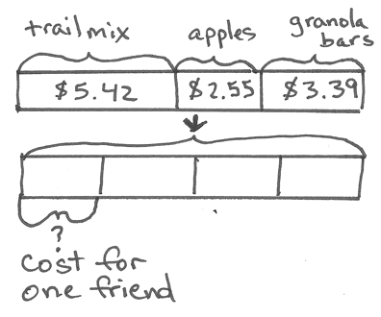

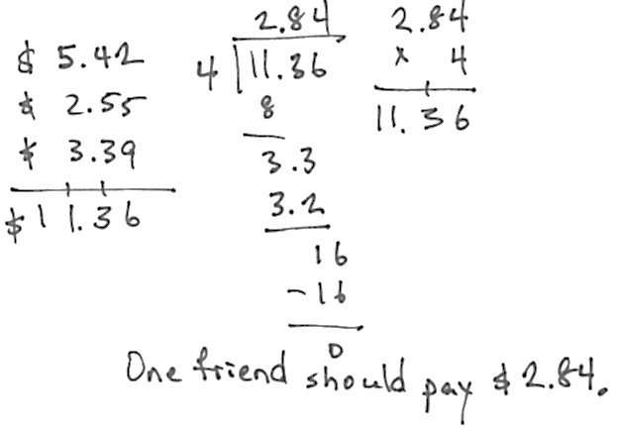

Note: Adding and dividing decimals are taught in this module. Teachers may choose to help students draw the tape diagram before students do the calculations independently.

Concept Development (31 minutes)

Materials: (T/S) Problem Set, pencil

Problem 1

Mr. Frye distributed $126 equally among his 4 children for their weekly allowance. How much money did each child receive?

As the teacher creates each component of the tape diagram, students should re-create the tape diagram on their Problem Sets.

T: We will solve Problem 1 on the Problem Set together. (Project the problem on the board.) Read the word problem together.

S: (Read chorally.)

T: Who and what is this problem about? Let’s identify our variables.

S: Mr. Frye’s money.

T: Draw a bar to represent Mr. Frye’s money. (Draw a rectangle on the board.)

*Mr. Frye’s Money*

T: Let’s read the problem sentence by sentence and adjust our diagram to match the information in the problem. Read the first sentence together.

S: (Read.)

T: What is the important information in the first sentence? Turn and talk.

S: $126 and 4 children received an equal amount.

T: (Underline the stated information.) How can I represent this information in my diagram?

S: 126 dollars is the total, so put a bracket on top of the bar, and label it.

T: (Draw a bracket over the diagram and label as $126. Have students label their diagrams.)

*Mr. Frye’s Money*

*$126*

|  |  |
| --- | --- |
|  | NOTES ON  MULTIPLE MEANS  OF REPRESENTATION: |
| Students may use various approaches for calculating the quotient. Some may use place value units 12 tens + 60 tenths. Others may use the division algorithm. Comparing computation strategies may help students develop their mathematical thinking. | |

T: How many children share the 126 dollars?

S: 4 children.

T: How can we represent this information?

S: Divide the bar into 4 equal parts.

T: (Partition the diagram into 4 equal sections, and have students do the same.)

*Mr. Frye’s Money*

*$126*

|  |  |
| --- | --- |
|  | NOTES ON  MULTIPLE MEANS  OF ENGAGEMENT: |
| If students struggle to draw a model of word problems involving division with decimal values, scaffold their understanding by modeling an analogous problem substituting simpler, whole-number values. Then, using the same tape diagram, erase the whole-number values, and replace them with the parallel values from the decimal problem. | |

T: What is the question?

S: How much did each child receive?

T: What is unknown in this problem? How will we represent it in our diagram?

S: The amount of money one of Mr. Frye’s children received for allowance is what we are trying to find. We should put a question mark inside one of the parts.

T: (Write a question mark inside one section of the tape diagram.)

*Mr. Frye’s Money*

*$126*

?

T: Make a unit statement about your diagram. How many unit bars are equal to $126?

S: Four units is the same as $126.

T: How can we find the value of one unit?

S: Divide $126 by 4. 🡪 Use division because we have a whole that we are sharing equally.

T: What is the expression that will give us the amount that each child received?

S: $126 ÷ 4.

T: Solve and express your answer in a complete sentence.

*Mr. Frye’s Money*

*$126*

?

4 units = $126

1 unit = ?

1 unit = $126 ÷ 4

= $31.50

S: Each child received $31.50 for his weekly allowance.

T: Read Part (b) of Problem 1, and solve using a tape diagram.

S: (Work for 5 minutes.)

As students are working, circulate and be attentive to accuracy and labeling of information in the students’ tape diagrams. Refer to the example student work on the Problem Set for one example of an accurate tape diagram.

Problem 4

Brandon mixed 6.83 lb of cashews with 3.57 lb of pistachios. After filling up 6 bags that were the same size with the mixture, he had 0.35 lb of nuts left. What was the weight of each bag?

T: (Project Problem 4.) Read the problem. Identify the variables (who and what), and draw a bar.

S: (Read and draw. Draw a bar on the board.)

*Brandon’s Cashews and Pistachios*

T: Read the first sentence.

S: (Read.)

T: What is the important information in this sentence? Tell a partner.

S: 6.83 lb of cashews and 3.57 lb of pistachios.

T: (Underline the stated information.) How can I represent this information in the tape diagram?

**MP.8**

S: Show two parts inside the bar.

T: Should the parts be equal in size?

S: No. The cashews part should be about twice the size of the pistachios part.

*Brandon’s Cashews/Pistachios*

*3.57*

*6.83*

T: (Draw and label.) Let’s read the next sentence. How will we represent this part of the problem?

S: We could draw another bar to represent both kinds of nuts together. Then, split the bar into parts to show the bags and the part that was left over. 🡪 We could erase the bar separating the nuts, put the total on the bar we already drew, and split it into the equal parts. We would have to remember he had some nuts left over.

T: Both are good ideas. Choose one for your model. I am going to use the bar that I’ve already drawn. I’ll label my bags with the letter *b*, and I’ll label the part that wasn’t put into a bag.

T: (Erase the bar between the types of nuts. Draw a bracket over the bar, and write the total. Show the leftover nuts and the 6 bags.)

*Brandon’s Cashews/Pistachios*

b

*10.4*

*0.35*

left

b

b

b

b

|  |  |
| --- | --- |
|  | NOTES ON  MULTIPLE MEANS  OF REPRESENTATION: |
| Complex relationships within a tape diagram can be made clearer to students with the use of color. The bags of cashews in Problem 4 could be made more visible by outlining the bagged nuts in red. This creates a classic part–part–whole problem. Students can readily see the portion that must be subtracted in order to produce the portion divided into 6 bags.  If using color to highlight relationships is still too abstract for students, colored paper can be cut, marked, and manipulated.  Thinking Blocks is a free Internet site that offers students with fine motor deficits a tool for drawing bars and labels electronically. Models can be printed for sharing with classmates. | |

10.4

0.35

left

b

b

?

b

b

b

b

T: What is the question?

S: How much did each bag weigh?

T: Where should we put our question mark?

S: Inside one of the units that is labeled with the letter *b*.

*Brandon’s Cashews/Pistachios*

left

b

b

?

b

b

b

*10.4*

*0.35*

T: How will we find the value of 1 unit in our diagram? Turn and talk.

S: Part of the weight is being placed into 6 bags, so we need to divide that part by 6. 🡪 There was a part that didn’t get put in a bag. We have to take the leftover part away from the total so we can find the part that was divided into the bags. Then, we can divide.

T: Perform your calculations, and state your answer in a complete sentence. (See the solution on the next page.)

|  |  |
| --- | --- |
|  | NOTES ON  MULTIPLE MEANS  OF REPRESENTATION: |
| The equations pictured to the left are a formal teacher solution for Problem 4. Students should not be expected to produce such a formal representation of their thinking. Students are more likely to simply show a vertical subtraction of the leftover nuts from the total and then show a division of the bagged nuts into 6 equal portions. There may be other appropriate strategies for solving offered by students as well.  Teacher solutions offer an opportunity to expose students to more formal representations. These solutions might be written on the board as a way to translate a student’s approach to solving as the student communicates the strategy aloud to the class. | |

left

b

b

?

b

b

b

*10.4*

*0.35*

*Brandon’s Cashews/Pistachios*

6 units + 0.35 = 10.4

1 unit = (10.4 – 0.35) ÷ 6

1 unit = 1.675 lb

Each bag contained 1.675 lb of nuts.

T: Complete Problems 2, 3, and 5 on the Problem Set, using a tape diagram and calculations to solve.

Circulate as students work. Listen for sound mathematical reasoning.

Problem Set (10 minutes)

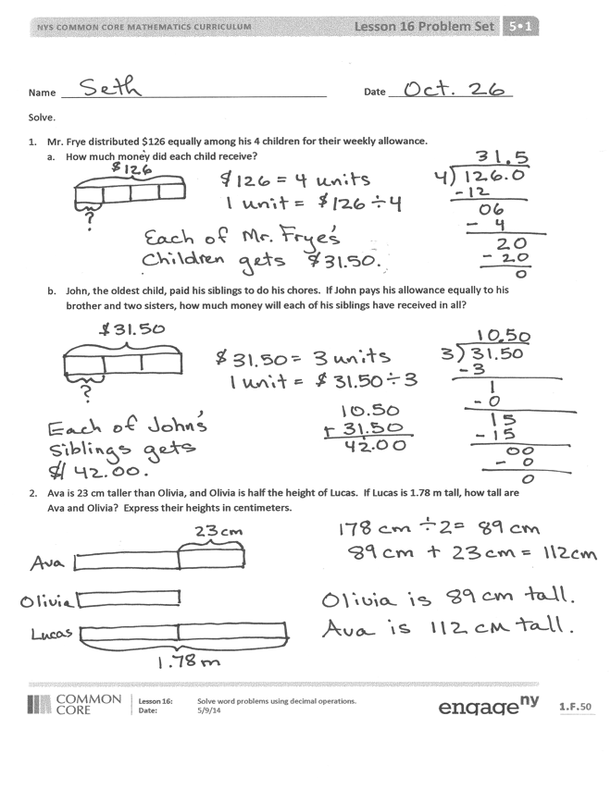Today’s Problem Set forms the basis of the Concept Development. Students solve Problems 1 and 4 with   
teacher guidance, modeling, and scaffolding.   
Problems 2, 3, and 5 are designed to be independent work.

Student Debrief (10 minutes)

**Lesson Objective:** Solve word problems using decimal operations.

The Student Debrief is intended to invite reflection and active processing of the total lesson experience.

Invite students to review their solutions for the Problem Set. They should check work by comparing answers with a partner before going over answers as a class. Look for misconceptions or misunderstandings that can be addressed in the Debrief. Guide students in a conversation to debrief the Problem Set and process the lesson.

Any combination of the questions below may be used to 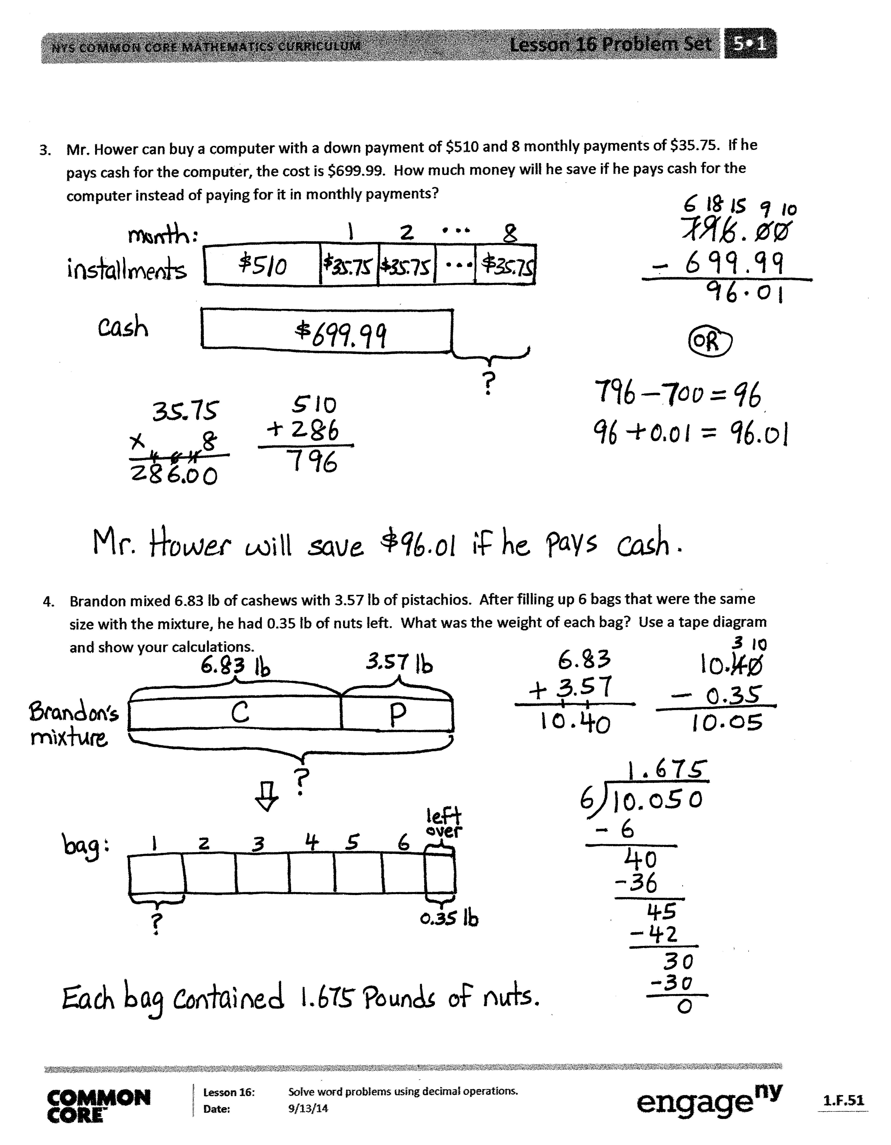lead the discussion.

* How did the tape diagram in Problem 1(a) help you solve Problem 1(b)?
* In Problem 3, how did you represent the information using the tape diagram?
* Look at Problem 1(b) and Problem 5(b). How are the questions different? (Problem 1(b) is partitive division—groups are known, size of group is unknown. Problem 5(b) is measurement division—size of group is known, number of groups is unknown.) Does the difference in the questions affect the calculation of the answers?
* As an extension or an option for early finishers, have students generate word problems based on labeled tape diagrams, or have them create one of each type of division problem (group size unknown and number of groups unknown).

Exit Ticket (3 minutes)

After the Student Debrief, instruct students to complete the Exit Ticket. A review of their work will help with assessing students’ understanding of the concepts that were presented in today’s lesson and planning more effectively for future lessons. The questions may be read aloud to the students.

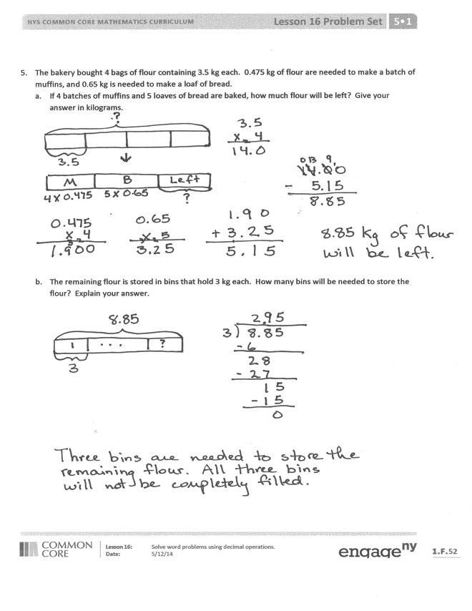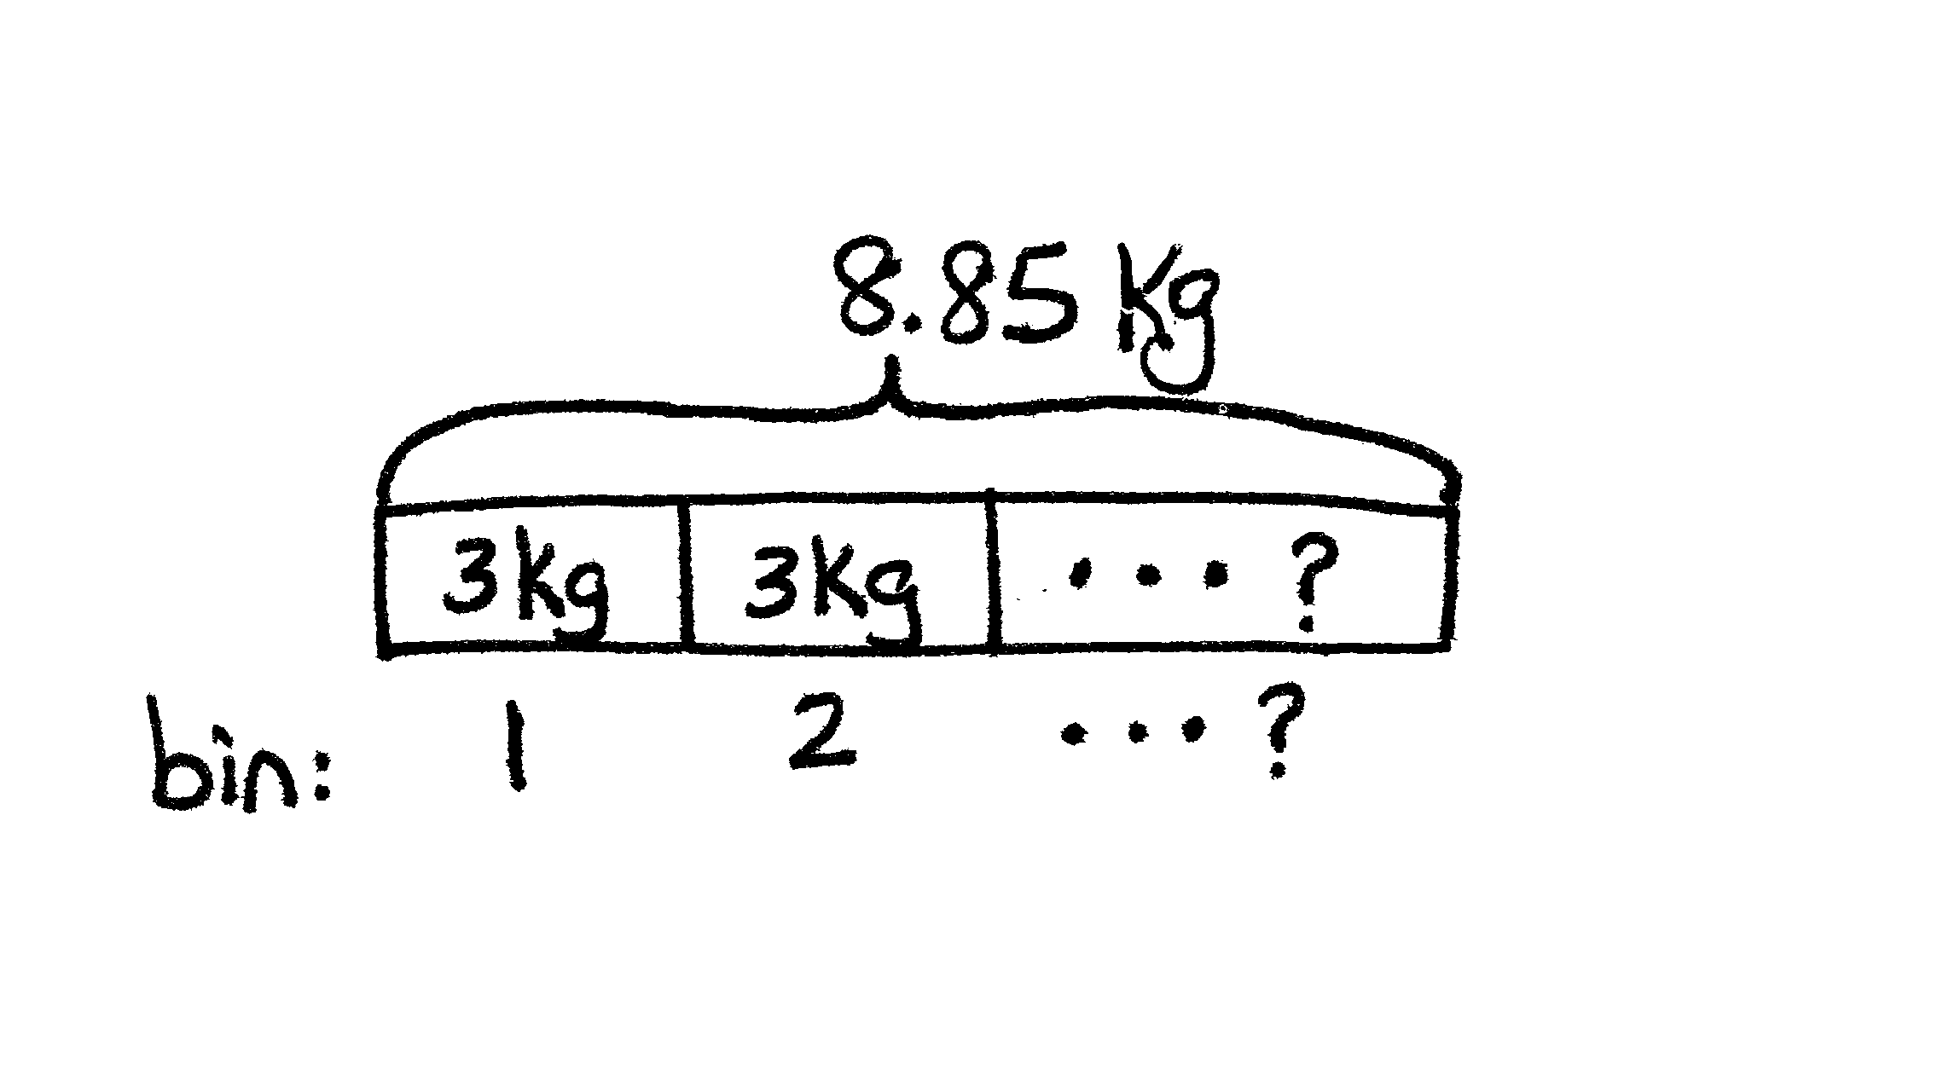

Number Correct: _______

**A**

Multiply and Divide by Exponents

|  |  |  |  |  |  |  |
| --- | --- | --- | --- | --- | --- | --- |
|  | 10 × 10 = |  |  |  | 3,400 ÷ 102 = |  |
|  | 102 = |  |  |  | 3,470 ÷ 102 = |  |
|  | 102 × 10 = |  |  |  | 3,407 ÷ 102 = |  |
|  | 103 = |  |  |  | 3,400.7 ÷ 102 = |  |
|  | 103 × 10 = |  |  |  | 63,000 ÷ 1,000 = |  |
|  | 104 = |  |  |  | 63,000 ÷ 103 = |  |
|  | 3 × 100 = |  |  |  | 63,800 ÷ 103 = |  |
|  | 3 × 102 = |  |  |  | 63,080 ÷ 103 = |  |
|  | 3.1 × 102 = |  |  |  | 63,082 ÷ 103 = |  |
|  | 3.15 × 102 = |  |  |  | 81,000 ÷ 10,000 = |  |
|  | 3.157 × 102 = |  |  |  | 81,000 ÷ 104 = |  |
|  | 4 × 1,000 = |  |  |  | 81,400 ÷ 104 = |  |
|  | 4 × 103 = |  |  |  | 81,040 ÷ 104 = |  |
|  | 4.2 × 103 = |  |  |  | 91,070 ÷ 104 = |  |
|  | 4.28 × 103 = |  |  |  | 120 ÷ 102 = |  |
|  | 4.283 × 103 = |  |  |  | 350 ÷ 103 = |  |
|  | 5 × 10,000 = |  |  |  | 45,920 ÷ 104 = |  |
|  | 5 × 104 = |  |  |  | 6,040 ÷ 103 = |  |
|  | 5.7 × 104 = |  |  |  | 61,080 ÷ 104 = |  |
|  | 5.73 × 104 = |  |  |  | 7.8 ÷ 102 = |  |
|  | 5.731 × 104 = |  |  |  | 40,870 ÷ 103 = |  |
|  | 24 × 100 = |  |  |  | 52,070.9 ÷ 102 = |  |

**B**

**[KEY]**

Number Correct: _______

Improvement: _______

Multiply and Divide by Exponents

|  |  |  |  |  |  |  |
| --- | --- | --- | --- | --- | --- | --- |
|  | 10 × 10 × 1 = |  |  |  | 4,300 ÷ 102 = |  |
|  | 102 = |  |  |  | 4,370 ÷ 102 = |  |
|  | 102 × 10 = |  |  |  | 4,307 ÷ 102 = |  |
|  | 103 = |  |  |  | 4,300.7 ÷ 102 = |  |
|  | 103 × 10 = |  |  |  | 73,000 ÷ 1,000 |  |
|  | 104 = |  |  |  | 73,000 ÷ 103 = |  |
|  | 500 ÷ 100 = |  |  |  | 73,800 ÷ 103 = |  |
|  | 500 ÷ 102 = |  |  |  | 73,080 ÷ 103 = |  |
|  | 510 ÷ 102 = |  |  |  | 73,082 ÷ 103 = |  |
|  | 516 ÷ 102 = |  |  |  | 91,000 ÷ 10,000 = |  |
|  | 516.7 ÷ 102 = |  |  |  | 91,000 ÷ 104 = |  |
|  | 6,000 ÷ 1,000 = |  |  |  | 91,400 ÷ 104 = |  |
|  | 6,000 ÷ 103 = |  |  |  | 91,040 ÷ 104 = |  |
|  | 6,200 ÷ 103 = |  |  |  | 81,070 ÷ 104 = |  |
|  | 6,280 ÷ 103 = |  |  |  | 170 ÷ 102 = |  |
|  | 6,283 ÷ 103 = |  |  |  | 450 ÷ 103 = |  |
|  | 70,000 ÷ 10,000 = |  |  |  | 54,920 ÷ 104 = |  |
|  | 70,000 ÷ 104 = |  |  |  | 4,060 ÷ 103 = |  |
|  | 76,000 ÷ 104 = |  |  |  | 71,080 ÷ 104 = |  |
|  | 76,300 ÷ 104 = |  |  |  | 8.7 ÷ 102 = |  |
|  | 76,310 ÷ 104 = |  |  |  | 60,470 ÷ 103 = |  |
|  | 4,300 ÷ 100 = |  |  |  | 72,050.9 ÷ 102 = |  |

Name Date

Solve.

1. Mr. Frye distributed $126 equally among his 4 children for their weekly allowance.
2. How much money did each child receive?
3. John, the oldest child, paid his siblings to do his chores. If John pays his allowance equally to his brother and two sisters, how much money will each of his siblings have received in all?
4. Ava is 23 cm taller than Olivia, and Olivia is half the height of Lucas. If Lucas is 1.78 m tall, how tall are Ava and Olivia? Express their heights in centimeters.
5. Mr. Hower can buy a computer with a down payment of $510 and 8 monthly payments of $35.75. If he pays cash for the computer, the cost is $699.99. How much money will he save if he pays cash for the computer instead of paying for it in monthly payments?
6. Brandon mixed 6.83 lb of cashews with 3.57 lb of pistachios. After filling up 6 bags that were the same size with the mixture, he had 0.35 lb of nuts left. What was the weight of each bag? Use a tape diagram, and show your calculations.
7. The bakery bought 4 bags of flour containing 3.5 kg each. 0.475 kg of flour is needed to make a batch of muffins, and 0.65 kg is needed to make a loaf of bread.
8. If 4 batches of muffins and 5 loaves of bread are baked, how much flour will be left? Give your answer in kilograms.
9. The remaining flour is stored in bins that hold 3 kg each. How many bins will be needed to store the flour? Explain your answer.

Name Date

Write a word problem with two questions that matches the tape diagram below, and then solve.

*16.23 lb*

*Weight of John’s Dog*

*?*

*?*

*Weight of Jim’s Dog*

Name Date

Solve using tape diagrams.

1. A gardener installed 42.6 meters of fencing in a week. He installed 13.45 meters on Monday and   
   9.5 meters on Tuesday. He installed the rest of the fence in equal lengths on Wednesday through Friday. How many meters of fencing did he install on each of the last three days?
2. Jenny charges $9.15 an hour to babysit toddlers and $7.45 an hour to babysit school-aged children.
3. If Jenny babysat toddlers for 9 hours and school-aged children for 6 hours, how much money did she earn in all?
4. Jenny wants to earn $1,300 by the end of the summer. How much more will she need to earn to meet her goal?
5. A table and 8 chairs weigh 235.68 lb together. If the table weighs 157.84 lb, what is the weight of one chair in pounds?
6. Mrs. Cleaver mixes 1.24 liters of red paint with 3 times as much blue paint to make purple paint. She pours the paint equally into 5 containers. How much blue paint is in each container? Give your answer   
   in liters.