Predicting Air BnB Prices

Andrew Cohen

1/10/2020

## R Markdown

This is an R Markdown document. Markdown is a simple formatting syntax for authoring HTML, PDF, and MS Word documents. For more details on using R Markdown see <http://rmarkdown.rstudio.com>.

When you click the **Knit** button a document will be generated that includes both content as well as the output of any embedded R code chunks within the document. You can embed an R code chunk like this:

library(readr)  
library(ggplot2)  
library(plyr)  
library(dplyr)

##   
## Attaching package: 'dplyr'

## The following objects are masked from 'package:plyr':  
##   
## arrange, count, desc, failwith, id, mutate, rename, summarise,  
## summarize

## The following objects are masked from 'package:stats':  
##   
## filter, lag

## The following objects are masked from 'package:base':  
##   
## intersect, setdiff, setequal, union

library(xgboost)

##   
## Attaching package: 'xgboost'

## The following object is masked from 'package:dplyr':  
##   
## slice

library(dummies)

## dummies-1.5.6 provided by Decision Patterns

library(rsample)

## Loading required package: tidyr

df_listings <- read_csv("/Users/cohean/Desktop/DataSciChallenge/listings.csv",   
 col_types = cols(host_id = col_character(),   
 id = col_character()))  
# EDA  
# library(rpivotTable)  
# rpivotTable(df_listings)  
  
summary(df_listings)

## id name host_id   
## Length:48864 Length:48864 Length:48864   
## Class :character Class :character Class :character   
## Mode :character Mode :character Mode :character   
##   
##   
##   
##   
## host_name neighbourhood_group neighbourhood latitude   
## Length:48864 Length:48864 Length:48864 Min. :40.50   
## Class :character Class :character Class :character 1st Qu.:40.69   
## Mode :character Mode :character Mode :character Median :40.72   
## Mean :40.73   
## 3rd Qu.:40.76   
## Max. :40.91   
##   
## longitude room_type minimum_nights   
## Min. :-74.24 Length:48864 Min. : 1.000   
## 1st Qu.:-73.98 Class :character 1st Qu.: 1.000   
## Median :-73.96 Mode :character Median : 2.000   
## Mean :-73.95 Mean : 7.093   
## 3rd Qu.:-73.94 3rd Qu.: 5.000   
## Max. :-73.71 Max. :1250.000   
##   
## calculated_host_listings_count availability_365 number_of_reviews  
## Min. : 1.000 Min. : 0.0 Min. : 0.00   
## 1st Qu.: 1.000 1st Qu.: 0.0 1st Qu.: 1.00   
## Median : 1.000 Median : 41.0 Median : 5.00   
## Mean : 7.438 Mean :112.5 Mean : 23.39   
## 3rd Qu.: 2.000 3rd Qu.:232.0 3rd Qu.: 24.00   
## Max. :343.000 Max. :365.0 Max. :639.00   
##   
## reviews_per_month price   
## Min. : 0.010 Min. : 0.0   
## 1st Qu.: 0.190 1st Qu.: 69.0   
## Median : 0.710 Median : 105.0   
## Mean : 1.366 Mean : 151.5   
## 3rd Qu.: 2.000 3rd Qu.: 175.0   
## Max. :66.610 Max. :10000.0   
## NA's :10131

# remove nuisance columns  
# additional analysis thoughts, potentially can include the "name" column using nlp techniques  
df_listings <- subset(df_listings, select = -c(id, name, host_id, host_name, neighbourhood))  
  
# check categorical for errors vars before encoding   
df_listings %>% count(neighbourhood_group, sort = TRUE)

## # A tibble: 5 x 2  
## neighbourhood_group n  
## <chr> <int>  
## 1 Manhattan 21456  
## 2 Brooklyn 20114  
## 3 Queens 5811  
## 4 Bronx 1105  
## 5 Staten Island 378

df_listings %>% count(room_type, sort = TRUE)

## # A tibble: 3 x 2  
## room_type n  
## <chr> <int>  
## 1 Entire home/apt 25296  
## 2 Private room 22397  
## 3 Shared room 1171

#df_listings %>% count(neighbourhood, sort = TRUE)  
  
  
# lapply(df_listings,class)  
hist(df_listings$price, breaks = 500, main = "Price")

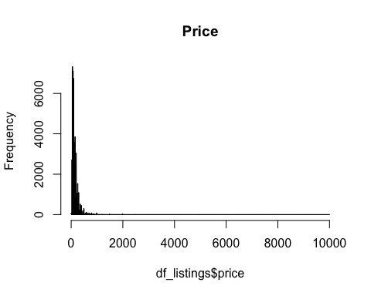

# boxplot(df_listings$price)  
  
#remove outliers  
df_model <- df_listings[df_listings$price<3500,]  
# remove zeros  
df_model <- df_model[df_model$price != 0,]  
hist(df_model$price, breaks = 250, main = "Price")

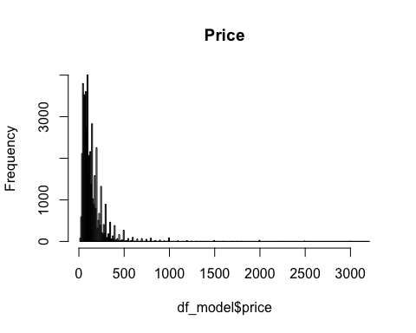

# boxplot room type  
ggplot(df_model, aes(x=room_type, y=price, fill=room_type)) +   
 geom_boxplot() +   
 coord_cartesian(ylim = c(0, 500)) #zoom into center of data

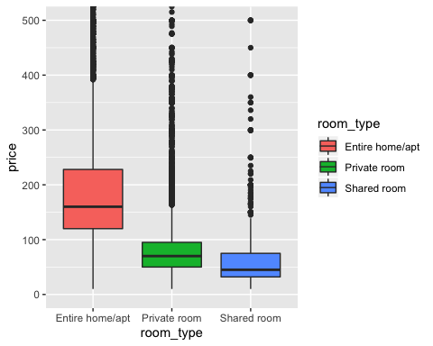

# boxplot boro  
ggplot(df_model, aes(x=neighbourhood_group, y=price, fill=neighbourhood_group)) +   
 geom_boxplot() +   
 coord_cartesian(ylim = c(0, 500)) #zoom into center of data

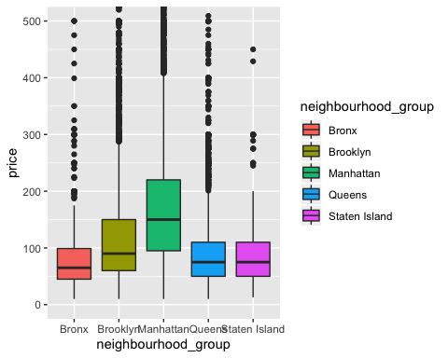

# grouped boxplot  
ggplot(df_listings, aes(x=neighbourhood_group, y=price, fill=room_type)) +   
 geom_boxplot() +   
 coord_cartesian(ylim = c(0, 500)) #zoom into center of data

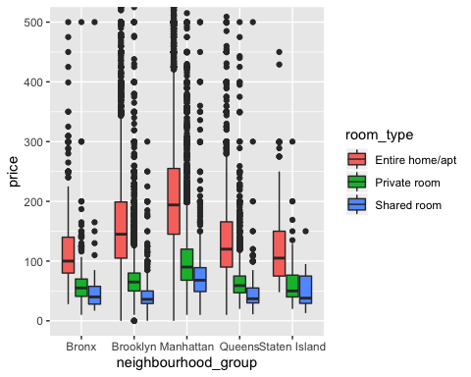

numericV <- which(sapply(df_model, is.numeric))   
cor(df_model$price,df_model[,numericV])

## latitude longitude minimum_nights calculated_host_listings_count  
## [1,] 0.04812225 -0.2158065 0.04180992 0.09620459  
## availability_365 number_of_reviews reviews_per_month price  
## [1,] 0.1047912 -0.05645767 NA 1

#not much correlation among numeric vars

# impute mean for missing to keep from loosing data  
df_imp <- transform(df_model,   
 reviews_per_month = ifelse(is.na(reviews_per_month),   
 mean(reviews_per_month, na.rm=TRUE), reviews_per_month))  
  
# split data for models  
df_split <- initial_split(df_imp, prop = .7)  
df_train <- training(df_split)  
df_test <- testing(df_split)  
  
# one-hot  
df_dummy_train <- dummy.data.frame(df_train, names = c("neighbourhood_group","room_type") , sep = ".")

## Warning in model.matrix.default(~x - 1, model.frame(~x - 1), contrasts =  
## FALSE): non-list contrasts argument ignored  
  
## Warning in model.matrix.default(~x - 1, model.frame(~x - 1), contrasts =  
## FALSE): non-list contrasts argument ignored

df_dummy_test <- dummy.data.frame(df_test, names = c("neighbourhood_group","room_type") , sep = ".")

## Warning in model.matrix.default(~x - 1, model.frame(~x - 1), contrasts =  
## FALSE): non-list contrasts argument ignored  
  
## Warning in model.matrix.default(~x - 1, model.frame(~x - 1), contrasts =  
## FALSE): non-list contrasts argument ignored

# seperate X and Y matrices  
df_train_x <- subset(df_dummy_train, select = -c(price))  
df_train_y <- subset(df_dummy_train, select = c(price))  
df_test_x <- subset(df_dummy_test, select = -c(price))  
df_test_y <- subset(df_dummy_test, select = c(price))  
  
# using xgboost is one of the best places to start for a predictive model because it usually fits very well without much tuning.  
xgb.train <- xgb.DMatrix(data = as.matrix(df_train_x), label=as.matrix(df_train_y))  
xgb.test <- xgb.DMatrix(data = as.matrix(df_test_x), label=as.matrix(df_test_y))  
  
# parameters based on some light tuning using regression performance metrics like rmse  
params <- list(  
 booster = "dart",  
 #objective = "reg:gamma",  
 max.depth = 5,  
 eta = 0.007,  
 #subsample = 0.60,  
 eval_metric = "rmse"  
 # ,eval_metric = "mae"  
 )  
  
xgb.fit<-xgb.train(  
 data = xgb.train,  
 params = params,  
 nrounds = 300, # cut off based on rmse  
 #watchlist = list(test=xgb.test,train=xgb.train),  
 #verbose = 1  
 )  
  
# performance  
xgb.fit

## ##### xgb.Booster  
## raw: 684 Kb   
## call:  
## xgb.train(params = params, data = xgb.train, nrounds = 300)  
## params (as set within xgb.train):  
## booster = "dart", max_depth = "5", eta = "0.007", eval_metric = "rmse", silent = "1"  
## xgb.attributes:  
## niter  
## callbacks:  
## cb.print.evaluation(period = print_every_n)  
## # of features: 15   
## niter: 300  
## nfeatures : 15

# feature importance  
xgb.importance(colnames(xgb.train), model = xgb.fit)

## Feature Gain Cover Frequency  
## 1: room_type.Entire home/apt 0.4218285084 1.997174e-01 0.03362475  
## 2: longitude 0.1815729138 2.330068e-01 0.18527236  
## 3: latitude 0.1119538120 1.217534e-01 0.20836135  
## 4: availability_365 0.0920004455 1.673531e-01 0.16072629  
## 5: minimum_nights 0.0746621677 1.106368e-01 0.16565792  
## 6: number_of_reviews 0.0541606471 9.390369e-02 0.09683927  
## 7: calculated_host_listings_count 0.0404913949 2.195000e-02 0.06624075  
## 8: reviews_per_month 0.0096605850 1.004297e-02 0.02824479  
## 9: neighbourhood_group.Manhattan 0.0050707230 2.606892e-02 0.01087200  
## 10: neighbourhood_group.Queens 0.0047920200 1.488781e-05 0.01882986  
## 11: neighbourhood_group.Brooklyn 0.0014684083 6.585368e-05 0.00493163  
## 12: room_type.Private room 0.0014411331 1.548383e-02 0.01457072  
## 13: neighbourhood_group.Bronx 0.0008972411 2.360976e-06 0.00582829

# pred price distrubution comparison  
xgb.pred <- predict(xgb.fit,xgb.test,reshape=T)  
hist(xgb.pred, breaks = 100,main = "XGB Pred Price",xlim = c(-20 , +500))

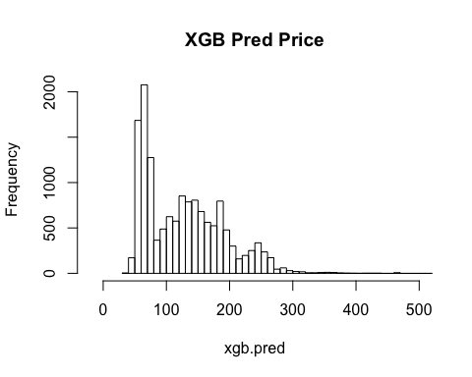

hist(df_test_y$price, breaks = 1000,main = "Price",xlim = c(-20 , +500))

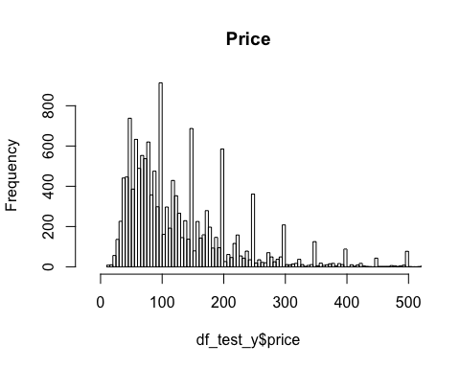

# generalized linear model  
df_train$logprice <- log(df_train$price)  
df_test$logprice <- log(df_test$price)  
  
glm_m <- glm(logprice ~ ., data = subset(df_train, select = -c(price)))  
summary(glm_m)

##   
## Call:  
## glm(formula = logprice ~ ., data = subset(df_train, select = -c(price)))  
##   
## Deviance Residuals:   
## Min 1Q Median 3Q Max   
## -3.0303 -0.3067 -0.0499 0.2387 4.1952   
##   
## Coefficients:  
## Estimate Std. Error t value Pr(>|t|)  
## (Intercept) -1.959e+02 8.183e+00 -23.946 < 2e-16  
## neighbourhood_groupBrooklyn -7.376e-02 2.234e-02 -3.302 0.000961  
## neighbourhood_groupManhattan 2.246e-01 2.024e-02 11.098 < 2e-16  
## neighbourhood_groupQueens 4.181e-02 2.146e-02 1.949 0.051354  
## neighbourhood_groupStaten Island -8.739e-01 4.218e-02 -20.722 < 2e-16  
## latitude -6.398e-01 7.971e-02 -8.027 1.03e-15  
## longitude -3.069e+00 9.186e-02 -33.413 < 2e-16  
## room_typePrivate room -7.489e-01 5.506e-03 -136.027 < 2e-16  
## room_typeShared room -1.156e+00 1.743e-02 -66.288 < 2e-16  
## minimum_nights -1.998e-03 1.299e-04 -15.378 < 2e-16  
## calculated_host_listings_count -1.030e-04 7.862e-05 -1.310 0.190162  
## availability_365 7.253e-04 2.143e-05 33.844 < 2e-16  
## number_of_reviews -8.678e-04 6.969e-05 -12.452 < 2e-16  
## reviews_per_month 1.086e-02 2.069e-03 5.250 1.53e-07  
##   
## (Intercept) ***  
## neighbourhood_groupBrooklyn ***  
## neighbourhood_groupManhattan ***  
## neighbourhood_groupQueens .   
## neighbourhood_groupStaten Island ***  
## latitude ***  
## longitude ***  
## room_typePrivate room ***  
## room_typeShared room ***  
## minimum_nights ***  
## calculated_host_listings_count   
## availability_365 ***  
## number_of_reviews ***  
## reviews_per_month ***  
## ---  
## Signif. codes: 0 '***' 0.001 '**' 0.01 '*' 0.05 '.' 0.1 ' ' 1  
##   
## (Dispersion parameter for gaussian family taken to be 0.2351061)  
##   
## Null deviance: 16117.4 on 34166 degrees of freedom  
## Residual deviance: 8029.6 on 34153 degrees of freedom  
## AIC: 47514  
##   
## Number of Fisher Scoring iterations: 2

hist(predict(glm_m,df_test), breaks = 100,main = "Predicted Log Price")

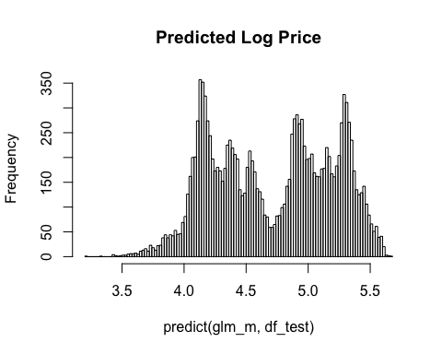

hist(df_test$logprice, breaks = 100, main = "Log Price")

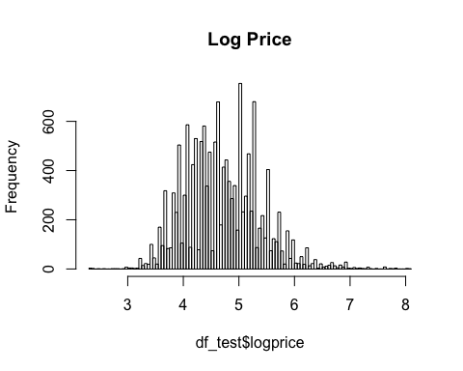

# both models are pretty good starts  
# xgboost seems better based on the distribution of the residuals   
# similar feature importance