Testquery 1:

SELECT * {?s ?p ?o} LIMIT 10

Testquery 2:

PREFIX text: <http://purl.org/acoli/open-ie/acoli.in2rdf.Sentence2Triple/16787226#>
PREFIX tbox: <http://purl.org/acoli/open-ie/>
PREFIX rdfs: <http://www.w3.org/2000/01/rdf-schema#>
PREFIX rdf: <http://www.w3.org/1999/02/22-rdf-syntax-ns#>
CONSTRUCT { ?aC ?r ?bC. ?bC ?s ?aC. ?cC ?t ?bC. ?bC ?u ?cC }
WHERE {
?a ?ign ?c. ?c a ?cC. ?a a ?aC.
{ ?a a tbox:king } UNION { ?c a tbox:king}.
{{ ?a ?r ?b } UNION { ?b ?s ?a}. ?b a ?bC.} UNION
{{ ?c ?t ?b } UNION { ?b ?u ?c}. ?b a ?bC.}
}

Screenshots
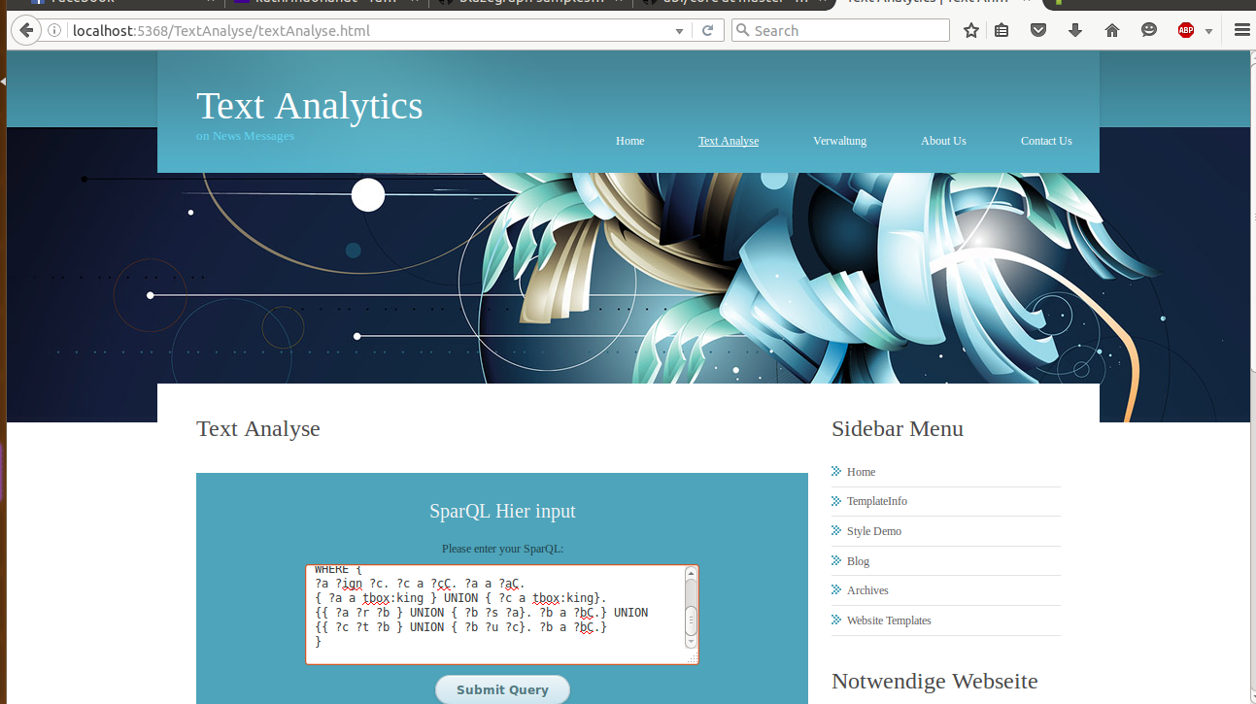

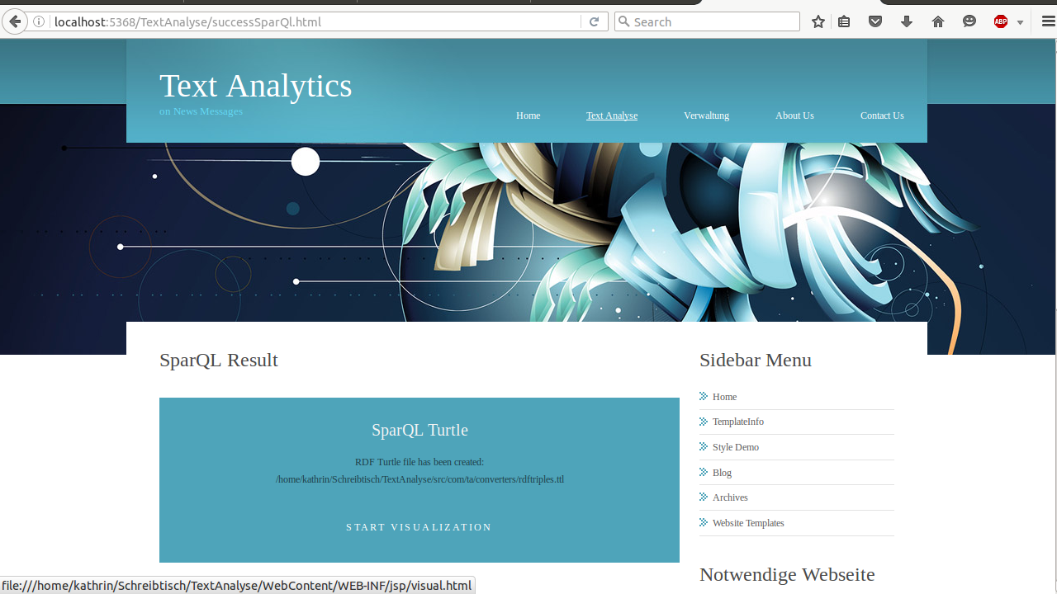

Ergebnis 1

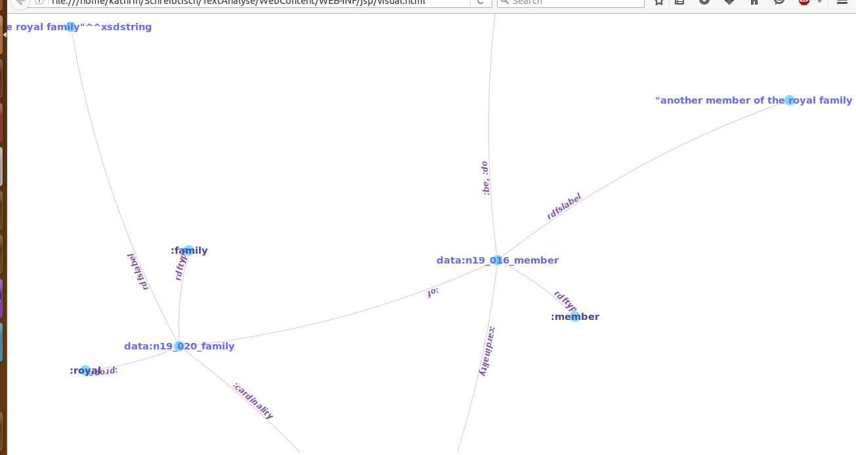

Ergebnis 2

