CoNLL-RDF Ontology

- for tab-separated values, “CoNLL formats”
- based on a subset of NIF 2.0
- conll: properties created on the fly from user-provided column labels, e.g., ID WORD LEMMA UPOS XPOS FEATS HEAD EDGE DEPS MISC for CoNLL-U
- special handling for ID (=> URI), HEAD (=> links to head or sentence), SRL-Pred (=> links for Semantic Role Annotation), all other column labels become datatype properties with string values
- extensions:
  - phrase structure syntax and labelled (reified) edges with POWLA vocabulary
  - metadata for documenting the serialization into CoNLL formats

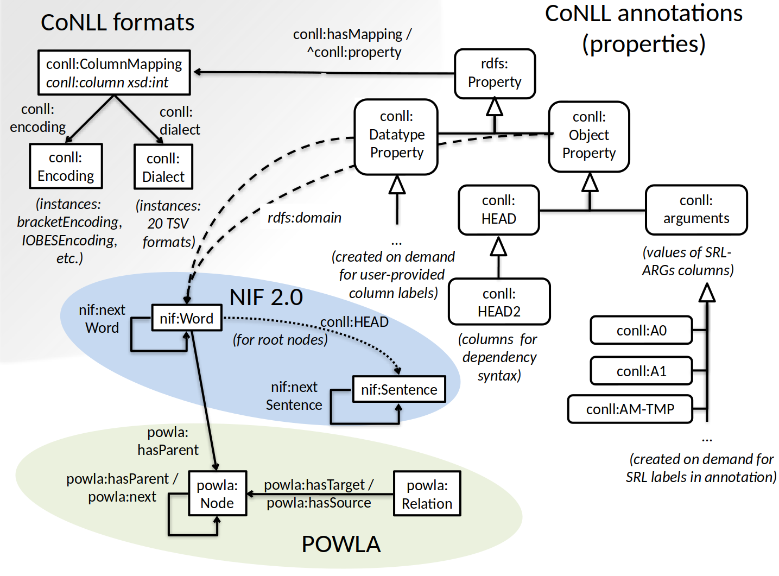
prefixes

PREFIX conll: <http://ufal.mff.cuni.cz/conll2009-st/task-description.html#>
PREFIX nif: <http://persistence.uni-leipzig.org/nlp2rdf/ontologies/nif-core#>
PREFIX powla: <http://purl.org/powla/powla.owl#>

(source: https://github.com/acoli-repo/conll-rdf)

