Sumerian

Polysynthetic, agglutinative, defective orthography, case stacking

Note that the paradigms below are an excerpt only. We omit non-finite verbs.

# Verbal system: Finite Verb

traditionally described in terms of a “slot grammar” where every position is associated with a certain position

Examples taken from Gábor Zólyomi (2016), An introduction to the grammar of Sumerian

| Slot 1 | MODAL prefix (**ḫa**), negative particle, prefix of ANTERIORITY, STEM (in imperative  forms) |
| --- | --- |
| Slot 2 | FINITE-MARKER prefix, MODAL prefixes (all the other) |
| Slot 3 | COORDINATOR prefix |
| Slot 4 | VENTIVE (cislocative) prefix |
| Slot 5 | MIDDLE prefix or the 3.SG.NH PRONOMINAL prefix **/b/** (specifying the person,  gender and number of the first in the sequence of adverbial prefixes) |
| Slot 6 | INITIAL PRONOMINAL prefix (= IPP) (specifying the person, gender and number  of the first in the sequence of adverbial prefixes) |
| Slot 7 | Adverbial I: DATIVE prefix |
| Slot 8 | Adverbial II: COMITATIVE prefix |
| Slot 9 | Adverbial III: ABLATIVE or TERMINATIVE prefix |
| Slot 10 | Adverbial IV: LOCATIVE1, LOCATIVE2, or LOCATIVE3 prefix |
| Slot 11 | FINAL PRONOMINAL PREFIX (= FPP) (referring to A or P, depending on the tense,  or LOCATIVE3) |
| Slot 12 | STEM |
| Slot 13 | PRESENT-FUTURE MARKER (*in intransitive verbs*) |
| Slot 14 | PRONOMINAL SUFFIX (referring A, S, or P depending on the tense) |
| Slot 15 | SUBORDINATOR |

Suggestion: model the following tables (from the documentation of the ETSCRI corpus, implements Zolyomi’s grammar, [http://oracc.museum.upenn.edu/etcsri/parsing/index.html](http://oracc.museum.upenn.edu/etcsri/parsing/index.html#VPT); also cf. <https://cdli.ucla.edu/pubs/cdlp/cdlp0002_20160104.pdf>, p. 155)

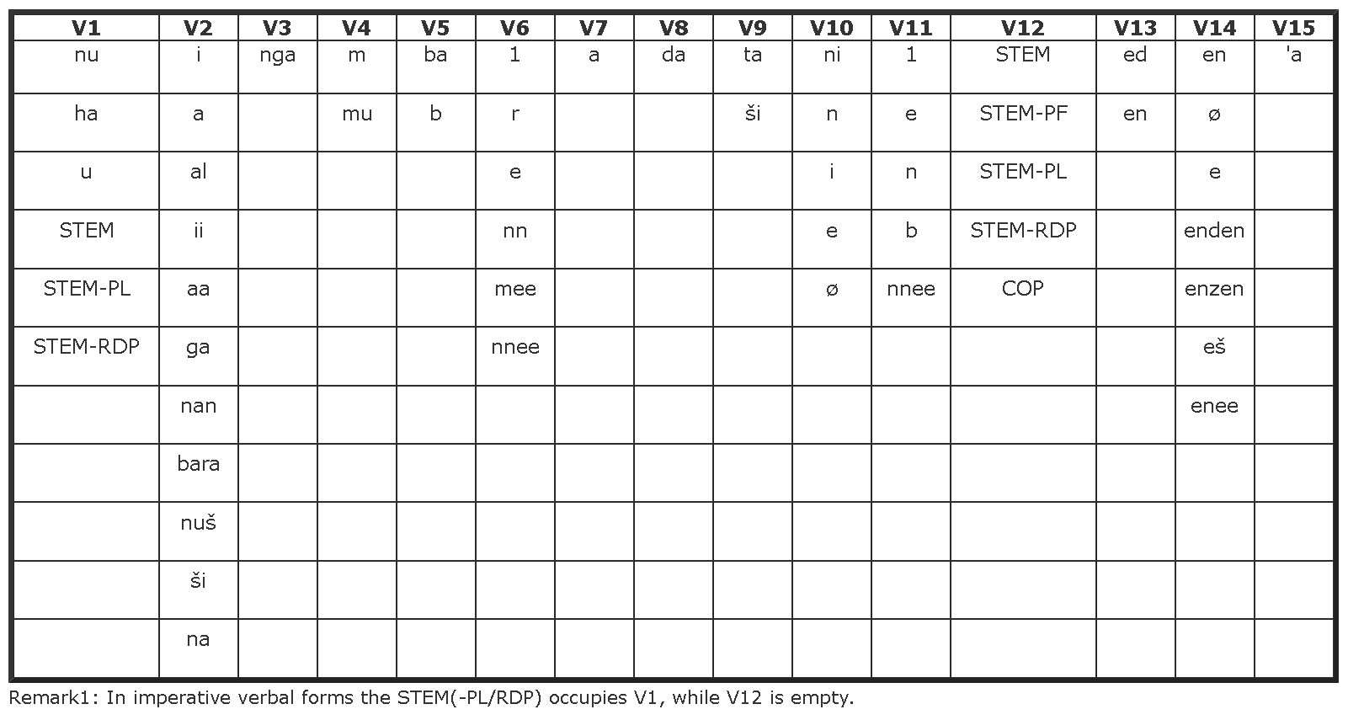

Morphemes (p-tag: slot, M2: gloss):

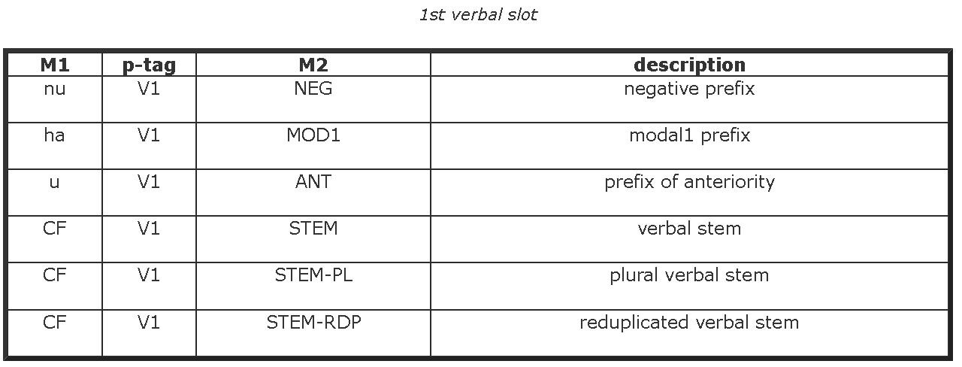

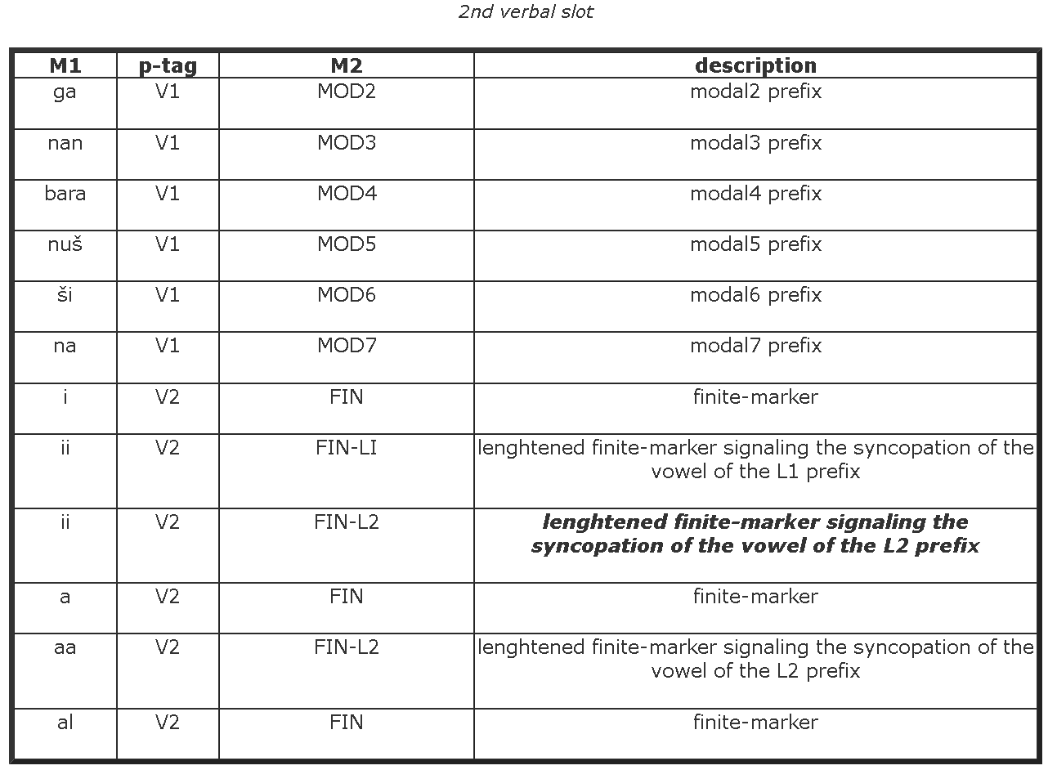

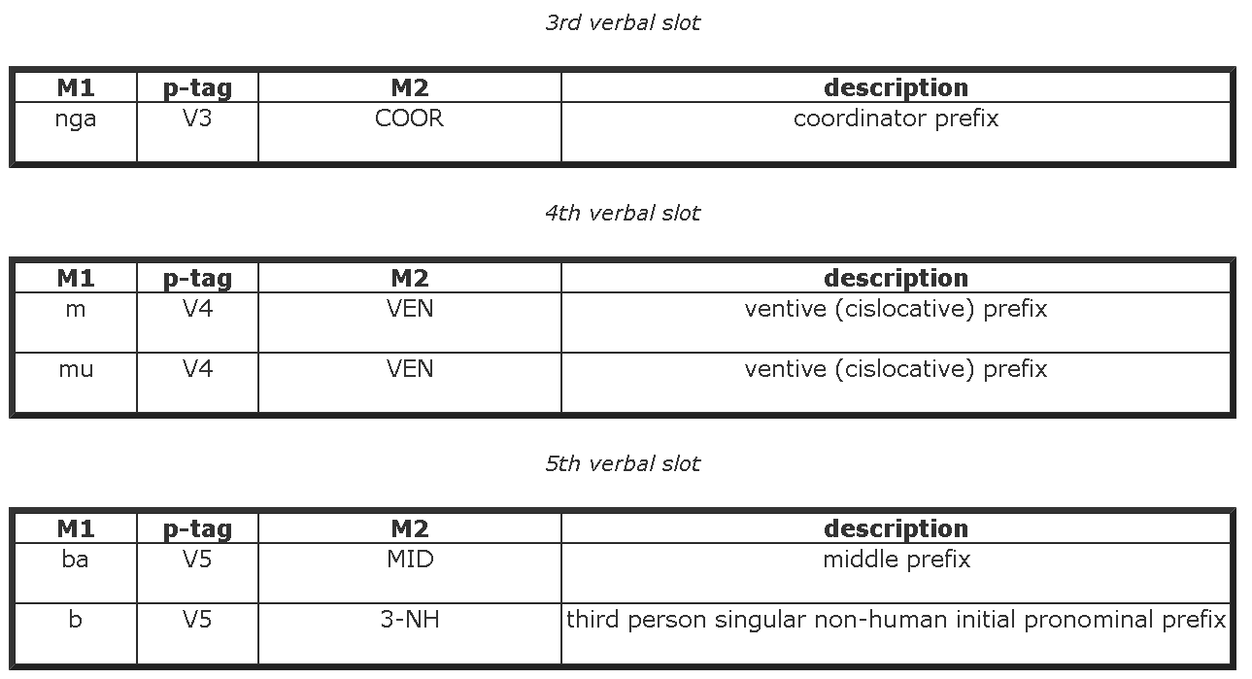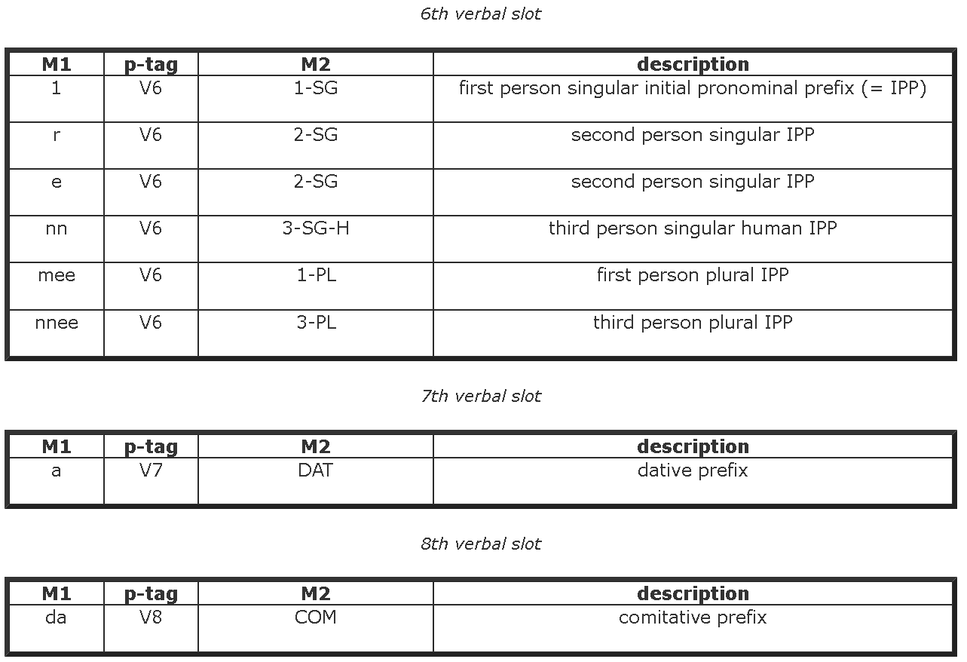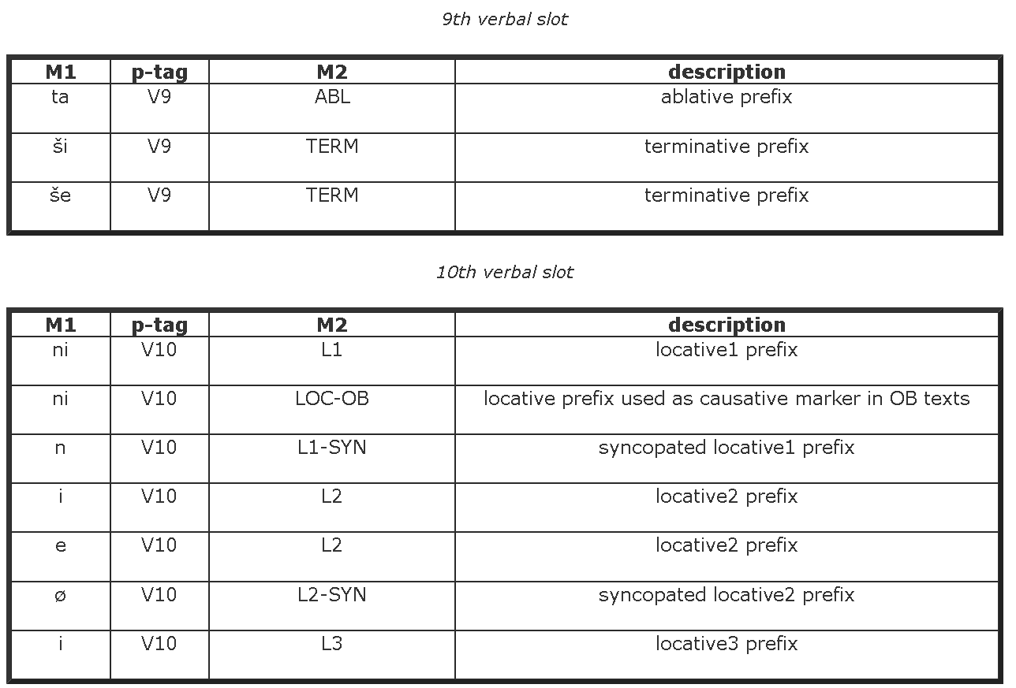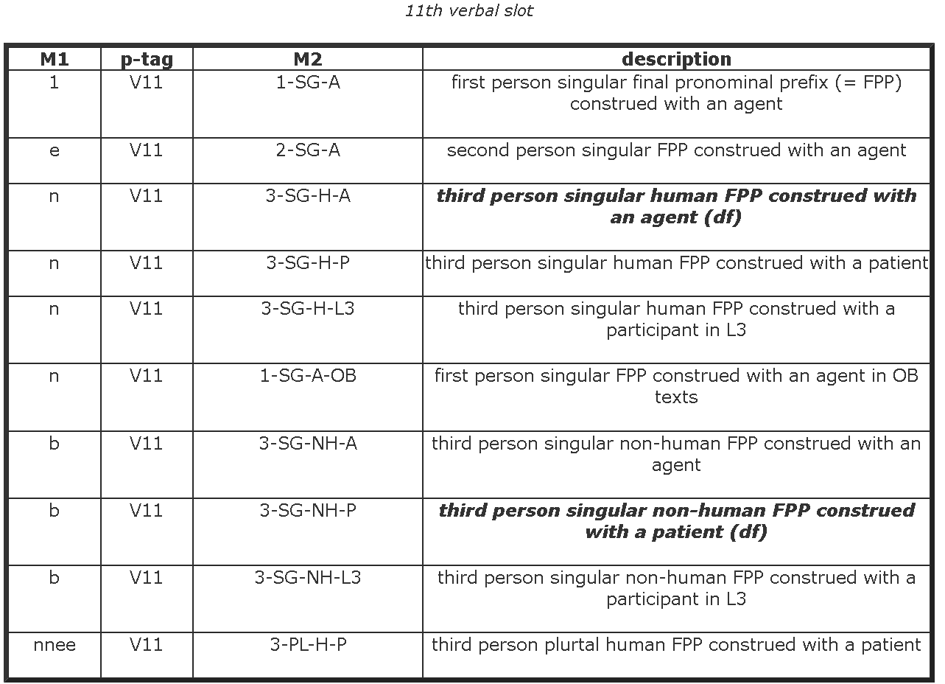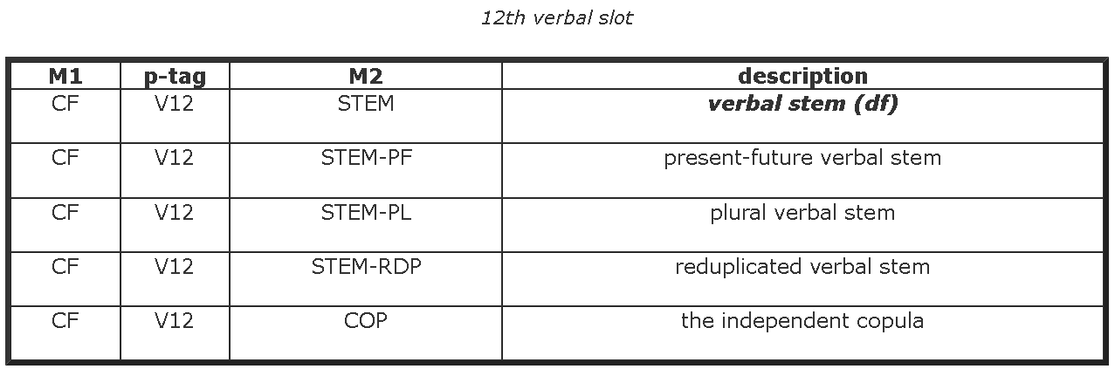

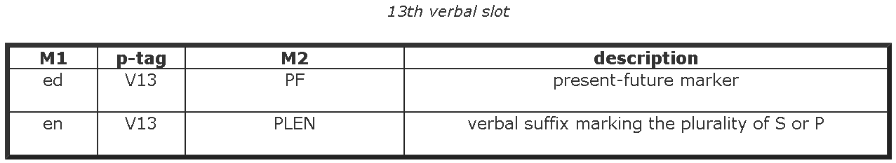

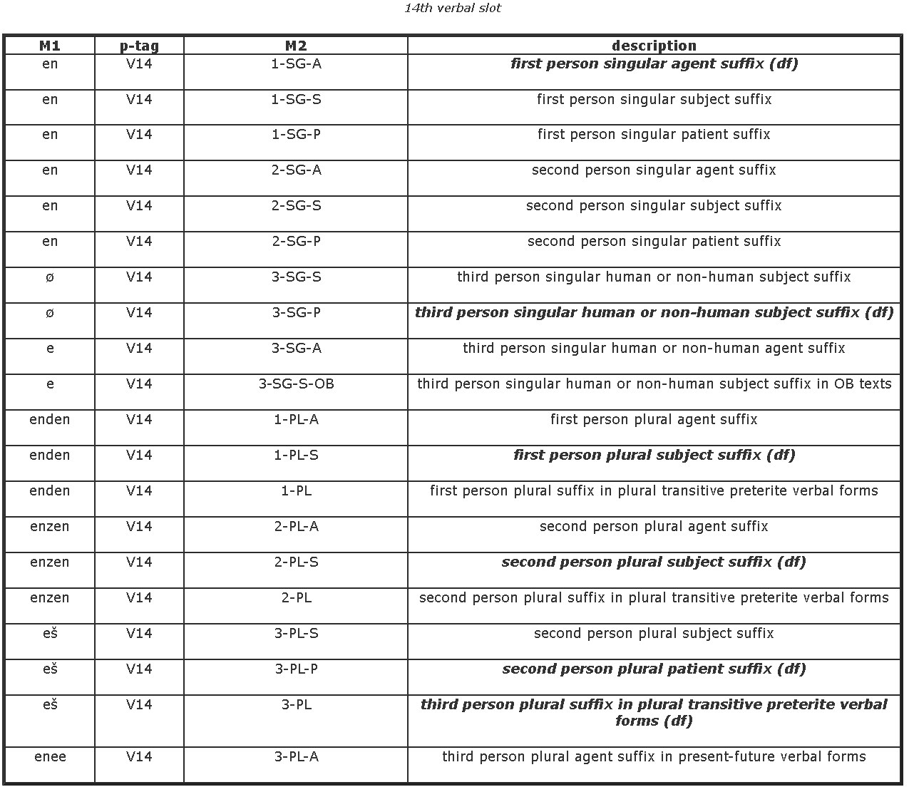

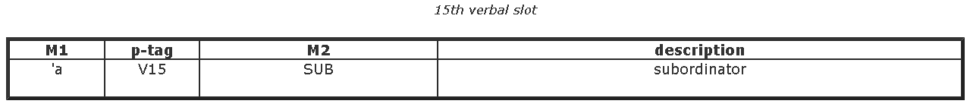

Note: Slot 15 can be a morpheme that makes this a nominal (~ relative clause). The result can then be inflected according to the nominal template

# Nominal system

| 1. | 2. | 3. | 4. | 5. |
| --- | --- | --- | --- | --- |
| HEAD | MODIFIER | POSSESSOR | PLURAL-MARKER | CASE-MARKER |

Table 3.1: The Sumerian nominal template

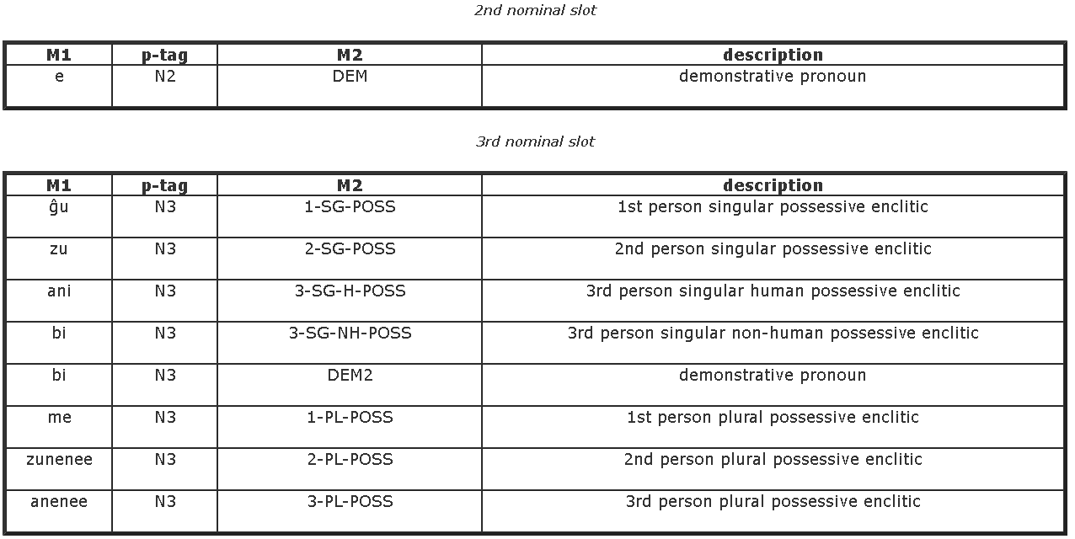

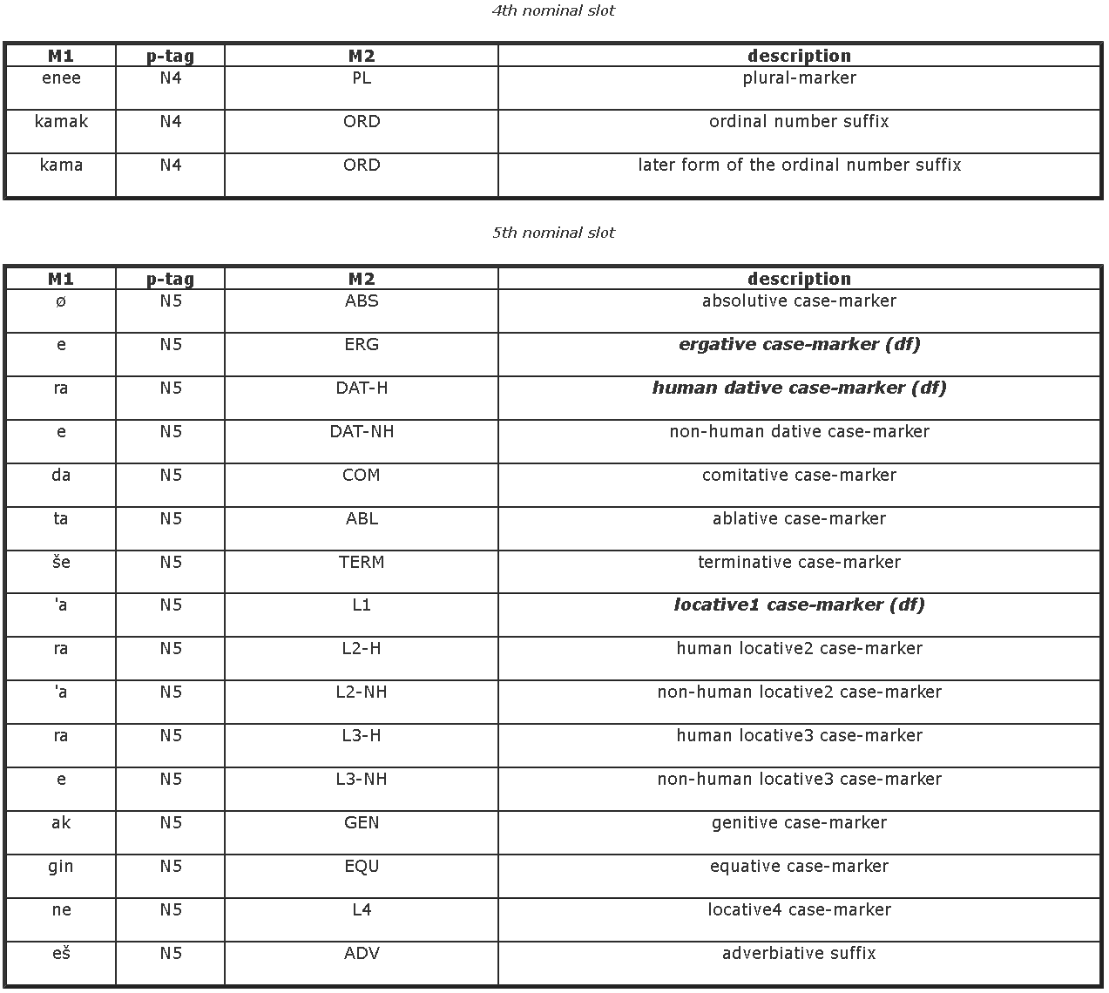

Suggestion: model (the morphemes of) the following examples and their combinatorics.

(11) Gudea Statue B 7:24 (Lagash, 21st c.) (P232275)

dnin-ŋir₂-su-ra

P1 P5

ninŋirsuk= ra

DN= DAT.H

“for (the god) Ningirsu”

(slots 3-4 empty here)

But Sumerian inflection is recursive:

In ex. (12), however, it follows the genitive case-marker of the noun phrase in P3.

(12) Ur-Bau 1 3 (RIME 3/1.6.1) (Lagash, 22nd c.) (P231808)

Dumu an-na-ra

P1 P3 [ P1 P5 ] P5

dumu an= ak= ra

child DN= GEN= DAT.H

“for the child of (the god) An”

P3 of *dumu* contains another independent word [could also be empty, a possessive suffix, a word or phrase like here, or full nominalized sentences]

After that word, its inflection is added

Normally, we don’t have the phrase structure, but we analyze morphemes for every word individually: Then, we have the word *an-na-ra* with two case markers

This doesn’t stop with two case markers, and it is not limited to elements of slot 5:

(14) Iri-kagina 1 3:18 (RIME 1.9.9.1) (Lagash, 24th c.) (P222607)

Sipad udu siki-ka-ke₄-ne

Sipad [ udu [ siki =ak ]=ak ]=enē=e

Shepherd sheep wool =GEN =GEN =PL=ERG

“the shepherds of sheep of wool (= wool-bearing sheep)”

Note the plural marker among the inflections

Note that it is not required that the syntactic head of a nominal dependent is realized as another word. It can be left implicit:

# Jagersma, Chap. 5 (21)

# ‘They are the ones of Geme-Bau.’

# (Nik 1:7 2:4; L; 24)

geme2-{d}ba-ú-ka-me

geme2.ba.ú.k=ak=Ø=me-eš

Geme-Bau=GEN=ABS=be-3PL.S

Geme-Bau: nominal stem (divine name)

=GEN: "of Geme-Bau"

=ABS: "the (one) of Geme-Bau", head (in absolutive case) not overtly realized

=be (or -COP): copula (because the ABS has a zero morpheme, the copula requires us to infer it, because genitives are adnominal only)

-3PL.S: subject argument

We can thus not just assume that the morphology must just be copied to another word. It must be modelled as a property of the word that carries it, regardless of the syntax.

Note that after slot 5, there can be an enclitic copula (glossed COP or *be* below) that makes the noun (phrase) the predicate of a copular clause. It is a verb, then, and can be further inflected according to the verbal table above. In the ETSCRI corpus, the enclitic copula is described as Slot 6 (in addition to the five slots above): <http://oracc.museum.upenn.edu/etcsri/parsing/index.html#NP>

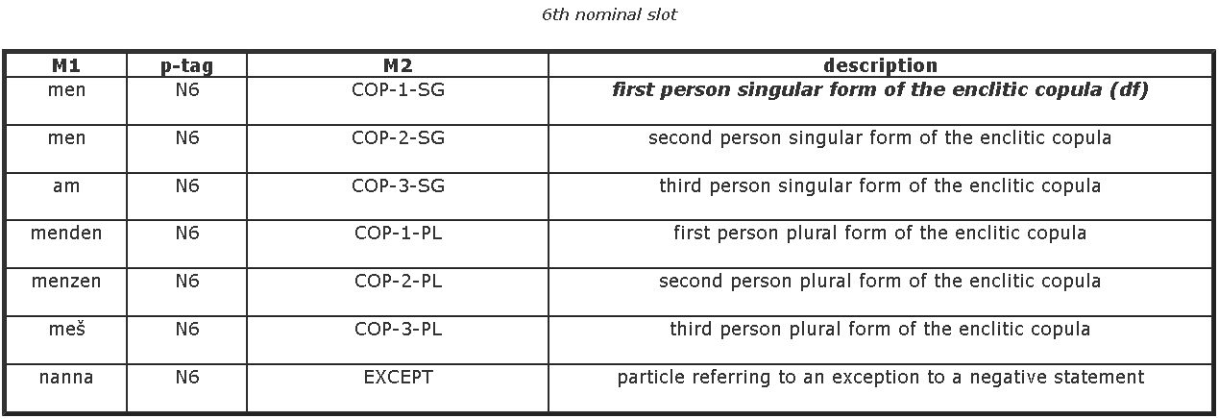

(105) NG 11 obv. 13–14 (Lagash, 21st c.) (P111315)

lu₂ inim-ma ŋeškiri₆, ur-dnanše-ra ba-na-gid₂-da-me

lu inim=ak kiri=ø ur-nanšek=ra S5ba-S6nn-S7a-S12gid-S14ø-S15ʾa=ak=ø=me-eš

person word=GEN garden=ABS PN=DAT.H

MID-3.SG.H-DAT-long-3.SG.S-SUB=GEN=ABS-COP-3.PL.S

“They were the witnesses that the garden was measured out for Ur-Nanshe.”

It is possible that a single word carries multiple markers for nominalization and copula.

us₂-sa-zu-me-en,

follow-PT=2.SG.POSS=ABS=COP-1.SG.S

Verbal root

+PT => noun (participle)

+Poss

+ABS

+COP => predicate

+inflection

Examples for modelling:

Al-til-la

FIN-complete-3.SG.S-SUB=ABS=COP-3.SG.S

Urim₅ki-ma-gin₇-nam

GN=GEN=EQU=COP-3.SG.S

Ba-na-gid₂-da-me

MID-3.SG.H-DAT-long-3.SG.S-SUB=GEN=ABS-COP-3.PL.S

MID-3.SG.H-DAT-long-3.SG.S (finite verb)

+SUB => noun (relative clause)

+GEN+ABS (stacked cases)

+COP => predicate

+inflection

i₃-me-a

FIN-COP-3.SG.S-SUB=GEN

FIN-COP-3.SG.S verb (copula)

+SUB => relative clause (noun)

+GEN

# Modelling challenges

For ambiguity and compact encoding of alternative analyses and for context dependencies in the orthography/spellout, cf. Inuktitut (there is some allophony, for Sumerian, this is less the case, but the mapping from transliteration to orthography is imperfect)

Novel things:

* Sumerian inflectional(!) morphology is recursive. Anything coming out of one “paradigm” can be the “input” to the next. In terms of slots, the following regular expressions describe the patterns
* For nominal stems, the morphology of the final word in a phrase can be
  + STEM-N1?-N2?-N3?-N4?-N5*[-N3?-N4?-N5*]*[-COP-{further like verbs}]?
  + With N1..N5 being nominal slots
* For non-imperative verbal stems, their morphology can be described as
  + [V1-]?[V2-]*[V3-]?[V4-]?-[V5-]?[V6-]?[V7-]?[V8-]?[V9-]?[V10-]?[V11-]?STEM[-V13]?[-V14]?[-V15[-... further like a nominal stem]?]?
  + With V1..15 being verbal slots
* Question: how do slots relate to paradigms? Is a paradigm (the set of possible fillers for) one slot? Is a paradigm a finite sequence of a series of slots? Is a paradigm the combination of all possible values for all possible slots (Note: that would lead to a combinatoric explosion, with 15 verbal slots and at least two possible fillers for each of them, every verbal root yields at least 2^15 possible forms, we don’t want to store all of that)

(NB: Sumerian is a little bit extreme, but recursive inflection is a widely known feature, so these are not language-specific requirements, cf. <https://en.wikipedia.org/wiki/Suffixaufnahme>)