**Participants:**

Bettina Klimek (BK)

1. **Module draft 4.7**

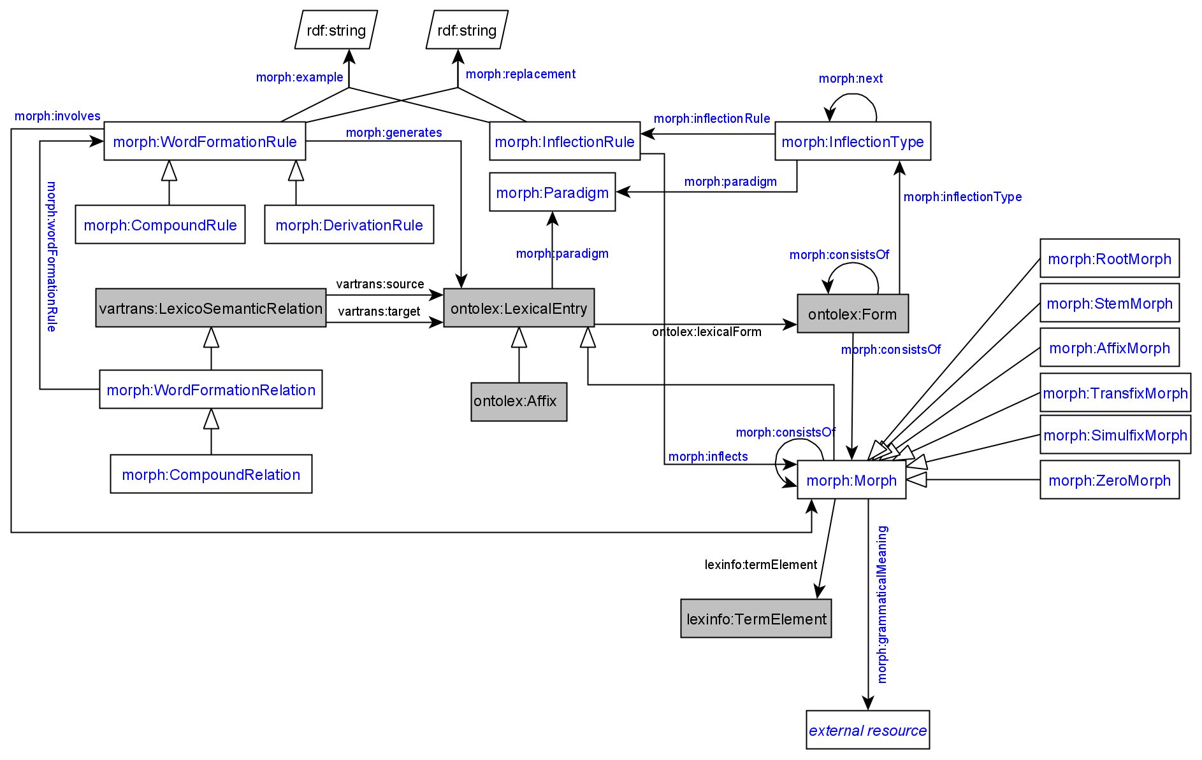

Adaptations of module draft 4.7 to be included for next telco:

* MorphValue is removed and lexinfo:TermElement (includes instances lexinfo:inflectionElement) with property lexinfo:termElement used instead
* remove morph:DerivationRelation (CC in favor of eliminating the redundancy between DerivationRelation subclasses and DerivationRule (would make diagram more readable) because the difference between morph:DerivationRelation and morph:DerivationRule can be expressed in morph:DerivationRule alone
* other proposed changes:
  + merge ontolex:LexicalEntry and ontolex:Affix subclasses, turning ontolex:Affix and morph:Non-Affix subclasses of morph:Morph and sort the morph affix subclasses under ontolex:Affix
  + composition with more than 2 elements resolved by CC by using morph:CompositionalRelation and the decomp vocabulary
  + example (after call):
    - Blutspendezentrale Blut spenden Zentrale “blood donation center” (GermaNet: <https://www.sfs.uni-tuebingen.de/GermaNet/documents/compounds/split_compounds_from_GermaNet16.0.txt>)

<entry#Blutspendezentrale>

decomp:subterm <entry#Zentrale> ;

decomp:subterm <entry#spenden> ;

decomp:subterm <entry#Blut> ;

rdf:type ontolex:LexicalEntry ;

ontolex:canonicalForm <form#Blutspendezentrale> .

<form#Blutspendezentrale>

rdf:type ontolex:Form ;

ontolex:writtenRep "Blutspendezentrale" .

<entry#Blut> rdf:type ontolex:LexicalEntry ;

ontolex:canonicalForm <form#Blut> .

<form#Blut> rdf:type ontolex:Form ;

ontolex:writtenRep "Blut" .

<entry#spenden> rdf:type ontolex:LexicalEntry ;

ontolex:canonicalForm <form#spenden> .

<form#spenden> rdf:type ontolex:Form ;

ontolex:writtenRep "spenden" .

<entry#Zentrale> rdf:type ontolex:LexicalEntry ;

ontolex:canonicalForm <form#Zentrale> .

<form#Zentrale> rdf:type ontolex:Form ;

ontolex:writtenRep "Zentrale" .

<rule#0> morph:generates <entry#Blutspendezentrale> ;

morph:example "Blut + spenden > Zentrale" .

# currently, we only create a rule if there is an interfix involved

[] rdf:type morph:CompoundRelation;

vartrans:source <entry#Zentrale>;

vartrans:target <entry#Blutspendezentrale>.q

1. **ontolex:Form generation workflow diagram**

* for the process of creating the [finnish example data](https://docs.google.com/document/d/1iCv865GtEksO_wd0WC7bfU-at1dEKOOea9HSlFcTTkA/edit) generating:
  + ontolex:Form resources
  + ontolex:Morph resources
  + ontolex:LexicalEntry resources
  + triples: ontolex:LexicalEntry ontolex:lexicalForm ontolex:Form
  + triples: ontolex:Form morph:consistsOf morph:Morph

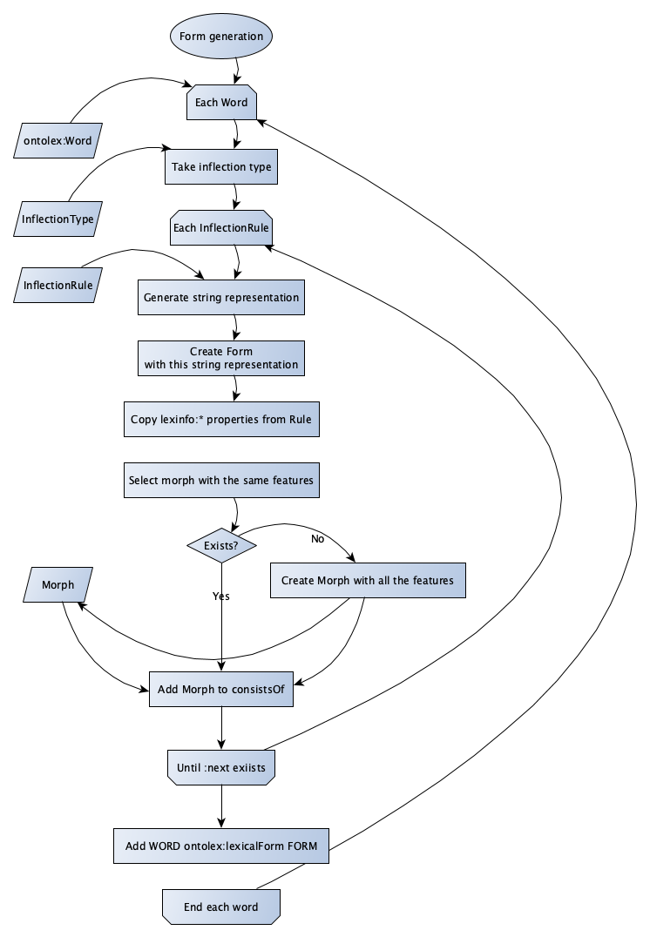

* BK: can we modify this diagram to include ontolex:LexicalEntry wordformation by compounding and derivation as well?

**Todo for today:**

**BK:** look into lexinfo to be reused for MorphValue (CC: we can say "lexinfo:termElement lexinfo:inflectionElement", so MorphValue is not necessary) + create module diagram draft 4.7

**Matteo:** reports about representing compounds in Lila with more than 2 components

**Penny:** shares Greek inflectional data example based on morph module vocabulary

topics for the next telco:

* representing ordering
* creating a property to express <morph#dNV09%3E> morph:PLEASE_GIVE_ME_A_NAME_FOR_CONSTRAINTS "Nn"