**Participants:**

Bettina Klimek (BK)

Jakub Šimek

Max Ionov

Stefania Racioppa (DFKI)

1. **Module draft 4.3**

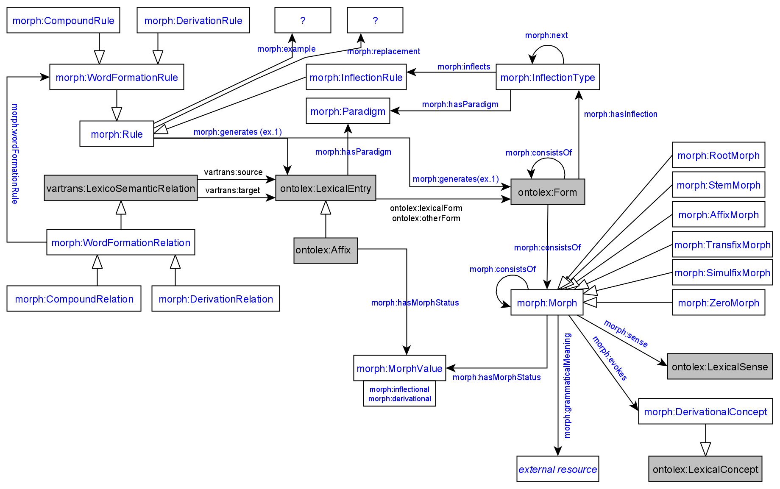

Adaptions of module draft 4.3 to be included for next telco:

* none

**2. Module Draft Evaluation**

Stefania’s [example to apply the vocabulary for generating ontolex:Form resources:](https://docs.google.com/document/d/1stKL92xx-ONhDw9hRshIS65VHY7rkk5Hy6hhHd08BJg/edit?usp=sharing)

Result:

* Representation from full-form lists (explicit statements of forms without paradigm and inflection type information) possible with draft
* Reconstruction from paradigm tables containing only the full forms of an example lemma possible (paradigm and inflection type information given for a lemma and with one full-form paradigm table, e.g. wiktionary tables) with draft (note: wait for Max review)

**Side issue that arised:**

What kind of data is processed by the morph:Rule? As it is now, only strings are processed but these are not interconnected to their respective morph:Morph resources.

That means that in Stefania’s Latin example the resource :form_abdicatio_root has to be discussed for its morphological status (is it really a root, then it should be a morph:RootMorph or is it an ontolex:Form resource, then the “root” should be excluded from the URI)

Is it possible to integrate the written representation strings of morph:Morph resources into the morph:Rule and provide this option in addition to using unrelated strings of the morphs an ontolex:Form consists of?

Max: we proposed already that the object of morph:generates could be a list of grammatical categories (as it is right now: morph:generates [ lexinfo:number lexinfo:plural ]) or a list of morph:Morph resources (then the morph:Morph resources have to exist beforehand):

If we have morph resources:

:rule_01 morph:generates :morph_01

If we don’t:

:rule_01 morph:generates [ ... ]

**3. Representation needs modeling**

Revision of N17-N25 done by Max, see comments of [Telco minutes from 21/07/2021](https://docs.google.com/document/d/1nCq97-G6sruQphBPkZft6F_iSKkJ3Wtd-T2_47o-m1o/edit?usp=sharing)

* all solved with current module draft 4.3
* N25 out of scope, can be removed

Todo next telco on 8th of September:

* Max: review Stefania’s example, proposed solution to problem nb. 2
* Stefania: prepares German compound example data for evaluation
* Max: prepares example data for evaluation
* Bettina: prepares documentation of module draft evaluation, includes results of today