**Participants:**

Bettina

Thierry

Christian

Julia

Francesca

Fahad

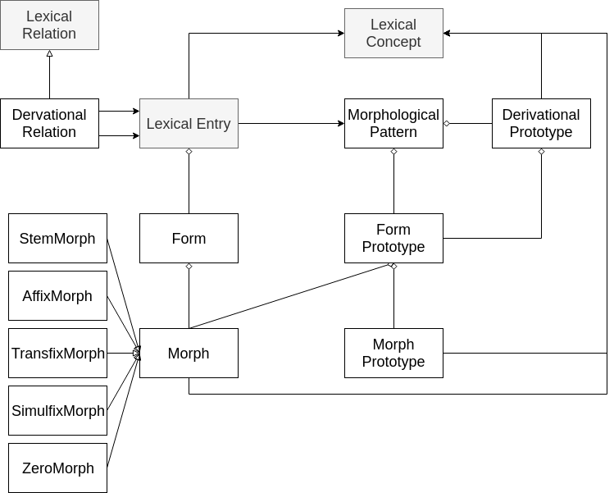

**Representing the lexical entries of which a derived word (as a lexical entry) consists:**

ex:lex_driver a ontolex:LexicalEntry ;

proposal:consistsOfLexEntry ex:lex_drive , ex:lex_er .

*consistsOfLexEntry* for decomposing lexical entries, which can only consist of other lexical entries (not of morphs).

Domain: ontolex:LexicalEntry

Range: ontolex:LexicalEntry

Note: The elements of which a lexical entry consists should be also lexical entries. Equivalently there could be a consistsOfMorphEntry object property for stating of which morph resources ontolex:Form (i.e. wordforms in inflectional paradigms) consist.

Decomp:constituent

Definition: The property **constituent** relates a lexical entry or component to a component that it is constituted by.

Domain: LexicalEntry or Component

Range: Component

decomp:Component

Definition: A **component** is a particular realization of a lexical entry that forms part of a compound lexical entry.

Bettina: the consistsOfLexEntry should interrelate also other parts (i.e. derivational affixes) and not only a “particular realization of a lexical entry that forms part of a compound lexical entry”

Christian: compound is used more technically here, would reuse decomp:constituent

Thierry: is also ok with decomp:constituent

Francesca: for NLP users it is confusing to have compounds composed of morphemes (de-compounding is a specific task)

Thierry: maybe adjust the existing decomp model?! To describe more encompassing properties.

Christian: agrees with Thierry (roughly: vocabulary needs to be consolidated in the end, and existing terminology has to take priority, not for the moment, though)

Fahad: hasAffix, has Root etc. instead of concepts?

Christian: We need an explicit subproperty for zero derivations. As RDF operates under the OWA, we have no other way to make sure a derivRel with only one known consistsOfLexEntry doesn't have more than one.

Bettina: Do you like to have a subproperty of derivRel or consistsOfLexicalEntry?? I think for zero morphs it would be sufficient to use consistsOfLexical entry with a zero morph Morph instance in the object slot.

Fahad: it might be an idea to have more specific properties such as hasRoot and hasAffix/prefix/suffix/infix here instead of the rather generic consistsOfLexEntry

**Stating that a derived word is derived from another (derived) word:**

Ex:lex_driverless a ontolex:LexicalEntry ;

proposal:derivRel ex:lex_driver .

*derivRel* subPropertyof vartrans:lexicalRel

vartrans:lexicalRel

Definition: The **lexicalRel** property relates two lexical entries that stand in some lexical relation.

Domain: ontolex:LexicalEntry

Range: ontolex:LexicalEntry

Note: The lexical entry in the subject slot is alway the derivative of the lexical entry in the object slot.

Christian: as the note indicates, the naming needs to be improved. Can we go for derivedFrom?

Julia: agrees, because position of subject and object slot matter

Christian: derivedFrom can still be a subproperty of vartrans:lexicalRel (doesn’t inherit symmetry)

Christian: could also be a subProperty of consistsOfLexEntry. The latter provides all morphemes, this one only the morphological nucleus

**Relating selected inflectional affixes to lexical entries (related to N12):**

Suggestion 2 (Bettina): link the lexical entry to specific inflectional morphs:

ex:lex_driver proposal:lexicalMorph ex:suffix_s_plural .

**Example**: Many dictionaries contain information about the morphology, this is typically given relative to the lemma, e..g., (from "Langenscheidt Taschenwörterbuch Deutsch als Fremdsprache")

* **Bedingung** die; -, -en
* **Bedürfnis** das; -ses, -se
* **Beitrag** der; -(e)s, Beiträge

*lexicalMorph* as new property

Domain: ontolex:LexicalEntry

Range: proposal:Morph

Note: This property is suggested to enable the plain enumeration of selected inflectional morphs that are usually directly given behind the headword indicating with which affixes certain wordforms are built. It does not make any statement about the exact position of the affix within the stem or potential spelling or pronunciation changes that these affixes my cause to the stem.

John: I don't think this (ex:suffix_s_plural) should be a form, it is a Morph, right?

Bettina: yes, it should be a morph and in reply to Christian, it is not intended to be a resource of the type ontolex:Form. Therefore, I suggest to have it as a new property with the domain and range defined as above.

Julia: would like to separate that information (lexicograph. convention) from lexical level and split it up to wordforms and then specify the affixes

* This kind of recording information could be described with the lexicog module (for recording the stuff you don’t want to lose) - add a usage recommendation to use lexicog module for people who like to keep this kind of information. And go for full wordform listings as default case (--> but how do we record -(e)s as genitive ending if we don’t generate the final form?)

Thierry: linking the full wordforms to the lexical entry instead of selected affixes

Fahad: distinguish intensional and extensional morphology as in LMF

Julia: as label to a lexicog:Entry (~intensional, but not machine-readable)

Others: all forms listed (= extensional)

Christian: could the machine-readable way of capturing this information be a MorphologicalPattern? Definition of MP to be clarified, though.