Morph telco 2022-04-06, 13:00 CET

**Link:** [**https://meet.google.com/nsj-tbcy-yop**](https://meet.google.com/nsj-tbcy-yop)

**Latest Definitions:**  <https://github.com/ontolex/morph/blob/master/draft.md>

**Participants [please add yourself]:**

Christian Chiarcos (CC) [christian.chiarcos@gmail.com](mailto:christian.chiarcos@gmail.com)

Max Ionov (MI)

Katerina Gkirtzou (KG)

Fahad Khan (FK)

Matteo Pellegrini (MP)

Agenda (please add, *but* do not edit table of contents directly, but add sections below and then update here):

**0. Module draft** **1**

**1 LDL submission** **2**

2 Consolidation for LDL submission **3**

2.1 crafting/collecting definitions 3

2.2 OntoLex TermElement vs. Morph subclasses 3

**2 vartrans:orthVariant (Greek/Penny; Old English/Fahad)** **3**

**3 Discussion order for other data** **5**

# 0. Module draft

**draft 4.12 (not updated for today)**

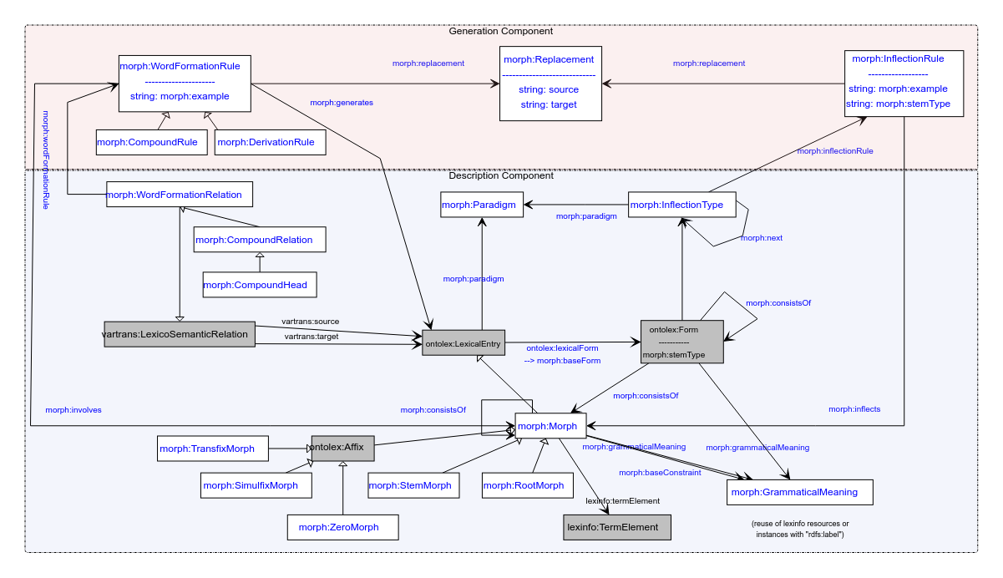

**Model draft 4.13 updates:**

* Rename morph:stemType property in the morph:Form (not in the InflectionRule) => morph:baseType ? (for analogy with morph:baseForm)
  + can be marked on both the baseForm and derived forms, morph:baseForm (or, if absent, morph:canonicalForm) can be used to mark non-derived forms

# 1 LDL submission

could document modelling progress, current status

Deadline: April 8th => 14th

overleaf: <https://www.overleaf.com/4868363189kczjzdndgxwc>

LDL or otherwise?

* SIGUL <https://sigul-2022.ilc.cnr.it/>
* LAW?

Willing to contribute:

* Christian
* Matteo
* Penny
* Max
* Katerina
* ?Fahad (if needed for an example)
  + Potential examples: [wiht - Wiktionary](https://en.wiktionary.org/wiki/wiht#Old_English), [cuman - Wiktionary](https://en.wiktionary.org/wiki/cuman#Old_English)

Doodle poll to discuss the plan and responsibilities: <https://doodle.com/meeting/participate/id/bo2RrRYa>

* idea: diff to 2019 and examples

TBC: which examples?

NB: <https://link.springer.com/chapter/10.1007/978-3-030-98876-0_34>: MMoOn modelling for Greek morphology. Worth a comparison?

# 2 Consolidation for LDL submission

## 2.1 crafting/collecting definitions

* <https://github.com/ontolex/morph/blob/master/draft.md>
* you can contribute suggestions by creating issues (<https://github.com/ontolex/morph/issues>), via pull requests, or by direct editing (share your GitHub username)

## 2.2 OntoLex TermElement vs. Morph subclasses

* <https://www.w3.org/community/ontolex/wiki/Morphology#Fixed_set_of_morph:Morph_classes:_Telco_12.05.2021>
* <https://github.com/ontolex/lexinfo/issues/21>
* question: extend lexinfo (and abandon morph subclasses) or morph subclasses (and replicate lexinfo) ?
  + the current modelling with some subtypes of morph(eme)s modelled as subclasses and others as TermElements is inconsistent
* update: lexinfo also has Infix etc. class, use that instead of lexinfo:termElement
  + tentative consensus

# 2 vartrans:orthVariant (Old English/Fahad)

OE sample data: coman/quoman example, cf. <https://en.wiktionary.org/wiki/cuman#Old_English>

issues with dialects (reference dialect vs. other dialects) and diachrony (phonological processes); treatment of syncopation, suppletion, fusion of different roots [=> variants?] ?

question how to model

Penny/Greek: (old notes)

New examples with vartrans:orthVariant as a vartrans:category (found it more interesting to instead of adding it just as a subproperty). What is still not clear though is how to define that the two (or more) orthographic variants share the same senses and syntactic behaviour.

lexis_data:augo_26232 a ontolex:LexicalEntry ;

rdfs:label "αυγό"@el ;

ontolex:canonicalForm lexis_data:augo_form

lexinfo:partOfSpeech lexinfo:commonNoun ;

morph:paradigm lexis_data:vouno ;

ontolex:sense lexis_data:augo_sense_USem1074 ;

synsem:synBehavior lexis_data:augo_SUNo25013 .

lexis_data:avgo_34067 a ontolex:LexicalEntry ;

rdfs:label "αβγό"@el ;

ontolex:canonicalForm lexis_data:avgo_form

lexinfo:partOfSpeech lexinfo:commonNoun ;

morph:paradigm lexis_data:vouno ;

~~ontolex:sense lexis_data:augo_sense_USem1074 ;~~

~~synsem:synBehavior lexis_data:augo_SUNo25013~~ .

lexis_data:avgo_form ontolex:writtenRep "αβγό"@el .

lexis_data:augo_form ontolex:writtenRep "αυγό"@el .

lexis_data:avgo_orthVariants a vartrans:LexicalRelation ;

vartrans:source lexis_data:avgo ;

vartrans:target lexis_data:augo ;

vartrans:category lexis:orthVariant .

Questions:

* morph namespace instead of lexis for orthVariant?
* any relation with `morph:baseForm` ?

Option with lexicog module works but multiplies the lexical entry data, e.g. senses have to be created for all lexicographic components.

* consensus

→ to be developed as part of the vartrans module but applied in order to connect two ontolex:LexicalEntry resources that only differ in their orthographic representation but share the same senses: a vartrans:orthVariant subproperty of vartrans:lexicalRel that entails that the same senses apply to both variants (restriction has to be formulated)

* possibilities (last time):

1. create separate entries and link them with a subproperty of vartrans:lexicalRel (your_namespace:orthVariant sub vartrans:lexicalRel) between two ontolex:LexicalEntries that are orthographic variants - the shared data of both would have to be repeated for both entries then or it has to be stated only on one lexical entry resource (duplicate all senses)
2. alternatively, leave senses of the variant empty, define in the semantics of orthVariant that this entails that the same senses apply to both variants)
3. use owl:sameAs and share senses (a bit messy, because semantically this means they are the same thing)

# 3 Discussion order for other data

define discussion order for

* FST grammars (German, Christian, <https://github.com/acoli-repo/acoli-morph/tree/main/morphisto>)
* sample data on GDrive
  + where is the link?
* semitic roots
  + last time:
    - FK: need a Semitic example, from the same consonant cluster, we can generate different POSes, <https://en.wikipedia.org/wiki/K-T-B>, <https://en.wiktionary.org/wiki/%D9%83_%D8%AA_%D8%A8>
    - OntoLex limitations: one POS per lexical entry
    - Max: example from Arabic dictionary (<https://en.wikipedia.org/wiki/Dictionary_of_Modern_Written_Arabic>): organized by roots, but root is not made explicit
    - postponed until we have a Semitic speaker
    - Ilan?
      * but first, check Bettina’s conversion of KDictionaries’ Hebrew dict

# 

## 