Morph telco 2022-09-07, 13:00 CET

**Link:** [**https://meet.google.com/nsj-tbcy-yop**](https://meet.google.com/nsj-tbcy-yop) **[check here for link updates if it doesn’t work]**

[**https://meet.google.com/kiw-gfvk-ffk**](https://meet.google.com/kiw-gfvk-ffk)

**Latest Definitions:**  <https://github.com/ontolex/morph/blob/master/draft.md>

**Nexus:** https://nexuslinguarum.eu/the-action/join-us

**Participants [please add yourself]:**

Christian Chiarcos (CC)

Max Ionov (MI)

Katerina Gkirtzou (KG)

Fahad Khan (FK)

Khadija Ait ElFqih (KAE)

Matteo Pellegrini (MP)

Ciprian-Octavian Truică (CT) - excused

Penny Labropoulou (PL) - excused

Elena Simona Apostol (ESA)

Sina Ahmadi (SA)

Elena Benzoni (EB)

Petra Steiner (PS)

# 0. Module draft

**Draft 4.16 (proposal, to be confirmed)**

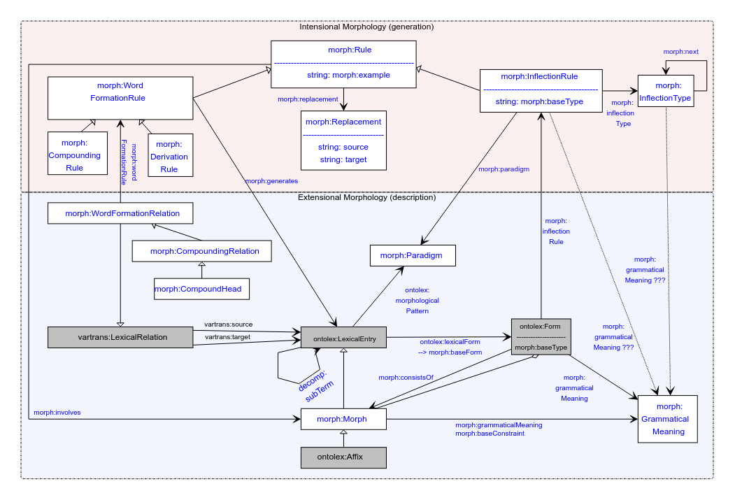

**Draft 4.15 (current)**

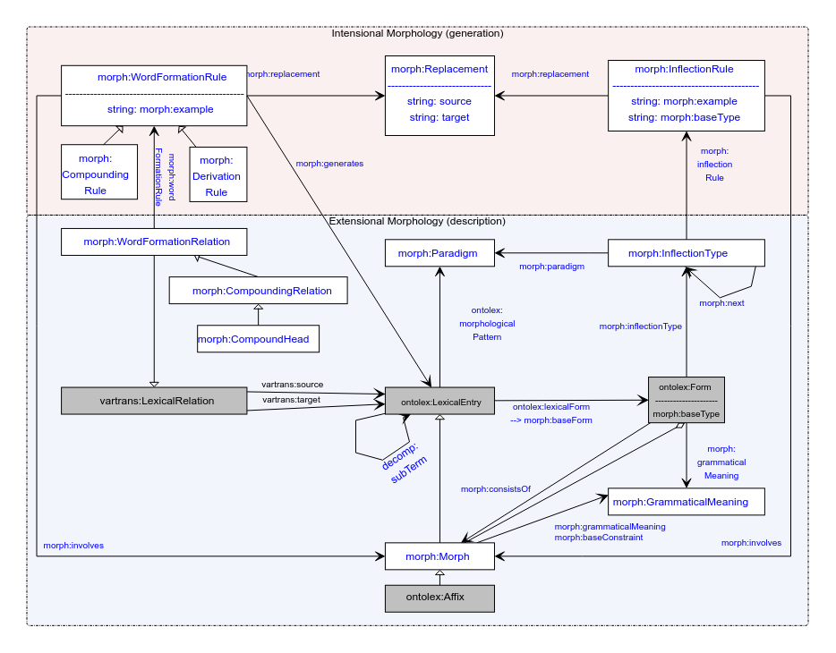

Differences:

1. InflectionType handling: now it is detached and is not necessary to describe, e.g. fusional languages (“alternative 1” — see [minutes 27/07/2022](https://docs.google.com/document/d/1fnYnXWoNFdTHCkTCKwsgMgozspiixuXK6kRE5Q5fGl4/edit#))
2. grammaticalMeaning: linked with inflection rule and inflection type (with question marks, link with inflection type requested by Penny&Katerina)
3. Rule resurrected (only to simplify diagram: holds properties replacement, involves and examples, inherited by inflection rule and word formation rule)
   1. Form -inflectionRule-> InflectionRule
   2. Paradigm <-paradigm- InflectionRule
   3. InflectionRule -inflectionType-> InflectionType
   4. InflectionType -next-> InflectionType

Can diagram 4.16 be confirmed?

* Yes, no objections
* So this is the current version

# 1. Publications

LLODream: discuss offline, coordinate via Slack

* KG: In slack we decided to have Christian and Max as moderators and the rest as contributors for the LLODREAM morph abstract, but I think the submission was done by Matteo
* We also need to decide about presenter, etc.

Otherwise postponed

# 2. Definitions

See <https://github.com/ontolex/morph/blob/master/draft.md> and <https://github.com/ontolex/morph/issues> .

* PS: how to represent order of morphemes (more than one affix)
  + MI: inflectionType next (only for inflection)
  + CC: for derivation, we can decompose it into a tree structure by nesting lexical entries in derivation then order is indirectly encoded
  + CC: we also have an aggregate relation between form and morph, that can be an rdf:Seq [**TODO**: check that this is explicitly mentioned in draft]
    - Proposal@CC (after telco): that should be the preferred answer
* PS: how to represent derivation trees? ((A B) C)
  + CC: has been one of the original requirements (https://www.w3.org/community/ontolex/wiki/Morphology#Representation_needs, "N7: Multiple segmentation strategies")
  + Current solution: use decomp (note we have decomp:subterm already in diagram); if all intermediate steps are valid lexemes, this can also be done via multiple WordFormationRelations (Rules)
* Otherwise postponed, leaving more time for 3.
* CC (after telco): started to check and update requirements in wiki: <https://www.w3.org/community/ontolex/wiki/Morphology#Representation_needs>

# 3. Handling of Semitic languages

Special thanks to Khadija for helping us with some input on Semitic languages. That has been a long-standing desideratum.

* Initial look onto some (which?) arabic data
* Issues with text editor used in telco (direction of Arabic writing) – not a problem in data
  + TODO: any recommended editor for mixed direction writing
* Khadija: can we have multiple writtenReps for different language tags?
  + Yes, e.g., “...”@ar-Latn, “...”@ar
* Deeper look next time

Second telco link:

<https://meet.google.com/kiw-gfvk-ffk>

# 4. AoB

Next call in 4 weeks (in 2 weeks is Nexus MC meeting)