Morph telco 2022-02-08, 13:00 CET

**Link:** [**https://meet.google.com/yzu-bzkd-xbp**](https://meet.google.com/yzu-bzkd-xbp) **[one-time-link; check here for link updates if it doesn’t work]next : https://meet.google.com/irb-dovk-qpy**

**Latest Definitions:** [**https://github.com/ontolex/morph/blob/master/draft.md**](https://github.com/ontolex/morph/blob/master/draft.md)

**Nexus:** [**https://nexuslinguarum.eu/the-action/join-us**](https://nexuslinguarum.eu/the-action/join-us)

**Participants [please add yourself]:**

Christian Chiarcos (CC)

Max Ionov (MI)

Katerina Gkirtzou (KG)

Fahad Khan (FK)

Khadija Ait ElFqih (KAE)

Matteo Pellegrini (MP)

Ciprian-Octavian Truică (CT)

Penny Labropoulou (PL)

Elena Simona Apostol (ESA)

Sina Ahmadi (SA)

Elena Benzoni (EB)

Petra Steiner (PS)

Theodorus Fransen (TF)

Thierry Declerck (DFKI)

Ranka Stanković

Gilles Sérasset (GS)

Mike Rosner (MR)

# 0. Module draft (4.17)

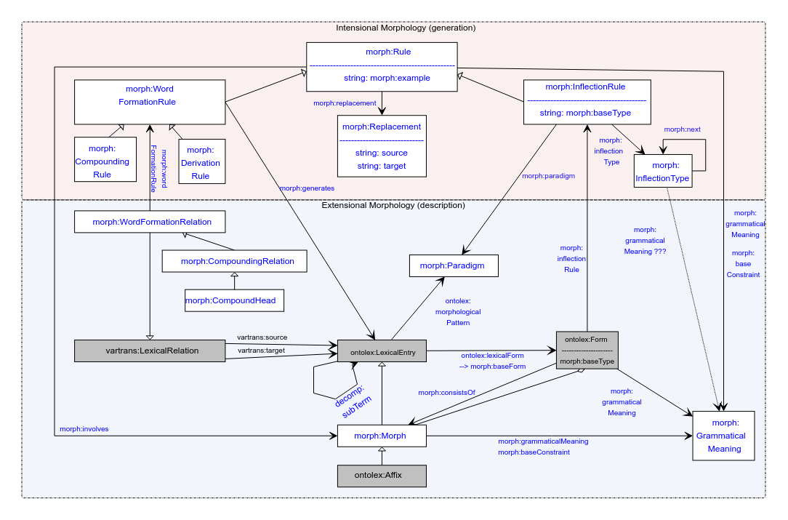

No changes

# Organisational

* MP: What prefix is for morph?
* MI: morph? <http://www.w3.org/ns/lemon/morph> ?

# Publications

## eLex 2023

Didn’t happen, MI apologises

## MWE Chapter

* Deadline March 1st
* Draft for chapter: <https://www.overleaf.com/8285444258rpfnbwgwbrdp>
* Slack channel: #frac-mwe-chapter
* Some gaps
* FK:
  + FK: For what cases do we recommend to use Morph module and not decomp?
  + MP: For Latin we used morph because we needed a reification of the relation between elements (but that was for compounds, not specifically for MWE)
  + CC: When we have an analysis using morphology, we shouldn’t be using decomp, should use morph
  + KG: More generally, if we have something that needs morph classes, we should use morph, if it’s sufficient to just have core ontolex to encode all the information, we can use decomp
  + CC: decomp is not only about structure but also about semantics, which is not modelable in morph
  + FK: if it’s not a semantically transparent MWE (e.g. idiomatic), we can’t use morph? So the suggestion will be to use decomp and not use morph?
  + KG: RDF has the open world assumption, so it’s possible to describe using both morph and decomp
  + CC: What only decomp covers are semantic relationships (roles), what decomp doesn’t cover are morphemes
* FK, CC: The idea is to introduce morph, frac and decomp, in section 2 and use section 3 to applying them to MWEs

## Open questions

* morph:baseConstraint — found only in one example with Inuktitut generation.

In a nutshell, morph:baseConstraint can be used to provide prerequisites for a morph to be compatible. For example

:m1 morph:baseConstraint [ :pos "v" ] .

sets the requirement for the word that this morph can be added to. And morph:grammaticalMeaning holds grammatical categories for the morph itself, as before. But shouldn’t it be only for a Rule, not for a Morph?

# It is 2023, we need to finish the module

* MI: I think we achieved a level where we freeze everything and write it up
* Is there anything we are missing?
  + KG: LREC paper discusses the limitations of the module, we need to look at this, discuss the asap. **TODO@KG**: look into it and add this to the agenda or report it
  + MI: I think that we can still have limitations unsolved for the final module, we just need to explicitly decide
* Should we vote in Slack+mailing list since not everyone is in the call (*prediction*)
  + CC and MI should decide, then send to OntoLex chairs to approve
  + TODO@MI,CC: discuss
* Thoughts?
  + FK: maybe we still need more discussions, especially w.r.t. Semitic languages
  + FK: maybe we can take a couple of Wiktionary examples, model them (naively) and then show to experts (Mike, Khadija, Ilan)
  + FK: it is very important that we deal with non-European languages (non-Indo-European), so we need to make sure that we *can* model at least a good sample of languages of the world
  + MR are we going to try to handle Maltese data of [this kind](https://docs.google.com/document/d/1Z7z36kjzgTjLCB3YJswqzh1lLhN9GDKZ2ecACcXYeqI/edit?usp=sharing)? If so I would be glad to help.

# Handling of Semitic languages [maybe today]

**TO-BE-DONE**: figure out how to include missing categories to LexInfo

Khadija: data prepared for Arabic (cf. last time):

* [Morph Module semitic.odt](https://drive.google.com/file/d/1NST-qdkxAw7am6F3vGAap5o4eQv0ulV1/view?usp=sharing)

Necessary features:

* lexinfo:POS extensions (solved? See last call minutes for procedure)
* Modelling diacritics in Arabic (cf. call minutes last time)
  + Also cf. Umlaut in German and vowel harmony in Turkish for similar challenges
    - Recommendation (< GS): NFD normalization in morph:Replacement
    - **TBC:** are we ok with modelling roots as Morphs (i.e., LexicalEntries)?
  + If not modelled as morphs, then they could be modelled as rules (replacements)
    - **DONE@CC**: model updated
      * morph:grammaticalMeaning and morph:baseConstraint as properties of morph:Rule, the grammatical meaning is the change in meaning or morphology of the word (root)
    - **TO-BE-DONE@FK:** model a Hindi/Urdu example, e.g., <https://en.wiktionary.org/wiki/%E0%A4%96%E0%A5%81%E0%A4%B2%E0%A4%A8%E0%A4%BE#Hindi>
    - **TO-BE-DONE@Khadija:** Modelling examples for Arabic entries
* Not discussed yet: Circumfix
  + Morph:CircumfixParadigm
  + Prefix+suffix combination

## AoB ?

* We moved weeks, is that okay for everyone?
* Next call: 25.01.23