**Participants:**

Bettina Klimek (BK)

Max Ionov (MI)

Matteo Pellegrini

https://datathon2022.linkeddata.es/

1. **Module draft 4.10**

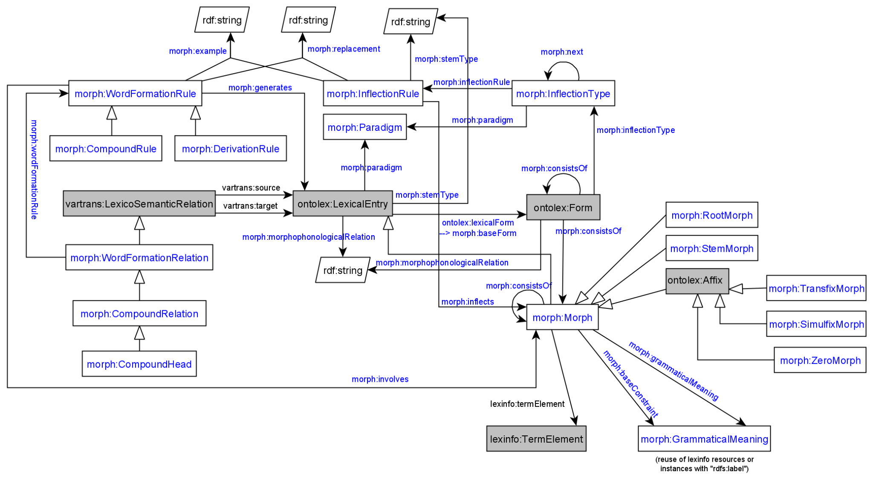

Adaptations included into module draft 4.10:

* added domain ontolex:LexicalEntry to property morph:stemType

Adaptations to be included into module draft 4.11:

* create morph:MorphosyntacticPropertySet
* add ontolex:Form as domain of morph:grammaticalMeaning and morph:MorphosyntacticPropertySet as range

OR

* create morph:MorphosyntacticPropertySet as a subclass of morph:GrammaticalMeaning
* add ontolex:Form as domain of morph:grammaticalMeaning

**Latin inflectional data example by Matteo (continued from telco on 26.01.2022)**

URL to presentation: slide 28 ongoing<https://drive.google.com/file/d/1v2M-LbCdrdaPl2LVuPKzOfU-fQjv_5_1/view?usp=sharing>

* establish a latinflexi:MicroClass in order to apply the LiLa modeling to the morph module vocabulary
  + CC: is latinflexi:MicroClass similar to morph:InflectionType? MP: yes, the idea is that the concatenation of all patterns is the inflection type
* latinflexi:fillsCell domain ontolex:Form and domain latinflexi:Cell, latinflexi:Cell is the intersection of lexeme and the paradigm cells with the morphosyntactic properties and values expressed by a form
  + MP question: is a link between a Form and the whole set of infl. property-values like latinflexi:fillsCell in the morph module? CC: the latinflexi:Cell class accumulates all grammatical meanings of a form but there are different ways to express grammatical meanings across datasets
  + In LiLa inflection dataset this would be the only way to express the grammatical meanings, which are linked to a full wordform and not their individual morphs
  + CC: another less-ambiguous name for latinflexi:Cell would be helpful to differentiate it from morph:grammaticalMeaning, e.g. morphosyntactic property set

Max current inflectional modeling :

lexinfo:tense lexinfo:present ;

lexinfo:person lexinfo:secondPerson ;

lexinfo:number lexinfo:singular ;

ontolex:writtenRep "amas"@es .

MP: the ontolex:Form should be able to be linked to a set of these lexinfo morphos. features as one resource (= latinflexi:Cell)

<#spanish_verb_type_1a_amar_conj_2sg> a morph:Morph ;

lexinfo:tense lexinfo:present ;

lexinfo:person lexinfo:secondPerson ;

lexinfo:number lexinfo:singular ;

ontolex:writtenRep "-as"@es .