**Participants:**

Bettina Klimek (BK)

Jakub Šimek

Matteo Pellegrini

Julia Bosque-Gil (UNIZAR)

Stefania Racioppa (DFKI)

Max Ionov (GUF)

Fahad Khan (CNR)

1. **Module draft 4.1**

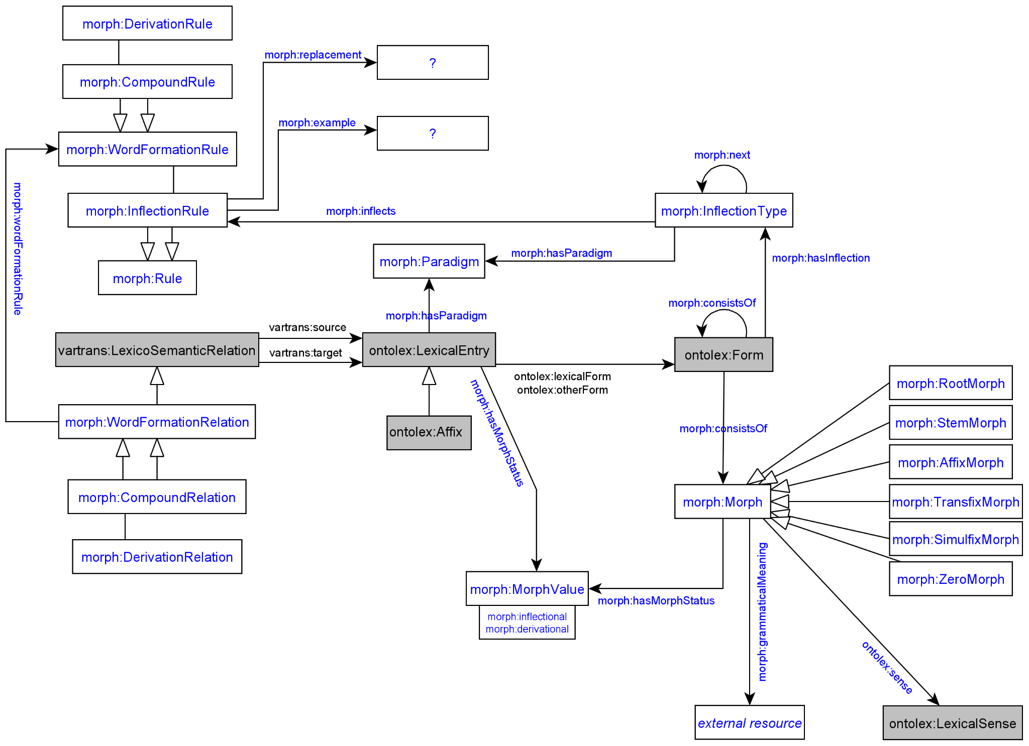

Adaptions of module draft 4.1 to be included for next telco:

* insert morph:generates from moprh:InflectionRule to ontolex:Form
* property morph:evokes with morph:Morph in domain and ontolex:LexicalConcept (DerivationalConcept as subclass) in range
* property morph:sense with morph:Morph in domain and ontolex:LexicalSense in range
  + JBG> With the use of ontolex:LexicalSense we are assuming an ontological reference, so we might run into the same problems as the ones we found when converting dictionaries (which ontological references to point to?). Since in the lexicog specification we opted to stick to ontolex:LexicalConcepts for the meaning of lexical entries in the conversion of dict entries to LLD, why would we want to point to LexicalSense in this case, instead of Concept?

1. **Vocabulary for N4: Inflectional paradigm**

Proposed definitions as of telco from [10.12.2019](https://docs.google.com/document/d/1wybx2_U0EcqmefRRiAABha-cFII6H2rZBtlgTcjLYjg/edit?usp=sharing)

## Classes

### morph:Paradigm

A class that represents a theoretically motivated type of declination, e.g.

* “a” stem declension in Latin
* First declension in Russian

*May* contain metadata information about this type of declination.

**Book analogy**: a full paradigm table with possible allomorphy/alternative variants

### morph:InflectionType

A class that represents a single slot for a single grammatical category for all its possible values (e.g. all the cases)

**Book analogy**: a column from a paradigm table *without* allomorphy/alternative variants for just a single morpheme

### morph:Rule

A class containing necessary information to add **one morpheme** to **a single word form**. It *must* contain either morph:example or morph:replacement (or both). “Tabular” value of a morpheme *must* be stored in rdfs:label (e.g. “-s”@en for usual PL in English)

## Properties

### morph:paradigm

**Domain**: morph:InflectionType

**Range**: morph:Paradigm

A link to the paradigm for the inflection type

### morph:example

**Domain**: morph:Rule

**Range**: string literal

A single generated form that was generated using this rule

### morph:next

**Domain**: morph:InflectionType

**Range**: morph:InflectionType

Links two consecutive inflection types (“slots”), e.g. number and case in Finnish

### morph:inflects

**Domain**: ontolex:Word

**Range**: morph:InflectionType

A link to the first “slot” (inflection type), e.g. an inflection type for number for English nouns

### morph:inflectionType

**Domain**: morph:Rule

**Range**: morph:InflectionType

### morph:replacement

**Domain**: morph:Rule

**Range**: [morph:source, morph:target, both are string literals]

### morph:generates

**Domain**: morph:Rule

**Range**: unrestricted?

BK: currently missing in draft image, does the inflection rule generate the ontolex:Form resources? yes

**3. Representation needs modeling**

**modeled as draft:**

**N11: Meanings of stems and roots**

BK proposal: The description of meanings of stems and roots could be realized in the same way as the description of meanings of lexical entries as given in ontolex. For the representation of roots maybe external resources such as Concepticon could be recommended or the possibility of a plain textual definition could be established in addition.

Extend domain of ontolex:sense: domain: ontolex:LexicalEntry and morph:StemMorph and morph:RootMorph

JMC: not in favour of extending ontolex:sense domain with morph:Morph, proposes new property morph:sense with ontolex:LexicalSense and another Concept class

draft: property morph:sense with morph:Morph in domain and ontolex:LexicalSense in range

**not modeled yet:**

**N12: Derivational Meanings**

John: Model derivational meanings as concepts and link morph instances to this concept.

Fahad: Ignore examples with lexicalized words (e.g. computer). We do not need to model too deeply - just state “diminutive”.

John: Proposes to have DerivationalConcept as subclass of ontolex:Concept (but no need for InflectionalConcept subclass).

property morph:evokes with morph:Morph in domain and ontolex:LexicalConcept (DerivationalConcept as subclass) in range

**N5: Morphology crosses part-of-speech boundaries (derivation)**

BK proposal: use established means for derivation to represent conversion and specify zero morph, e.g. “play” (noun):

ex:lex_play_noun ontolex:lexicalForm ex:form_play_noun_sg .

ex:form_play_noun_sg morph:consistOf morph:ZeroMorph .

WFL: implemented alternative option by creating wfl:ConversionRelation with no zero morph

**N6: Morphs linked to Lexical Entries**

BK proposal: created object property morph:morphologicalForm (in parallel to ontolex:lexicalForm) with domain ontolex:LexicalEntry and range morph:Morph

→ different positions on whether this should be representable in the module at all because all information/data is already covered with the vocabulary and it is a need of space-restricted print dictionaries - discuss again later