**Participants:**

Bettina

Max

Fahad

Maria

## Form Generation

Initial idea:

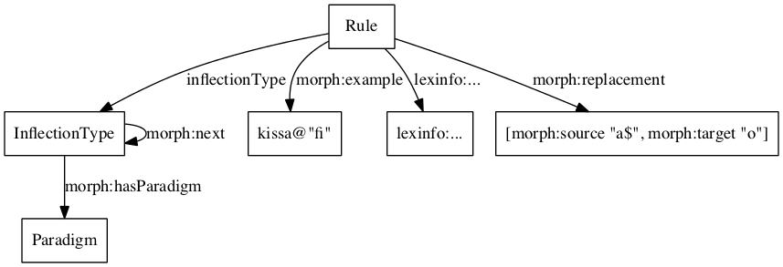

Reversed:

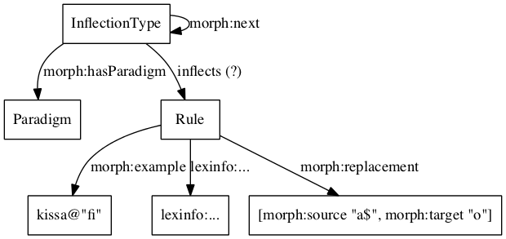

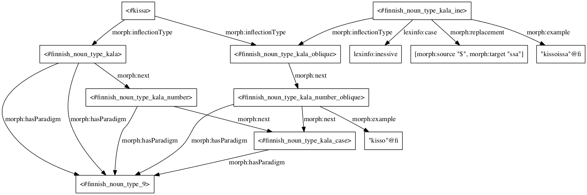

Ontolex connection:

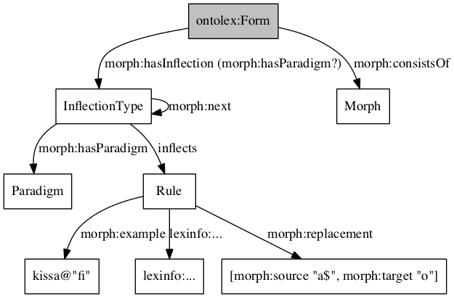

Connection to Morph

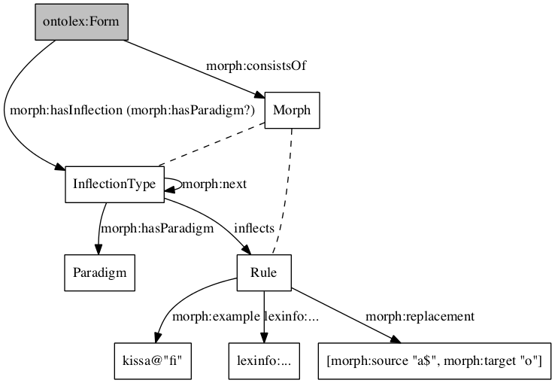

Problems (?):

1. Recursive forms
2. Detachable affixes (clitics)
3. ???

Bettina notes:

* morph:MorphologicalPattern replaced with max:Paradigm (different naming but the same)
* morph:InflectionalParadigm replaced with max:InflectionType
* Proposal works for derivation and inflection, question: double the vocab for inflection and derivation or choose a new more neutral (and maybe more technical) vocabulary that covers both processes?
* Where is the data for max:InflectionType and max:Rule coming from?! What is the minimal dataset to apply this generation process? A: dataset should contain forms, inflection types and rules.

To do for next telco:

Max prepare documentation for how to create all forms of a finnish noun in for one case. Including: description of input data (in ontolex RDF or other structured data), description of how to use presented modelling, SPARQL query for the generation process and what the created output data would look like.