**Participants:**

Bettina

Max  
Julia  
Fahad

**Updated modelling draft for automatic generation process of ontolex:LexicalEntry and ontolex:Form instances**

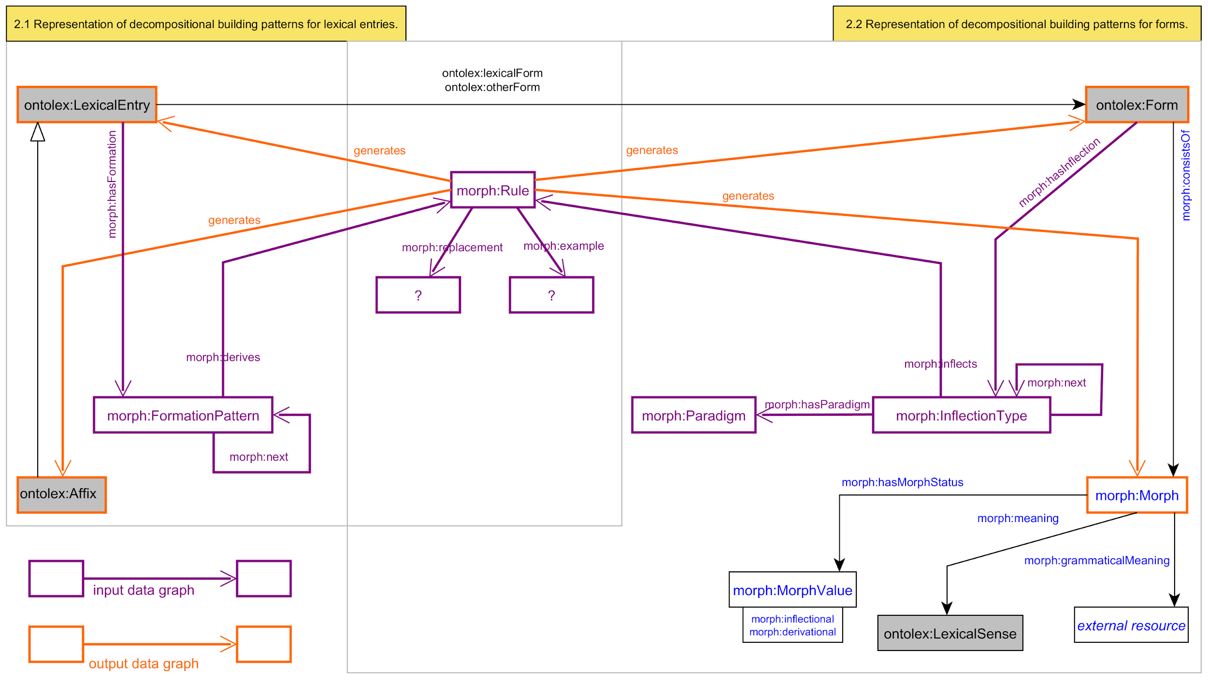

**Modelling issues:**

* What to do with morph:MorphologicalPattern, morph:belongsToMorphPattern, morph:InflectionalParadigm and morph:hasParadigm? Substitute completely?
* What classes have to be created for the two indicated “?” placeholders?
* Keep two separate diagrams: one for decomposition and one for generation or merge both into one diagram?

**Current modelling draft (as published in eLex paper)**

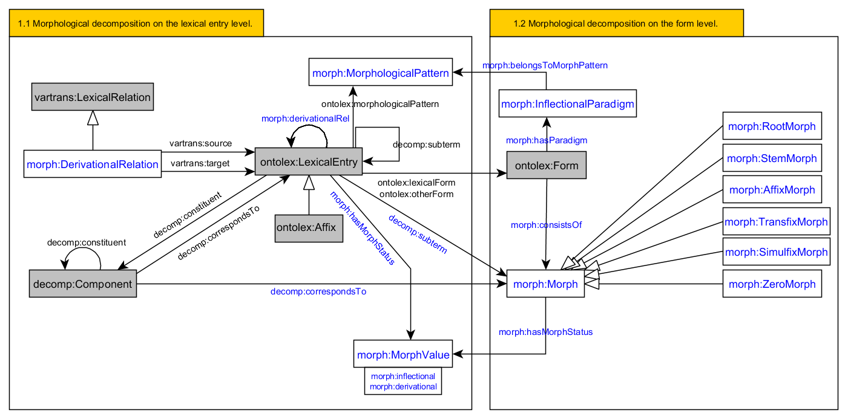

Original ontolex:morphologicalPattern

Definition: The 'morphological pattern' property indicates the morphological class of a word.

domain: ontolex:LexicalEntry

**Todo Max:**

Definition of Max’ new elements:

Classes:

Properties:

**Todo Bettina: Adjust diagram according to Max definitions.**

**Spanish example (synthetic, fusional)**

@prefix : <file:///Users/max/Projects/LiODi/Ontolex-morph/dataset-generation-example.ttl#> .

@prefix rdf: <http://www.w3.org/1999/02/22-rdf-syntax-ns#> .

@prefix ontolex: <http://www.w3.org/ns/lemon/ontolex#> .

@prefix lexinfo: <http://www.lexinfo.net/ontology/2.0/lexinfo#> .

@prefix morph: <https://www.w3.org/community/ontolex/wiki/Morphology#> .

@prefix rdfs: <http://www.w3.org/2000/01/rdf-schema#> .

# Morphology with only one segment

# Can still have InflectionTypes for assimilation

# If we have morph:example provided for each Rule, we have all the forms already generated. We don't have to, though.

<#amar> a ontolex:Word ;

ontolex:canonicalForm [ontolex:writtenRep "amar"@es];

morph:inflects <#spanish_verb_type_1a> .

<#comprar> a ontolex:Word ;

ontolex:canonicalForm [ontolex:writtenRep "comprar"@es];

morph:inflects <#spanish_verb_type_1a> .

<#spanish_verb_type_1> a morph:Paradigm ;

rdfs:comment “Theoretically motivated Spanish conjugation type 1” .

<#spanish_verb_type_1a> a morph:InflectionType ;

morph:paradigm <#spanish_verb_type_1> ;

morph:example "amar"@es .

# *** CASES ***

<#spanish_verb_type_1a_amar_1sg> a morph:Rule ;

morph:inflectionType <#spanish_verb_type_1a_amar> ;

lexinfo:tense lexinfo:present ;

lexinfo:person lexinfo:firstPerson ;

lexinfo:number lexinfo:singular ;

morph:example "amo"@es ; # optional

morph:replacement [morph:source "ar$"; morph:target "o"] .

<#spanish_verb_type_1a_amar_conj_2sg> a morph:Rule ;

morph:inflectionType <#spanish_verb_type_1a_amar> ;

lexinfo:tense lexinfo:present ;

lexinfo:person lexinfo:secondPerson ;

lexinfo:number lexinfo:singular ;

rdfs:label “-as” ;

morph:example "amas"@es ; # optional, but if we provide it, all the examples are here

# morph:replacement [morph:source "ar$"; morph:target "ás"] ; # in principle, this should probably be a separate InflectionType. Or not?

morph:replacement [morph:source "ar$"; morph:target "as"] .

An example for a language with just one “slot”, but with not much weird stuff going on (relatively)

**Sanskrit example (synthetic, *extremely* fusional)**

@prefix : <file:///Users/max/Projects/LiODi/Ontolex-morph/dataset-generation-example.ttl#> .

@prefix rdf: <http://www.w3.org/1999/02/22-rdf-syntax-ns#> .

@prefix ontolex: <http://www.w3.org/ns/lemon/ontolex#> .

@prefix lexinfo: <http://www.lexinfo.net/ontology/2.0/lexinfo#> .

@prefix morph: <https://www.w3.org/community/ontolex/wiki/Morphology#> .

@prefix rdfs: <http://www.w3.org/2000/01/rdf-schema#> .

# Morphology with tables

# There are no rules/transformations, only examples

<#kāma> a ontolex:Word ; # if we shouldn't use unicode, we need to encode URIs

ontolex:canonicalForm [ontolex:writtenRep "kāmaḥ"@sa];

morph:inflects <#sanskrit_noun_type_a_stem> .

<#sanskrit_noun_type_kama> a morph:InflectionType ;

morph:paradigm <#sanskrit_noun_type_a_stem> ;

morph:example "kāmaḥ"@sa .

# *** CASES ***

<#sanskrit_noun_type_kama_nom_sg> a morph:Rule ;

morph:inflectionType <#sanskrit_noun_type_kama> ;

lexinfo:number lexinfo:singular ;

lexinfo:case lexinfo:nominative ;

morph:example "kāmaḥ"@sa .

<#sanskrit_noun_type_kama_acc_sg> a morph:Rule ;

morph:inflectionType <#sanskrit_noun_type_kama> ;

lexinfo:number lexinfo:singular ;

lexinfo:case lexinfo:nominative ;

morph:example "kāmam"@sa .

<#sanskrit_noun_type_kama_nom_dual> a morph:Rule ;

morph:inflectionType <#sanskrit_noun_type_kama> ;

lexinfo:number lexinfo:dual ;

lexinfo:case lexinfo:nominative ;

morph:example "kāmau"@sa .

This is an example with a language where it’s not really wise to give any rules for transformation, just a table (at least, this a morphological tradition → no morph:replacement, only morph:example).