Morph telco 2022-06-15, 13:00 CET

**Link:** [**https://meet.google.com/nsj-tbcy-yop**](https://meet.google.com/nsj-tbcy-yop) **[check here for link updates if it doesn’t work]**

**Latest Definitions:**  <https://github.com/ontolex/morph/blob/master/draft.md>

**Latest Paper (LDL-2022):** <https://www.overleaf.com/4868363189kczjzdndgxwc> (folder submission/)

**Participants [please add yourself]:**

Christian Chiarcos (CC) [christian.chiarcos@gmail.com](mailto:christian.chiarcos@gmail.com)

Max Ionov (MI)

Katerina Gkirtzou (KG)

Fahad Khan (FK)

Matteo Pellegrini (MP)

Ciprian-Octavian Truică (CT)

Penny Labropoulou (PL)

Elena Simona Apostol (ESA)

Sina Ahmadi (SA)

Elena B.

Agenda (please add, *but* do not edit table of contents directly, but add sections below and then update here):

**0. Module draft** **2**

**1. Publications** **3**

2. definition consolidation **4**

**3. AOB** **5**

# 

# 0. Module draft

**draft 4.15**

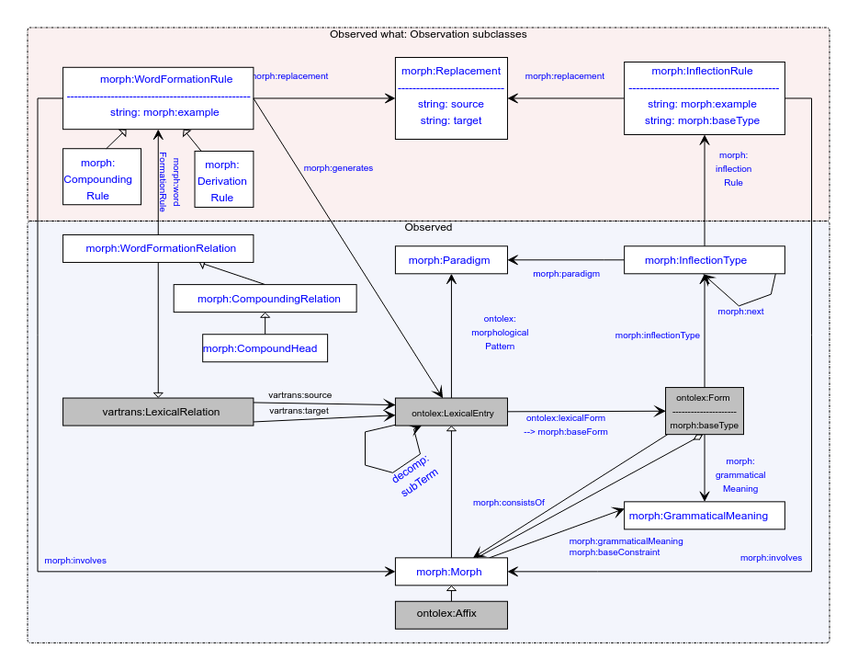

**updates from 4.14**

* consistsOf changed according to tentative consensus last time:
  + drop consistsOf
    - between morph and morph
    - between form and form
    - *keep* between form and morph
      * we need consistsOf to mark *morphological* segments in case somebody else defiunes a form as an aggegrate of sth else
    - **TODO@all**: think about whether you ever used one of the dropped consistsOf properties
  + define ontolex:Form as container (seq, aggregation) of morphs to reflect absolute order
    - => rdfs:_1 etc. to encode position
    - Note: distinguish prefix, suffix and infix if relative order is needed or no absolute order can be given
  + Matteo: why changes to consistsOf?
    - CC:
      * formal reasons: defining domain and range of consistsOf with a single class
      * didactic reasons: more readable diagram
      * theoretical reasons: if morph(eme)s are minimal elements, how can they have parts? what is the value of a morphological conisistsOf relation between forms if they are not mediated by a morphological unit?
      * practical reasons: such data doesn’t seem to exist (and if it does, it can still be modelled)
  + Matteo: can we still model that a form consists of multiple forms
    - Christian: yes, but indirectly, only:
      * 1 form -> n morphs (= LexicalEntry) -> n forms
      * or using decomp: morph = morph1 + morph2
    - does such data exist?
      * Max: diachronically, two morphemes combined into one, synchronically no longer transparent
      * Christian: alternative views on circumfixes: circumfix or prefix+suffix
      * it seems that no such data*set* exists

**Model draft 4.16 updates (to be discussed) & open issues:**

* inflection type to be discussed

# 1. Publications

* LDL
  + status: accepted and final submitted
  + presentation: 11:50-12:10, 15+5
    - LiLa+Lexis 1 presenter
      * Matteo not attending (Marco?)
      * Penny and Katerina attending
    - gen+overview
      * CC or Fahad?
    - presentation slides: <https://docs.google.com/presentation/d/1st1snmgOYM4lwPj4Pai-w7KuQ0BfcqIZNvDC5R1MEpU/edit?usp=sharing> (template can be changed at any time; for now added the fonts, colours and logo of Nexus)
* general OntoLex overview
  + ?ESWC: Deadline?
    - ESWC: 2 Dec 2021 for ESWC2022 -> there are no dates for the ESWC2023 CFP as the ESWC2022 is between 29th May and 2nd June
  + update of OntoLex, incl. FrAC, Morph, MModality
* paper on word formation?
  + idea for novel paper: word formation in OntoLex-Lemon
    - not original content, but more like a survey and documentation of best practices?
    - can be helpful to consolidate/revise word formation part of the module
    - possible input from LiLa
    - **TODO@all:** think about possible venues
* LLODREAM? <https://easychair.org/cfp/llodream2022>
  + OntoLex-Morph status update
  + last time: we’d like to do that
  + deadline june 23rd
    - 350 -400 words
  + contributors (order tbd)
    - Christian
    - Max
    - Fahad
    - Matteo
    - Marco
    - Penny
    - Ciprian
    - Katerina
    - Elena A.
  + topic: motivation / general overview
    - sth more specific?
  + **todo@Penny**: GDoc link
    - **todo@all**: co-write
    - <https://docs.google.com/document/d/1a7OWCgcD6qDYPta0shiIh6CzWTw7E1ptnwQKXVA4xDo/edit> (only template as in the conference site)
* later journal paper
  + After the final publication
  + Or: an overview of the current state. Frac + Morph or Frac separately, Morph separately?
  + (at some point) a book?

# 2. definition consolidation

* **standing TODO@all**: provide/refine/review definitions
  + under <https://github.com/ontolex/morph/blob/master/draft.md>
  + technical definitions, but linguistic explanation (“definition”) in text
  + **@all**: you can contribute suggestions by creating issues (<https://github.com/ontolex/morph/issues>), via pull requests, or by direct editing (share your GitHub username)
  + procedure: for definition refinement:
    - open an issue
    - pull request + close the issue
* status:
  + pull requests by Matteo and Penny *merged*
  + draft contains now a number of notes
  + **more consolidation needed**
* model overview for Elena B. and Sina
* Sina: Allomorphs?
  + depending on data source, morph:Morph can be used to represent morphemes (incl. all different forms), but also independent allomorphic variants on their own. they are not marked as allomorphs, though
* Sina: The necessity of adding more specifications to ontolex:Affix was raised by Sina asking whether it’d make sense to have bound morphemes and free morphemes specified along with affixes and clitics.
  + Christian suggested to add that to lexinfo. (we had that in morph, but moved it to lexinfo because other morph subclassed [suffix, prefix, infix] were defined there already and users should work with a single namespace for these)
* Sina: Should reduplications be added to the formation part?
  + not clear whether this would be word formation or inflection, can be modelled, but we cannot mark a reduplication rule as a reduplication rule (do we have to? is there any such data?)
* Sina: how to model type of morphemes, e.g., clitics?
  + not in morph, but using lexinfo (e.g., lexinfo:cliticness)
  + but this doesn’t allow to model types of clitics => could be added to lexinfo
* Sina: how to model cliticization?
  + could be modelled (depending on theoretical background/language features) as inflection rule, as word formation rule or by decomp
  + Max: we can model cliticization, but we better leave the details of modelling open to accomodate different theoretical views
    - there was an example from Stefania (Italian), modelling is a bit dated, though
    - Fahad: e.g., in Italian: <https://en.wiktionary.org/wiki/andiamoci>
      * Matteo: representing this as compound isn’t quite right …
      * Fahad: <https://en.wiktionary.org/wiki/andarsene>
  + **TODO@Sina**: provide sample data, maybe we can come up with a recommendation
* **TODO@next time**: brief overview over inflection part of the diagram for Sina and Elena (@Max?)

# 3. AOB

next call in two weeks

CC, after call: 4 weeks?