**Participants:**

Bettina

Thierry

Fahad

Maria

Ilan

Max

Julia

John

Adrian

**Modelling Paradigms**

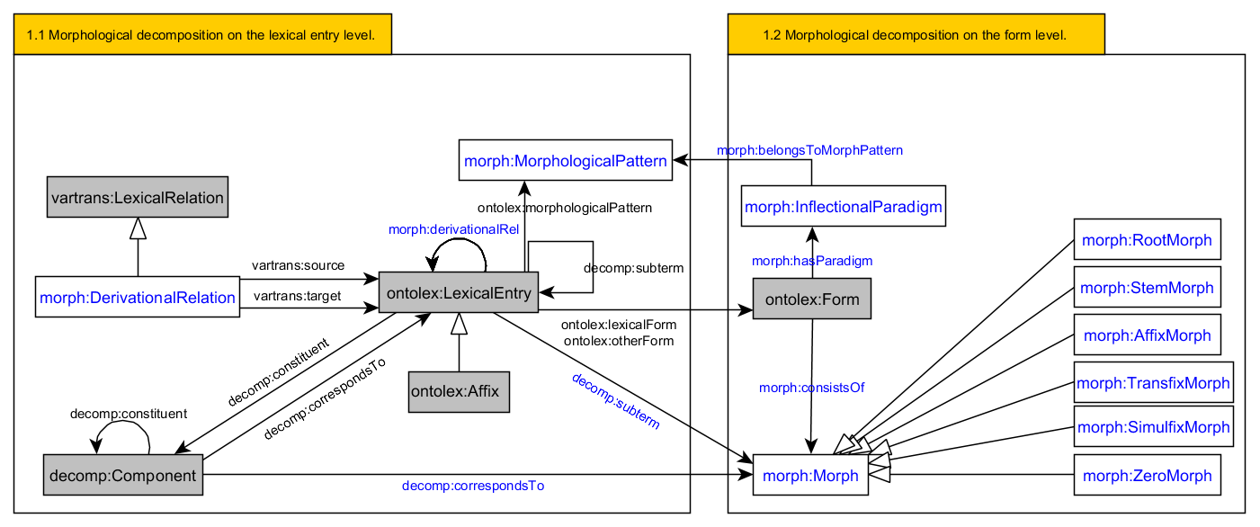

ontolex:morphologicalPattern: The **morphological pattern** property indicates the morphological class of a word. Domain: LexicalEntry

Example code from OntoLex-Lemon specification:

:amare ontolex:morphologicalPattern :latin_regular_conjugation ;

ontolex:canonicalForm :amare_form .

:amare_form ontolex:writtenRep "amare"@la .

:videre ontolex:morphologicalPattern :latin_second_conjugation ;

ontolex:canonicalForm :videre_form .

:videre_form ontolex:writtenRep "videre"@la

Example code for proposal:

:amare ontolex:morphologicalPattern :latin_regular_conjugation ;

ontolex:canonicalForm :amare_form ;

ontolex:otherForm :amo_form ,:amas_form ,:amat_form .

:amo_form morph:hasParadigm :present_indicative_active .

:present_indicative_active a morph:InflectionalParadigm ;

morph:belongsToMorphPattern :latin_regular_conjugation .

**Modelling inflectional, derivational, etymological morph via values**

Proposal:

* Create morph:Morph_value class for the three instances
* Creating three individuals morph:inflectional, morph:derivational, morph:etymological as values
* Create property morph:has_morph_status

:Morph_value

a owl:Class ;

~~owl:equivalentClass~~

~~[ a owl:Class ;~~

~~owl:oneOf (:inflectional :derivational :etymological)~~

~~]~~ .

:inflectional

a :Morph_value ;

owl:differentFrom :derivational ~~, :etymological~~ .

:derivational

a :Morph_value ;

owl:differentFrom :inflectional ~~, :etymological~~  .

~~:etymological~~

~~a :Morph_value ;~~

~~owl:differentFrom :inflectional , :derivational .~~

:has_morph_status

a owl:ObjectProperty , owl:FunctionalProperty ;

rdfs:domain :Morph , ontolex:Affix.

rdfs:range :Morph_value .

English comparative suffix -er:

:Suffix_er a morph:SuffixMorph ;

:has_morph_status morph:inflectional .

**Defining morph:Morph**

mmoon:Morph definition:

A morph is a concrete realization of a single morpheme which usually results from segmentation.

Haspelmath and Sims 2013: *Understanding Morphology:*

Morph: A concrete primitive element of morphological analysis.

Lehmann:*Lido*: definition of ‘morph’

A morph is an uncategorized smallest meaningful unit as resulting from segmentation. It manifests the morpheme.

Lehmann:*Lido*: definition of ‘morpheme’:

A morpheme is a smallest linguistic sign, i.e. a smallest unit that is semantically distinct from all other signs of the language.

Delimitation and History:

The significance of the two conditions of the definition is as follows:

1) A morpheme is irreducible to smaller significative units; i.e. what results if it is segmented may only be distinctive units. This condition distinguishes it from larger units, esp. the word.

2) To be distinct from all other morphemes of the language, it isn’t allowed to be in complementary distribution or free variation with another morpheme. This condition distinguishes it from the morph.

Glottopedia Entry for ‘Morph’

Morph is a term which refers to alternative forms or realizations of a single morpheme.

Example:

the English plural suffix is found in precisely three different pronounciations, /s/, /z/, and /@z/: cats /kats/, dogs /dogz/, and horses /ho:s@z/. Since these three elements all represent a single morpheme, they are called morphs, and we say that /s/, /z/, and /@z/ are allomorphs of the abstract or underspecified plural suffix /-Z/.

University Düsseldorf [Glossary](https://www.uni-due.de/ELE/LinguisticGlossary.html) entry for ‘Morph’:

Any item of language which cannot be broken down any further without a loss of meaning. A morph usually realises a morpheme, the unit of grammar on an abstract level, e.g. /ʌn/ in *undoable* but also /ɪm/ in *impossible*.

**Discussion for the definition of morph:Morph:**

It must clearly state that the instances of this class cannot be lexical entries. This is what distinguishes it from ontolex:Affix which could otherwise be a subclass of morph:Morph. I would also avoid to reduce it to inflectional morphs because it hinders the description of phonological alternations that can be involved in forming word-forms with morph:Morph resources.

Max: - state that it does not carry a meaning but corresponds to meanings

Julia, John, Max, Bettina and others agreed on using Haspelmath’s definition.

Use it for now, wait until new insights, comments arise and eventually discuss it again:

“A concrete primitive element of morphological analysis.”

* State Haspelmath as source of the definition
* Create disjoint class axiom between Morph and LexicalEntry cannot be lexical entries