**Participants:**

Bettina

Maria Pia

Giulia

Stefania

John  
Julia

MMoOn example for representing analytic word-forms:

eng_inv:Lexeme_to_play rdf:type mmoon:Lexeme ,

mmoon:hasWordform eng_inv:analyticWordform_have_played .

eng_inv:analyticWordform_have_played **mmoon:consistsOfWord** eng_inv:syntheticWordform_have ,

eng_inv:syntheticWordform_played .

eng_inv:syntheticWordform_have mmoon:belongsToLexicalEntry eng_inv:Lexeme_to_have_aux ;

mmoon:grammaticalMeaning mmoon:AuxiliaryVerb .

eng_inv:syntheticWordform_played mmoon:belongsToLexicalEntry eng_inv:Lexeme_to_play ;

mmoon:grammaticalMeaning mmoon:Past , mmoon:Participle .

Italian examples

**Italian - accorgersi (become aware)**

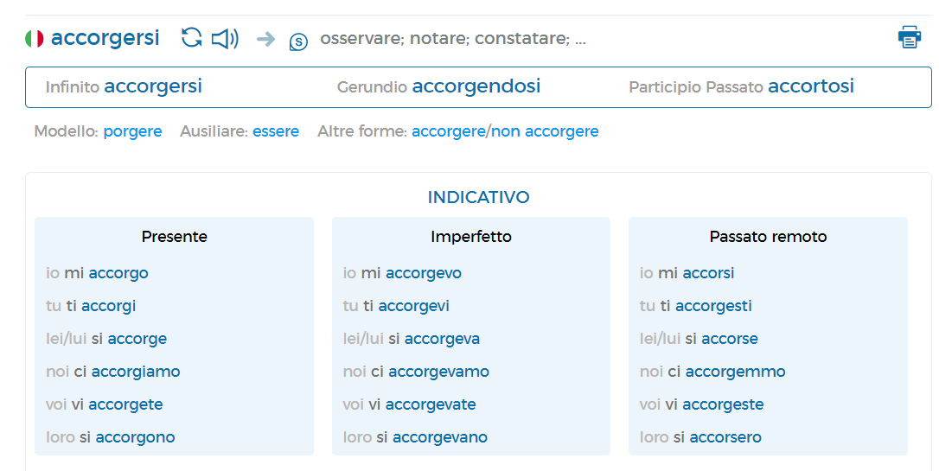

1. **based on Stefania’s example (previous telco)**

<https://docs.google.com/document/d/1wybx2_U0EcqmefRRiAABha-cFII6H2rZBtlgTcjLYjg/edit?usp=sharing>

#accorgersi

:lex_accorgersi a ontolex:LexicalEntry ;

    lexinfo:partOfSpeech lexinfo:mainVerb ;

    ontolex:canonicalForm [ ontolex:writtenRep "accorgersi"@it ] ;

    ontolex:morphologicalPattern :it-refVerb . #ontolex:morphologicalPattern John’s suggestion instead of morph:inflects

:it-refVerb a morph:Paradigm ;

rdfs:comment "some metadata about this paradigm" .

:it-refVerb_2_type_infin a morph:SubParadigm ;

morph:paradigm :it-refVerb .

#infinitive rule - output: accorgersi

:it-refVerb_2_type_infin a morph:Rule ;

morph:subParadigmOf :it-refVerb ; #subParadigmOf - John’s suggestion instead of subParadigm/inflectAs

morph:inflectsFor [lexinfo:tense lexinfo:present ;

lexinfo:mood lexinfo:infinitive];

rdfs:label ""@it ;

morph:replacement [morph:source "$"; morph:target ""] .

#indicative present rule - output: mi accorgo

:it-refVerb_2_type_indic_1p_sg a morph:Rule ;

morph:subParadigmOf :it-refVerb ;

morph:inflectsFor [lexinfo:tense lexinfo:present ;

lexinfo:mood lexinfo:indicative];

rdfs:label ""@it ;

morph:replacement [morph:source "^(.)ersi$" ; morph:target "mi \1o"] ;

**2. Root and morph decomposition**

:lex_abbondante a ontolex:LexicalEntry ;

    lexinfo:partOfSpeech lexinfo:mainVerb ;

    ontolex:canonicalForm [ ontolex:writtenRep "accorgersi"@it ] ;

    ontolex:morphologicalPattern :it-refVerb .

# morph decomposition

:form_accorgersi a ontolex:Form ;  
morph:consistOf :it-refverb_002_const  
morph:rootMorph [ ontolex:writtenRep "accorg"@it ]  
morph:affixMorph [ ontolex:writtenRep “ere”@it ]  
morph:partMorph [ ontolex:writtenRep “si”@it ] #morph:partMorph refers to particles and clitics which do not fall into the existing subcategories of morph:Morph - to be defined (see below for the subclass definition)

# 1st person singular present indicative: mi accorgo

:it-refVerb_2_type_1p_sg a morph:Rule ;

morph:subParadigm :it-refVerb ;

morph:inflectsFor [lexinfo:tense lexinfo:present ;

lexinfo:mood lexinfo:indicative];

rdfs:label ""@it ;

morph:replacement [ [ morph:source morph:affixMorph ; morph:target “o” ] ; [morph:source morph:partMorph morph:target “mi”]]

morph:displacement [ morph:source “^ morph:rootMorph” ; morph:target “morph:partMorph “]

#may we use morph:affixMorph in morph:source instead of a literal value?

#this replacement stands for the present indicative inflection for the 2nd type of IT verbs and can be applied to any other 2 types of IT verbs (even though they do not present a merged clitic)

### morph:partMorph

A subclass of morph:morph that represents particles which can be detached from the lexical entry without any inflection (e.g., **an**rufen - ich rufe **an**) or clitics which are merged to a verb form or climb the matrix verb as detached and inflected elements (e.g. accorger**si - mi** accorgo).

* [Clitic climbing](https://en.wikipedia.org/wiki/Clitic_climbing)
* [Parseme annotation and shared task - Language-specific inherently clitic verbs (LS.ICV)](https://parsemefr.lis-lab.fr/parseme-st-guidelines/1.1/?page=060_Language-specific_tests/015_Inherently_clitic_verbs__LB_LS.ICV_RB_)

Notes Bettina:

Two ways of generating ontolex:Form resources:

1. Existing morph:Morph resources are used as input together with the rules to generate ontolex:Form resources of an ontolex:LexicalEntry.
2. Existing string data for morphemic elements (i.e. roots, stems, affixes) are used together with the rules to generate ontolex:Form resources of an ontolex:LexicalEntry PLUS the respective morph:Morph resources .

Todo next telco:

Bettina: create general overview of the generative part of the Morph Module (including different input data and inflection plus derivation)

Max: take Italian example and provide code representing the generation of the ontolex:Form resource “mi accorgo” from the ontolex:LexicalEntry “accorgersi”.

Morph:replacement or German Verbs: participles?

Example: kaufen, gekauft

Deal it with regex? e.g.

morph:replacement [ morph:source "^(.)en$" ; morph:target "ge\1t" ]