**Participants:**

Bettina Klimek (BK)

Jakub Šimek

Stefania Racioppa (DFKI)

Fahad Khan (CNR)

Matteo Pellegrini  
JBG Julia Bosque-Gil (UZAR)

1. **Module draft 4.3**

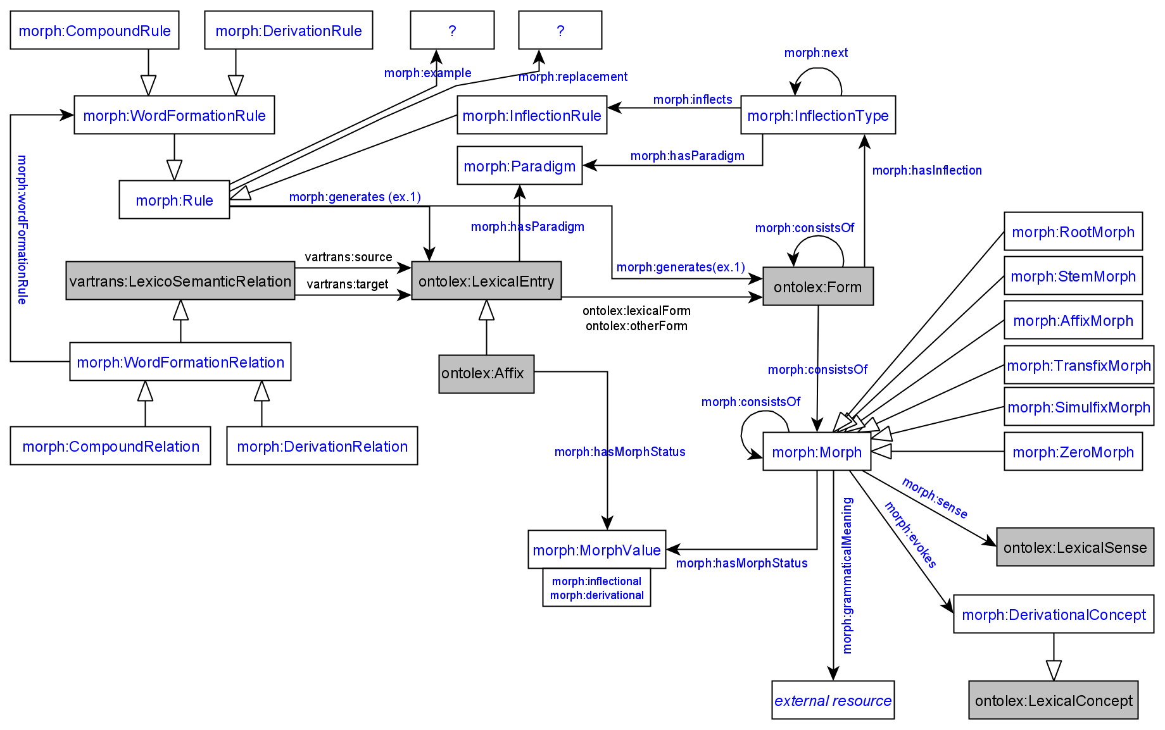

Adaptions of module draft 4.3 to be included for next telco:

* none

**2. Representation needs modeling**

**not modeled yet:**

**N17: Part of Speech transformation** **Description**:

For lexical entries of categories that systematically come in two variants by “Zero Derivation”, e.g., every German adjective is an adverb, but this cannot be modelled with OntoLex vocabulary, and it is a productive process (so it’s within morphology)

BK: This need should be solved by the existing model draft. Zero morphs can be expressed with the morph:ZeroMorph class and it can be expressed by the morph:DerivationRelation class.

Decision: sufficiently modeled

**N18: Recursive morphology** **Description**:

Current focus is on inflectional morphology. But there are languages where after inflection is applied, additional layers of inflection can be applied (see data samples for Sumerian).

BK: This need should be solved by the existing model draft. The object property morph:consistsOf allows to express that an ontolex:Form resource can consist of another ontolex:Form resource.

Decision: sufficiently modeled

**N19: Incorporation** **Description**:

In many languages, incorporation is a way for a verb to refer to a specific semantic role (usually THEME). This is a productive process and it corresponds in function to case inflection in standard average european, so within the realm of inflection (see data samples on Inuktitut).

This need is similar to:

**N15: Word-form generation takes LexicalEntry and Form as input**

| Description: The generation of ontolex:LexicalEntry resources should allow to take resources of the type ontolex:LexicalEntry as well as ontolex:Form as input sources. This is required for languages which form new lexemes with inflected word-forms. |
| --- |
|  |
| BK suggestion: extend morph:consistOf range to ontolex:LexicalEntry next to morph:Morph and ontolex:Form  Decision: no, keep vartrans:source and vatrans:target restricted to ontolex:LexicalEntry |

Decision: Ask Christian to present examples

**N21: Derivation** **Description**:

With recursion and incorporation, two morphological processes are addressed that share important characteristics with derivation: incorporation takes a noun and uses a verbal affix to produce a verb (so it involves a shift in parts of speech), recursive morphology is a recursive process (like most forms of derivation). As a generalization over both these aspects, derivation would require that an affix (morph?) posits constraints on the base form it is applied to (e.g., nominal for incorporation), and the grammatical features (“meaning”?) of the resulting form (e.g., verbal for incorporation). Sample data for derivation (plus the variants above) in Inuktit data sample.

Decision: the morph:Rule class can be used for representation purposes to express affix constraint

**N20: Weak noun/verb distinction** **Description**:

Some languages are relatively flexible in “recasting” a verb into a noun, e.g., Standard Average European participles (verb => adjectives) but also finite verbs (Inuktitut qimmiuvuq “he has a dog” (verb) = “dog-owner” (noun), as a noun, this can be inflected as a noun, e.g., qimmiuvup “dog owner”.ERG). The mechanism here is that a particular type of inflection is “repurposed” for derivation. Technically, this can be treated like Zero Derivation.

Decision: Ask Christian to present examples

**N22: Compositional structure of compounds and derivations** **Description**: Basically, being able to represent morphological parses. See Old High German sample data.

Decision: might be a too narrow request, not sure if this is in the realm of the ontolex vocabulary (maybe a better way to have a seperate - more general -vocabulary for morphological parses), find out if parse trees are included in existing dictionaries and discuss it again. If many people need it/datasets include it, it might be considerable to model it.

**N23-25:** get Christian to show examples

→ is the morph:Rule class sufficient?

Fahad: these needs have to be motivated be actual dictionaries using these rules

Todos Bettina:

* add Jakub to google drive folder
* invite CC to the next call
* ask Stefania if she is present in the next call and can present the italian examples
* update Wikipage with RN decisions
* update evaluation google spreadheet
* think about representative set of languages with different morphological types to be sufficient for the module evaluation (Wiktionary can be also used as a test data source for multiple languages for many phenomena, i.e. inflection, derivation, compounding)

Next telco:

* CC explains his RNs
* Start to go through evaluation with Italian language data (Stefania)