Morph telco 2022-02-22, 14:00 CET

TODAY: chapter on multi-word expressions

**Link:** [**https://meet.google.com/vvf-qdnd-xrq**](https://meet.google.com/vvf-qdnd-xrq) **[one-time-link; check here for link updates if it doesn’t work]next : tba.** <https://meet.google.com/npd-ptui-bfv>

**Latest Definitions:** [**https://github.com/ontolex/morph/blob/master/draft.md**](https://github.com/ontolex/morph/blob/master/draft.md)

**Nexus:** [**https://nexuslinguarum.eu/the-action/join-us**](https://nexuslinguarum.eu/the-action/join-us)

**Participants [please add yourself]:**

Christian Chiarcos (CC)

Max Ionov (MI)

Katerina Gkirtzou (KG)

Fahad Khan (FK)

Khadija Ait ElFqih (KAE)

Matteo Pellegrini (MP)

Ciprian-Octavian Truică (CT)

Penny Labropoulou (PL)

Elena Simona Apostol (ESA)

Sina Ahmadi (SA)

Elena Benzoni (EB)

Petra Steiner (PS)

Theodorus Fransen (TF)

Thierry Declerck (DFKI)

Ranka Stanković

Gilles Sérasset (GS)

Mike Rosner (MR)

# 0. Module draft (4.17)

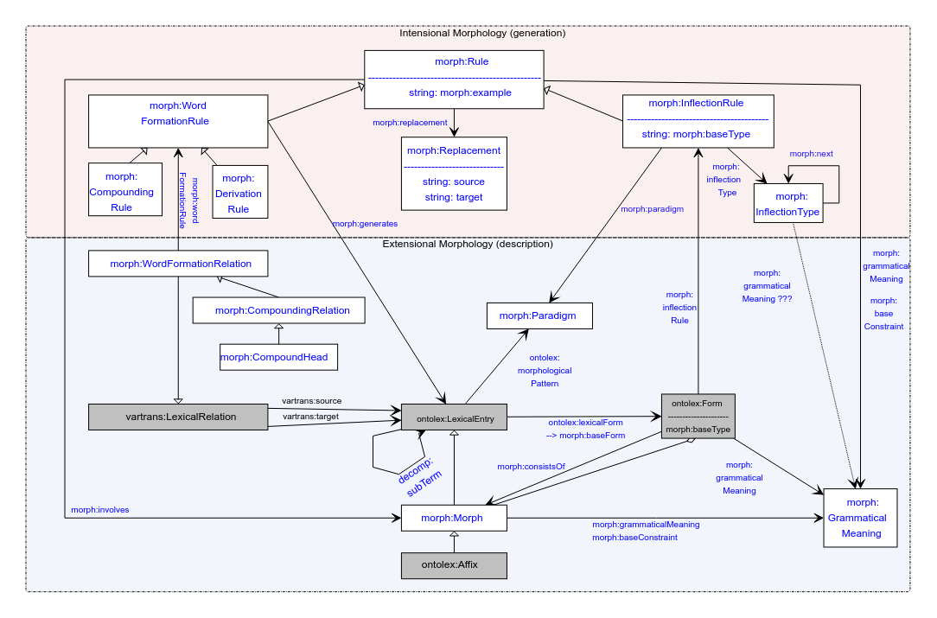

No changes

## MWE Chapter

* Draft under: <https://www.overleaf.com/8285444258rpfnbwgwbrdp>
* Deadline March 1
* Slack channel: #frac-mwe-chapter
* CC+MI: page limits
  + Added to the overleaf in the title
* KG: confirm page limits for models, reduce/cut cscores
* KG: moving diagrams to appendix? – makes it harder to read
* Sect. 2: drop all examples, refer to sect. 3
* Merge 3.1 + 5.2 (TEI/LMF discussion)
  + Tentatively: as 5.2 => **TODO@FK**

**TODOS for today**

* all : proof-read, correct; if cutting: make a note with a suggestion (unless it’s your section)
* All: cut (at your sections)
* FK: merging TEI/LMF sections, check OZDIC section
* BK: MWE typology, rephrase literal quotations
* MI page lengths, read/comment/improve overall, incl. Cutting *suggestions*
* CC: page lengths, maybe proof-reading
  + TODO: We need to mention Lexicog in the beginning, because we use it for some modeling. TODO: add this to the structure
* KG: move cscores into appendix (possibly: cuts in that section), balancing/cutting in modelling section
* Katerina: balance level of detail of modelling section (\section{The OntoLex Vocabulary})
* Overall todos
  + Christian: Cutting (at the very end)

Last FrAC call:

* Use Case: Designing an API for Collocation Analysis on the Web
  + Christian: moved into discussion, currently more as an outlook without details
  + Last time: Ranka: did scripts, could elaborate that