**Participants [add yourself:**

Christian Chiarcos (CC) [christian.chiarcos@gmail.com](mailto:christian.chiarcos@gmail.com)

1. **Module draft 4.11 [before last call]**

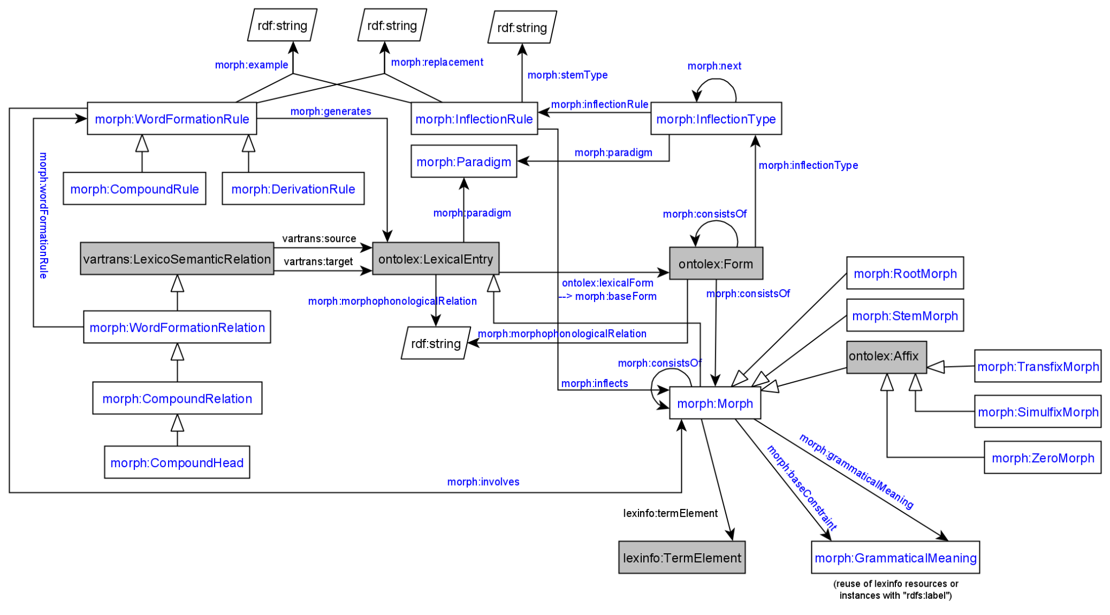

**Model draft 4.11 updates**

* changed display of datatype properties (as in UML)
* round edges replaced by squared edges (in order to work with online editor)
* morph:replacement points to a class Replacement which takes source and target datatype properties (as modelled in Thierry’s paper)

1. **Evaluation of inflectional data modeling**

**Greek inflectional data example including lexicog vocabulary by Penny**

# example of a lemma with two orthographic variants (GMus)

lexis_data_lexis:augo_UMNo29917 a lexicog:Entry ;

rdfs:label "αυγό"@el ;

rdfs:member augo_GMu26232, augo_GMu34067 .

lexis_data_lexis:augo_GMu26232 a lexicog:LexicographicComponent ;

lexicog:describes augo_26232 .

lexis_data_lexis:augo_GMu34067 a lexicog:LexicographicComponent ;

lexicog:describes augo_34067 .

lexis_data_lemon:augo_26232 a ontolex:LexicalEntry ;

rdfs:label "αυγό"@el ;

lexinfo:partOfSpeech lexinfo:commonNoun ;

morph:paradigm lexis_data:vouno ;

ontolex:sense lexis_data:augo_sense_USem1074 ;

synsem:synBehavior lexis_data:augo_SUNo25013 .

lexis_data_lemon:avgo_34067 a ontolex:LexicalEntry ;

rdfs:label "αβγό"@el ;

lexinfo:partOfSpeech lexinfo:commonNoun ;

morph:paradigm lexis_data:vouno ;

ontolex:sense lexis_data:augo_sense_USem1074 ;

synsem:synBehavior lexis_data:augo_SUNo25013 .

It works but multiplies the lexical entry data, e.g. senses have to be created for all lexicographic components.

=> morph:stemType (identifier for different stems, also needed for Latin)

question: why at inflecxtion rule and at ontolex:LexicalEntry ?

* consensus

→ to be developed as part of the vartrans module but applied in order to connect two ontolex:LexicalEntry resources that only differ in their orthographic representation but share the same senses: a vartrans:orthVariant subproperty of vartrans:lexicalRel that entails that the same senses apply to both variants (restriction has to be formulated)

* possibilities (last time):

1. create separate entries and link them with a subproperty of vartrans:lexicalRel (your_namespace:orthVariant sub vartrans:lexicalRel) between two ontolex:LexicalEntries that are orthographic variants - the shared data of both would have to be repeated for both entries then or it has to be stated only on one lexical entry resource (duplicate all senses)
2. alternatively, leave senses of the variant empty, define in the semantics of orthVariant that this entails that the same senses apply to both variants)
3. use owl:sameAs and share senses (a bit messy, because semantically this means they are the same thing)

**Orth. variants @ Old English**

* was TODO@Fahad: sample data

**Latin inflectional data example by Matteo**

<https://drive.google.com/file/d/1v2M-LbCdrdaPl2LVuPKzOfU-fQjv_5_1/view?usp=sharing>

was this complete?

Representation of inflectional information of orthographic variants:

class: lila:Flexeme (subclass of ontolex:LexicalEntry) are linked to lila:Lemma

*lexemes → lexical units with a unique meaning*

*▶ flexemes → lexical units with a unique form (i.e., a unique inflectional paradigm)*

object property between lila:Lemma: lila:lemmaVariant (subclass of ontolex:Form)

Matteo continues his presentation on Latin inflection and raises further questions.

Latest vocabulary definitions:

Proposed definitions as of telco from [10.12.2019](https://docs.google.com/document/d/1wybx2_U0EcqmefRRiAABha-cFII6H2rZBtlgTcjLYjg/edit?usp=sharing)

## Classes

### morph:Paradigm

A class that represents a theoretically motivated type of declination, e.g.

* “a” stem declension in Latin
* First declension in Russian

*May* contain metadata information about this type of declination.

**Book analogy**: a full paradigm table with possible allomorphy/alternative variants

### morph:InflectionType

A class that represents a single slot for a single grammatical category for all its possible values (e.g. all the cases)

**Book analogy**: a column from a paradigm table *without* allomorphy/alternative variants for just a single morpheme

### morph:Rule

A class containing necessary information to add **one morpheme** to **a single word form**. It *must* contain either morph:example or morph:replacement (or both). “Tabular” value of a morpheme *must* be stored in rdfs:label (e.g. “-s”@en for usual PL in English)

## Properties

### morph:paradigm

**Domain**: morph:InflectionType

**Range**: morph:Paradigm

A link to the paradigm for the inflection type

### morph:example

**Domain**: morph:Rule

**Range**: string literal

A single generated form that was generated using this rule

### morph:next

**Domain**: morph:InflectionType

**Range**: morph:InflectionType

Links two consecutive inflection types (“slots”), e.g. number and case in Finnish

### morph:inflects

**Domain**: ontolex:Word

**Range**: morph:InflectionType

A link to the first “slot” (inflection type), e.g. an inflection type for number for English nouns

### morph:inflectionType

**Domain**: morph:Rule

**Range**: morph:InflectionType

### morph:replacement

**Domain**: morph:Rule

**Range**: [morph:source, morph:target, both are string literals]

### morph:generates

**Domain**: morph:Rule

**Range**: unrestricted?

BK: currently missing in draft image, does the inflection rule generate the ontolex:Form resources? yes