**Participants:**

Bettina Klimek (BK)

Matteo Pellegrini

Jakub Šimek

Stefania Racioppa (DFKI)

1. **Module draft 4.2**

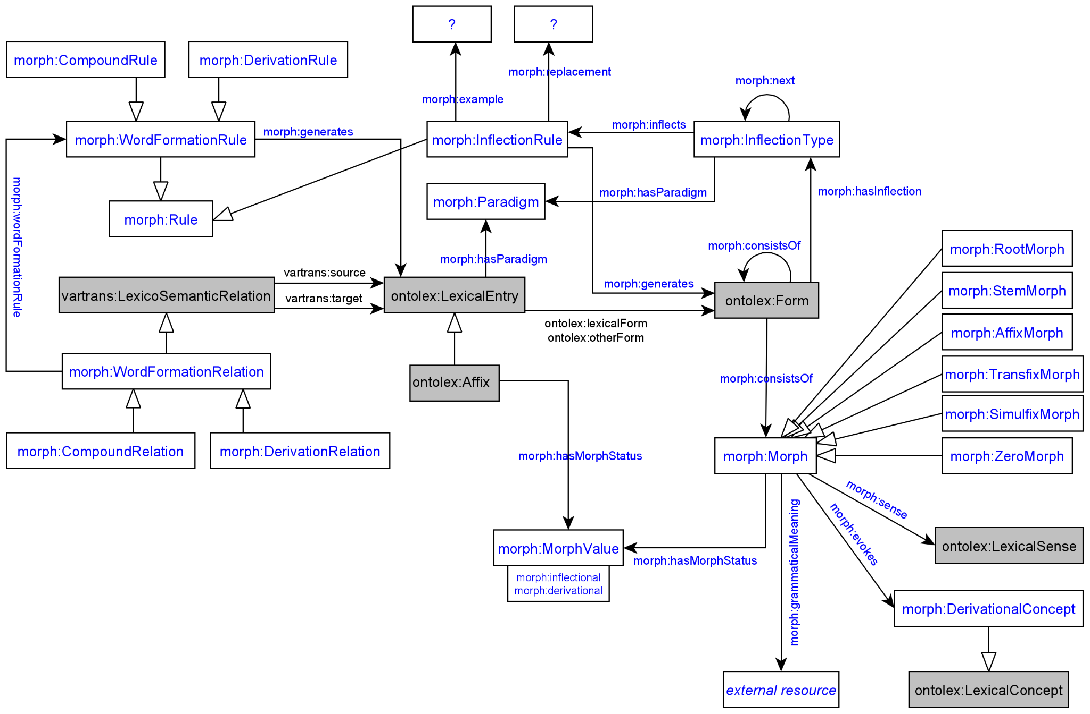

Adaptions of module draft 4.2 to be included for next telco:

* link morph:generates from morph:Rule to ontolex:LexicalEntry and ontolex:Form
* link morph:example and morph:replacement to morph:Rule

**2. Representation needs modeling**

**not modeled yet:**

**N7: Multiple segmentation strategies**

The segmentation of lexical entries or wordforms varies with different granularity:

German verb *jagte* "hunted"

Complete segmentation: root-stem-suffix

[[[jag]-t]-e] - [[[root]tense suffix]number suffix]wordform

Contracted segmentation: stem-suffix

[[jagt]-e] - [[past tense stem]number suffix]wordform

Christian: Does occur in Splett's Old High German dictionary (<https://brill.com/view/journals/abag/42/1/article-p264_28.xml>): Here, full morphological parses (tree structures) are being used. The other (main) use case is in language documentation (with Toolbox, from which dictionaries are being created): Linguistic glossing can operate on a superficial level or on a deep level, cf. German *fressen* ("to eat, of an animal") which superficially involves two morphemes (fress- + -en), but on a deep level involves three (*ver- + ess- + -en, *ver- contributing the derogative [non-human] meaning as in verwerfen "reject", lit. "cast away"). Normally, while one dictionary may chose one level of depth, another dictionary may chose another. Admitting more than one level of depth allows to merge information from different sources in a coherent representation. Wrt. morphological pattern: Isn't the idea that the morphological pattern describes a context for one given morph(eme)? So if have more than one (-t- and -e-) here, how will be formalize their combination?

Issue: the inflection rule forces the generation of two distinct ontolex:Form resources with different segmentation strategies (i.e. everything that is stated for ontolex:Form morph:consistsOf …) , but they are actually identical resources. Solution: interconnect both ontolex:Form resources with some “has segmentation variant” symmetric property?

**3. Initial discussion of Stefania’s Latin word form generation example data**

Stefania’s [example to apply the vocabulary for generating ontolex:Form resources:](https://docs.google.com/document/d/1stKL92xx-ONhDw9hRshIS65VHY7rkk5Hy6hhHd08BJg/edit?usp=sharing)

WordNet Latin Lexicon:

,base,forms,uri,pos,number,gender,case,group,stem,degree

25,abdicatio,abdication,a0031,noun,singular,feminine,nominative,3,,

[GitHub - latinwordnet/latinwordnet-archive: Repository for archived Latin WordNet data](https://github.com/latinwordnet/latinwordnet-archive)

Italian example:

abbracci abbraccio noun gen=m num=p

abbraccio abbraccio noun gen=m num=s

:lex_abbraccio a ontolex:LexicalEntry ;

lexinfo:gender lexinfo:masculine ;

lexinfo:partOfSpeech lexinfo:noun ;

ontolex:canonicalForm [ ontolex:writtenRep "abbraccio"@it ] ;

ontolex:morphologicalPattern :it-noun_002 .

:it-noun_002 a morph:subParadigm ;

morph:paradigm :it-noun .

:it-noun_002_pl a morph:rule ;

morph:inflectsFor [ lexinfo:number lexinfo:plural ] ;

morph:replacement [ morph:source "o$" ;

morph:target "" ] ;

morph:subParadigm :it-noun_002 .

:it-noun_002_sg a morph:rule ;

morph:inflectsFor [ lexinfo:number lexinfo:singular ] ;

morph:replacement [ morph:source "$" ] ;

morph:subParadigm :it-noun_002 .

**Main issue that arised:**

What kind of data is processed by the morph:Rule? As it is now, only strings are processed but these are not interconnected to their respective morph:Morph resources.

That means that in Stefania’s Latin example the resource :form_abdicatio_root has to be discussed for its morphological status (is it really a root, then it should be a morph:RootMorph or is it an ontolex:Form resource, then the “root” should be excluded from the URI)

Is it possible to integrate the written representation strings of morph:Morph resources into the morph:Rule and provide this option in addition to using unrelated strings of the morphs an ontolex:Form consists of?