**Participants:**

Bettina Klimek (BK) bettina.klimek@semalytix.com

1. **Module draft 4.9**

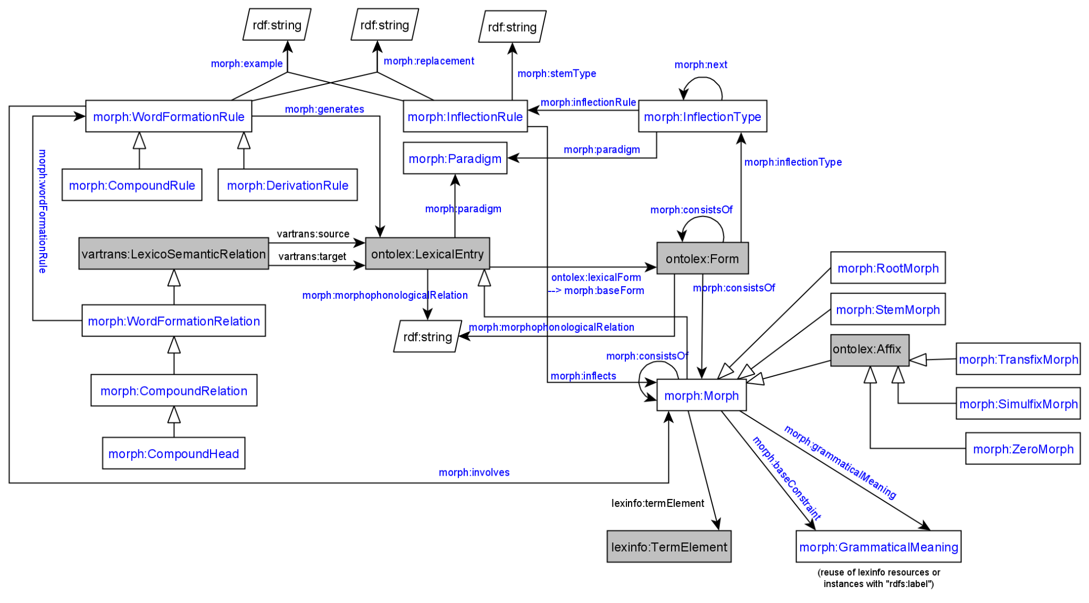

Adaptations included into module draft 4.9:

* datatype property morph:stemType with a literal and domain morph:InflectionRule
* add morph:baseForm as subproperty of ontolex:lexicalForm (in order to link a stem morph with a lexical entry)
* datatype property morph:morphophonologicalRelation on ontolex:LexicalEntry and ontolex:Form

Adaptations to be included into module draft 4.10:

* add domain ontolex:LexicalEntry to property morph:stemType

→ to be developed as part of the vartrans module but applied in order to connect two ontolex:LexicalEntry resources that only differ in their orthographic representation but share the same senses: a vartrans:orthVariant subproperty of vartrans:lexicalRel that entails that the same senses apply to both variants (restriction has to be formulated)

1. **Evaluation of inflectional data modeling**

**Greek inflectional data example including lexicog vocabulary by Penny**

# example of a lemma with two orthographic variants (GMus)

lexis_data_lexis:augo_UMNo29917 a lexicog:Entry ;

rdfs:label "αυγό"@el ;

rdfs:member augo_GMu26232, augo_GMu34067 .

lexis_data_lexis:augo_GMu26232 a lexicog:LexicographicComponent ;

lexicog:describes augo_26232 .

lexis_data_lexis:augo_GMu34067 a lexicog:LexicographicComponent ;

lexicog:describes augo_34067 .

lexis_data_lemon:augo_26232 a ontolex:LexicalEntry ;

rdfs:label "αυγό"@el ;

lexinfo:partOfSpeech lexinfo:commonNoun ;

morph:paradigm lexis_data:vouno ;

ontolex:sense lexis_data:augo_sense_USem1074 ;

synsem:synBehavior lexis_data:augo_SUNo25013 .

lexis_data_lemon:avgo_34067 a ontolex:LexicalEntry ;

rdfs:label "αβγό"@el ;

lexinfo:partOfSpeech lexinfo:commonNoun ;

morph:paradigm lexis_data:vouno ;

ontolex:sense lexis_data:augo_sense_USem1074 ;

synsem:synBehavior lexis_data:augo_SUNo25013 .

It works but multiplies the lexical entry data, e.g. senses have to be created for all lexicographic components.

* CC suggestion: create separate entries and link them with a subproperty of vartrans:lexicalRel (your_namespace:orthVariant sub vartrans:lexicalRel) between two ontolex:LexicalEntries that are orthographic variants - the shared data of both would have to be repeated for both entries then or it has to be stated only on one lexical entry resource (duplicate all senses)
  + alternatively, leave senses of the variant empty, define in the semantics of orthVariant that this entails that the same senses apply to both variants)
* another possibility: use owl:sameAs and share senses (a bit messy, because semantically this means they are the same thing)
* FK: make a design decision by lexicographer
* CC: consumer should be able to decide

**Latin inflectional data example by Matteo**

URL to presentation: slide 28 ongoing <https://drive.google.com/file/d/1v2M-LbCdrdaPl2LVuPKzOfU-fQjv_5_1/view?usp=sharing>

Representation of inflectional information of orthographic variants:

class: lila:Flexeme (subclass of ontolex:LexicalEntry) are linked to lila:Lemma

*lexemes → lexical units with a unique meaning*

*▶ flexemes → lexical units with a unique form (i.e., a unique inflectional paradigm)*

object property between lila:Lemma: lila:lemmaVariant (subclass of ontolex:Form)

**Todo:**

Fahad tries to provide Old English examples for orth. variants

Matteo continues his presentation on Latin inflection and raises further questions.

Latest vocabulary definitions:

Proposed definitions as of telco from [10.12.2019](https://docs.google.com/document/d/1wybx2_U0EcqmefRRiAABha-cFII6H2rZBtlgTcjLYjg/edit?usp=sharing)

## Classes

### morph:Paradigm

A class that represents a theoretically motivated type of declination, e.g.

* “a” stem declension in Latin
* First declension in Russian

*May* contain metadata information about this type of declination.

**Book analogy**: a full paradigm table with possible allomorphy/alternative variants

### morph:InflectionType

A class that represents a single slot for a single grammatical category for all its possible values (e.g. all the cases)

**Book analogy**: a column from a paradigm table *without* allomorphy/alternative variants for just a single morpheme

### morph:Rule

A class containing necessary information to add **one morpheme** to **a single word form**. It *must* contain either morph:example or morph:replacement (or both). “Tabular” value of a morpheme *must* be stored in rdfs:label (e.g. “-s”@en for usual PL in English)

## Properties

### morph:paradigm

**Domain**: morph:InflectionType

**Range**: morph:Paradigm

A link to the paradigm for the inflection type

### morph:example

**Domain**: morph:Rule

**Range**: string literal

A single generated form that was generated using this rule

### morph:next

**Domain**: morph:InflectionType

**Range**: morph:InflectionType

Links two consecutive inflection types (“slots”), e.g. number and case in Finnish

### morph:inflects

**Domain**: ontolex:Word

**Range**: morph:InflectionType

A link to the first “slot” (inflection type), e.g. an inflection type for number for English nouns

### morph:inflectionType

**Domain**: morph:Rule

**Range**: morph:InflectionType

### morph:replacement

**Domain**: morph:Rule

**Range**: [morph:source, morph:target, both are string literals]

### morph:generates

**Domain**: morph:Rule

**Range**: unrestricted?

BK: currently missing in draft image, does the inflection rule generate the ontolex:Form resources? yes