**Participants:**

Bettina Klimek (BK)

Jakub Šimek

Julia Bosque-Gil (UZAR)

Katerina Gkirtzou (ARC)

Fahad Khan (CNR)

Stefania Racioppa (DFKI)

Matteo Pellegrini

1. **Module draft 4**

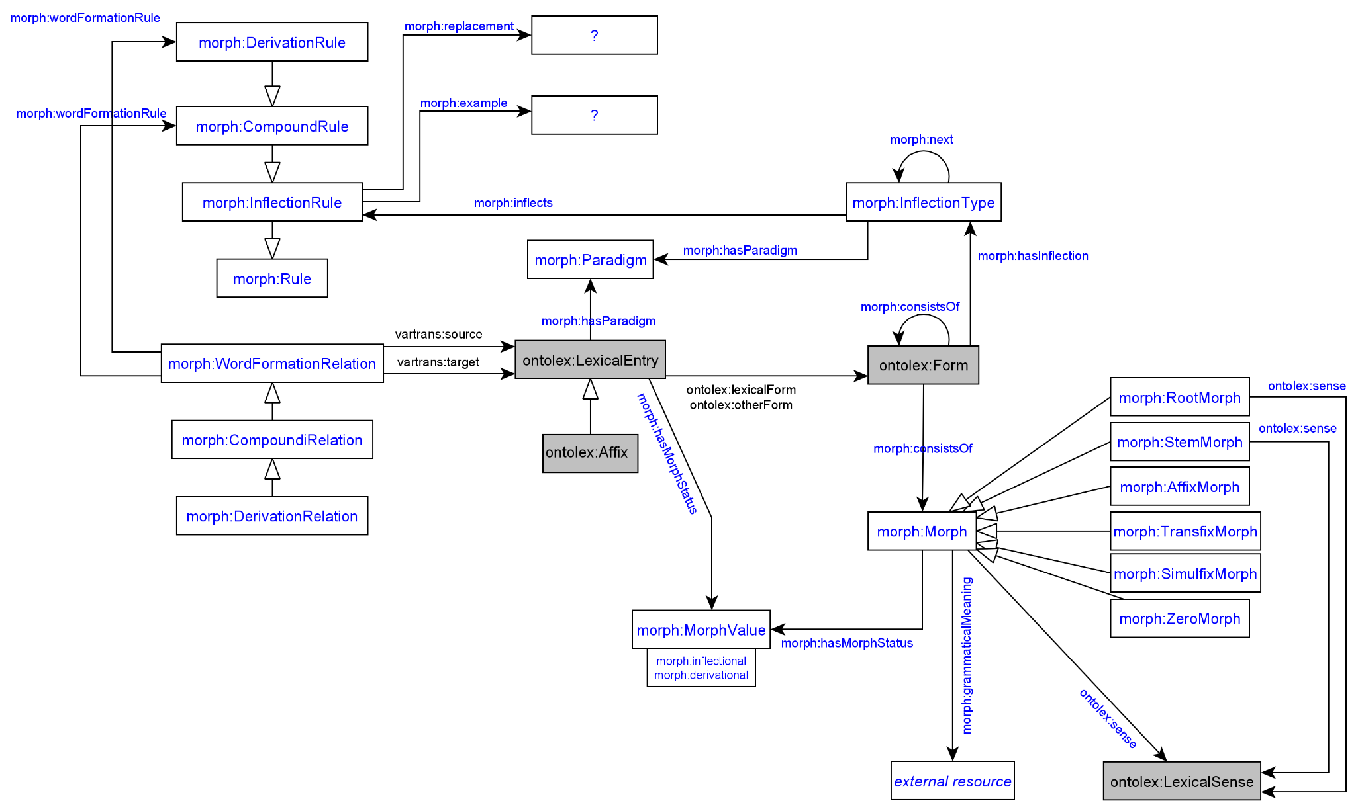

Changes in modulue draft 4:

* removed interrelations to decomp module (cf. decision of t[elco 12.05.2021](https://docs.google.com/document/d/1476BO3smUjAlomC7vTXpwD3q094UmosHDxRSyfqMxhw/edit?usp=sharing))
  + removed range morph:Morph of property decomp:subterm
  + removed range morph:Morph of property decomp:correspondsTo
* added domain morph:Morph, morph:StemMorph, morph:RootMorph to property ontolex:sense
* added domain ontolex:Form to property morph:consistsOf
* added class morph:WordFormationRelation (and removed subclass relation to vartrans:LexicalRelation) with subclasses morph:CompoundRelation and morph:DerivationRelation
* added class morph:Rule with subclasses morph:InflectionRule, morph:CompoundRule and morph:DerivationRule
* added morph:wordFormationRule with domain morph:WordFormationRelation and range morph:DerivationRule and morph:CompoundRule
* added classes morph:Paradigm, morph:InflectionType
* added object properties morph:hasParadigm, morph:inflects, morph:hasInflection, morph:example, morph:replacement

Adaptions of module draft 4 to be included for next telco:

* extend range of vatrans:source and vartrans:target with ontolex:Form and morph:Morph and domain with morph:morph:WordFormationRelation (or make this class a subclass of vartrans:LexicoSemanticRelation)? → yes, make this class a subclass of vartrans:LexicoSemanticRelation
* explicit representation of input and output part of speech for word-formation required (cf. LiLa WFL modeling) or is the statement of the pos of source and target lexical entry with lexinfo sufficient? → yes, sufficient
* correct subclass relations
* create morph:WordFormationRule as superclass subsuming morph:DerivationRule and morph:CompundRule
* remove ontolex:sense property between morph:Stem and morph:Root

1. **Representation needs modeling**

**modeled as draft:**

**N8: The morphosyntax of a language describes how the morphemes in a word affect its combinatoric potential**

BK proposal: allow ontolex:Form as input to generate new word-forms and as an element of word-forms by extending the range of morph:consistOf with domain: morph:Morph and ontolex:Form

N8 is about derivation, not inflection: finite tables can not be used to represent Japanese word-forms because they are very productive

→ take N8 out of the RNs

**N9: The phones making up a morpheme don’t have to be contiguous**

BK proposal: This could be treated like suppletion, i.e. the grammatical meanings and the lexical sense of the word-form is given with the lexinfo vocabulary and ontolex:sense. If the phones are productive, they might actually be infixes and then the word-form can be represented as all other word-forms with an explicit order to allow an automatic generation of these word-forms as well.

→ yes, these are infixes, remove N9

**N10: The form of a morpheme doesn’t have to consist of phones**

BK proposal: For the German example of Mutter-->Mütter, the affected morph is a simulfix (= A simulfix is a change or replacement of vowels or consonants (usually vowels) which changes the meaning of a word, e.g. "eat" in past tense becomes "ate "tooth" becomes "teeth" when plural.<http://www-01.sil.org/linguistics/GlossaryOflinguisticTerms/WhatIsASimulfix.htm>) and this is considered under N2 already. The Lango example seems to also contain simulfix morphs. Therefore, I propose to delete this modeling need and consider it as covered under N2.

→ remove it

**N11: Meanings of stems and roots**

BK proposal: The description of meanings of stems and roots could be realized in the same way as the description of meanings of lexical entries as given in ontolex. For the representation of roots maybe external resources such as Concepticon could be recommended or the possibility of a plain textual definition could be established in addition.

Extend domain of ontolex:sense: domain: ontolex:LexicalEntry and morph:StemMorph and morph:RootMorph

JMC: not in favour of extending ontolex:sense domain with morph:Morph, proposes new property morph:sense with ontolex:LexicalSense and another Concept class

**not modeled yet: → discussed in next telco**

**N5: Morphology crosses part-of-speech boundaries (derivation)**

**N12: Derivational Meanings**

**N6: Morphs linked to Lexical Entries**

**N7: Multiple segmentation strategies**