Morph telco 2022-11-02, 13:00 CET

**Link:** [**https://meet.google.com/nsj-tbcy-yop**](https://meet.google.com/nsj-tbcy-yop) **[check here for link updates if it doesn’t work]**

**Latest Definitions:**  <https://github.com/ontolex/morph/blob/master/draft.md>

**Nexus:** https://nexuslinguarum.eu/the-action/join-us

**Participants [please add yourself]:**

Christian Chiarcos (CC)

Max Ionov (MI)

Katerina Gkirtzou (KG)

Fahad Khan (FK)

Khadija Ait ElFqih (KAE)

Matteo Pellegrini (MP)

Ciprian-Octavian Truică (CT)

Penny Labropoulou (PL)

Elena Simona Apostol (ESA)

Sina Ahmadi (SA)

Elena Benzoni (EB)

Petra Steiner (PS)

Theodorus Fransen (TF)

Thierry Declerck (DFKI) excused

Ranka Stanković

# 0. Module draft (4.17)

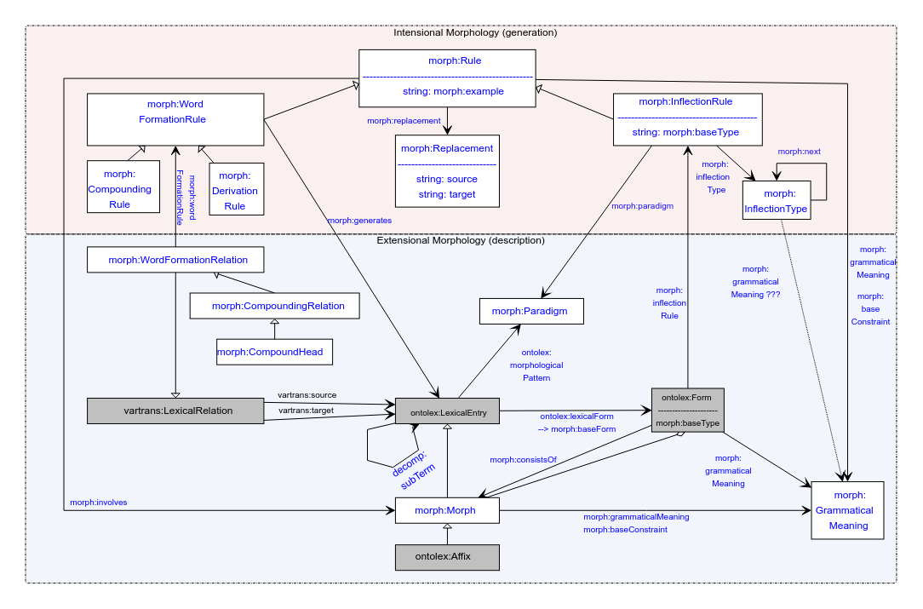

Updates:

* Domain of baseConstraint and grammaticalMeaning now includes morph:Rule
* New section: <https://github.com/ontolex/morph/blob/master/draft.md#overall-structure>

# 1. Publications

## LLODream postproceedings

deadline 01.12, post-presentation publication

Consensus: wait with an overview until model is stable

## MWE Chapter

* Initiated in FrAC
* Doodle poll: <https://doodle.com/meeting/participate/id/dyrZg8ze>
* Draft for chapter: <https://www.overleaf.com/8285444258rpfnbwgwbrdp>
* Template: <https://www.overleaf.com/latex/templates/langsci-skeleton-for-edited-volumes-2022-06/vvjbpxnrbnkk>, chapters/01.tex
* Initial abstract: <https://docs.google.com/document/d/1HLTsYScMiZE4Nb6b7mozN-SoKAIWtisdiKLa0OoXPuU/edit?usp=sharing>
* Slack channel: #frac-mwe-chapter
* authors: CC KG MI BK FK CT EA
  + We also asked Matteo to join
  + Anyone else?

## eLex 2023

<https://elex.link/elex2023/>

Submission deadline: 31.01.2023

Dates: 27.06-29.06

MI (last call)

* Overview of the model
  + (Maybe just the dynamic part and changes since the last presentation)
* Use case: Semitic? [if we have a consensus on that]

# 2. Handling of Semitic languages

**TO-BE-DONE**: figure out how to include missing categories to LexInfo

Khadija: data prepared for Arabic (cf. last time):

* [Morph Module semitic.odt](https://drive.google.com/file/d/1NST-qdkxAw7am6F3vGAap5o4eQv0ulV1/view?usp=sharing)

Necessary features:

* lexinfo:POS extensions (solved? See last call minutes for procedure)
* Modelling diacritics in Arabic (cf. call minutes last time)
  + Also cf. Umlaut in German and vowel harmony in Turkish for similar challenges
    - Recommendation (< GS): NFD normalization in morph:Replacement
    - **TBC:** are we ok with modelling roots as Morphs (i.e., LexicalEntries)?
  + If not modelled as morphs, then they could be modelled as rules (replacements)
    - **DONE@CC**: model updated
      * morph:grammaticalMeaning and morph:baseConstraint as properties of morph:Rule, the grammatical meaning is the change in meaning or morphology of the word (root)
    - **TO-BE-DONE@FK:** model a Hindi/Urdu example, e.g., <https://en.wiktionary.org/wiki/%E0%A4%96%E0%A5%81%E0%A4%B2%E0%A4%A8%E0%A4%BE#Hindi>
    - **TO-BE-DONE@Khadija:** Modelling examples for Arabic entries
* Not discussed yet: Circumfix
  + Morph:CircumfixParadigm
  + Prefix+suffix combination

## 3. Results of the STSM

* Thierry: blog post in prep

## 4. Definitions (old)

See <https://github.com/ontolex/morph/blob/master/draft.md> and <https://github.com/ontolex/morph/issues> .

Old minutes:

* PS: how to represent order of morphemes (more than one affix)
  + MI: inflectionType next (only for inflection)
  + CC: for derivation, we can decompose it into a tree structure by nesting lexical entries in derivation then order is indirectly encoded
  + CC: we also have an aggregate relation between form and morph, that can be an rdf:Seq [**TODO**: check that this is explicitly mentioned in draft]
    - Proposal@CC (after telco): that should be the preferred answer
* PS: how to represent derivation trees? ((A B) C)
  + CC: has been one of the original requirements (https://www.w3.org/community/ontolex/wiki/Morphology#Representation_needs, "N7: Multiple segmentation strategies")
  + Current solution: use decomp (note we have decomp:subterm already in diagram); if all intermediate steps are valid lexemes, this can also be done via multiple WordFormationRelations (Rules)
* Otherwise postponed, leaving more time for 3.
* CC (after telco): started to check and update requirements in wiki: <https://www.w3.org/community/ontolex/wiki/Morphology#Representation_needs>

## 5. AoB ?