**Participants:**

Bettina Klimek (BK)

Fahad Khan (FK)

Julia Bosque-Gil (JBG)

Matteo Pellegrini

Max Ionov (GUF)

**Agenda**

Update by JBG on confirmation from OntoLex chairs that it’s OK to create a partially redundant model with the decomp module:

* JBG: Contacted co-chairs, we will discuss this in a telco after the Easter break (together with the W3C Day schedule)

**Lila group follow-up on last telco**

* made changes on compounding example
  + added lexinfo part of speech
  + added individual rules specific to lexemes involved and which are subclasses of superclass rules
  + wordformation relation relates 2 lexemes and do only have one source and target because vartrans:lexicalRel allows exactly one source and target, lila group satisfied with this

**Setup for testing pipeline**

2 evaluation tests required:

1. for static conversion of input data into OntoLex-Morph (only manual evaluation of modeling needs in [evaluation sheet](https://docs.google.com/spreadsheets/d/177RFPRO8WH4HjRW3GzXxDEMkIWegWzu_wUfk0GrfJFo/edit?usp=sharing))
2. autogeneration of additional resources of OntoLex-Morph RDF data based on converted source dataset into OntoLex-Morph RDF

Input data

* autogeneration part of module is the syntax (= vocabulary) that allows to generate resources, specifies how resources are generated
* rules are required to apply the autogeneration syntax of the module in the first place and then they have to be converted into the morph module syntax/rules (which is out of scope of the morph module!)
* can we represent rule of input data in module syntax? → add this as modeling need (BK)!
* Data format for testing autogeneration: [current test data](https://drive.google.com/drive/folders/1hNOj5qm34J7uGJrsudI4eDuQAMCFFfzv?usp=sharing) not in RDF - source/input data has to be already in OntoLex-Morph RDF
* Extent? with/without morph:Morph resources or only ontolex:LexicalEntry and ontolex:Form

Module draft

* OWL file required? Upload to [git repo](https://github.com/ontolex/morph)?
* SPARQL queries?!

Output data

* Separate file or integrated into ontolex input dataset?
* If generated output will it be integrated into existing OntoLex dataset already containing morphological data? Additional indication to differentiate generated vs. existing data?
* Granularity:
  + ontolex:LexicalEntry/ontolex:Form resources only
  + ontolex:LexicalEntry/ontolex:Form resources + morph:Morph resources
  + ontolex:LexicalEntry/ontolex:Form resources + morph resources + interrelation between ontolex:LexicalEntry/ontolex:Form and morph:Morph resources

Testing documentation

* Table with all modeling needs, stated input data and underlying modeling draft OWL file
* [documentation of evaluation on results of output data against modeling needs](https://docs.google.com/spreadsheets/d/177RFPRO8WH4HjRW3GzXxDEMkIWegWzu_wUfk0GrfJFo/edit?usp=sharing)
* Separate place to store input and output data?

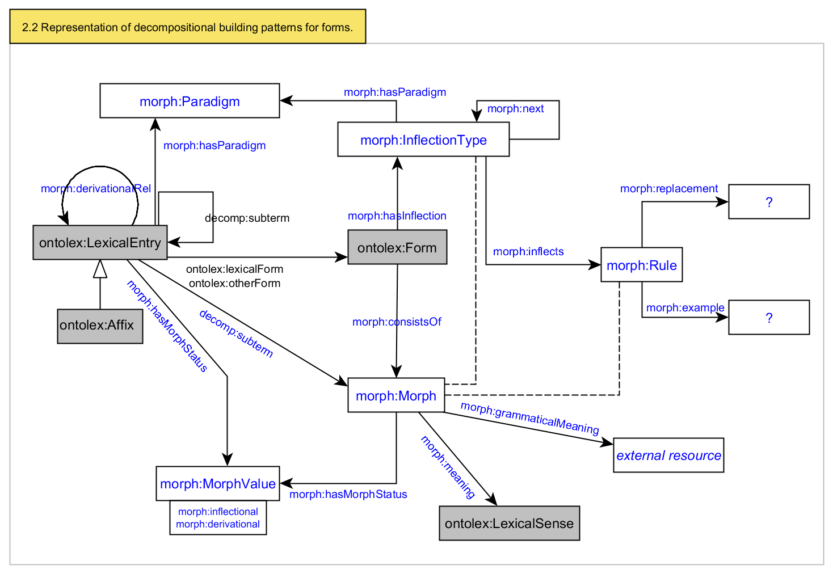

**Decisions on further progress:**

1. in the next telco on April 14th we will go through the module OWL file and evaluation sheet as the starting point for evaluating and developing the module vocabulary
2. every following telco we will go through example data and filll in the evaluation table
3. after that we will apply the collected “required adaptions” to the OWL file and evaluate the next example dataset - repeat until vocabulary is validated
4. Apply testing for a whole dataset converted into OntoLex-Morph RDF

**Todos for next telco:**

* Max will update OWL file with his latest suggestion for inflection and the latest Lila proposal for representing compounding and derivation
* Bettina will sort and update modeling needs