University of Utrecht

Experimental Quantum Physics: Dark Matter

December 2015 – January 2016

A.P. Colijn, C.D. Tunnell

contact: [colijn@nikhef.nl](mailto:colijn@nikhef.nl)

Table of Contents

Introduction: Why Dark Matter – Why these lectures? 3

1 Lecture 1: The dark matter model 4

1.1 What is our Universe made of? 4

1.2 Dynamics of our Galaxy 5

1.2.1 Our Galaxy 5

1.2.2 Rotation curve 6

1.3 Standard Halo Model 7

1.4 Dark Matter Particles 9

1.4.1 Standard Model 9

1.4.2 WIMP hypothesis 10

1.4.3 WIMP production in the early Universe 10

1.5 Summary 13

2 Lecture 2: WIMP meets matter 14

2.1 Nuclear recoils 14

2.2 Kinematics 15

2.3 Event rate 17

2.4 WIMP nucleon cross-section 20

2.4.1 Spin-independent interactions 21

2.4.2 Spin dependent interactions 22

2.5 Corrections to the event rate 23

2.5.1 Movement of earth and sun 23

2.5.2 Nuclear form factors 25

2.6 Summary 26

3 Lecture 3: WIMP meets detector 26

3.1 Phonons, Scintillation & Ionization 26

3.2 Backgrounds 28

3.2.1 The enemies: Uranium & Thorium 28

3.2.2 Neutrons 29

3.2.3 Gamma rays and Electrons 31

3.2.4 Your worst enemy: internal backgrounds 32

3.2.5 The unbeatable enemy: neutrino’s 32

3.3 Summary 33

4 Lecture 4: Data analysis in dark matter experiments (TBD) 33

5 Exercises 34

5.1 Lecture 1 34

5.2 Lecture 2 35

5.3 Lecture 3 36

6 Literature 38

# Introduction: Why Dark Matter – Why these lectures?

There is overwhelming evidence that we can only account for a small fraction of the content of our Universe. Besides the ordinary matter there appears to be a large fraction of so-called dark matter (dark because we can’t see it) and dark energy (dark because we don’t have a clue what it is). Dark matter is necessary to coherently explain phenomena at large, larger and largest scales in out Universe. At a relatively small scale the rotation curves of Galaxies can be only explained if there is a large halo of dark matter permeating and surrounding the spiraling arms we usually see. Secondly, at much larger scales collisions of clusters of Galaxies also point to a large fraction of the mass in these clusters to be dark matter. Finally the small temperature fluctuations in the cosmic microwave background (largest possible object) can only be explained if there is a large fraction of dark matter in the Universe.

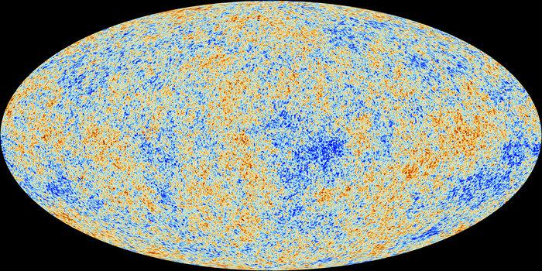

Figure : Image of the temperature of the CMB as seen by the Planck satellite. Although the temperature is almost constant at 2.72548±0.00057 K, The red areas are 100-200 micro Kelvin hotter than the blue regions. The structure in these fluctuations can properly be explained if there is about 25% dark matter in our universe.

The reason to discuss dark matter as a topic of a lecture on experimental quantum physics, is that we think that dark matter particles are ‘quantum particles’. The ‘experimental’ aspect comes from the possibility we have to do experiments to verify/falsify the dark matter particle hypothesis. During these lectures I will first give an overview of what I know of our Universe and how rotation curves of our Galaxy lead us to a prediction of the behavior of dark matter around us. I will focus on one particular particle model for dark matter - Weakly Interacting Massive Particles (WIMPs) - and I will try to convince you why this is a viable dark matter model. For the second lecture I will outline the strategy of WIMP detection and we will derive the *master* equation to calculate event rates for nuclear recoils in earth-based experiments. Please note that during these lectures I will only focus on the detection of WIMPs in underground labs: there are other ways that scientists are trying to find these particles, mostly with X-ray and gamma ray satellite observatories. Furthermore in the Large Hadron Collider at CERN we are trying to produce the dark matter particles. During the third lecture I will discuss several detection techniques for WIMPs and discuss the limiting factors of the experiments currently being executed. For the final lecture Chris Tunnell will focus on the analysis strategies employed by WIMP hunting experiments, with an emphasis on the XENON experiment in Gran Sasso (Italy).

# Lecture 1: The dark matter model

## What is our Universe made of?

Since 100 years we know that we live in an expanding Universe. The expansion of the Universe is characterized by a scale factor called the Hubble constant. Like in an inflating balloon the speed at which on object moves away from you is given by the scale factor times the distance of the object. So:

And the Hubble constant can be written as:

with indicating the scale of the Universe.

The measurements of the CMB by the WMAP and Planck satellites give an accurate measure of the composition of the Universe. Our current understanding of these data make us believe that only 4% of the Universe is made out of ordinary matter, 23% is dark matter and 73% is made of a substance called dark energy. The abundances are usually expressed in terms of the density of each substance divided by a critical density, . So:

The critical density is the density for which the Universe is flat, meaning for infinite times the expansion would come to a halt. If the Universe would eventually shrink and we would experience a ‘big-crunch’, while for the Universe would expand forever. The critical density, expressed in terms of the Hubble constant and Newtons constant is given by:

|  |  |
| --- | --- |
| parameter | value |
| Ω |  |
| Ωbaryons | 0.0456 ± 0.0016 |
| Ωdark matter | 0.227 ± 0.014 |
| Ωdark energy |  |
| H | km/s/Mpc |
| τU | 13.75 ± 0.11 Gyr |

In the table you notice the parsec (pc) as a unit of distance. It seems to be the preferred distance unit of astronomers. Conversion to light-years (ly):

## Dynamics of our Galaxy

### Our Galaxy

In Figure 2 a schematic view is presented of our Galaxy – the Milky Way. A rough description of the contents:

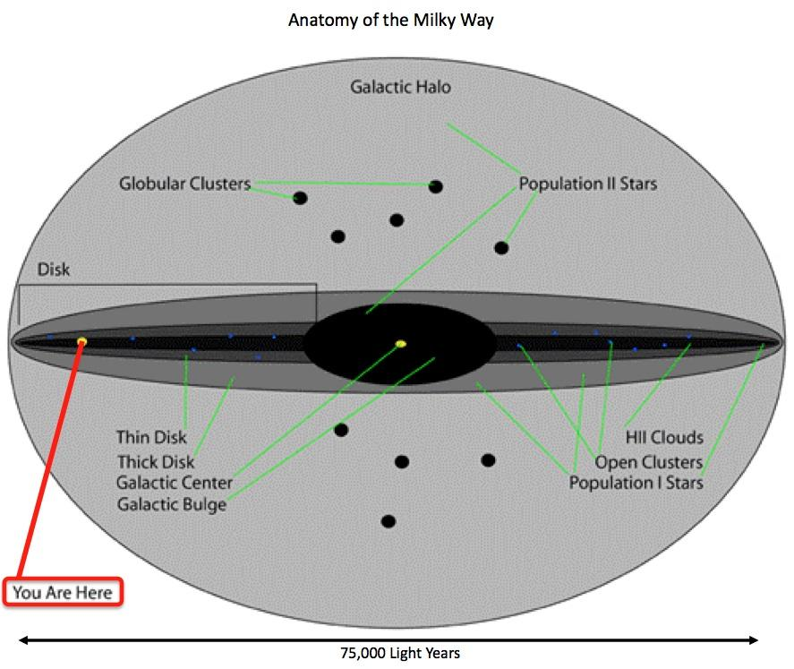

Figure : Anatomy of our Milky Way

* a central bulge region with a radius of a few kpc with and .
* a disk with the spiraling arms with and extending to a radius of 20-25 kpc. A thin disk of about 300pc thick with young stars and a thick disk of 1kpc thick with 8.5% of the mass. The density of stars in the disk falls of exponentially with a characteristic radial length of 3kpc.
* a halo with stars, globular clusters, gas, and dark matter (!) with about 90% of the Galaxy mass.

The ratio of mass-to-light of the Milky Way:

We expect this quantity to remain constant throughout spiral galaxy arms under the assumption that the population of stars remains more or less the same. The observation however, shows an increase of for larger radii, indicating more mass that is not luminous. A first indication of dark matter or is something else going on?

The Sun is at a radius away from the galactic center. The velocity of the sun around the galactic center:

### Rotation curve

The key reason why we believe our galaxy contains dark matter comes from the study of rotation curves (of other galaxies mostly). The rotation curve as shown in Figure 3 shows orbital velocity of stars in the Milky Way as a function of the distance to the center. From classical Newtonian mechanics we can calculate this velocity by simply balancing gravity to the centripetal force:

Since we expect that essentially all mass is ‘enclosed’ at large radii we expect that the orbital velocity of stars at large r decreases like . However, as shown in the rotation curve here the velocity as a function of radius remains constant even to very large radii. This effect is observed for all spiral galaxies, and is in strong contradiction to what we expect from the laws of gravity. Two possible explanations are:

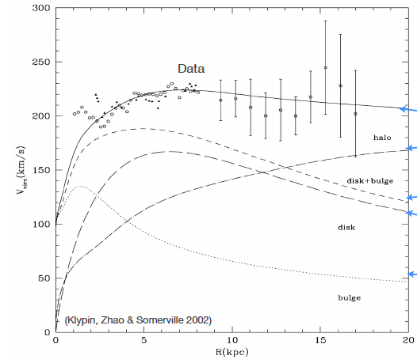

Figure : Rotation curve of the Milky Way, clearly showing that the orbital velocity becomes constant.

1. the laws of gravity need to be modified. With the laws of gravity modified at large distances it is possible to explain the rotation curves of galaxies (but not clusters of galaxies colliding, or the structure in the CMB)
2. there is more matter in a galaxy than we can observe. During these lectures this is the option we will pursue – we will try to see what kind of matter could fill our galaxy and how we could detect it. But as long as we don’t observe the missing matter, please do not completely discard option (i).

Since we will only consider option (ii) it would be worth to investigate further what kind of matter distribution would be needed to explain the observed rotation curve. The first thing we should note is that we do not ‘see’ this matter as we do with ordinary matter, so the stuff we are looking for does not participate in any electro-magnetic processes. Also strong forces are not an option for this substance. Hence the name: ‘dark matter’.

So how can we explain a rotation curve that does not change as a function of radius? As before we balance gravity and the centripetal force, but now we *assume* a constant circular velocity, . So:

In this equation represents the mass within a radius . The density corresponding to this mass distribution is given by:

It should be clear from this density distribution there is something strange going one here. If we would integrate such a mass distribution to infinitely large the mass of a galaxy becomes infinitely large! So even though the constant orbital velocity of spiral galaxies is observed to arbitrarily large radii, at some point there should be a hard cut-off of some kind.

For the Milky Way the current observations imply a luminous mass of and a total mass within 25 kpc of and within 230kpc even !

## Standard Halo Model

We will now see what we can further learn from the fact that we “observe” a dark matter halo with a density distribution. A reasonable assumption for our dark matter is that it consists of collision less particles in a sense behaving like an ideal gas: if the particles would not be collision less we would have easily observed the dark matter in our Milky Way and it would no longer be dark matter. In this section we will derive the explicit equation of

From statistical mechanical arguments there are a few statements we can make. The first one it relating the average kinetic energy and thus the mean square speed of the dark matter particles to their temperature:

In this equation represents the mass of a hypothetic dark matter particle, is the temperature and is Boltzmann’s constant.

Now I will now assume that the velocity distribution function, , is Maxwellian:

with the velocity dispersion. With this assumption I will prove that the corresponding density behaves like : of course I only make this assumption because I know it will eventually provide me with the right answer. The formal derivation is more complicated and beyond the scope of these lectures. In any case it should be noted that it is a bit strange that a Maxwellian distribution can be used for the density profile, since usually a Maxwellian distribution originates from gas molecules undergoing elastic collisions.

We can derive that the average square velocity corresponding to a Maxwellian distribution is given by:

Comparing to the previously obtained equation for we can immediately see that:

The next step in the derivation of the density is by looking at the equation of state. For an ideal collisionless gas we know the equation of state:

Here we have explicitly used the relation between temperature and velocity dispersion as used above. Now we can assume that in our collisionless gas we have the hydrostatic pressure supporting the gas against gravitational collapse. So:

Multiplying both sides of the last equation by leads to:

Differentiation to leads to:

In the derivation of the right side of the equation we have used:

A beautiful equation that can be solved to give:

Now we compare the density we calculated based on the assumptions made above to the ‘observed’ density profile derived from the rotation curves:

In order to describe the rotation curve the following relation must hold:

At very good approximation the orbital velocity at the sun’s distance from the galactic center has already reached the constant value, so . The dark matter particle velocity distribution can now be written as:

with as before.

So what have we done here? We have found a mechanism by which we can explain a dependence. For this we only had to assume that the dark matter halo around our Milky Way is isotropic and in hydrostatic equilibrium with gravity. What we have gotten in return is a model for the velocity distribution of the dark matter particles: namely a Maxwellian distribution. The reason for presenting this derivation here is that it will turn out to be of crucial importance to dark matter detection experiments to know this distribution. It turns out to be one of the key ingredients to predicting interaction rates in dark matter search experiments!

|  |  |  |
| --- | --- | --- |
| parameter | value |  |
|  | GeV/cm3 | local dark matter density |
|  | 220 km/s | circular speed at |
|  | 544 km/s | escape velocity at |

The information from the density distribution of dark matter is best summarized in the Standard Halo Model (SHM) of our galaxy. Besides the local circular velocity the SHM has a value for the local dark matter density, , and the escape velocity at . For most calculations no dark matter particles are considered that have a velocity higher than the escape velocity, and the Maxwell distribution is truncated accordingly.

## Dark Matter Particles

### Standard Model

Let us have a look whether there are particles within the Standard Model of particle physics that could account for the dark matter. The table below shows all the particles we currently know of.

|  |  |  |  |  |  |
| --- | --- | --- | --- | --- | --- |
| Fermions | Name | Symbol | EM charge | Weak charge | Color charge |
| Lepton | electron | e | -1 | -1/2 | 0 |
| muon | μ | -1 | -1/2 | 0 |
| tau | τ | -1 | -1/2 | 0 |
| electron neutrino | νe | 0 | +1/2 | 0 |
| muon neutrino | νμ | 0 | +1/2 | 0 |
| tau neutrino | ντ | 0 | +1/2 | 0 |
| Quark | up | u | +2/3 | +1/2 | RGB |
| down | d | -1/3 | -1/2 | RGB |
| charm | c | +2/3 | +1/2 | RGB |
| strange | s | -1/3 | -1/2 | RGB |
| top | t | +2/3 | +1/2 | RGB |
| bottom | b | -1/3 | -1/2 | RGB |

Since all particles are taking part in gravitational interactions in principle these particles could be dark matter candidates. But there are several conditions for dark matter candidates:

1. no color charge: bye-bye to the quarks
2. no electromagnetic charge: bye-bye to the quarks (again), and to the electron and the muon, and the tau.
3. should be stable

From the Standard Model particles we are left with the neutrino’s only. We know the neutrino’s have a non-zero mass, they are stable, and they only participate in gravity and the weak interaction. And there are many, very many neutrino’s in the Universe: 100/cm3, corresponding to a flux of /cm2/s. However, given the limits we currently have on neutrino masses, neutrinos cannot be dark matter – at least not in the amount we need. For dark matter particles we will have to look beyond the Standard Model.

### WIMP hypothesis

Currently there are many different models of physics beyond the Standard Model from which new particles can be expected that could be dark matter. At the moment all of these models are hypothetical in a sense that as of now (December 2015) no-one has ever observed a particle not in the list of Standard Model particles. For these lectures we will focus on one particular class of dark matter candidates, namely the Weakly Interacting Massive Particles (WIMPs). There are a few reasons why many physicists think that WIMPs are the most attractive candidates for the dark matter particle:

1. we have a mechanism to explain the production of WIMPs from the Big Bang, and we can explain the abundance of dark matter that we observe in our Universe.
2. we have theories like SuperSymmetry in which there are particles that have the right properties to be dark matter.
3. for an experimentalist the most important argument: we can test the WIMP hypothesis. WIMPs can be detectable, because they at least participate in the weak interation.

### WIMP production in the early Universe

We will first focus on the production of WIMPs during the very early Universe. The detailed derivation are rather complicated and long and will not be treated during the lectures, instead a sketchy argument is presented as to how we get to an observable abundance of WIMPs today.

Let’s go back to the beginning: 13 Gyr ago the Universe was an extremely unpleasant hot place. The temperature was much higher than the rest energies of all known particles. Suppose for the argument that there exists for example one type of Supersymmetric particle, denoted by , and that these particles can be produced by collisions of ordinary Standard Model particles. Also the inverse process will be possible and therefore we expect there to be a thermal and chemical equilibrium between these Standard Model particles and the new Supersymmetric one:

Here denotes any of the neutrino species and can be any of the six quarks. The masses of the particles are completely irrelevant as long as . The number density, is then expected to behave as:

This means that at these temperatures there are roughly as many particles as photons. Now we know that the Universe is in fact expanding, reducing the temperature. If the thermal energy of particles becomes low enough at some point the WIMP creation is no longer possible, because we assume that a WIMP particle is heavier than at least most of the Standard Model particles. Now the number density is Boltzmann suppressed:

If the WIMPs had remained in chemical equilibrium with the Standard Model particles, the reduction of the temperature would have made the WIMP density essentially zero today. But here the expansion of the Universe comes to a rescue: the expansion is fast enough that at some point in time - still well within the first nanosecond after the Big Bang – the WIMP density becomes low enough that the annihilation reaction no longer takes place. In other words: the equilibrium ceases to exist and the WIMPs freeze out.

Let’s have a bit more quantitative look at the description of the WIMP number density. It can be effectively described by the Boltzmann equation (I don’t really know how many Boltzmann equations are around):

In this equation is the Hubble constant, is the thermally averaged cross section for WIMP annihilation into Standard Model particles, and represent the production of WIMPs from lighter particles in the chemical equilibrium.

Let us first forget about the complicated terms on the right hand side of the equation by setting them to zero. We are now in a situation where no WIMPs are produced or annihilating. The solution to the equation in this extreme case is a number density that falls off like:

with the scale (i.e. size of the Universe). In other words the number density is inversely proportional to the volume of the Universe if WIMPs there is no mechanism for either production or annihilation. This corresponds perfectly to the qualitative statement made above about WIMP freeze-out.

Now let us see whether we can understand the right side of the equation. What exactly does the term mean? We will have a small intermezzo to elucidate this. Let us look at an example where two cubic volumes with size , containing particles each are passing through each other as shown in Figure 4. We suppose we also know the annihilation cross section, for the collision of two of the particles.

Macintosh HD:Users:Auke:Documents:college:DMUU2014:dictaat:collision_example.pdf

Figure : Two volumes with annihilating / colliding particles moving through each other.

The probability that one particle from the moving box hits one particle in the other volume is calculated by calculating the effective area that is covered by the particles in that box, and dividing by the total area of the box:

The total number of collisions if the volumes pass through each other is simply obtained by multiplying with :

The time for the volumes to pass though each other with constant velocity is given by . So the rate can be calculated as:

In the last step we have divided both sides by to get the number density, , on both sides of the equation. The quantity is called the rate of the interaction and unsurprisingly its unit is in 1/s. The rate is often written as the product of flux, , of the incoming particles times the cross-section:

Multiplied by the interaction rate gives the change in number density measured in 1/cm3/s. The rate and the above formulae are routinely used throughout particle physics.

The result looks very much like the right side of the equation for the WIMP number density. The only difference is the <> in around the , which is needed for the distribution of velocities. Also the cross section in general depends on the velocity therefore it is inside the brackets.

Now we can identify the terms on the right side of our famous equation for the time evolution of the WIMP density. The first term with the minus sign corresponds to the annihilation of WIMPs (the minus sign indicating the disappearance). The second term with the positive sign represents the creation of WIMPs from Standard Model particles. In general we can state that as long as the system remains in chemical equilibrium. So at some point we get the Boltzmann suppression of the WIMP density as the temperature drops. At some later time when the WIMPs have frozen-out and the number density drops like as discussed before. In Figure 5 the number density corrected for the expansion of the Universe is shown as a function of “time”, and indicating the different conditions as discussed in this section. It should be clear that a larger annihilation cross-section lead to a freeze-out at lower density, and vice versa.

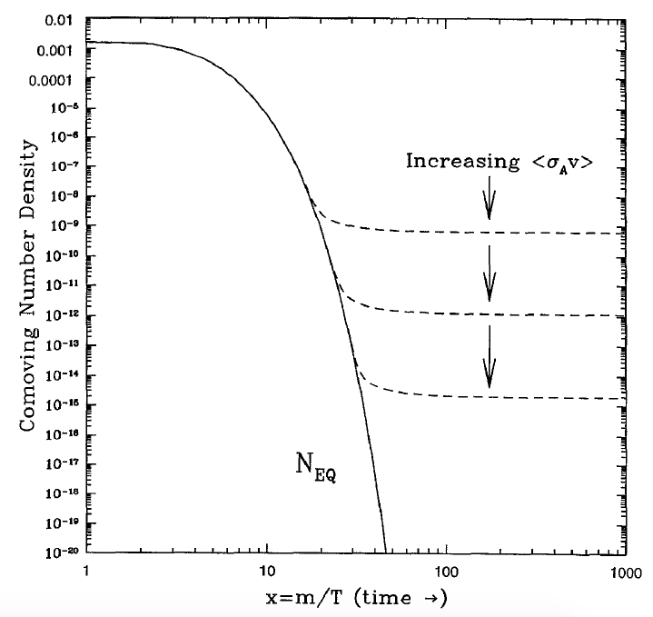

Figure : Dark matter number density corrected for the expansion of the Universe as a function of time.

The so-called freeze-out temperature, , is defined as the temperature for which the annihilation rate is balanced by the expansion:

The derivation of is a bit complicated and not necessary for the rest of these lectures. The result however is extremely important. The temperature is roughly given through a relation to the WIMP mass as:

There are small variations in the free-out temperature as a function of which is in principle unknown. But since the WIMPs are extremely non-relativistic at freeze-out. In principle this is corroborative evidence that the Maxwellian velocity distribution with particles at typical velocities of several 100’s of km/s may not be completely wrong ☺

Finally there is an important observation related to the value of the number density. If we assume a value of around the weak energy scale, so around 100 GeV the abundance of dark matter is of the same order as observed today. The remarkable coincidence - and certainly no proof at all – is that this is at the energy scale at which theories like SuperSymmetry, predict new particle.

## Summary

A large amount of experimental data proves that a large fraction of our Universe consists of dark matter. In this lecture I have shown that a dark matter halo around our Milky Way should contain most of its mass. If we are dealing with particles and the velocity distribution is Maxwellian the density profile can be explained. The particles making dark matter cannot be Standard Model particles. WIMPs are presented here as a viable candidate for the dark matter particle: non-relativistic, with a mass around the weak energy scale, and with the right abundance if at the weak scale.

# Lecture 2: WIMP meets matter

In the last lecture we saw that there may exist unobserved particles that could account for the dark matter in our Universe. For this lecture we will investigate the interactions these dark matter particles may have with ordinary matter. From the event rates we will be able to get an idea what the requirements are that a dark matter detector will have to fulfill.

## Nuclear recoils

The good news about WIMP particles is that they can interact with ordinary matter through the weak interaction: in principle the interaction can take place with both the electrons and the quarks in a nucleus. The bad news is that the rate of interactions turns out to be extremely small, because the weak force is weak. As we will see later for kinematic reasons interactions with electrons are suppressed, so we will focus here on the interactions between WIMPs and atomic nuclei.

The only process we will consider for interaction is by which the WIMP elastically scatters of an atomic nucleus or one of its constituents as shown in Figure 6. The scattering happens by exchanging a Z-boson or Higgs boson between the nucleus and the WIMP. As we will see later the energy transferred in such a collision is very low, and in most models both the WIMP and the nucleus stay intact.

Macintosh HD:Users:Auke:Documents:college:DMUU2014:dictaat:nucleus_WIMP_scatter.pdf

Figure : Elastic scattering of a WIMP to a Nucleus

I will start with a rough estimate of the nuclear recoil event rate, and later in section 2.3, a more refined calculation is presented. So what are the ingredients that we need for the calculation of the interaction rate of dark matter particles with a target composed of ordinary matter? It obviously depends on the interaction cross-section . If the cross-section equals zero the interaction does not take place. As for the annihilation of WIMPs in the early universe we can write the interaction rate per nucleus,, as:

And the rate per gram of the target material is:

with Avogadro’s number and the atomic mass in g/mol. The flux can be calculated from the WIMP number density and the WIMP velocity as:

So the total R is now given by:

In this equation there are two unknowns, both the mass of the dark matter particle and its cross-section for nuclear elastic scattering. This immediately puts a nasty degeneracy in the interpretation of our results once we would actually measure a dark matter rate. But in our estimate we assume a 100GeV/c2 WIMP with a typical weak scale cross section of cm2. Furthermore we use the WIMP density as found in the standard halo model of 0.3GeV/cm3 and for the velocity of our WIMPs we take the most probably value of our Maxwell distribution of . Finally we assume the target is made of xenon atoms: A=131 g/mol. The rate is now (I left the unit with each quantity):

Note that even though I have calculated the rate per kg instead of gram and per year instead of second it is still an extremely low number, and as we will see later the number for the cross section I have used is way too high.

Considering the low rate of nuclear recoils, we need to have a more accurate calculation of the rate, but also of the energy transferred by a WIMP to a nucleus. This will be the topic of the rest of this lecture.

## Kinematics

As a first step towards a more accurate description of the WIMP scattering to a nucleus, we need to take a closer look at the kinematics involved in the collision. If we ignore the thermal movement of nuclei, we can assume that the nucleus involved in a collision with a WIMP is not moving, while the WIMP approaches the nucleus with a certain velocity , .

Macintosh HD:Users:Auke:Documents:college:DMUU2014:dictaat:kinematics.pdf

Figure : WIMP nucleon scattering in the center of mass frame

We need to calculate the momentum transfer from the WIMP to the nucleus, since this directly gives us the recoil energy of the nucleus after the collision. Since the momentum transfer is independent of the reference frame, it is a clever choice to do all calculations in the center of mass frame of the collision as shown in Figure 7. Please note that we can do all our calculations without bothering about special relativity, since the velocities involved are of the order of hundreds of km/sec only as we have shown in section 1.3. In this reference frame the momentum *p* is given by:

with the velocity of the incoming WIMP in the lab frame and the reduced mass of the WIMP nucleus system:

The relevant quantity from a kinematic point of view is the momentum transfer ., which can be explicitly written as:

where is the WIMP scattering angle in the center of mass frame. Furthermore:

From the last equation it immediately follow that the recoil energy, , is given by:

with:

and the kinetic energy of the incoming WIMP.

Now we consider a WIMP with a mass of 100 GeV/c2 and velocity of 220km/s, colliding into an atom with the same mass. In this case we can calculate that is now:

Even though the velocity distribution has a tail to higher velocities, the recoil energy is unusually low for an experimental particle physicist. From this calculation it immediately follows that if one wants to construct a WIMP detector it should be sensitive to relatively low energies. Please check for yourself what the recoil energy for electrons would be: can you see why it is hard to make an experiment to detect WIMP-electron scattering?

Another interesting quantity is the momentum transfer itself. From the equations above it follows that:

What does such a number mean? Well, we can look at the corresponding De Broglie wavelength, , which for a momentum transfer of 75 MeV/c is:

The wavelength corresponding to is larger than the size of most nuclei, so the scattering to a nucleus is coherent. This means that the WIMP is scattering to all the constituents of the nucleus – i.e. quarks – simultaneously. This feature will prove to be very important for enhancing the event rate, especially for nuclei with large atomic mass.

## Event rate

In this section all the pieces will be put in place to calculate the nuclear recoil rate as a function the recoil energy, . We will start with the important assumption that the scattering of the WIMPs to nuclei is isotropic: there is no preferential scattering angle in the center of mass frame. As long as we don’t use polarized targets I think this assumption should be fine. Since we know from the pervious section that:

We know that if a nuclear recoil is caused an incoming particle with energy, , the rate in terms of the recoil spectrum is evenly divided over the energy range:

The differential rate in terms of can therefore be written as:

In this equation represents the rate of nuclear recoils within an energy range between and . Note that at this point I have not added any information about the physical processes responsible for nuclear recoils.

The next step is to integrate over all the possible values of the incoming energy that can cause a recoil energy . We now obtain the basic equation for the differential rate:

Note that I don’t care about the bounds of integration here, since we will make a change of variables later.

Furthermore we define as the minimal energy needed to make a nuclear recoil with energy . So:

From this we can derive the corresponding minimal velocity as:

We will need this expression later when we integrate over all possible WIMP velocities. Strictly speaking is determined by the escape velocity of WIMPs from the Milky Way: we don’t expect any WIMPs wit h a velocity higher than 544km/s. For the derivations here this effect will be ignored, since it does not affect the results in a qualitative way.

Now we are ready to write down the differential rate in a similar way as in section 2.1. The only difference is that we now want to include the velocity dependence of the rate in a correct way. In the earlier estimate of the nuclear recoil rate we assumed that all the WIMPs move at one velocity, but we know from the derivation in section 1.3 that the velocities are distributed according to a Maxwellian. This important piece of information we will use below.

So the differential rate is now written as:

with the WIMP density with velocity between and . We know how to write this down, since we know the velocity distribution function:

To determine the normalization constant we integrate this equation over all velocities demanding that we should get the total number density of WIMPs, . So:

resulting in:

The expression for the differential rate now becomes:

In the last equation we have factorized a 0th order interaction rate, , out of the equation and we have a term depending on the velocity . is equal to:

The value we find for is almost identical to the rough equation we derived in section 2.1, with the only difference that the velocity is no longer , but the average velocity (sounds pretty reasonable, doesn’t it?).

In order to get to our main result for the differential rate in terms of the recoil energy a rather technical derivation remain. Since the result is essential for the understanding of dark matter search experiments we will go all the way in the derivation. Let us recall the result we achieved before on the differential rate and transform the integration over the energy of the incoming WIMP into integration over the velocity:

With the minimum velocity as before. With a little reworking the integration is written as:

In the last step we defined = as the most probable energy of the incoming WIMP. Using the explicit expression for we find for the differential rate the following expression:

So after all these calculations we see that we can just expect a simple exponential distribution for the recoil energy.

Macintosh HD:Users:Auke:Documents:college:DMUU2014:python:recoil_Mwimp100.pdf

Figure : Recoil spectrum of a WIMP with a mass of 100GeV/c2 to Targets with different masses

As an example Figure 8 shows the recoil spectrum of a WIMP with a mass 100 GeV/c2 to targets with different masses, . The first thing to notice is that most of the interactions result in recoil energy lower than 10keV. The highest recoil energy is obtained when the mass of the WIMP perfectly matches the mass of the target, as expected from the classical mechanics involved in the kinematics. Although not shown in the figure, for even higher target masses the maximum recoil energy obtained is again slightly lower. In fact we can calculate the average recoil energy:

In Figure 9 the average recoil energy is shown as a function of the target mass. For all assumptions of the WIMP mass it is clear that the average recoil energy is maximum when the WIMP mass is equal to the target mass (i.e. . It should also be clear once again that for low mass WIMPs the average recoil energy is low, and most detectors will only be able to probe the high-end tails of the distribution.

Macintosh HD:Users:Auke:Documents:college:DMUU2014:python:ER_WIMP.pdf

Figure : The average recoil energy as a function of the target mass foR different AssumptionS of the WIMP mass

An important aspect to remember from the recoil distribution is that in order to become more sensitive to WIMPs it will be beneficial to have an experimental energy threshold as low as possible, since most events are in the lowest energy range of your detector. Note that I have not made any assumptions about the particle physics component in this equation, which are all ’hidden’ inside : we have only used basic classical mechanical kinematics and the Maxwell distribution of the velocity. In the next section we will ‘put the physics’ into our equations. Finally it has to be noted once again that I have neglected some important physics input in the derivation: (i) movement of earth through the Milky Way (ii) a finite escape velocity of WIMPs (iii) nuclear form factors. These points will be addresses later.

## WIMP nucleon cross-section

In this section we will have a closer look at the rate that appears in our equation of the interaction rate. has been defined earlier as:

with all the particle physics hidden inside the cross-section . Remember that the cross section is for the process WIMP colliding into a nucleus, which poses a problem to compare results from experiments done with different target materials. We now will dissect the WIMP-nucleus cross-section to get a description of it in terms of a WIMP-nucleon cross-section. Please read the previous sentence again and pay attention to difference between *nucleus* and *nucleon*. With a nucleon we mean a constituent of the nucleus – a proton or a neutron. We then assume the scattering to protons and neutrons to be the same for all nuclei.

Let us first have a look at the differential cross section as a function of the momentum transfer (It will become clear soon why we do this). We will start with an obvious identity:

We will prove that for an isotropic cross section – no dependence on the scattering angle - we can write the differential cross section as:

The proof is straightforward if we recall that:

Make a change of variables from to using this Jacobian:

Q.E.D.

The reason to calculate is that we have a fundamental identity from particle physics relating the differential cross section to a quantum mechanical matrix element, . The identity is known as ‘Fermi’s Golden rule’ and reads:

Before we continue: for those of you that did not follow a course in particle physics don’t despair. The most important thing you should remember is that represents the ‘probability’ for a process to occur, which in our case is the scattering of a WIMP to a nucleus. It turns out that there are two distinct cases of elastic scattering of non-relativistic WIMPs to a nucleus. In the first case the WIMP couples to all the protons and neutrons in a nucleus in a coherent way, while for the second case the WIMP spin interacts with the total spin of the target nucleus. In the next two sub-sections I will derive the relations between the rates caused by both these types of interactions, which are called spin-independent (SI) and spin-dependent (SD), respectively. The cross-sections that are discussed here are exactly those that are being quoted in almost all papers from experiments that are hunting for dark matter.

### Spin-independent interactions

To quantify the matrix element for spin-independent interactions we consider the contents of a nucleus, and we denote the coupling to either a proton or a neutron by and , respectively. We know from the momentum transfer involved in the scattering that the process is coherent, because the De Broglie wavelength corresponding to the momentum transfer is similar or larger in size to a nucleus. Under the assumption of coherent scattering we can write as:

This equation only states that the coherent scatter is simultaneously to all protons with strength , and to all neutrons with strength . In most literature it is assumed that the coupling of the WIMPs to protons and neutrons is identical, such that the matrix element simply reduces to:

The last result we will plug back into the equation of the differential cross-section:

In this equation indicates the total spin-independent WIMP-*nucleus* cross section. This we can in turn equate with the relation between the differential cross section and total cross section:

Where we have defined the WIMP-*nucleon* (note the difference between *nucleus* and *nucleon*) cross-section as:

The SI in the cross-section suffix indicates we are dealing here with a spin-independent coupling to the nucleons. Currently most experiments first do a measurement to this spin-independent cross-section.

One important observation that we have to make here is that the total cross section now depends on of the target material. This observation plays a crucial role in the choice of target material for dark matter detectors: a general rule is to use materials with an atomic mass as high as possible, unless you are looking for extremely low-mass WIMPs where the average recoil energy becomes very low for high atomic mass.

We now explicitly write down once again, but now in terms of the spin independent WIMP nucleon cross-section:

If we make the reasonable assumption that is the same for the nucleons in each element, the only difference between different targets can be expressed by the dependence of . After a discussion of the spin-dependent interaction in the next section, some important corrections to the rate will be discussed, and after that we are ready to start thinking of how to design a dark matter detection experiment.

### Spin-dependent interactions

In case of a spin-dependent coupling of a WIMP to a nucleus the situation is slightly more complicated and the derivation of the relevant quantities is less intuitive. I will give the expression of the differential cross section first and then briefly describe the terms that appear without going in too much detail. The differential cross section for the spin-dependent coupling is given by:

The structure of the differential cross section is similar to the one for the spin-independent cross section, but the different terms reflect the different type of interaction that has taken place. First of all Fermi’s constant is now explicitly left in the equation, caused by the fact that we are assuming a WIMP to undergo a weak interaction. Strange enough it does no appear in the spin-independent cross-section, where it is ‘absorbed’ in by convention. Second we see a term J, which indicates the total angular momentum of the target nucleus: a rather obvious observation is that a nucleus without spin/angular momentum does not interact through a spin-dependent interaction with a WIMP.

Furthermore we see a term that contains all the particle physics that took place at a microscopic level. It is defined as:

In this equations denotes the effective coupling of the WIMP to the protons and neutrons, respectively. It is multiplied by the average spin carried by the protons and neutrons, called . Some rough argument based on the Pauli exlusion principle may elucidate the equation a bit. Suppose you have for example a nucleus with an even number of protons, like for example xenon (Z=54). For such a nucleus the protons can fill quantum states to essentially spin zero pairs. Therefore you expect the . Now let us look at the neutron contribtion to the spin-dependent coupling. If we take xenon isotopes with even numbers of neutrons, it is expected that , while for nuclei with odd numbers of neutrons, in general. Nice thing is that my favorite dark matter target, xenon, comes with a sizable fraction of odd-numbered isotopes, so it is intrinsically sensitive to spin-dependent couplings of WIMPs with neutrons.

The terms in this equation are hard to accurately calculate, so many approximations are made to get reasonable values. Realize we are dealing with a strongly bound system where we now need to calculate the distribution of spins: pretty tough indeed (your teacher cannot do this himself).

We now integrate over the momentum transfer in the collision, , as we did before for the spin-independent case. We now get for the total spin-dependent cross-section:

In this equation denotes the WIMP-nucleus cross-section, which is again hard to compare between experiments using different targets. It is common practice to analyze experimental data under the assumption that the SD scattering is only with protons, while zero for neutrons, or the other way around. In this context the cross section will be expressed in terms of the SD cross-section with a proton or neutron. The latter can be easily calculated as:

where is the reduced mass of the WIMP and proton or neutron. With a little bit of formula-workout we obtain the following relation:

This is usually what is referred to as the spin-dependent WIMP cross section if experiments are compared with one another.

A final remark about the SI and SD cross sections. As a rule of thumb the spin dependent cross section is usually larger for elements with For higher atomic number the term in the SI cross section ‘wins’.

## Corrections to the event rate

### Movement of earth and sun

So far we have assumed for our rate derivations that the sun and earth are not moving with respect to the galactic coordinate frame. We do know of course that the sun is rotation about the center of our galaxy with a velocity of 220km/s and that the earth revolves around the sun with a velocity of 30km/s. Let us have a closer look at the Maxwellian distribution:

The velocity is the WIMP velocity with respect to the galactic rest-frame. Suppose we measure a WIMP velocity on earth of and we call the velocity of the earth with respect to the galactic rest-frame . At this point we assume that the Earth’s velocity is just the same as the Sun’s velocity. Then we can substitute in the Maxwellian:

If we now also include the effect of a finite escape velocity of WIMPs we arrive at the following equation, which I will present without any derivation. Requires a lot of integrations of exponentials while the procedure does not yield any new insights. So we get:

with a normalization factor given by:

Beautiful isn’t it? By the way the “erf” you se in the equation is a so called error function, given by:

The main effect of the movement of the sun around the galactic center is that the recoil spectrum becomes a bit boosted to higher recoil energies, like the raindrops on a car windshield making harder splashes if you drive though the rain.

Macintosh HD:Users:Auke:Documents:college:DMUU2014:python:MovingEarth.pdf

Figure : The effect of the movement of the earth through The galaxy on the recoil rate

In Figure 10 the effect of this movement on the recoil rate has been calculated for a WIMP with a mass of 100GeV/c2 interaction with a nucleus with (i.e. xenon). The blue line shows the rate if the earth would be at rest in the galactic coordinate frame (i.e. non rotation around the galactic center), while the green line shows the harder spectrum you obtain if the sun is moving with 220 km/s as it does. This slightly helps dark matter experiments increase their sensitivity. Also the finite escape velocity is taken into account, although the effect is small.

The movement of the earth around the sun causes a more subtle effect, effectively increasing the speed with respect to the galactic center in the summer with a maximum a June 2nd and a minimum in the speed half a year later. The effect to the rate can to 1st order be approximated as:

The period of the oscillation will be one year year and the rate will be maximum at corresponding to June 2nd. The amplitude is a couple percent, but it allows a measurement of dark matter with an intrinsic way of suppressing backgrounds. Some experiments exploit the effect of the change in amplitude – resulting in a change of event rate – as a way to subtract all constant background sources that do not show a seasonal effect. One of the most famous / notorious claims of dark matter discovery made by the DAMA/LIBRA collaboration is based on a seasonal effect in detector counting rates.

### Nuclear form factors

The last important correction originates from the fact that a nucleus has a finite size. Thus far we have treated the nucleus as a point object and therefore we could justify the assumption of coherent – to all protons and neutron at once – scattering of a WIMP. For high enough energy transfer the corresponding wavelength becomes of the same order and shorter than the size of a nucleus. In that case coherence is be lost and the cross-section WIMP to nucleus no longer depends on : the nucleons no longer work together. The size of a nucleus can roughly be approximated by:

And the momentum transfer we are considering is of the order of 50 MeV/c or less, corresponding to a De Broglie wavelength of about 5 fm. To correct for the size of the nucleus a so called form factor, is calculated that accounts for the size of the nucleus (for the connoisseurs it is the Fourier transform of the spatial distribution of the nucleons in a nucleus). I want you all to understand where these form factors come from and why they depend on the momentum transfer in a collision.

Macintosh HD:Users:Auke:Documents:college:DMUU2014:python:Targets.pdf

Figure : Recoil rate for some favorite Target materials corrected for the Nuclear Form factor.

Figure 11 shows the recoil rate of a 100 GeV/c2 WIMP to some of our favorite target materials: argon, germanium and xenon. Since Ar and Ge have atomics masses of 40 and 73 respectively, they have relatively small nuclei and therefore they don’t suffer too much from the loss of coherence. Xenon however, with an average atomic mass of 131 does suffer and for higher recoil energies the rate drops significantly, even below the rate of the lower A targets. Please note that the effect at low recoil energies is rather modest: this is the region where by far most of the recoils are expected to happen.

## Summary

In this chapter we have developed a model by which WIMPs can interact with ordinary matter through nuclear recoils. We have started with a calculation of the interaction rate based on kinematical arguments. Then we inserted a model of the cross-section in terms of coherent WIMP to nucleon scattering instead of scattering to a nucleus, in order to be able to compare experiments that use different target materials. Finally we implemented corrections to our interaction rate that are due to the movement of the sun and earth in the galaxy, and one due to the loss of coherence in the scattering to large nuclei.

# Lecture 3: WIMP meets detector

## Phonons, Scintillation & Ionization

In this lecture I will discuss how we are able to detect a nuclear recoil caused by a WIMP collision. As we have seen in the previous lecture such detection may be hard for two reasons: (i) the nuclear recoil energy is low and (ii) the rate of events is low. So the first things we need is a detector that is sensitive to these low keV energy range recoils. To understand how such low energy detectors work we need to discuss the three ways that the nuclear recoil energy can be dissipated in a target:

1. *Phonons*. Lattice vibrations – phonons – cause an increase in temperature of the target material. At temperatures close to the absolute zero the specific heat of an object is low (Debye theory!) and the temperature changes become of the order , which is detectable.
2. *Scintillation.* Some of the liquid and solid-state detectors emit part of the absorbed energy in the form of scintillation light with a characteristic spectrum. In for example liquid xenon the light is emitted from excited molecular like states of multiple xenon atoms, causing the wavelength of the scintillation light to be different from its own absorption lines. Therefore, the material is transparent to its own scintillation light, which can therefore be detected.
3. *Ionization*. Ionization is the process by which electrons are ejected from the target atom. These electrons can be separated from the positive ion by applying an electric field over the target. There is an intricate interplay between the ionization and scintillation process: separating the charges with an electric charge leaves fewer possibilities for charge recombination processes causing scintillation light.

I will discuss how detectors based on detection of either one or two of these signals work and how background events in such detectors are suppressed. Where needed I will go into deeper detail for describing the energy dissipation mechanisms.

Due to the extremely low expected event rate the different sources of backgrounds that can pollute and obscure our WIMP signals must be discussed: nuclear (NR) and electromagnetic recoils (ER) as shown in Figure 12.

Macintosh HD:Users:Auke:Documents:college:DMUU2014:dictaat:NR_ER_explain.pdf

Figure : Nuclear recoil of a nucleus from a collision with a WIMP or Neutron (left), and Electromagnetic recoil from A β or γ (right)

The first class of backgrounds is from neutrons that can cause genuine nuclear recoils, which cannot always be distinguished from a real WIMP collision. The second class of backgrounds originates from beta- or gamma rays that recoil electromagnetically to an electron. The last class of events is usually the dominant source of background, but in most detectors that detect a combination of two of the dissipation mechanisms these backgrounds may be reduced by several orders of magnitude.

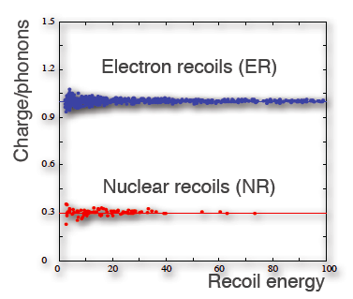

Figure : Separation of ER and NR events in a hypotheical detector measuring charge and phonons simultaneously.

As an example Figure 13 shows the response to NR and ER for a hypothetical detector that simultaneously detects both phonons and ionization. The energy in such a case will most likely be determined from the size of the phonon signal, which is in principle proportional to the absorbed energy. The reason for this is that there exist many more lattice vibration modes than there are electron-ion pairs created when dissipating the energy, causing a much-reduced statistical error on the energy determined from the phonon signal. So on the x-axis of the figure the energy is shown and on the y-axis the ratio of charge to phonon signal. This ratio is different for ER compared to NR and therefore an excellent discriminator. The reduced response to recoil energy through the ionization mechanism in this case is quantified in terms of the quenching factor, . The visible ionization energy is written as:

where represents the nuclear recoil energy as usual. In this particular case the quenching can be roughly understood by the fact that for the ER’s an electron is ejected from an atom with high-speed, making more ionizations along its (short) track, while for the NRs the target nucleus gets a small kick, not separating charges too drastically.

## Backgrounds

### The enemies: Uranium & Thorium

Any experiment searching for dark matter (and also other low-counting rate experiments) need to worry about contamination of their detector with uranium and thorium. These elements have lifetimes of Gy and Gyr and have been present since the genesis of the Earth (sounds dramatic), and they are still around today. Even though the contamination of most materials with these elements is usually small we will see in sections 3.2.2 and 3.2.3 that they can be responsible for quite some backgrounds in many different ways.

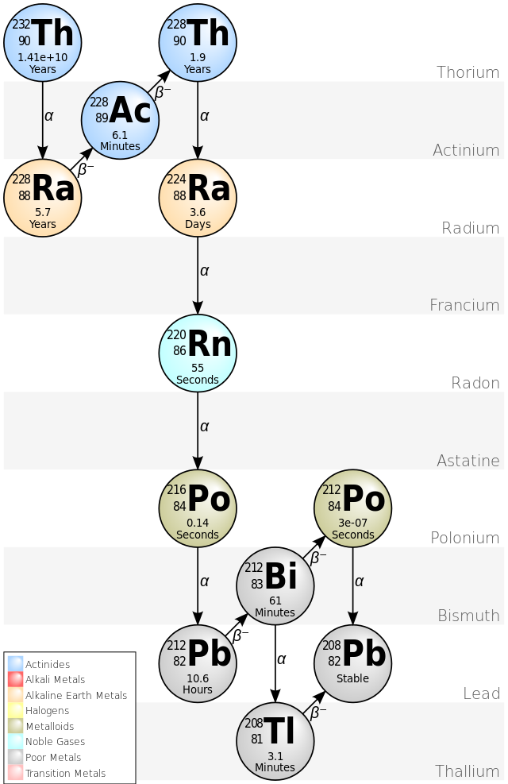 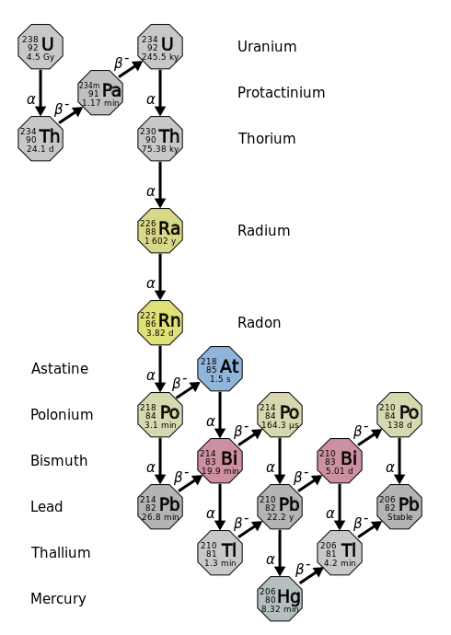

Figure : Thorium and Uranium decay chains

For completeness and because I think everybody should see these decay chains every once in a while Figure 14 shows both the decay chains. You see that in both cases there are abundant α and β emitters in the decay chains and it should be noted that the lifetime of the top-element is by far the longest in the chain. As a result of the large differences in lifetimes between uranium and thorium and their progenitors, after some time all isotopes in the decay chain will be in a so-called ‘secular equilibrium’. To describe this equilibrium we have to note that for an isotope somewhere in the decay chain, denoted with index *i*, the following differential equations holds:

The first part of the equation is the ordinary radioactive decay law, while the second part of the equation describes the growth of isotope *i*, due to the decay of its ‘mother’ element denoted by index *j*. As we will see in the exercises, equilibrium will be established with a constant amount of all the isotopes in the chain. In other words for all isotopes:

So for all isotopes the abundances are now related by the simple expression above. Of course for extremely long times the equilibrium will not hold as the amount of uranium and thorium will eventually disappear, but we can be pretty sure that this will happen only on a timescale longer than any experiment you plan to do.

As you can see from the equation above, secular equilibrium is of crucial importance to measure the amount of uranium and thorium in a sample of your construction materials. If you are able to identify the abundance of only one isotope, you know how much of each isotope is present. Secular equilibrium is pretty cool!

### Neutrons

Potentially the most harmful background to a WIMP search experiment comes from neutrons. The major difficulty with neutrons is that they have a chance to undergo elastic scattering in a target and subsequently escape the detector. The nuclear recoil that originates from this process cannot be distinguished from a WIMP collision. All WIMP detectors currently operational or planned have target materials that are not a source of neutrons themselves, so only neutrons coming from the outside need to be considered. The two main sources of neutrons are:

1. *Cosmogenic.* Cosmic muons may undergo an interaction with materials in or close to your dark matter detector. In this process high energetic neutrons may be formed that can penetrate your detector. The strategy to get this source of neutrons under control is by building dark matter experiment in deep underground labs to reduce the flux of the cosmic muons.

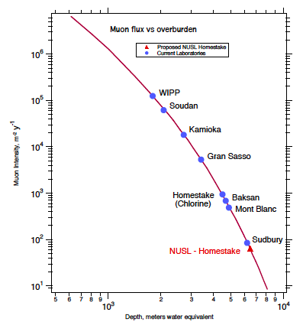

Figure : Muon flux as a function of the overburden measured in equivalent meters of water.

As you can see from Figure 15 the muon flux can be reduced by many orders of magnitude by going deep underground. In “my” lab in Gran Sasso the muon flux is around 104 m-2 yr-1, much lower than at the surface. Just going underground is however not good enough anymore since dark matter detectors are becoming more and more sensitive. To eliminate the remaining cosmic neutrons, most new detectors are located inside a large water volume to moderate and stop the neutrons. In addition these water volumes can be made ‘active’ by instrumenting them with light detectors, which can see the Cherenkov light from a muon passing though the water. If a muon is observed a ‘veto’ signal can be issued to the dark matter detector indicating that any activity may be caused by a cosmic ray. These, so called, active muon veto detectors are extremely powerful in getting rid of both cosmic muons and the neutrons they induce.

1. *Construction material.* A second source of neutrons comes from the material used in the construction of the detector. The problem here is that this source includes all construction materials of a detector, also inside a muon veto. The first source of the neutrons are the so called, reactions where there are traces of emitting elements in the construction materials: in almost all materials you can find traces of 238U, 235U or 232Th, and the all elements somewhere in the decay chain of these elements. The particles in themselves are not much of a problem, since they are essentially stopped immediately, but the may induce a nuclear process releasing neutrons. Especially in lighter elements, like for example C, this can form a nasty source of MeV neutrons.

*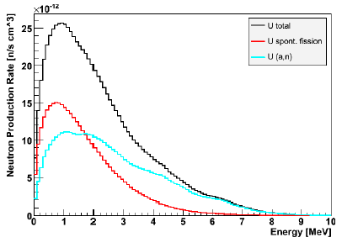*

Figure : Neutron energy spectrum from 238U (α,n) reactions with rocks

As an example Figure 16 shows the neutron energy spectrum for neutrons generated by 238U reactions in the rock surrounding the Gran Sasso underground lab (LNGS) in Italy. As a second source of neutrons there is natural fission of 238U. The same is true for other elements undergoing natural fission. The main strategy to avoid these sources of neutrons is to carefully screen all building materials of your detector, and reject materials that are too active. This is of course a painful, time-consuming activity, but all dark matter experiments go through an extensive period of material screening.

If some of the neutrons make it into the active area of your target, even despite a muon veto and careful screening, sometimes it is possible to distinguish a neutron from a nuclear recoil of a WIMP. The first and most powerful way to see a neutron is the observation of neutrons double-scattering in a detector: neutrons have a path length in for example xenon of a few cm. A WIMP essentially has an infinite free path length, and interacts at most once in your detector. Secondly a neutron can be captured by a nucleus, a process that is usually accompanied by the emission of high-energy gamma rays that can be easily observed.

### Gamma rays and Electrons

The second source of background is also originating from α and β decays. In most of these decays a daughter nucleus is usually left in an excited state with a very short lifetime. Usually the nucleus reaches its ground state by the emission of one or more γ rays. It has to be noted that both the α and β radiation itself usually does not pose a problem for the detectors, due to their short range causing them to be absorbed before reaching the active parts of a detector. The γ rays can penetrate much deeper and may become a serious background. Again a prominent source of these backgrounds are the construction materials of your detector: besides the γ rays from the uranium and thorium series there are some other isotopes now that are famous for giving dark-matter hunters a headache. Some famous isotopes include 39Ar, 60Co, 40K, 137Cs and many other beta emitters, some of which have an extremely long lifetime like 40K, while others have a much shorter lifetime and are only present due to the fact that they are continuously produced by cosmogenic activation of materials while these materials are above ground. This activation is caused mostly by (n,X) reactions and for a smaller part by (p,X) reactions. In the list of isotopes 39Ar plays a special role, since some detectors use argon as target material for their detectors. These experiments can only use argon that comes from deep underground sources.

As we saw in section 3.1 the recoils originating from γ rays can in principle be distinguished from nuclear recoils if you have a detector sensitive to more than one type of signal. It has to be noted however that in most detectors the separation between nuclear and electronic recoils is not perfect. In general the γ rays from your materials can be much more abundant than neutrons and at some point a small fraction of the electronic recoils ‘leak’ into the sample of nuclear recoils. To be sure that an experiment will not suffer from too much from γ ray backgrounds all constructions materials are again screened.

### Your worst enemy: internal backgrounds

So far I have only discussed the problem of backgrounds that come from sources external to the detector. These backgrounds are bad enough in themselves, but in principle it is possible to reduce these backgrounds by appropriate shielding of the actual target from these sources. A successful strategy employed by several detectors is to use part of the dark matter the target itself as a radiation shield. This technique is possible only if a detector allows the determination of the location of an interaction in the target. In that case interactions on the edge of the target – close to the radioactivity in the construction materials – can be rejected as likely background events.

Some backgrounds however are inside the target itself! For example detectors that use argon as a target should be extremely careful to make sure to have no pollution. Another example is a pollution with krypton in a noble gas detector, since there will be a small pollution with the β emitter . These pollutions are perfectly soluble in the liquid xenon target material and are equally distributed through the system. Even though the decays will result in an electronic recoil, instead of a nuclear recoil, the separation is not perfect and eventually there will be events leaking into the dark mater signal region. It is interesting to know that we have to thank ourselves for having a pollution of : atmospheric nuclear weapons tests after the 1940s and nuclear reactors are responsible for most of the we currently have.

The examples of internal background mentioned above are bad, but can be mostly avoided. It is possible to buy clean argon from underground sources, and it is possible to distill most of the krypton from for example xenon gas. In detectors with a xenon target, there is another nasty internal background that is extremely hard to eliminate: radon. Radon is a heavy noble gas without any stable isotopes, and a decay time of a few days. As you can see from Figure 14 it is produced in both the thorium and uranium series. So the surface of any detector construction material containing a pollution of these two isotopes – so essentially all materials – breathe a bit of radon gas into you detector. The radon unfortunately is well soluble into the xenon and will therefore decay inside the active detector volume: the decay itself is not so much of problem, since radon is an α emitter causing a huge signal. However further down the radon decay chains there are some isotopes that decay in the right way as to leave false dark matter signals.

### The unbeatable enemy: neutrino’s

Suppose that you are able to beat all the backgrounds described thus far, so you have a detector in which there are no neutrons, no beta and gamma rays. If you have a detector with a large enough target at some point you will become sensitive to a background of neutrinos. These neutrinos come from essentially two sources: (i) nuclear processes in our Sun (ii) supernovae.

Neutrinos can essentially do two things in your detector. They can undergo a weak interaction with one of the atomic electrons, causing electronic recoil. Just as for the other electronic recoils these may leak into the nuclear recoil signal region, if there are enough of them.

A second, much more interesting way in which neutrinos *may* leave a signal in your dark matter detector, is by coherent scattering to the atomic nucleus. Please pay special attention to the word ‘may’ in the previous sentence, since coherent neutrino scattering to an atomic nucleus has never been observed in any experiment. Figure 17 shows the predicted nuclear recoil spectrum of coherent neutrinos scattering for both germanium and xenon targets.

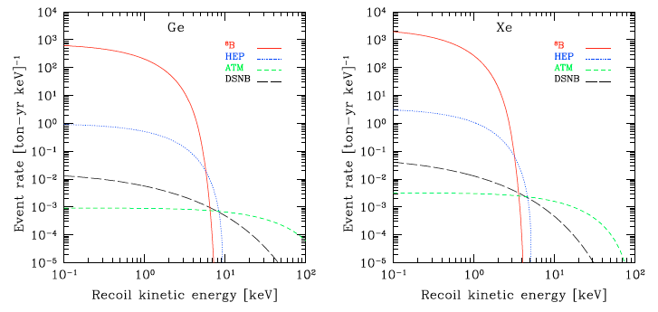

Figure : recoil energy spectrum of neutrino backgrounds in Germanium and xenon targets

It should be immediately clear that especially for low recoil energies such a recoil spectrum could become a problem, since these events give a signal identical to a WIMP interaction. For the current generation of dark matter detectors we know that this background is smaller than all other backgrounds we expect, but in a few years from now (=2015) we may reach a limit where dark matter detectors become so big that they sensitive to coherent neutrino scattering. As soon as you discover (!) coherent neutrino scattering, there is no point in making your dark matter detector larger anymore, unless you will be able to reject events pointing to the Sun.

## Summary

WIMPs may cause nuclear recoils in a target. In this lecture we discussed the three possibilities to see these nuclear recoils: (i) phonons (ii) scintillation (iii) ionization. If you build a detector that uses more than one of these signals it is sometimes possible to discriminate between electronic and nuclear recoils, thereby suppressing backgrounds effectively. The most important backgrounds to dark matter experiments were discussed, including the eventual limiting factor due to neutrinos.

# Lecture 4: Data analysis in dark matter experiments (TBD)

# Exercises

## Lecture 1

1. A closer look at the dark matter density as it is explained in section 1.2.2.
2. Show that is a solution to .
3. We have seen that the velocity distribution does not depend on position in the Milky Way: what can you say about the temperature of dark matter?
4. Draw the gravitational potential as a function of radius (i) assuming there is no dark matter (ii) assuming there is dark matter distributed according to .
5. A closer look at the dark matter density as it is explained in section 1.2.2. Assume a Maxwellian
6. What is the average velocity corresponding to the Maxwellian velocity distribution?
7. What is the most probable velocity?
8. Prove the relation
9. Prove the relation from section 1.2.2 and the results from the previous question.
10. Study section 1.4.3
11. Explain Figure 5
12. Explain why the WIMP number density decreases as after freeze-out.
13. Neutrinos were long considered to be good candidates for dark matter. However, it turns out that they are too light: for a fixed energy density, if neutrinos are light, then the number density is so high that there is actually not enough phase space in the Galaxy to pack them in. It is due to the Pauli exclusion principle. The computation is a bit complex, but we can approximate it pretty well as follows:
    1. The local density of dark matter in the neighborhood of the Sun is around 0.3 GeV/c2/cm3. For a neutrino of mass 10.6 eV/c2, which is a current upper limit, what is the local number density n of neutrinos?
       1. For this 10.6 eV/c2: How is this upper limit measured?
    2. Suppose I placed each neutrino in a box where each side had length L. What would be the size of the box such that the density of neutrinos would match the previous part (a)?
    3. According to quantum mechanics, to fit a particle in a box of size L would require it to acquire a momentum of 𝑝=𝜋ℏ/𝐿. Work out the corresponding momentum. The most convenient units for this would be eV/c.
       1. Side note: this is related to solving the Schrodinger equation in a 3D box, but for our purposes just assume 1D approximation.
    4. What is the corresponding velocity of the neutrinos? Compare to the approximate escape velocity of a galaxy like ours, probably around 400 km/s.
    5. Comment on your results and be sure to include the words (in a reasonably intelligent manner):
       1. Phase space
       2. Identical fermion
       3. Spin ½

## Lecture 2

1. Basic rate question: Here we will compute an interaction rate. Assume 50 kg of Xenon. . Assume a 100 GeV WIMP, an average WIMP wind velocity of 240 km/s, and an energy density of 0.3 GeV, unless otherwise specified.
   1. How many targets are there?
   2. Assume a WIMP-nucleon (spin independent) cross section of . What is the WIMP-nucleus cross section?
   3. What is the flux? Assume a reasonable WIMP mass and the average velocity.
   4. How many interactions are there?
   5. (optional) how many WIMPs have interacted in *you*?
2. Advanced rate question: Assume a 100 GeV WIMP, the rotation speed of the Sun around the galactic of 220 km/s, and an energy density of 0.3 GeV, unless otherwise specified.
   1. Assuming a Maxwellian velocity distribution, calculate the average WIMP velocity.
   2. Suppose you have a xenon target of 100kg and you measure 2 WIMP events in 1 year. How large is the spin independent WIMP-nucleon cross-section?
   3. Can you give an estimate on the uncertainty of the cross-section found under b)?
   4. Use the ‘full’ equation for the event rate from section 2.5.1 to estimate the term in the time dependent rate *(Hint: this is a tough question – I did not calculate it myself)*.
3. Kinematics of a WIMP with mass and incoming energy scattering from a nucleus with mass .
   1. Show that with the recoil energy.
   2. Explain why it is reasonable to assume that the WIMP scattering is isotropic.
   3. Explain with a kinematics argument why it will be extremely hard to detect WIMPs scattering from electrons
4. Derive the equation for spin-dependent WIMP-proton scattering as presented in section 2.4.2.
5. The nuclear form factor has a significant effect on the recoil rates for some of the heavier targets. In Figure 18 the nuclear form factor for xenon is shown as a function of the recoil energy.

Macintosh HD:Users:Auke:Documents:college:DMUU2014:python:F2.pdf

Figure : Nuclear form factor for Xenon

1. Explain qualitatively why the form factor drops to zero for a recoil energy of around 95MeV
2. Calculate the corresponding momentum transfer and compare the corresponding wavelength to the estimated size of the nucleus. Does your answer under a) make sense? *(Hint: I don’t understand the answer completely)*

## Lecture 3

1. Neutron backgrounds are not so good for WIMP search experiments, since a neutron may cause a nuclear recoil indistinguishable from a WIMP. Now consider a 5MeV neutron colliding elastically with a spherical liquid xenon target with a radius of 50cm.
   1. In what range is the recoil energy? Compare to WIMPs.
   2. How often do you expect a WIMP to double scatter?
   3. In Figure 19 the mean free path for different types of neutrons with liquid xenon are shown. Explain the different processes.

Macintosh HD:Users:Auke:Documents:college:DMUU2014:dictaat:LXe_neutron.pdf

Figure : Mean free path for different types of neutron interactions in liquid xenon

* 1. Use Figure 19 to estimate how often a neuron double scatters in the target *(Hint: rough estimates are allowed)*
  2. Give a strategy to eliminate (or reduce) your neutron backgrounds.

1. In this exercise I would like you to prove the claim that a decay chain with a long-living isotope on the top leads to a secular equilibrium. Let us consider the first part of the uranium decay chain: and call the decay constants , and respectively. Assume that at there is no thorium and palladium, while the amount of uranium is called .
   1. Calculate the amount of thorium as a function of time *(Hint: solve the differential equations explicitly).*
   2. Show that the amount of thorium becomes constant with the time characterized by the thorium decay time (and not the uranium decay time!) (*Hint: make the appropriate approximations).*
   3. What does the answer under b) imply for the other isotopes in the decay chain?
2. For SPECT images 99mTc can be used as a single photon emitter. The lifetime of 99mTc however is a 6 hours and it is unpractical to store such an isotope in a hospital for longer times. 99Mo can be made in nuclear reactors (like Petten in NL) and it decays to 99mTc with a lifetime of 66 hours: the 99mTc can be separated chemically from the 99Mo.
   1. How long does it take to get rid of 99% of 99mTc?
   2. How long does it take to get rid of 99% of 99Mo?
   3. Explain how the Mo “cow” works.
3. Neutrinos will at some point become an irreducible background to dark matter detectors.
   1. Explain the two mechanisms by which neutrinos interact with your dark matter detector.
   2. Which of these two mechanisms will yield an irreducible background.
   3. Find out the neutrino flux on Earth and compare to the WIMP flux. What can you say about neutrino interactions.
4. In the slides that were presented during Lecture 3 figures, like Figure 20, have been shown that summarize the status of all WIMP direct detection experiments.

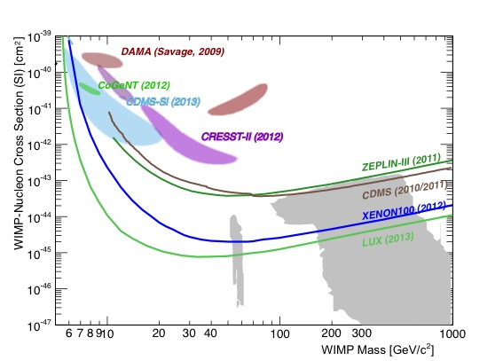

Figure : Summary plot of direct detection WIMP experiments

1. Explain why we need a 2-dimensional exclusion plot like the one above. Why can we just not set a limit on the WIMP-nucleon cross section?
2. Explain the shape of the solid curves. Why do they go up for low WIMP mass? Why do they go up for high WIMP mass?What can you say about the minimum in the curve?
3. Explain the colored ‘islands’. (Hard question: why are there two of these islands for DAMA and CRESST, while there is only one for CoGeNT and CDMS?)
4. 222Rn originates from the decay of 226Ra and unfortunately it is very well soluble in xenon. It emanates from essentially all surfaces, welds and lots of other components in a detector, in an unpredictable way. For xenon filled detectors it is one of the nastiest backgrounds.
   1. 222Rn is an -emitter and the energy deposited in a xenon detector is much higher than a WIMP could ever do. How could this become a background for a WIMP detector? (*Hint: study the 238U decay chain*)
   2. Suppose you have a pollution of 222Rn of in your xenon. How many atoms of 222Rn are present in each kg of xenon?
   3. How many background events do you expect? (*Hint: this is a rather open question*)
   4. 1M€ question: Can you find a way to remove radon from xenon? I don’t know, but if you find a good way, you will be famous in the field of direct detection dark matter experiments!

# Literature

* L. Baudis, Lecture notes, Sao Paolo 2012
* G. Jungman et al. Physics Reports 267 (1996) 195-373
* Binney & Tremaine, “Galactic Dynamics”, Princeton