

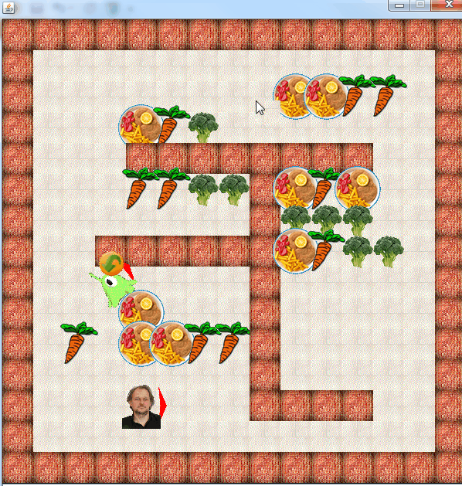

Miklas

Tutorial

Autor: Alexander Wendt

Version 1.0

**Purpose of the Document**

Miklas tutorial

**Document history**

|  |  |  |  |
| --- | --- | --- | --- |
| Version | Date | Changes | Authors |
| 0.1 | 2014-11-10 | Created template | Darth Vader |
|  |  |  |  |
|  |  |  |  |

Table of contents

1. Introduction 3

1.1 Research question and analysis 3

1.2 Expected Result 3

1.3 Evaluation criteria / requirements 3

1.3.1 General 3

1.3.2 Project-specific 3

2. Information on layout 4

3. Template Chapter 5

3.1 Template 5

3.1.1 Cc 5

Literature 7

Internet references 8

Annex A 9

Abbreviations

OLTC On-load Tap Changer

JAAJet Another Abbreviation

# Introduction

Preamble

## Setup Game

In eclipse, for the Launcher, set the Working directory to “${workspace_loc}/miklas, in order to include the config files at the start of the application

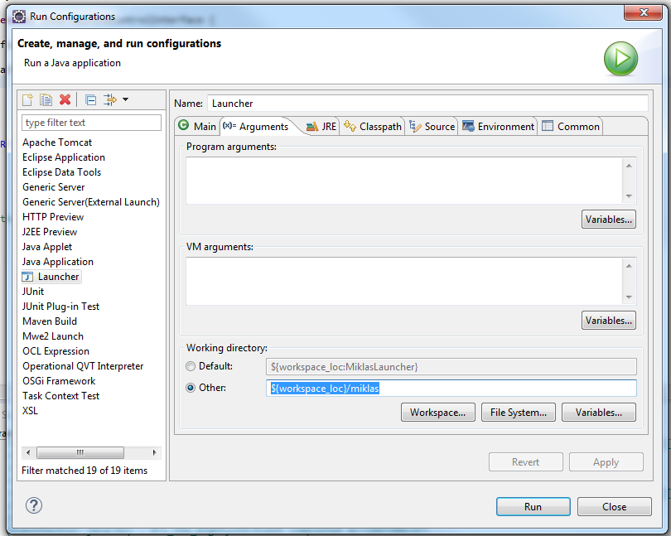

## Config Files

In the config file game.ini, a link to the real game config files exist.

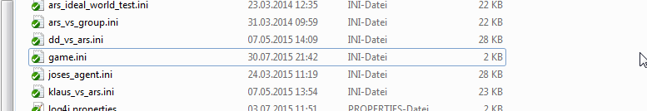

Here, the Path is set to “conf/ariverp2.ini”

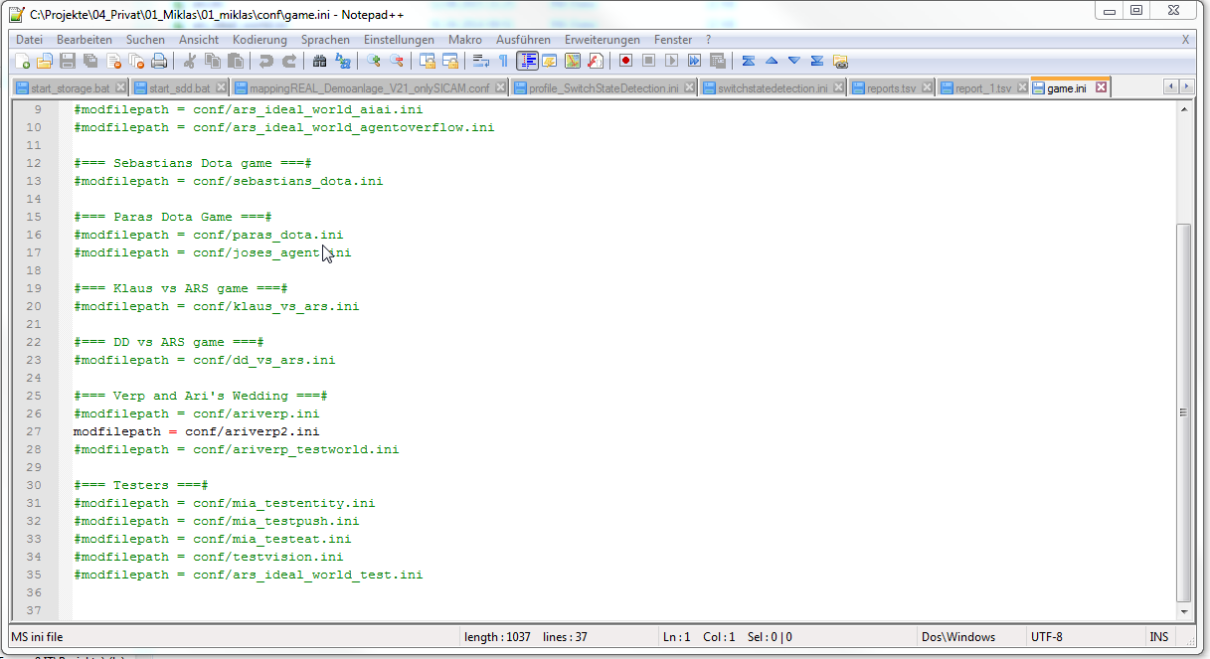

The world is created with layers. “_” means nothing. All other letters are assigned to certain “actors” in the world.

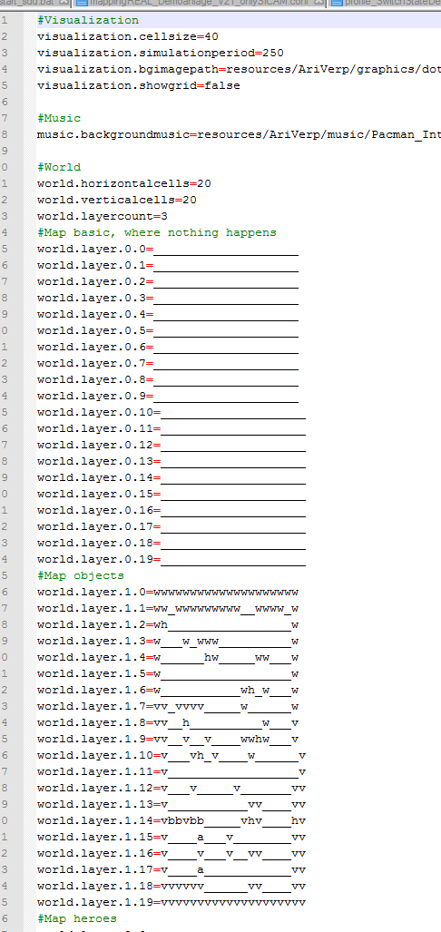

For instance, the letter “w” in the map is here a piece of forest.

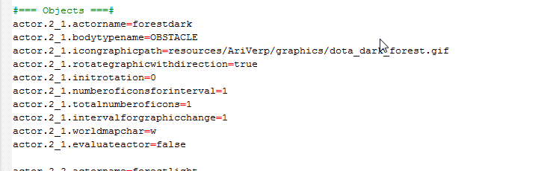

Each actor has a bodytypename. The bodytype defines the body of the actor.

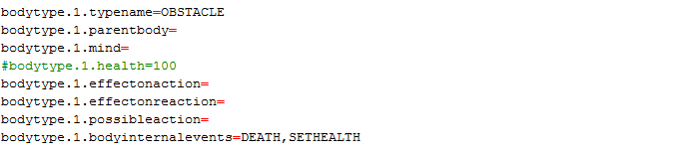

In the case above, only internal events are associated with the body. An example is the “SETHEALTH”. The event is invoked from a class in the “classname”. If an event is activated it performs some action on the body.

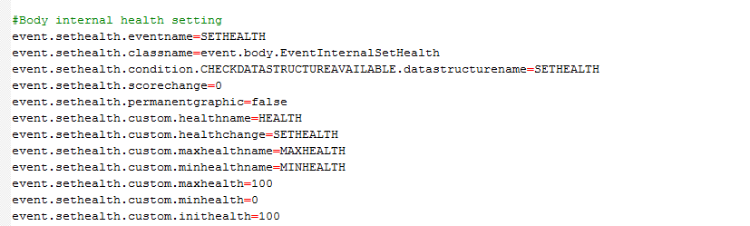

Only if a condition is satisfied, the event will execute. Conditions are defined as own invoked classes.

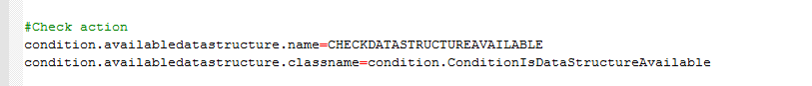

Literature

Internet references

Annex A