PENN STATE GREAT VALLEY
School of Graduate Professional Studies

AN OPEN SOURCE EVALUATION MODEL

by

Joel P. Confino

Submitted in Partial Fulfillment
of the Requirements
for the Degree of

MASTER OF SOFTWARE ENGINEERING

January 2009

© 2009, Joel P. Confino

I grant The Pennsylvania State University the non-exclusive right to use this work for the University’s own purposes and to make single copies of the work available to the public on a not-for-profit basis if copies are not otherwise available.

Date |  | Joel P. Confino
Date |  | Dr. Phillip A. Laplante, Adviser
Date |  | Dr. James A. Nemes, Professor and Division Head
Abstract

Selecting an appropriate open source software for a given problem or set of requirements is very challenging. Difficulties in selection include the fact that there is not a generally accepted set of criteria to use in evaluation, and that there are a proliferation of open source software projects to choose from. Given the lack of formal evaluation processes, evaluation is often performed in an ad hoc manner using whatever criteria the evaluators can muster. This sort of process leads to evaluations that are not standardized within an organization or between organizations, are not truly repeatable, and make learning from bad decisions difficult.

The paper will propose a set of criteria and a methodology for evaluating candidate open source software. The criteria examine a wide range of attributes of the software including the code quality, license, community, project velocity, pedigree, market penetration, documentation and support. To test this evaluation model, several real world open source projects were examined. Additionally the results of this model will be compared against the published results of an evaluation performed by the Defense Research and Development Canada agency.

The contribution of this paper is a set of criteria and a methodology for assessing candidate open source software for fitness for use. This evaluation model relies on publicly-accessible data, and is not prohibitively time-intensive to perform.
Table of Contents

List of Figures iv
List of Tables v
Introduction 1
PREVIOUS AND RELATED WORK 3
Overview of the Evaluation Process 4
Evaluation Criteria: Functionality (m₁) 5
Evaluation Criteria: Licensing (m₂) 7
Evaluation Criteria: Code Quality (m₃) 10
Evaluation Criteria: Project Velocity (m₄) 15
Evaluation Criteria: Pedigree (m₅) 17
Evaluation Criteria: Community (m₆) 19
Evaluation Criteria: Market Penetration (m₇) 20
Evaluation Criteria: Documentation Quality (m₈) 21
Evaluation Criteria: Support (m₉) 23
Creating a Scorecard 25
OSSEvaluator Tool 28
Case Studies 31
15.1. ESC/Java2 33
15.2. JCSC 38
15.3. PMD 43
15.4. JavaChecker 48
15.5. FindBugs 53
15.6. JavaWizard 58
Summary and Conclusions 66

List of Figures

Figure 1– Example radar graph 27
Figure 2 – OSSEvaluator data entry 29
Figure 3-- OSSEvaluator radar graph 30
Figure 4 – ESC/Java2 radar graph 37
Figure 5 – JCSC radar graph 42
Figure 6 – PMD radar graph 47
Figure 7 – JavaChecker radar graph 52
Figure 8 – FindBugs radar graph 57
Figure 9 – JavaWizard radar graph 62
Figure 10 – Comparison of ESC/Java2, JCSC, & PMD 64
Figure 11 – Comparison of JavaChecker, FindBugs, & JavaWizard 65

List of Tables

Table 1 – Functionality sample evaluation 5
Table 2 – Popular Open Source Licenses 8
Table 3 – License Usage Rubric 9
Table 4 – Static Code Metrics 11
Table 5 – Static Analysis Scoring 12
Table 6 – Runtime Analysis Scoring 12
Table 7 – Design Analysis Scoring 14
Table 8 – Project velocity sample evaluation 16
Table 9 – Pedigree sample evaluation 18
Table 10 – Community sample evaluation 19
Table 11 – Documentation quality sample evaluation 22
Table 12 – Support quality sample evaluation 24
Table 13 – Example scorecard 25
Table 14 – Example weighted scorecard 26
Table 15 – Product ratings as determined by [17] 31
Table 16 – Combined scorecard 63
Table 17 – Comparison of the results of [17] and this evalution 63

Introduction
The term open source software implies more than just freely distributing source code. A generally accepted definition of open source software is the one proposed by the Open Source Initiative. It contains 10 criteria of open source software that are summarized below [16]:

- Free Redistribution – The software must be distributed freely without any license fee.

- Source Code – The source code must be freely accessible.

- Derived Works – The software license must allow modifications and derived works.

- Integrity of The Author's Source Code – The license may prohibit derived works from using the author’s name so there is no confusion as to who authored the software.

- No Discrimination Against Persons or Groups

- No Discrimination Against Fields of Endeavor – The license cannot limit the use of the software to a particular field or business or industry.

- Distribution of License – The license must be freely distributed along with the software.

- License Must Not Be Specific to a Product – The license must be contingent on the software being distributed in a particular product or package.

- License Must Not Restrict Other Software – The license can make no claims about other software that may be distributed along with licensed software.

- License Must Be Technology-Neutral – The license cannot dictate that only a particular technology be used with it.

The first three criteria are arguably the most important: free redistribution, access to the source code, and the allowance of derivative works.

Open source software is free to use and modify with no licensing fees and therefore attractive for use by government, businesses, and non-profits alike. The desire to use open source is generally based on financial benefits. However, even though the software is “free” to use, it is critical to select the right open source software solution for a given situation.

It can be difficult to evaluate any type of software, but open source software has both unique challenges and unique advantages with respect to its evaluation. One of the unique challenges of evaluating open source software is that the sheer number of open source projects. Anyone can freely create an open source project on any number of free hosting sites such as SourceForge.net. That low barrier to entry means that many open source software projects are very immature [2]. Another challenge is that open source software often has little documentation [10]. Without the documentation and marketing materials that traditionally accompany commercial software, it can be difficult to determine what features an open source software actually has.

Balancing the challenges of evaluating open source software are the unique advantages that it provides. The biggest advantage is the fact that the source code is freely available. Source code analysis is vital in determining whether the software is of high quality and is maintainable in the future. Another advantage is that many open source projects provide public read-only access to their issue tracking system which can give valuable insight into how fast the project is growing, whether defects are being found and fixed, and the amount of time it takes to resolve issues.

PREVIOUS AND RELATED WORK
There are at least four important open source software evaluation models in existence [22].

- The Capgemini Open Source Maturity Model (OSMM) was created in 2003 by the Capgemini consulting company [22]. It contains 12 weighted criteria and contains a spreadsheet that can be used for evaluation [18].
- The Navica Open Source Maturity Model (OSMM) was created in 2004 [22]. It seeks to assess the maturity of six key elements of software, and contains spreadsheets to assist in the evaluation. A book titled Succeeding with Open Source fully explains the model, and was authored by Navica’s CEO Bernard Golden [19].
- The Qualification and Selection of Open Source software (QSOS) was created in 2004 and sponsored by the consulting company Atos Origin [22]. The QSOS contains a set of evaluation criteria, and provides web-based tools to assist in the evaluation process. The website also contains a database of previous evaluations [20].
- The Business Readiness Rating (BRR) was created in 2005 and sponsored by Carnegie Mellon West, SpikeSource, O'Reilly, and Intel. The BRR provides evaluation criteria and spreadsheets for evaluation as well [21].

Even though it is not a formal evaluation model, another important work is Wheeler’s “How to Evaluate Open Source Software / Free Software (OSS/FS) Programs” [8]. It is rather informal but provides a very comprehensive look at evaluating open source software.

A comprehensive review and comparison of these four models is not offered here, but would be a valuable contribution to the literature. A comparison of QSOS and BRR is offered in [23]. However, it is worth noting that a weakness in all of these models is that they are too high level and do not attempt to evaluate the actual source code. This omission is despite the availability of source code, and the fact that code quality evaluation is an important part of determining the overall fitness of a piece of software. The evaluation model offered in this work seeks, among other things, to incorporate code quality in the evaluation model.

Overview of the Evaluation Process

The proposed evaluation model consists of nine criteria with a range drawn from the subset of Integers {0,1,2,3,4,5,6,7,8,9,10} where 0 represents complete non-satisfaction and 10 represents complete satisfaction. To allow for customization for various settings, each criterion will also be assigned a weighting factor, which is a real number in the range [0,1]. The more important the criterion, the greater its assigned weighting factor. The weighted criteria can be plotted on a radar type graph in order to facilitate the comparison of many criteria simultaneously.

Evaluation Criteria: Functionality (m₁)

The functionality criterion, m₁, is used to determine whether the open source software possesses the required features. There is no magic formula that can determine whether software meets its requirements, but by using the same standard to evaluate multiple products some objective comparisons can be drawn.

In creating a feature list for evaluation, both functional and non-functional features should be included. Examples of non-functional features include operating system and hardware requirements, meeting relevant standards, data exchange formats such as XML, communication protocols such as Internet Inter-Orb Protocol (IIOP), and database integration.

The functionality criterion represents the percentage of desired features that software possesses, and can be represented in tabular format. For example, Table 1 shows a feature comparison grid with features listed down the left side and fictional products listed in the other columns. A “1” is placed in a cell (with row i and column j) if product j includes feature i. Then, the percentage of non-empty cells is calculated. That is, if there are n features, and product i incorporates m of these features, then the total percentage of features for product i is r=n/m.

Table 1 – Functionality sample evaluation
Feature | Product A | Product B | Product C
Feature 1 | 1 |  | 1
Feature 2 | 1 | 1
Feature 3 | 1 |  | 1
… | … | … | …
Total Percentage | 83% | 68% | 77%
Functionality (m₁) Score | 8 | 7 | 8

The Functionality metric is then calculated as m₁₌ int(r)*10, where int represents the “nearest integer” function. A value of m₁ = 0 indicates that the evaluated software has none of the required features while m₁ = 10 indicates the software has all of the required features.

A 100% feature satisfaction rate is not always necessary for an open source software solution to be adopted since missing features can be implemented by the adopting organization.

Evaluation Criteria: Licensing (m₂)

The licensing criteria, m₂, is used to determine the appropriateness of the open source software’s license for the intended usage. Open source software licensing is one the most crucial yet confusing aspects of evaluating open source software’s fitness. Currently, there are well over 100 different open licenses [1]. To make sense of open source licenses it is useful to organize them into three general categories: permissive licenses, strong copyleft licenses, and weak copyleft licenses.

BSD-style Permissive Licenses

The Berkeley Software Distribution, or BSD, license was first used in 1980 for software developed by the University of California at Berkeley [3]. It is a very permissive license that allows users of the software the freedom to modify and redistribute it in any way. The only restrictions enforced by the BSD license are that if a user redistributes the software, modified or unmodified, they must:

- Include the original license with copyright notice
- Use the software “As Is” and not hold the author liable for any damages
- Not use the names of the authors in an advertising of derivative works

Users of open source software with BSD-style licenses are free to modify the source code, include it in their own proprietary software, and then sell the software commercially without releasing the source code.

GPL-style Copyleft Licenses

The General Public License, or GPL, was originally created by the Free Software Foundation for on the GNU project [4]. The GPL allows users to modify the software in any way and redistribute it. However, in contrast to BSB-style licenses, the GPL forbids someone from taking GPL-licensed open source software and turning it into proprietary commercial software. It enforces this restriction with a concept the Free Software Foundation calls “copyleft” [5].

If copyleft-licensed software is modified and redistributed, the source code of the modifications must be released as open source as well. This ensures that copyleft-licensed software and all of its derivatives will remain open source in perpetuity, and cannot be turned into proprietary software. However, there are some variations in what is considered a derivative, and therefore copyleft licenses are generally termed as “strong copyleft” or “weak copyleft”.

Strong copyleft licenses, such as the GPL, state that if the software is modified and redistributed, the derivative must also be released as open source. In addition, if the software is linked at runtime to another program and redistributed, that program must be open sourced as well [6]. This prevents GPL-licensed software from being embedded in a proprietary program that is redistributed.

Weak copyleft licenses, such as GNU's Lesser General Public License, also state that if the licensed software is modified and redistributed then the derivative must be open sourced. However weak copyleft licenses generally permit the runtime linking of the open source software to other programs [6]. This allows LGPL-licensed software to be embedded in a proprietary program that is redistributed. This makes the LGPL license more appropriate for software libraries that are embedded in other programs, and in fact the LGPL is sometimes called the Library General Purpose License.

The Open Source Initiative, or OSI, is a non-profit group that seeks to advocate open source software. The OSI maintains a list of various open source licenses, and indicates which licenses are “popular and widely used or with strong communities”. Table 2 lists several of the most the popular licenses according to the OSI and includes what style of license it supports, whether the license includes copyleft provisions [7], and the market share of the license [5].

Table 2 – Popular Open Source Licenses
License | Style | Copyleft | Market Share
GNU General Public License (GPL) | GPL-style | Strong | 59%
GNU Library or "Lesser" General Public License (LGPL) | GPL-style | Weak | 11%
New and Simplified BSD licenses | BSD-style | None | 7%
Apache License, 2.0 | BSD-style | None | 4%
MIT License | BSD-style | None | 3%
Mozilla Public License 1.1 (MPL) | Hybrid of BSD and GPL | Weak | 1.3%
Common Public License 1.0 | GPL-style | Weak | 0.7%
Common Development and Distribution License | Based on MPL, Hybrid of BSD and GPL | Weak | N/A

Once the style of license has been determined, it must be decided whether that type of license is acceptable for the intended use of the open source software. Table 3 lists a rubric that can used to determine the appropriateness of a license for the intended usage.

Table 3 – License Usage Rubric
Intended Usage | License Type of the Software
Intended Usage | Strong Copyleft | Weak Copyleft | Permissive
1. Open source software will be redistributed. | Pass | Pass | Pass
1. Open source software will be redistributed. | NOTE: Any OSS license is acceptable if you are not redistributing the software
2. Open source software will be modified and the modifications releases under a difference license. | Fail | Fail | Pass
3. Open source software will be dynamically linked to other software with a different license. | Fail | Pass | Pass
4. Open source software is intended to be embedded by other parties into proprietary products or open source software is intended to promote a technical standard. | Fail | Fail | Pass

Criterion m₂ = 0 when the rubric indicates the license fails for the intended usage, and m₂ = 10 when the rubric indicates the license passes for the intended usage. This means that software should only be used if m₂ = 10. If the desired open source software is deemed highly desirable but the license is not compatible with intended usage, the adopting organization could contact the author of the software and seek to negotiate a different license for a fee. Open source software can also be released under a different non-open-source license by the author so it is not uncommon to see a free and commercial version of the same software.

Evaluation Criteria: Code Quality (m₃)

This criterion, m₃, derives a quality metric through the use of various objective and subjective analysis techniques. One major advantage that open source software provides over closed source software is the obvious fact that you have access to the source code. Evaluating the source code gives you key insights into the quality of the product that are not observable otherwise.

Types of Analysis

There are three main types of code quality analysis: static, dynamic, and design.

Static analysis looks at the static structure of the code. Metrics such as cyclomatic complexity, cyclic dependency count, and number of lines per method are valuable in determining whether code is well structured. For example, a class with 100 methods is not easy to maintain because a typical person can only remember approximately seven items at a time [14]. A better structure would be to break the class up into multiple classes with fewer methods each.

A dynamic analysis looks at the code while it is executing. Typically, dynamic analysis is conducted during a performance test where memory allocation, CPU consumption, and I/O usage are measured. Clearly, more efficient code with respect to these attributes is desirable.

Design analysis is a subjective analysis of whether the code is designed optimally, according to a set of design heuristics. A set of accepted design heuristics for the Java programming language is Robert Martin's 10 object-oriented design principles [11]. While two different programs may look very similar during static and dynamic analysis, during a design analysis it may be apparent that one program adheres to an object-oriented (OO) design principles much better than the other program, which can have large benefits in terms of maintenance.

The code quality criterion is broken down into three sub-criterion: m₃s₁ which represents static analysis, m₃s₂ which represents runtime analysis, and m₃s₃ which represents design analysis.

Static Analysis
A static analysis is performed by running tools to calculate metrics, and then evaluating those metrics. While the metrics themselves are completely objective, the analysis of the metrics is subjective. For example, McCabe's Cyclomatic Complexity Number [12] is a well known metric that measures the number of execution paths through a block of code. It is generally accepted that a lower number is better, but there is not a clear cut upper limit that defines when a block of code is bad. An upper limit of desired Cyclomatic Complexity depends at least somewhat on the language and context [13]. Therefore customization of the following metric thresholds for specific scenarios is desirable.

Table 4 lists suggested static analysis metrics and suggests an appropriate open source tool that can be used to gather them.

Table 4 – Static Code Metrics
Metric | Description | Suggested Tool to Gather Metric
Cyclomatic Complexity | Number of execution paths through a block of code. The higher the number of paths, the more difficult the code is to write, test, and maintain. Lower is better. | JavaNCSS,  http://www.kclee.de/clemens/java/javancss/
Method Count | Number of methods in a class. Classes with too many methods are difficult to write, test, and maintain. Lower is better. | JavaNCSS,  http://www.kclee.de/clemens/java/javancss/
Dependency Cycles | One package depends on a second package which in turn depends on the first package. Dependency cycles mean packages are tightly coupled which means the packages must always be developed and released together. Cycles should always be avoided. Lower is better. | JDepend,  http://clarkware.com/software/JDepend.html

Let the variable ct represent the desired maximum Cyclomatic Complexity threshold. It is recommended ct = 10. Let the variable mt represent the desired maximum methods per class threshold. It is recommended that mt = 20.

cc is metric that represents the percentage of methods contained in the software that are below the Cyclomatic Complexity threshold. If a software contains n methods, and m methods have a cyclomatic complexity less than ct, then cc = n/m*10.

mc is metric that represents the percentage of classes contained in the software that have a method count below the method count threshold. If a software contains n classes, and m classes have a method count less than mt, then mc = n/m*10.

cy is a metric representing whether the software has any dependency cycles. If there are none, then cy=10. If there any cycles present then cy=0. Table 5 contains a scoring matrix for m₃s₁.

Table 5 – Static Analysis Scoring
Metric | Score
% of Methods Below the Cyclomatic Complexity Threshold (cc)
% of Classes Below the Method Count Threshold (mc)
Dependency cycles (cy)
Static Score (m₃s₁)

The Static Score (m₃s₁) is then calculated as m₃s₁ ₌ int( mt+ct+cy/3).

Runtime Analysis

The runtime analysis submetric may omitted from evaluations because it is often prohibitively time consuming to calculate. Runtime analysis may require a custom test program, a load generator, test data, instrumentation to gather the metrics, and an isolated test environment. In addition, the thresholds used for runtime analysis are highly dependent on the specific situation so even general guidelines are not possible. Describing a methodology for runtime testing procedures is beyond the scope of this document. However, for completeness, a general scoring matrix is suggested in Table 6.

In this case rc is metric that indicates whether a software performs under the desired CPU threshold. If the software’s CPU consumption is acceptable, rc = 10 otherwise rc = 0. rm is metric that indicates whether a software performs under the desired memory threshold. If the software’s memory footprint is acceptable, rm = 10 otherwise rm = 0. ri is metric that indicates whether a software performs under the desired I/O threshold. If the software’s I/O usage is acceptable, ri = 10 otherwise ri = 0.

Table 6 – Runtime Analysis Scoring
Metric | Score
Meets desired CPU threshold (rc)
Meets desired memory threshold (rm)
Meets desired I/O threshold (ri)
Runtime Score (m₃s₂)

The submetric m₃s_{2,} which is in represents the runtime score for software under evaluation, is calculated as m₃s₂ = int((rc + rm + ri)/3).

Design Analysis

A design analysis is achieved by a code review. It is usually not practical or necessary to examine every source file. A sufficient code review can be performed by identifying some key source files, such as the main bootstrapping class, and drilling down into other classes from there. It is important to “time box” the code review activity, that is to restrict the code review time to a firm schedule to not allow the process to continue endlessly.

Let m₃s₃ represent the design score for software under evaluation. The metric m₃s₃ is comprised of four other submetrics. The do submetric indicates whether the software conforms to generally accepted principles of object-oriented design. Robert Martin's 10 object-oriented design principles [11] states, among other things, that well designed software contains classes that have a single responsibility and use encapsulation to hide implementation details. It also has extension points that are open for extension but closed for modification.

The du submetric measures software’s understandability. The purpose of code should be easily understood by the evaluator. Class, method, and variable naming should be informative. Comments should be present to describe why certain implementation choices were made.

The de submetric evaluates software’s extensibility. Extension points should be clearly defined and seem reasonable. The software should appear extensible in ways the adopting organization foresees it will need to customize it.

dt is a submetric that determines a software’s testability. The software under evaluation should have an automated test suite present, and all the tests in that suite should pass when executed.

All of the submetrics, do, du, de, dt, are assigned a score using the following Likert scale:
0 = Complete Failure
1 = Strongly Disagree
2 = Disagree
3 = Neutral
4 = Agree
5 = Strongly Agree

The design score, m₃s₃, is then calculated as m₃s₃ = int((do + du + de + dt)/4)*2. Table 7 presents the scoring matrix for m₃s_{3.}

Table 7 – Design Analysis Scoring
Metric | Score
Object-Oriented (do)
Understandability (du)
Extensibility (de)
Testability (dt)
Design Score (m₃s₃)

The code quality criterion m₃ = int((m₃s₁ + m₃s₂ + m₃s₃)/3). In the case where runtime analysis is omitted, m₃ = int((m₃s₁ + m₃s₃)/2).

Evaluation Criteria: Project Velocity (m₄)

Criterion m₄ measures a project’s velocity to determine if this is a healthy, growing project, or a stagnant, dying project. Many open source projects grow stagnant after the initial author moves on to something else. Although there are project velocity metrics used in agile methodologies that rely on user stories or use cases completed per release, these presume more project structure than is existent in most open source communities. A literature review revealed that there are no other generally accepted means to measure project velocity. Therefore, the author proposes the use of the objective metric of release frequency.

A healthy project will have regular software releases and a fairly constant pace. Long periods of time without a release generally indicate a problem. There are different kinds of releases, and a commonly accepted definition of release types is the one defined by the Apache Portable Runtime project or APR. APR's release identifiers adhere to format of MAJOR.MINOR.PATCH such as 3.5.2 [9]. New major releases introduce a large quantity of new features and potentially break backwards compatibility. Minor releases add some new features, but remain backward compatible with other minor releases. Patch releases contain only bug fixes.

Totaling the major and minor releases per year indicates how quickly a project is adding new features. Totaling the patch releases per year indicates how quickly a project is fixing bugs.

There are multiple sources for gathering data about an open source project's releases including:

- A download page on the project's website will list at least the most current releases.
- A change log is often included in the current releases, and it often lists old releases.
- Repositories such as the Maven central repository (http://repo1.maven.org/maven2/) have release information that may extend back even further than what it available on a project's web site.
- The source code repository often will have labels or tags that indicate releases.

To calculate m₄ first define a target number of feature and patch releases per year. Then determine both a feature score vf and a patch score vp as a ratio r between the target value and the actual value.
Let t = number of target releases, and a = number of actual releases.
r = min(t,a) / max(1, max(t,a)) * 10.
Table 8 shows an example scoring matrix for project velocity.

Table 8 – Project velocity sample evaluation
Metric | Target | Product A |  | Product B
 | Target Value | Actual Value | Score | Actual Value | Score
Feature releases / yr (vf) | 2 | 4 | 5 | .5 | 2.5
Patch Releases / yr (vp) | 4 | 2 | 5 | 3 | 7.5
Velocity Score (m₄) |  |  | 5 |  | 5

The m₄ metric is calculated as m₄ = int((vf + vp)/2).

Evaluation Criteria: Pedigree (m₅)

The software pedigree criterion, m₅, is determined by evaluating the authors, patrons, and lineage of the project. Organization and individuals who have produced quality software in the past are more likely to produce quality software now. Additionally software derived from other software that is known to be of high quality is likely to benefit from that solid foundation. A review of the literature does not reveal any generally accepted metrics for determining a software product’s pedigree, therefore the author proposes the following rubric.

  - The pa submetric determines whether the author of this software is known to produce high quality software.
  - The pg submetric is used to evaluate whether the group sponsoring or funding this software is known to produce high quality software.
  - The pd submetric indicates whether this software is derived from or makes heavy use of another piece of software that is known to be of high quality.

Each submetric, pa, pg, pd, is evaluated on the following Likert scale:
0 = Complete Failure
1 = Strongly Disagree
2 = Disagree
3 = Neutral
4 = Agree
5 = Strongly Agree

Table 9 provides a sample evaluation of m₅.

Table 9 – Pedigree sample evaluation
Metric | Product A | Product B | Product C
The author of this software is known to produce high quality software (pa) | 3 | 4 | 2
The group sponsoring or funding this software is known to produce high quality software (pg)  For example, the Apache Software Foundation | 3 | 5 | 3
This software is derived from or makes heavy use of another piece of software that is known to be of high quality (pd)  For example, the Compass project (http://www.compass-project.org) is built on top of the highly regarded Lucene search engine (http://lucene.apache.org/) | 3 | 3 | 5
Average | 3 | 4 | 3.3
Pedigree Score (m₅) | 6 | 8 | 7

The pedigree criterion m₅ = int((pa + pg + pd)/3) * 2.

Evaluation Criteria: Community (m₆)

The community criterion, m₆, gauges the health of a community surrounding an open source project. An open source project benefits greatly from an involved user community beyond the project’s authors. A vibrant community is a good sign of project health. Signs of a good community include an updated website, an active mailing list, and active message board or Wiki where information between community members is being exchanged.

Criterion m₆ is evaluated using the following rubric:

- The submetric cw indicates whether the project website is regularly updated.
- The submetric cl determines if the project has an active mailing list.
- The submetric cb measures whether the project has an active bug tracker, message board or Wiki.

Each submetric, cw, cl, cb, is evaluated on the following Likert scale:
0 = Complete Failure
1 = Strongly Disagree
2 = Disagree
3 = Neutral
4 = Agree
5 = Strongly Agree

Table 10 provides a sample evaluation of m₆.

Table 10 – Community sample evaluation
Metric | Product A | Product B | Product C
The project website is regularly updated (cw) | 3 | 4 | 2
The project has an active mailing list (cl) | 3 | 5 | 3
The project has an active bug tracker, message board or Wiki (cb) | 3 | 3 | 5
Average | 3 | 4 | 3.3
Community Score(m₆) | 6 | 8 | 7

The community criterion m₆ = int((cw + cl + cb)/3) * 2.

Evaluation Criteria: Market Penetration (m₇)

Criterion m₇ refers to an open source software’s market penetration . It is important to include market leaders in a software evaluation [8]. Determining a market leader of open source software is a subjective determination because objective metrics such as sales figures or installed client base are not available since users of the software can download and use it anonymously. However, there are several sources that can be used to indirectly measure market penetration.

- Number of reviews in trade magazines, websites, and blogs. Sites such as Ohloh (http://www.ohloh.net) provide community reviews.
- Google Trends (http://trends.google.com) can be used to gauge popularity of the project's website
- For Linux-based software, inclusion in highly regarded Linux distributions such as Red Hat can be a sign of market penetration [8].

Let m₇ = 0 is the software is completely unknown, m₇ = 1 if the software is not well known, m₇ = 5 if the software is well known, and m₇ = 10 if the software is a market leader.

Evaluation Criteria: Documentation Quality (m₈)

Criterion m₈ assesses the quality of the open source software’s documentation. Software documentation is a critical component to software fitness, and yet many open source software projects have poor documentation [10]. There are many different types of documentation, and it is important to thoroughly evaluate the documentation along with the actual source and binaries. Documentation can be found in many places including code comments, separate documentation files accompanying the software, help files within the application, the project website, and in message boards.

A review of the literature does not reveal any generally accepted metrics for determining the quality of a software’s documentation. The author proposes grading the following types of documentation:

  - End user documentation (de)
  - Developer documentation (dd)
  - Code comments (dc)
  - Installation documentation (di)
  - Administration documentation (da)

Each type of documentation is evaluated on the following Likert scale:
0 = Complete Failure
1 = Strongly Disagree
2 = Disagree
3 = Neutral
4 = Agree
5 = Strongly Agree

Table 11 provides a sample evaluation of m₈.
Table 11 – Documentation quality sample evaluation
Documentation Type | Product A | Product B | Product C
End user documentation (de) | 3 | N/A | 2
Developer documentation (dd) | 3 | 5 | 3
Code comments (dc) | 3 | 3 | 5
Installation documentation (di) | N/A | 4 | 1
Administration documentation (da) | 2 | N/A | 1
Average | 2.75 | 4 | 2.4
Documentation Score (m₈) | 5.5 | 8 | 4.8

The documentation criterion m₈ = int((de + dd + dc + di + da)/5) * 2.

Evaluation Criteria: Support (m₉)

Criterion m₉ refers to the quality of the support, both commercial and community, available for the open source software under evaluation.

Commercial support may be provided by the author of software or by a third party company. While commercial support offerings vary, they generally include technical support, such as answering questions and providing bug fixes, and indemnification. Indemnification is legal or financial protection provided in the case of another party suing for intellectual property infringement or violating licensing terms of the open source software [15]. Such indemnification gives organizations an extra measure of risk mitigation.

Community support is free support provided by the software's developers and by the user community. Evidence of community support is usually found on the project's website, mailing lists, defect tracking systems, and message boards.

The following types of support will be rated:

- Commercial support (sc)
- Indemnification (si)
- Community support (sm)

Each type of support is evaluated on the following Likert scale:
0 = Complete Failure
1 = Strongly Disagree
2 = Disagree
3 = Neutral
4 = Agree
5 = Strongly Agree

Table 12 provides a sample evaluation of m₉.

Table 12 – Support quality sample evaluation
Category | Product A | Product B | Product C
Quality of commercial support (sc) | 3 | 5 | 3
Quality of indemnification (si) | N/A | N/A | N/A
Quality of community support (sm) | 3 | 4 | 1
Average | 2.75 | 4 | 2.4
Support Score (m₉) | 5.5 | 8 | 4.8

The support criterion m₉ = int((sc + si + sm)/3) * 2.

Creating a Scorecard

After a value has been calculated for each criterion, the results for each open source software being evaluated should be placed on a scorecard as shown in Table 13.

Table 13 – Example scorecard
Criterion | Product A | Product B | Product C
Functionality (m₁) | 3 | 5 | 3
Licensing (m₂) | 10 | 0 | 10
Code Quality (m₃) | 8 | 4 | 4
Project Velocity (m₄) | 8 | 3 | 6
Pedigree (m₅) | 6 | 3 | 4
Community (m₆) | 7 | 8 | 7
Market Penetration (m₇) | 3 | 4 | 8
Documentation Quality (m₈) | 4 | 1 | 6
Support (m₉) | 7 | 6 | 9
Total | 56 | 34 | 57

In order to customize the scorecard for a particular set of needs or preferences, a weighting factor w_{i} can be added to each criteria. Let wi = 0 when the criterion is minimally important and w_{i} = 1 when the criterion is essential. Let mw_{i} stand for the weighted criterion value. mw_{i} = m_{i}(w_{i} + 1). Table 14 shows an example of a weighted scorecard.

Table 14 – Example weighted scorecard
Criterion | Weight (w) | Product A |  | Product B |  | Product C
 |  | Score | Weighted Score | Score | Weighted Score | Score | Weighted Score
Functionality (m₁) | 1 | 3 | 6 | 5 | 10 | 3 | 6
Licensing (m₂) | 1 | 10 | 20 | 0 | 0 | 10 | 20
Code Quality (m₃) | .5 | 8 | 12 | 4 | 6 | 4 | 6
Project Velocity (m₄) | .5 | 8 | 12 | 3 | 4.5 | 6 | 9
Pedigree (m₅) | 0 | 6 | 6 | 3 | 3 | 4 | 4
Community (m₆) | 0 | 7 | 7 | 8 | 8 | 7 | 7
Market Penetration (m₇) | 0 | 3 | 3 | 4 | 4 | 8 | 8
Documentation Quality (m₈) | 1 | 4 | 8 | 1 | 2 | 6 | 12
Support (m₉) | 0 | 7 | 7 | 6 | 6 | 9 | 9
Total |  |  | 81 |  | 43.5 |  | 81

It is recommended that the scorecard values be plotted on a radar graph for easy comparison of multiple criteria at once as illustrated in Figure 1.

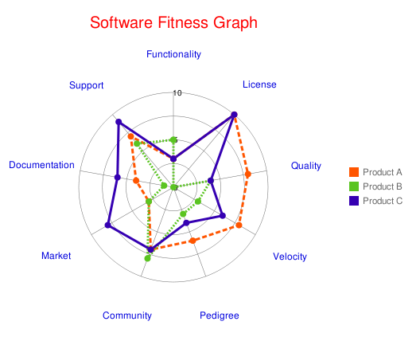
Figure 1– Example radar graph

OSSEvaluator Tool

A prototype tool called the OSSEvaluator was built in order to increase the efficiency of the evaluation process, and help validate the proposed methodology. The OSSEvaluator facilitates the evaluation of multiple open source software projects. For each open source software product under evaluation, the tool accepts the nine criteria values as input. Once all of the criteria values have been entered, the OSSEvaluator displays a radar graph allowing visual evaluation of the software along the dimensions of the nine metrics. Figure 2 displays the data entry page of OSSEvaluator with sample data entered.

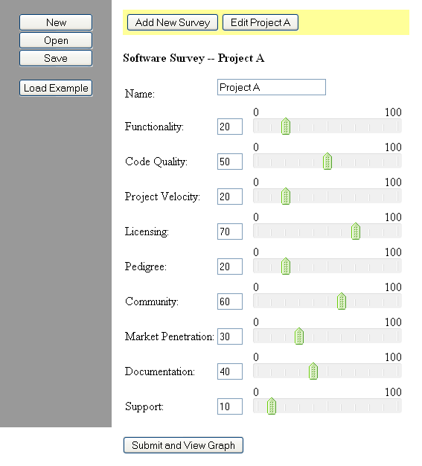
Figure 2 – OSSEvaluator data entry

The OSSEvaluator is a web-based application, and is implemented in the Java programming language. It makes use of several open source software frameworks most notably the Spring framework. It also uses the Google Charts JavaScript API as the underlying charting engine. Figure 3 shows the charting facility of OSSEvaluator.

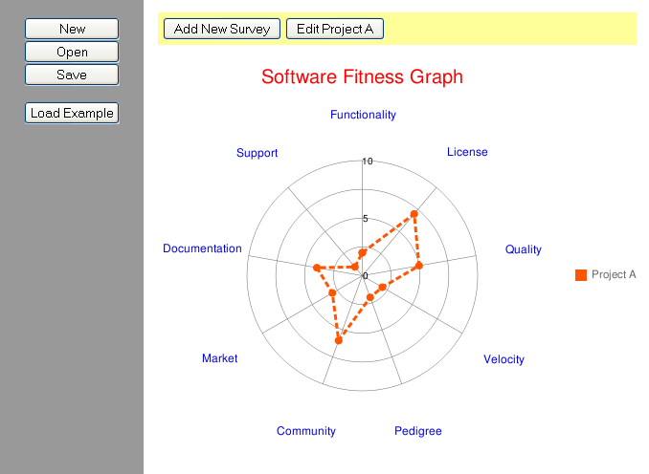
Figure 3-- OSSEvaluator radar graph

One valuable future enhancement to the OSSEvaluator would be the ability to use a wizard-style interface for inputting sub-criteria values that would then be used to calculate the main criteria values. Another enhancement would be the ability to load and save evaluations. The OSSEvaluator is released as open source software itself, which gives the open source community the ability to make these enhancements in the future.

Case Studies

In order to verify the accuracy of the evaluation model proposed by this paper, a case study was performed and the results compared against the published results of another software evaluation.

In February 2007 the Defense Research and Development Canada published a technical memorandum detailing how software verification tools can be used to assess open source software. Recognizing both the desire for use of open source software within the organization, and the need for an assessment tool for use by concerned managers, the memorandum details a process and set of tools used to evaluate open source software for maturity, quality, and security [17].

As part of the research, 23 software verification tools were evaluated and assigned a rating.
Some were commercial-off-shelf products and some were open source software. The rating scale was as follows:

1 = This tool’s capabilities were judged insufficient for proper application assessment.
2 = This tool’s capabilities were judged acceptable for proper application assessment.
3 = This tool’s capabilities were judged excellent for proper application assessment.

The tools were grouped by functional capability. One of the functional capabilities was detecting Java coding pitfalls such as code that was likely to cause bugs [17]. Six products with this capability were open source software implemented in the Java programming language. Table 15 lists the six products and the rating assigned to them by [17].

Table 15 – Product ratings as determined by [17]
Tool | Version | Rating | URL
ESC/Java2 | 2.0a7 | 3 | http://secure.ucd.ie/products/opensource/ESCJava2/
JCSC | 0.97 | 1 | http://jcsc.sourceforge.net/
PMD | 1.9 | 3 | http://pmd.sourceforge.net/
JavaChecker | 1.2 | 2 | http://javachecker.sourceforge.net/
FindBugs | 0.85 | 3 | http://findbugs.sourceforge.net/
JavaWizard | February 1999 | 1 | http://csdl.ics.hawaii.edu/Plone/research/javawizard/

To summarize the results, ESC/Java2, PMD, and FindBugs were deemed “excellent”. JavaChecker was deemed “acceptable” while JCSC and JavaWizard were deemed “insufficient”. The case study evaluated these same products to see if the proposed evaluation model would generate similar results.

ESC/Java2
The version of ESC/Java2 evaluated by [17] was 2.0a7. However, the source code for that version of the software is no longer available on the web site. The closest version with available source code was version 2.0b0 and that version was used for the evaluation.

Functionality Criterion (m₁)

Feature | Notes | Score
Detect Java coding pitfalls | In this case study it has already been determined that ESC/Java2 has the required functionality. | 1
Total Percentage |  | 100%
Functionality (m₁) Score |  | 10

Licensing Criterion (m₂)

 | Notes | Score
Licensing (m₂) Score | The software has an open source license, and is not going to be distributed. Therefore, it passes the licensing rubric. | 10

Code Quality Criterion (m₃)

Let ct = 10
Let mt = 25

Metric | Score
% of Methods Below the Cyclomatic Complexity Threshold (cc) | 93
% of Classes Below the Method Count Threshold (mc) | 97
Dependency cycles (cy) | 0
Static Score (m₃s₁) | 6
Object-Oriented (do) | 4
Understandability (du) | 4
Extensibility (de) | 4
Testability (dt) | 2
Design Score (m₃s₃) | 7
Code Quality Score (m₃) | 7

Note: Runtime analysis was not necessary for the purposes of this case study and therefore omitted.

Project Velocity Criterion (m₄)

Metric | Target
 | Target Value | Actual Value | Score
Feature releases / yr (vf) | 2 | 2 | 10
Patch Releases / yr (vp) | 2 | 0 | 5
Velocity Score (m₄) |  |  | 8

Pedigree Criterion (m₅)
Metric | Notes | Score
The author of this software is known to produce high quality software (pa) | Specific authors are unknown | 2.5
The group sponsoring or funding this software is known to produce high quality software (pg) | The project sponsor, KindSoftware, is part of a university and is focused on software engineering | 4
This software is derived from or makes heavy use of another piece of software that is known to be of high quality (pd) | ESC/Java2 was originally developed by the well regarded HP SRC Lab | 5
Average |  | 4
Pedigree Score (m₅) |  | 8

Community Criterion (m₆)
Metric | Notes | Score
The project website is regularly updated (cw) | Updated in Jan. 2009 | 5
The project has an active mailing list (cl) | Last post in Dec. 2008 | 4
The project has an active bug tracker, message board or Wiki (cb) |  | 0
Average |  | 3
Community Score(m₆) |  | 6

Market Penetration Criterion (m₇)

 | Score | Notes
Market Penetration (m₂) Score | 5 | ESC/Java2 is a relatively well known tool.

Documentation Criterion (m₈)

Documentation Type | Score
End user documentation (de) | 5
Developer documentation (dd) | 5
Code comments (dc) | 4
Installation documentation (di) | 5
Administration documentation (da) | N/A
Average | 5
Documentation Score (m₈) | 10

Support Criterion (m₉)
Category | Notes | Score
Quality of commercial support (sc) |  | N/A
Quality of indemnification (si) |  | N/A
Quality of community support (sm) | There is an active mailing list where you can ask questions. No wiki or bug tracker though. | 3
Average |  | 3
Support Score (m₉) |  | 6

Scorecard

Criterion | ESC/Java2
Functionality (m₁) | 10
Licensing (m₂) | 10
Code Quality (m₃) | 7
Project Velocity (m₄) | 8
Pedigree (m₅) | 8
Community (m₆) | 6
Market Penetration (m₇) | 5
Documentation Quality (m₈) | 10
Support (m₉) | 6
Total | 70

Figure 4 shows the radar graph for ESC/Java2.

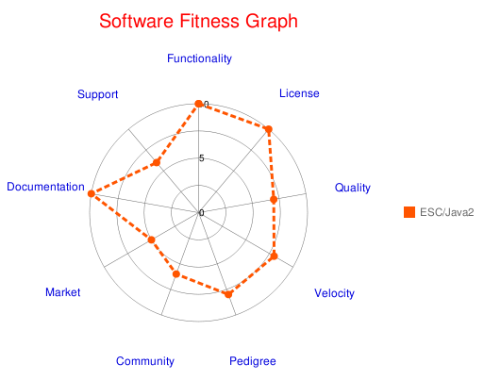
Figure 4 – ESC/Java2 radar graph

JCSC
The version of ESC/Java2 evaluated by [17] was 2.0a7. However, the source code for that version of the software is no longer available on the web site. The closest version with available source code was version 0.98.1 and that version was used for the evaluation.

Functionality Criterion (m₁)

Feature | Notes | Score
Detect Java coding pitfalls | In this case study it has already been determined that JCSC has the required functionality. | 1
Total Percentage |  | 100%
Functionality (m₁) Score |  | 10

Licensing Criterion (m₂)

 | Notes | Score
Licensing (m₂) Score | The software has an open source license, and is not going to be distributed. Therefore it passes the licensing rubric. | 10

Code Quality Criterion (m₃)

Let ct = 10
Let mt = 25

Metric | Score
% of Methods Below the Cyclomatic Complexity Threshold (cc) | 99
% of Classes Below the Method Count Threshold (mc) | 96
Dependency cycles (cy) | 0
Static Score (m₃s₁) | 7
Object-Oriented (do) | 4
Understandability (du) | 4
Extensibility (de) | 3
Testability (dt) | 5
Design Score (m₃s₃) | 8
Code Quality Score (m₃) | 8

Note: Runtime analysis was not necessary for the purposes of this case study and therefore omitted.

Project Velocity Criterion (m₄)

Metric | Target
 | Target Value | Actual Value | Score
Feature releases / yr (vf) | 2 | 0 | 0
Patch Releases / yr (vp) | 2 | 0 | 0
Velocity Score (m₄) |  |  | 0

Notes: Project has not had a release since 2005.

Pedigree Criterion (m₅)
Metric | Notes | Score
The author of this software is known to produce high quality software (pa) | Author is not well known | 2.5
The group sponsoring or funding this software is known to produce high quality software (pg) | Single author | 2.5
This software is derived from or makes heavy use of another piece of software that is known to be of high quality (pd) |  | 2.5
Average |  | 2.5
Pedigree Score (m₅) |  | 5

Community Criterion (m₆)
Metric | Notes | Score
The project website is regularly updated (cw) | Has not been updated since 2004 | 0
The project has an active mailing list (cl) |  | 0
The project has an active bug tracker, message board or Wiki (cb) |  | 0
Average |  | 0
Community Score(m₆) |  | 0

Market Penetration Criterion (m₇)

 | Score | Notes
Market Penetration (m₂) Score | 1 | Not well known

Documentation Criterion (m₈)

Documentation Type | Score
End user documentation (de) | 5
Developer documentation (dd) | 1
Code comments (dc) | 3
Installation documentation (di) | 4
Administration documentation (da) | N/A
Average | 3
Documentation Score (m₈) | 6

Support Criterion (m₉)
Category | Notes | Score
Quality of commercial support (sc) |  | N/A
Quality of indemnification (si) |  | N/A
Quality of community support (sm) | Dead project | 0
Average |  | 0
Support Score (m₉) |  | 0

Scorecard

Criterion | JCSC
Functionality (m₁) | 10
Licensing (m₂) | 10
Code Quality (m₃) | 8
Project Velocity (m₄) | 0
Pedigree (m₅) | 5
Community (m₆) | 0
Market Penetration (m₇) | 1
Documentation Quality (m₈) | 6
Support (m₉) | 0
Total | 40

Figure 5 shows the radar graph for JCSC.

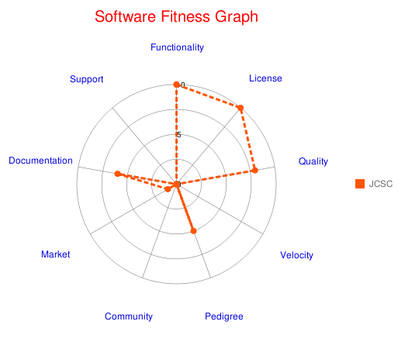
Figure 5 – JCSC radar graph

PMD
Functionality Criterion (m₁)

Feature | Notes | Score
Detect Java coding pitfalls | In this case study it has already been determined that JCSC has the required functionality. | 1
Total Percentage |  | 100%
Functionality (m₁) Score |  | 10

Licensing Criterion (m₂)

 | Notes | Score
Licensing (m₂) Score | The software has an open source license, and is not going to be distributed. Therefore, it passes the licensing rubric. | 10

Code Quality Criterion (m₃)

Let ct = 10
Let mt = 25

Metric | Score
% of Methods Below the Cyclomatic Complexity Threshold (cc) | 87
% of Classes Below the Method Count Threshold (mc) | 95
Dependency cycles (cy) | 0
Static Score (m₃s₁) | 6
Object-Oriented (do) | 4
Understandability (du) | 4
Extensibility (de) | 4
Testability (dt) | 4
Design Score (m₃s₃) | 8
Code Quality Score (m₃) | 7

Note: Runtime analysis was not necessary for the purposes of this case study and therefore omitted.

Project Velocity Criterion (m₄)

Metric | Target
 | Target Value | Actual Value | Score
Feature releases / yr (vf) | 2 | 1 | 5
Patch Releases / yr (vp) | 2 | 4 | 5
Velocity Score (m₄) |  |  | 5

Pedigree Criterion (m₅)
Metric | Notes | Score
The author of this software is known to produce high quality software (pa) | Tom Copeland is well known as a good developer | 5
The group sponsoring or funding this software is known to produce high quality software (pg) | The group of committers on PMD is well respected | 3
This software is derived from or makes heavy use of another piece of software that is known to be of high quality (pd) |  | 3
Average |  | 4
Pedigree Score (m₅) |  | 8

Community Criterion (m₆)
Metric | Notes | Score
The project website is regularly updated (cw) |  | 5
The project has an active mailing list (cl) | Very active project | 5
The project has an active bug tracker, message board or Wiki (cb) |  | 5
Average |  | 5
Community Score(m₆) |  | 10

Market Penetration Criterion (m₇)

 | Score | Notes
Market Penetration (m₂) Score | 10 | PMD is a top market leader in this space.

Documentation Criterion (m₈)

Documentation Type | Score
End user documentation (de) | 5
Developer documentation (dd) | 5
Code comments (dc) | 5
Installation documentation (di) | 5
Administration documentation (da) | N/A
Average | 5
Documentation Score (m₈) | 10

Support Criterion (m₉)
Category | Notes | Score
Quality of commercial support (sc) |  | N/A
Quality of indemnification (si) |  | N/A
Quality of community support (sm) | PMD has great community support. | 5
Average |  | 5
Support Score (m₉) |  | 10

Scorecard

Criterion | PMD
Functionality (m₁) | 10
Licensing (m₂) | 10
Code Quality (m₃) | 7
Project Velocity (m₄) | 5
Pedigree (m₅) | 8
Community (m₆) | 10
Market Penetration (m₇) | 10
Documentation Quality (m₈) | 10
Support (m₉) | 10
Total | 80

Figure 6 shows the radar graph for PMD.

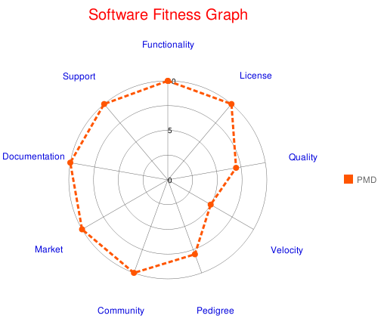
Figure 6 – PMD radar graph

JavaChecker

Functionality Criterion (m₁)

Feature | Notes | Score
Detect Java coding pitfalls | In this case study it has already been determined that JavaChecker has the required functionality. | 1
Total Percentage |  | 100%
Functionality (m₁) Score |  | 10

Licensing Criterion (m₂)

 | Notes | Score
Licensing (m₂) Score | The software has an open source license, and is not going to be distributed. Therefore it passes the licensing rubric. | 10

Code Quality Criterion (m₃)

Let ct = 10
Let mt = 25

Metric | Score
% of Methods Below the Cyclomatic Complexity Threshold (cc) | 94
% of Classes Below the Method Count Threshold (mc) | 91
Dependency cycles (cy) | 0
Static Score (m₃s₁) | 6
Object-Oriented (do) | 4
Understandability (du) | 4
Extensibility (de) | 4
Testability (dt) | 4
Design Score (m₃s₃) | 8
Code Quality Score (m₃) | 7

Note: Runtime analysis was not necessary for the purposes of this case study and therefore omitted.

Project Velocity Criterion (m₄)

Metric | Target
 | Target Value | Actual Value | Score
Feature releases / yr (vf) | 2 | 0 | 0
Patch Releases / yr (vp) | 2 | 0 | 0
Velocity Score (m₄) |  |  | 0

Notes: Project has not had a release since 2002.

Pedigree Criterion (m₅)
Metric | Notes | Score
The author of this software is known to produce high quality software. | Author is not well known | 2.5
The group sponsoring or funding this software is known to produce high quality software. | Single author | 2.5
This software is derived from or makes heavy use of another piece of software that is known to be of high quality. |  | 2.5
Average |  | 2.5
Pedigree Score (m₅) = Average * 2 |  | 5

Community Criterion (m₆)
Metric | Notes | Score
The project website is regularly updated (cw) |  | 0
The project has an active mailing list (cl) |  | 0
The project has an active bug tracker, message board or Wiki (cb) |  | 0
Average |  | 0
Community Score(m₆) |  | 0

Market Penetration Criterion (m₇)

 | Score | Notes
Market Penetration (m₂) Score | 1 | JavaChecker is not well known

Documentation Criterion (m₈)

Documentation Type | Score
End user documentation (de) | 3
Developer documentation (dd) | 1
Code comments (dc) | 3
Installation documentation (di) | 3
Administration documentation (da) | N/A
Average | 2.5
Documentation Score (m₈) | 5

Support Criterion (m₉)
Category | Notes | Score
Quality of commercial support (sc) |  | N/A
Quality of indemnification (si) |  | N/A
Quality of community support (sm) |  | 0
Average |  | 0
Support Score (m₉) |  | 0

Scorecard

Criterion | JavaChecker
Functionality (m₁) | 10
Licensing (m₂) | 10
Code Quality (m₃) | 7
Project Velocity (m₄) | 0
Pedigree (m₅) | 5
Community (m₆) | 0
Market Penetration (m₇) | 1
Documentation Quality (m₈) | 5
Support (m₉) | 0
Total | 38

Figure 7 shows the radar graph for JavaChecker.

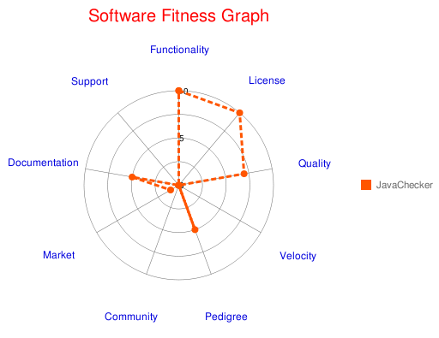
Figure 7 – JavaChecker radar graph

FindBugs
The version of FindBugs evaluated by [17] was 0.85. However the source code for that version of the software is no longer available on the web site. The closest version with available source code was version 1.2.0-RC3 and this version was used for the evaluation.

Functionality Criterion (m₁)

Feature | Notes | Score
Detect Java coding pitfalls | In this case study it has already been determined that JCSC has the required functionality. | 1
Total Percentage |  | 100%
Functionality (m₁) Score |  | 10

Licensing Criterion (m₂)

 | Notes | Score
Licensing (m₂) Score | The software has an open source license, and is not going to be distributed. Therefore, it passes the licensing rubric. | 10

Code Quality Criterion (m₃)

Let ct = 10
Let mt = 25

Metric | Score
% of Methods Below the Cyclomatic Complexity Threshold (cc) | 95
% of Classes Below the Method Count Threshold (mc) | 96
Dependency cycles (cy) | 0
Static Score (m₃s₁) | 6
Object-Oriented (do) | 4
Understandability (du) | 4
Extensibility (de) | 4
Testability (dt) | 4
Design Score (m₃s₃) | 8
Code Quality Score (m₃) | 7

Note: Runtime analysis was not necessary for the purposes of this case study and therefore omitted.

Project Velocity Criterion (m₄)

Metric | Target
 | Target Value | Actual Value | Score
Feature releases / yr (vf) | 2 | 4 | 5
Patch Releases / yr (vp) | 2 | 1 | 5
Velocity Score (m₄) |  |  | 5

Pedigree Criterion (m₅)
Question | Notes | Score
The author of this software is known to produce high quality software. | Bill Paugh, one of the project’s co-founders, is a well known computer scientist | 5
The group sponsoring or funding this software is known to produce high quality software. | The project is sponsored by the University of Maryland | 5
This software is derived from or makes heavy use of another piece of software that is known to be of high quality. |  | 2.5
Average |  | 4
Pedigree Score (m₅) = Average * 2 |  | 8

Community Criterion (m₆)
Metric | Notes | Score
The project website is regularly updated (cw) |  | 5
The project has an active mailing list (cl) | Very active project | 5
The project has an active bug tracker, message board or Wiki (cb) |  | 5
Average |  | 5
Community Score(m₆) |  | 10

Market Penetration Criterion (m₇)

 | Score | Notes
Market Penetration (m₂) Score | 10 | FindBugs is a market leader.

Documentation Criterion (m₈)

Documentation Type | Score
End user documentation (de) | 5
Developer documentation (dd) | 5
Code comments (dc) | 5
Installation documentation (di) | 5
Administration documentation (da) | N/A
Average | 5
Documentation Score (m₈) | 10

Support Criterion (m₉)
Category | Notes | Score
Quality of commercial support (sc) |  | N/A
Quality of indemnification (si) |  | N/A
Quality of community support (sm) |  | 5
Average |  | 5
Support Score (m₉) |  | 10

Scorecard

Criterion | FindBugs
Functionality (m₁) | 10
Licensing (m₂) | 10
Code Quality (m₃) | 7
Project Velocity (m₄) | 5
Pedigree (m₅) | 8
Community (m₆) | 10
Market Penetration (m₇) | 10
Documentation Quality (m₈) | 10
Support (m₉) | 10
Total | 80

Figure 8 shows the radar graph for FindBugs.

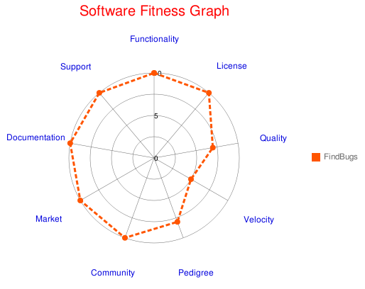
Figure 8 – FindBugs radar graph

JavaWizard

Functionality Criterion (m₁)

Feature | Notes | Score
Detect Java coding pitfalls | In this case study it has already been determined that JCSC has the required functionality. | 1
Total Percentage |  | 100%
Functionality (m₁) Score |  | 10

Licensing Criterion (m₂)

 | Notes | Score
Licensing (m₂) Score | The software has an open source license, and is not going to be distributed. Therefore, it passes the licensing rubric. | 10

Code Quality Criterion (m₃)

Let ct = 10
Let mt = 25

Metric | Score
% of Methods Below the Cyclomatic Complexity Threshold (cc) | 88
% of Classes Below the Method Count Threshold (mc) | 95
Dependency cycles (cy) | 100
Static Score (m₃s₁) | 9
Object-Oriented (do) | 3
Understandability (du) | 3
Extensibility (de) | 3
Testability (dt) | 4
Design Score (m₃s₃) | 6
Code Quality Score (m₃) | 8

Note: Runtime analysis was not necessary for the purposes of this case study and therefore omitted.

Project Velocity Criterion (m₄)

Metric | Target
 | Target Value | Actual Value | Score
Feature releases / yr (vf) | 2 | 0 | 0
Patch Releases / yr (vp) | 2 | 0 | 0
Velocity Score (m₄) |  |  | 0

Notes: Project has not had a release since 1999.

Pedigree Criterion (m₅)
Metric | Notes | Score
The author of this software is known to produce high quality software (pa) | Authors are not well known | 2.5
The group sponsoring or funding this software is known to produce high quality software (pg) |  | 2.5
This software is derived from or makes heavy use of another piece of software that is known to be of high quality (pd) |  | 2.5
Average |  | 2.5
Pedigree Score (m₅) |  | 5

Community Criterion (m₆)
Metric | Notes | Score
The project website is regularly updated (cw) |  | 0
The project has an active mailing list (cl) |  | 0
The project has an active bug tracker, message board or Wiki (cb) |  | 0
Average |  | 0
Community Score(m₆) |  | 0

Market Penetration Criterion (m₇)

 | Score | Notes
Market Penetration (m₂) Score | 1 | Project is not well known

Documentation Criterion (m₈)

Documentation Type | Score
End user documentation (de) | 3
Developer documentation (dd) | 1
Code comments (dc) | 3
Installation documentation (di) | 3
Administration documentation (da) | N/A
Average | 2.5
Documentation Score (m₈) | 5

Support Criterion (m₉)
Category | Notes | Score
Quality of commercial support (sc) |  | N/A
Quality of indemnification (si) |  | N/A
Quality of community support (sm) |  | 0
Average |  | 0
Support Score (m₉) |  | 0

Scorecard

Criterion | JavaWizard
Functionality (m₁) | 10
Licensing (m₂) | 10
Code Quality (m₃) | 8
Project Velocity (m₄) | 0
Pedigree (m₅) | 5
Community (m₆) | 0
Market Penetration (m₇) | 1
Documentation Quality (m₈) | 5
Support (m₉) | 0
Total | 39

Figure 9 shows the radar graph for JavaWizard.

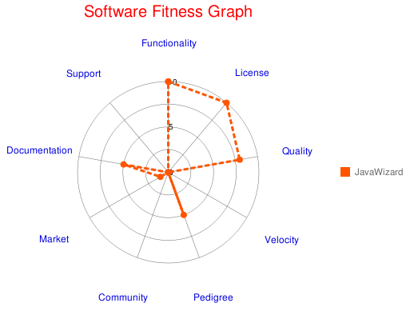
Figure 9 – JavaWizard radar graph

The combined scorecard for the six evaluated tools is shown in Table 16.

Table 16 – Combined scorecard
Criterion | ESC/Java2 | JCSC | PMD | JavaChecker | FindBugs | JavaWizard
Functionality (m₁) | 10 | 10 | 10 | 10 | 10 | 10
Licensing (m₂) | 10 | 10 | 10 | 10 | 10 | 10
Code Quality (m₃) | 7 | 8 | 7 | 7 | 7 | 8
Project Velocity (m₄) | 8 | 0 | 5 | 0 | 5 | 0
Pedigree (m₅) | 8 | 5 | 8 | 5 | 8 | 5
Community (m₆) | 6 | 0 | 10 | 0 | 10 | 0
Market Penetration (m₇) | 5 | 1 | 10 | 1 | 10 | 1
Documentation Quality (m₈) | 10 | 6 | 10 | 5 | 10 | 5
Support (m₉) | 6 | 0 | 10 | 0 | 10 | 0
Total | 70 | 40 | 80 | 38 | 80 | 39

The results of this evaluation were very similar to the results of [17] demonstrating the evaluation model proposed in this paper produces results that are valid. Table 16 compares the results of this evaluation and the results of [17].

Table 17 – Comparison of the results of [17] and this evalution
Tool | Rating using [17] | Rating using the model defined in this paper
ESC/Java2 | 3 | 70
JCSC | 1 | 40
PMD | 3 | 80
JavaChecker | 2 | 38
FindBugs | 3 | 80
JavaWizard | 1 | 39

Relatively speaking, all of the tools received similar ratings in this model as they did in [17]. The only anomaly was that JavaChecker was rated slightly lower by this model. A combined radar graph for the first three tools evaluated is presented in Figure 10.
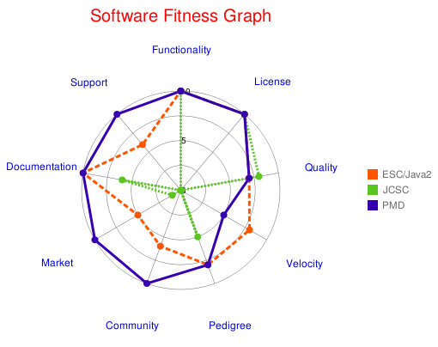
Figure 10 – Comparison of ESC/Java2, JCSC, & PMD

A combined radar graph for the final three tools evaluated is presented in Figure 11.
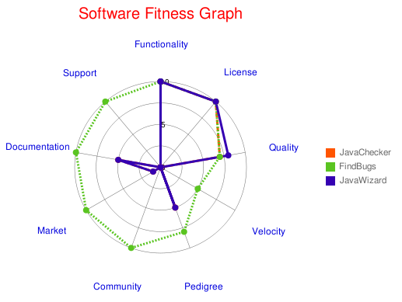
Figure 11 – Comparison of JavaChecker, FindBugs, & JavaWizard

Summary and Conclusions

This paper provides a set of criteria that can be applied to any open source software to determine fitness for use in a timely manner using publicly available data. While there is no substitute for a person actually trying out the software to verify if it works, a methodology such as this does give some rigor and repeatability to the generally subjective process of software selection. It also provides a way to compare different software to each other using a wide variety of attributes. The criteria have multiple tuning parameters that can be used to customize the methodology to work in a variety of settings.

The methodology was verified using the results of an evaluation performed by the Defense Research and Development Canada agency. Six open source software products were evaluated with this methodology and results were very similar to the agency’s findings published in 2007 [17]. This helps to verify the ability of this methodology to accurately determine software’s fitness for use.

Suggested future work includes verifying the results of this methodology against multiple other published evaluations of different software in different usage scenarios to further calibrate this instrument. Additional work on the OSSEvaluator tool to allow data entry of submetrics and store results from evaluations in a searchable database would also be valuable.
References

1. Ueda, M, “Licenses of Open Source Software and their Economic Values”,
Applications and the Internet Workshops, 2005. The 2005 Symposium on 31-04 Jan. 2005, Pages: 381 - 383

2. Polancic, G.; Horvat, R.V.; Rozman, T., “Comparative assessment of open source software using easy accessible data”, Information Technology Interfaces, 2004. 26th International Conference on 10-10 June 2004, Pages: 673 - 678 Vol.1

4. “BSD License Definition”, http://www.linfo.org/bsdlicense.html, accessed 11/11/2008

5. “GNU General Public License”, http://en.wikipedia.org/wiki/Gpl, accessed 11/13/2008

6. “Open Source License Resource Center ”, http://www.blackducksoftware.com/oss, accessed 11/13/2008

7. “Copyleft”, http://en.wikipedia.org/wiki/Copyleft, accessed 11/13/2008

8. “Comparison of free software licenses”, http://en.wikipedia.org/wiki/Comparison_of_free_software_licences, accessed 11/13/2008

9. D. Wheeler, “How to Evaluate Open Source Software / Free Software (OSS/FS) Programs”; http://www.dwheeler.com/oss_fs_eval.html, accessed 11/15/2008

10. “APR's Version Numbering”, http://apr.apache.org/versioning.html, accessed 12/6/2008

11. Stuart Yeates, “Documentation issues in open source”,
http://www.oss-watch.ac.uk/resources/documentation.xml, accessed 12/11/2008

12. Robert C. Martin, “Principles and Patterns”, http://www.objectmentor.com/resources/articles/Principles_and_Patterns.pdf, accessed 1/10/2009

13. “Software Metrics Glossary”, http://www.mccabe.com/iq_research_metrics.htm, accessed 1/13/2009

14. Migel Lopez, Naji Habra, “Relevance of the Cyclomatic Complexity Threshold for the Java Programming Language”, http://www.cetic.be/IMG/pdf/SMEF2005LOPEZ.pdf, accessed 1/13/2009

15. “The Magical Number Seven, Plus or Minus Two”, http://en.wikipedia.org/wiki/The_Magical_Number_Seven,_Plus_or_Minus_Two, accessed 1/16/2009

16. “Indemnification for Open Source Software”, http://www.openlogic.com/products/indemnification.php, accessed 1/16/2009

17. Ken Coar, “The Open Source Definition (Annotated)”, http://www.opensource.org/docs/definition.php, accessed 1/18/2009

18. F Painchaud, R Carbone, DRDC Valcartier, “Java software verification tools: evaluation and recommended methodology”, http://pubs.drdc.gc.ca/PDFS/unc57/p527369.pdf, accessed 1/18/2009

19. “OSMM Assessment”, http://www.osspartner.com/portail/sections/accueil-public/evaluation-osmm, accessed 1/25/2009

20. “Open Source Maturity Model (OSMM)”, http://www.navicasoft.com/pages/osmm.htm, accessed 1/25/2009

21. “Qualification and Selection of Open Source software (QSOS)”, http://www.qsos.org, accessed 1/25/2009

22. “Business Readiness Rating”, http://www.openbrr.org, access 1/25/2009

23. “Open source software assessment methodologies”, http://en.wikipedia.org/wiki/Open_source_software_assessment_methodologies, accessed 1/26/2009

24. Jean-Christophe Deprez, Simon Alexandre, “Comparing Assessment Methodologies for Free/Open Source Software: OpenBRR & QSOS”, http://www.qualoss.org/dissemination/DEPREZ_CompareFlOSSAssessMethodo-Camera-02.pdf, accessed 1/25/2009

