**How to Use SD Card Post Process Script**

Note: The script is developed and tested using Microsoft Excel 2016.

1. Open “ProcessData.xlsm” file inside “LOG” folder

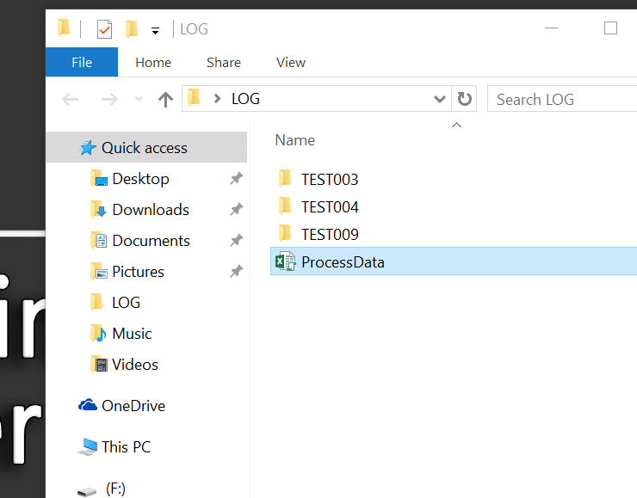

1. Click “Start Process Data” button

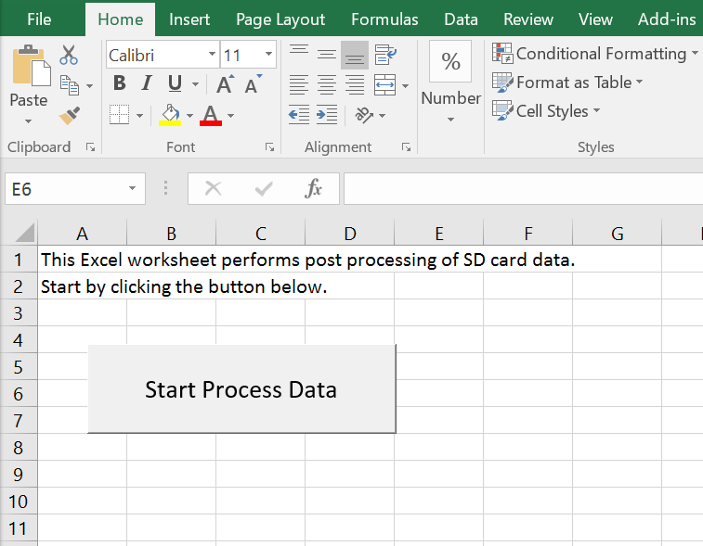

1. New Form will open up.   
   Select TEST to process from list. List will be auto-generated by scanning folder

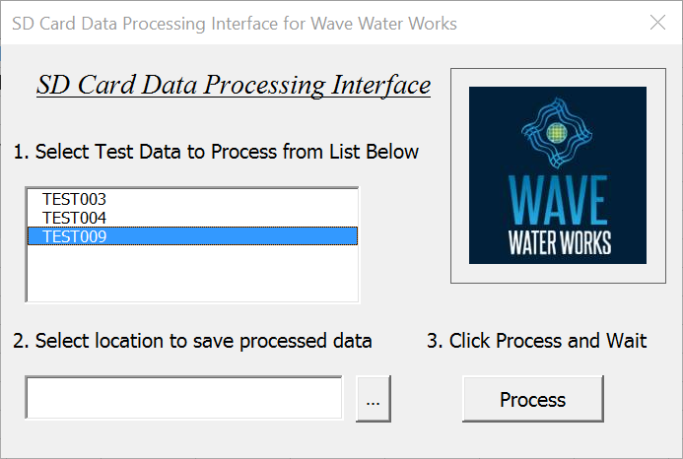

1. Select location to save. When click “…”, folder browser will open up.

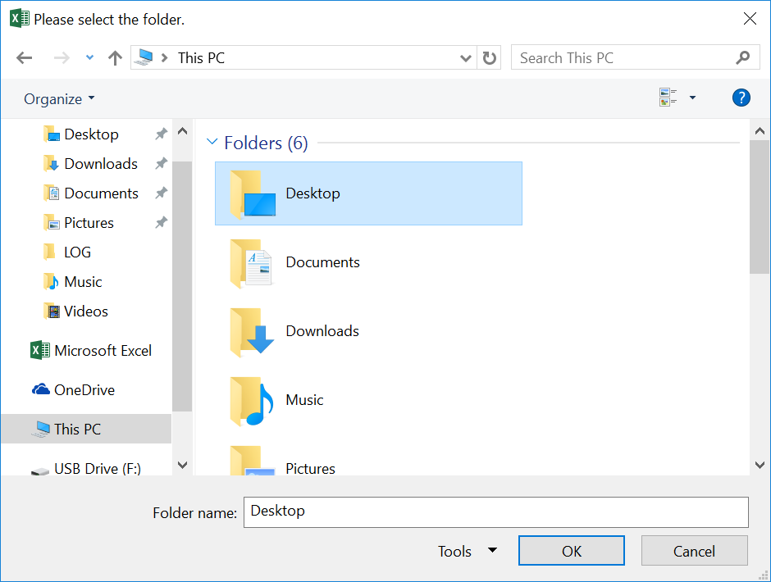

1. Click “Process” to start processing. 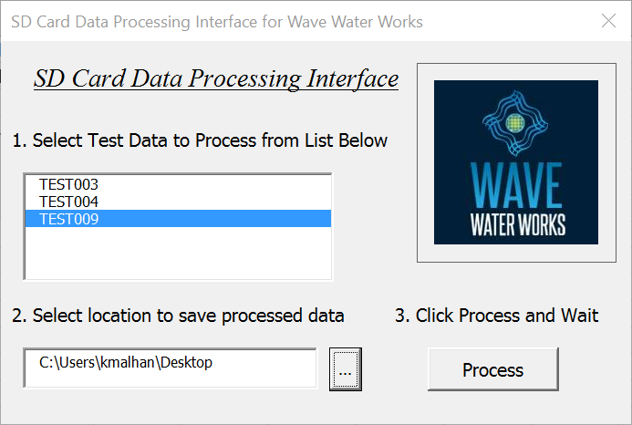
2. Once processing is done, new window will open and tells processed file location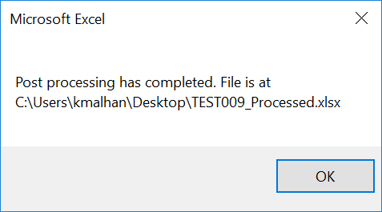
3. Open Processed file, and start analyze data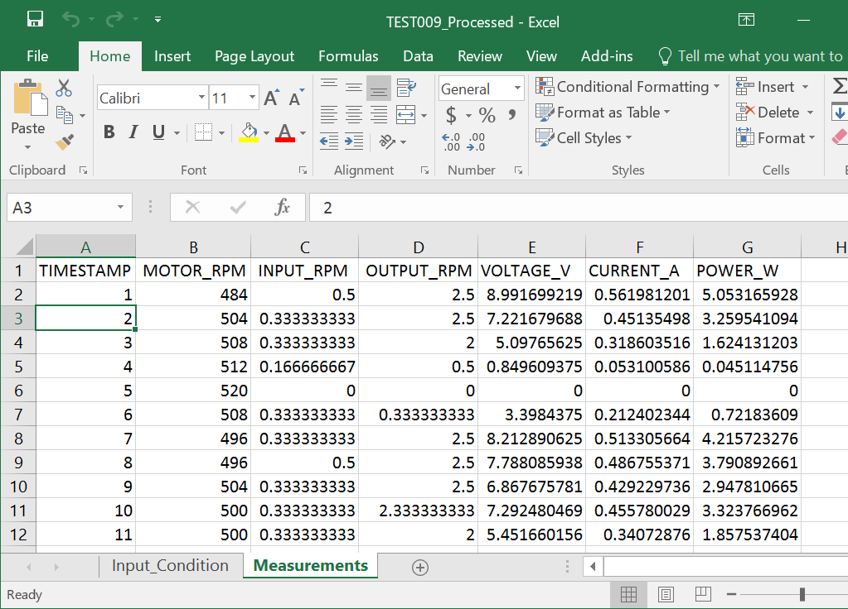

If you have any question, I can be reached at [kmalhan@oakland.edu](mailto:kmalhan@oakland.edu)