1/6 – Danielle Meyer – Resolved
Hi Andrew,
Could you help pull a report for us that is needed by the 9th for a call with BCBSA? The criteria we need to pull in is in the screenshot below. I will set a call to walk through this next week, but wanted to get this in front of you first.🙂

Response:
- 1/8 - I’ve attached the data for review. Could someone take a look and confirm if it's good to go? I'm also open to scheduling a working session to review the data together. Let me know!
- 1/15 - Hello Danielle, I have pulled another report that includes member brand and the AlphaPrefix.

12/30/2024 - Birchler, Katie – Resolved
Good afternoon Andrew!!
Amy and I have been discussing/reviewing our case and information.
Do you happen to have the below information from our last call?
Number of missed SLA for Adjustments? This would be from both BCBSA and Prompt Pay

- Response/Resolution:
- Good afternoon, Number of missed SLA for Adjustments:
  - YTD Count by Claim
  - Adjustments Completed After Due Date: 16,332
  - Adjustments Overdue: 3,735
- Provided Two files including fee data for Arb Adj completed after and overdue Arb

12/23 – Styles, Elena – Resolved
Hi Andrew
Been poking around Tableau to see if I can get the new fields added in the release. I found the Claim adjustment status, BUT had no luck finding the Adjuster Comments as a field option. Could this be labeled something different in Tableau?? Thanks

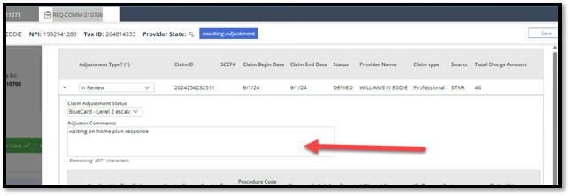
- Response/Resolution: I have not added in Adjustor Comments to the tableau data. It wasn’t initially requested to include. I can work on adding that this week.
- Updated NextGen Case Level Inventory: Views - Tableau Server SQL to include Adjustor Comments.

12/19 – Camille Christinana – Resolved
Hey there Andrew good morning. Can you do me a huge favor. Is it possible to pull all of IDR fees charged from 2022 - present day?

- Response/Resolution: Provided the ‘Resolved Arbitration Dollar Impact’ data for 2023-12/19/2024. NextGen Claims & Dollars: Resolved Arbitration Dollar Trend - Tableau Server
- Camille to send this to her team and will follow with me if the data isn’t what she needs.

12/18 – Denika Cannon – Resolved
I'm reaching out from IDR. Over the weekend, we implemented a release that added more dropdowns in the adjudication task. Could you let me know which report to pull in order to capture these new and selected fields? Adjustment Type( Additional dropdowns added )& Claim Adjustment Status ( New field & dropdowns). Thank you. Yes, two additional dropdowns were added to the adjustment type field: "In review" and "Paper Check." Additionally, the claim adjustment status is entirely new. From my understanding, a reporting story was also included in the release to ensure this information is captured in Tableau. If you have any questions, feel free to reach out to Nyathawada, Ramcharit from IT if you need assistance integrating the new field into Tableau. 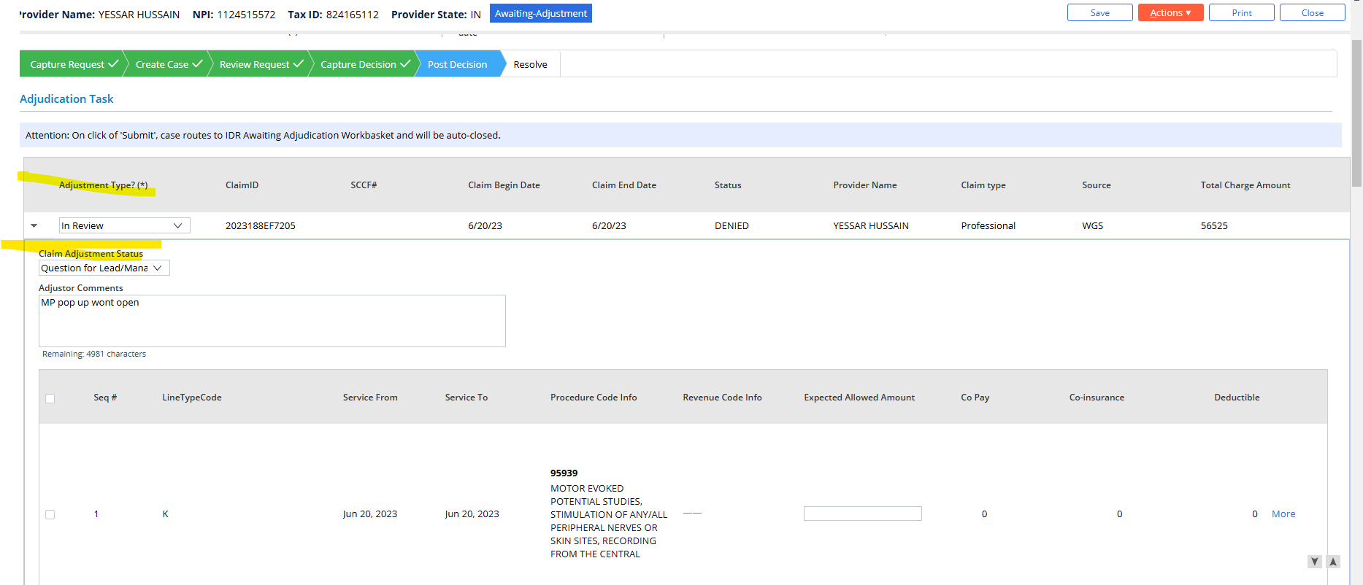

- Response/Resolution: Hi Denika, I’ve updated the inventory dashboard to include the new claim adjustment status. You can now extract the data directly from the dashboard. Please feel free to reach out if you have any questions. Dashboard: NextGen Case Level Inventory: Views - Tableau Server
- Updated base table SQL script with:
- ISNULL(ac2.ClaimAdjustmentStatus,ac.ClaimAdjustmentStatus) 'Claim Adjustment Status'

12/17 – Danielle Meyer – Resolved
- Hi Andrew, Can you take a look at the numbers under the grid and help me understand why the numbers are off for past due payment? NextGen Case Level Inventory: Arb Fee Invoice - Compliance - Tableau Server

- Response/Resolution: Hello Danielle, Great question! I looked into the data and noticed that different filters were applied depending on whether the status was open or closed. To make sure the data aligns with the visual, I separated the open and closed statuses into two distinct sections. The data now matches consistently across both the table and the bar chart.

12/17 – Danielle Meyer - Resolved
- Do you know how / Where Jesse pulled the CPT data in to the report? We have a few places in NextGen it could be pulled in from and based on where it pulled in from can tell us different stories https://tableauprod.elevancehealth.com/#/site/EntTab/views/IDR-NextGenCaseLevelInventory_16838177575500/ArbCaseCounts

- Response/Resolution: Hi Danielle, Just to clarify, when you mention CPT, are you referring to the procedure codes? If so, Jessie is pulling those from the claim line.

12/16 – Danielle Meyer - Resolved
- Hi Andrew! I was pulling the Scorecard today during my 1:1s and noticed that the QA information isn't pulling in and the last update on the workiq and workday is 12/1. I am not sure if this is something that Jesse updated weekly or if something is wrong behind the scenes? https://tableauprod.elevancehealth.com/#/site/EntTab/views/IDRAssociateScorecards/AssociateScorecard?:iid=1

- Response/Resolution: Hello, circling back on this, the issue lies with my access to the file’s location. I’m unable to run the process to extract the data from the workbook to upload the scores to the dashboard. Can you please submit an access request on my behalf? https://collaborate.wellpoint.com/sites/msteams_cb8bd3-QualityAuditTeam

- I ran the python ETL for the scorecard file and verified that the table data is populating in the dashboard and SQL Table.

12/16 – Danielle Meyer – Pending
- Hi Andrew! do you know if the green line is working correctly after September in the link below? Seems odd that it's 0%. NextGen Claims & Dollars: Arbitration Dollar Amounts - Tableau Server
- 1/14/2025 - Mundra, Shivam Hi Andrew, Can you share some examples so that we can check in the NextGen reporting db.

- Response/Resolution: Hello Danielle, I’ve have reviewed the data, specifically, September’s data and noticed that the decisions made are all showing dismissed. However, the status of these claims is showing statuses that are not “Resolved-Dismissed”. The decision is coming back as dismissed for statuses that are “Resolved-Overturned”. I don’t have access to NextGen UI, are you able to validate in NextGen that one of these cases that are showing ‘Decision – C’ as ‘Dismissed’ and the status is “Resolved-Overturned”?
- Followed up on 1/14
- Response: Sure! I’ve attached a report containing the full data from August to September. It includes a sheet for August, where the data seemed correct, and a sheet for September, where the data appears to have changed. We’re focusing on the GnADecision field from the 'nxt.ANTM_Claim' table labeled ‘Decision-C’ in the report. Up until September, the data showed multiple values, which we used to determine if a case was overturned. However, since September, the data has only been showing "dismissed" or "decision pending." I’d like to understand what drives the 'GnADecision' in the table—is it derived from another value and has anything changed that could be causing all cases to default to "dismissed"?

12/12 – Danielle Meyer - Resolved
- Hey Andrew! Can we please pull in Resolved-Dismissed into this report? We do pay fees on those cases.
- Christina and I are currenly in a call and are also noticing that we have different payment pulling in and not sure why:

- Response/Resolution: Circling back on this, I have added 'Resolved-Dismissed, to the 'Resolved Arbitration Dollar Trend' dashboard. I also figured out the discrepancies between the two dashboards. For the 'Arbitration Dollar Amounts', you have to change the 'Date Range' filter to "Resolved Date".

12/09 – Geronimo Hidalgo - Resolved
- Hey good day sir. Hope things are well and happy Monday. There seems to be a Field missing from IDR Negotiations - Neg Case Counts - Negotiation Inventory. - The Field is "Member Group Type"

- Response/Resolution: Updated the Custom query to include:
  - “m.GroupType,”
  - “LEFT JOIN nxt.ANTM_Member_Policy m ON ac.CaseID = m.CaseID AND ac.SubGroupIdentifier = m.SubGroupIdentifier AND ac.GroupID = m.GroupIdentifier” 