HOW TO INSTALL PEBBLE SDK IN UBUNTU 17.10:

- Follow the installation guides in : https://developer.rebble.io/developer.pebble.com/sdk/index.html &
https://developer.rebble.io/developer.pebble.com/sdk/download/index.html

- Once you have downloaded and unzipped the SDK, change the folder ‘pebble-tool’ (that must be in: ~/pebble-dev/pebble-sdk-4.5-linux64 (version number or linux distribution could change)) for the ‘pebble-tool’ folder available in: https://github.com/pebble-dev/pebble-tool , change the requirements.txt file to the outer folder (~/pebble-dev/pebble-sdk-4.5-linux64) from the zip downloaded onece you have unzipped the file, and run:
cd ~/pebble-dev/pebble-sdk-4.5-linux64
source .env/bin/activate
pip install -r requirements.txt
deactivate
- Install npm: sudo apt install npm (inside the virutal environmnet or not)
- Install the SDK: pebble sdk install latest
- Check that the installation is correct by introducing the following command: pebble sdk list
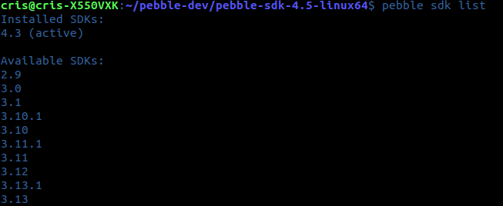

INFORMATION ABOUT EMULATORS:
Depending on your pebble device, you need to install one emulator or other, there are 3 different versions:
- Aplite: This platform focuses on monochrome rectangular displays.
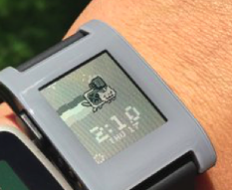

- Basalt: color displays that are also rectangular.

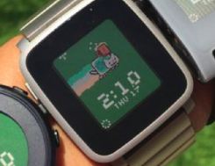

- Chalk: round interface
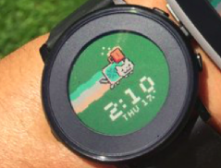

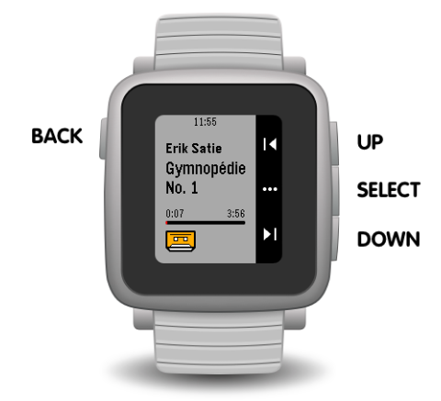

OTHER INTERESTING PAGES:
https://www.reddit.com/r/pebbledevelopers/comments/92lt6o/cannot_install_sdk/
https://github.com/pebble-dev/pebble-tool/commits/master
http://derekwilson.net/blog/2016/04/09/setting-up-for-pebble-development-on-ubuntu

HOW TO CREATE A PROJECT:

- pebble new-project helloWorld
- (Write code…)
- Compilation and so on: pebble build
- Installation(from the build folder): pebble install helloWorld.pwd --phone 192.168.1.39
  - For debugging: pebble install helloWorld.pbw --emulator basalt
  - pebble gdb --emulator basalt
Once the (gdb) prompt appears, the app is paused by GDB for observation. To resume execution, use the continue (or c) command. Similarly, the app can be paused for debugging by pressing control + c.
pebble gdb –help

- BETTER WAY FOR DEBUGGING:
Using console.log() as a debugging technique is a common practice. To view the logs from your Pebble watch, issue the following command:
pebble logs --phone IP_ADDRESS_OF_YOUR_PHONE
Note that if you need to debug some C code, you can use APP_LOG(). This is similar to console.log() in JavaScript. The message will show up in the logs, but will look something like this:
(https://www.sitepoint.com/pebble-watch-development-javascript/)

HOW TO INSTALL AN APP(watchapps) IN PEBBLES(MOBILE&SMARTWATCH) FROM GITHUB:

- MOBILE PHONE(ANDROID):
  - Download Pebble app & pebble alternative to update to Rebble
  - Once you have registered in Rebble and the Pebble app has been updated, enter in the app anf in settings, acgivate the developper option and in the connection with the developper connect to see the IP of the server.
- MOBILE PHONE(iOS):
  - Download Pebble app & pebble alternative to update to Rebble
  - Upload to Rebble: (https://www.youtube.com/watch?v=8Z4Jtl_0UMw)
  - (Steps on the video:
    - Go to : https://boot.rebble.io
    - Log in or register with your rebble acoount
    - Tap on swith to Rebble
    - Tap on ‘Open’ when they ask about open in Pebble app
    - Tap on ‘Change’ in Configuration Change
    - Wait at least 20 seconds before pressing the exclamation symbol in yellow at the top left of the display.
    - Tap on ‘Log in’.
    - Tap on ‘It’s Rebble Time!’

COMMON STEPS:
- OPTION1: Download the whole project in your phone and click on the .pwd file, it will be automatically open by the Pebble app and the new app will be installed.
- OPTION2(Just for the case of having all the development kit installed): From the computer (just tested on linux), go to the folder in whcih you have the .pwd and: pebble install pebble-health-export.pbw --phone 191.163.2.39,
- where pebble-health-export.pwd should be changed for the name or your app and the ip by the ip address of your server in the phone(check previous step)

APIS:
- HEALTH:
https://developer.rebble.io/developer.pebble.com/guides/events-and-services/health/index.html

FAQs AND SOME ERROR SOLUTIONS:
- Problems for finding js or c files: Go to wscript and check the paths because the build is done from the data & paths passed to this file.

