CSCE 616 Lab 1

Prof: Dr. Michael Quinn

TA: Trisha Ghosh

Ahmet Coskuner [126009366]

Santhosh Srinivasan [633002273]

Some new things we learned were using the clock edges for reading and writing to and from memory as opposed to using specific number delays. We also learned how to use functions vs tasks, and using the random keywords ($random and $urandom). We also learned how to use assert and the different error message types ($fatal, $error, $warning, $info). We identified the bug in the HDL to be the line that writes to memory. It should not contain the XOR, it should only pass data_in.

Incorrect line 33: #1 memory[addr] <= memory[addr] ^ data_in;

Corrected line 33: #1 memory[addr] <= data_in;

Figure 1. Simulation with HDL bug

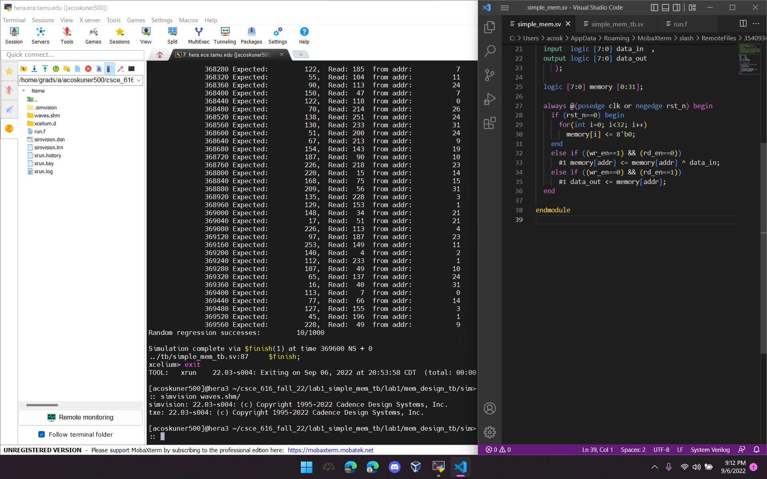

Figure 2. Simulation with HDL bug, showing “successes” for reset and writing iterator value to memory 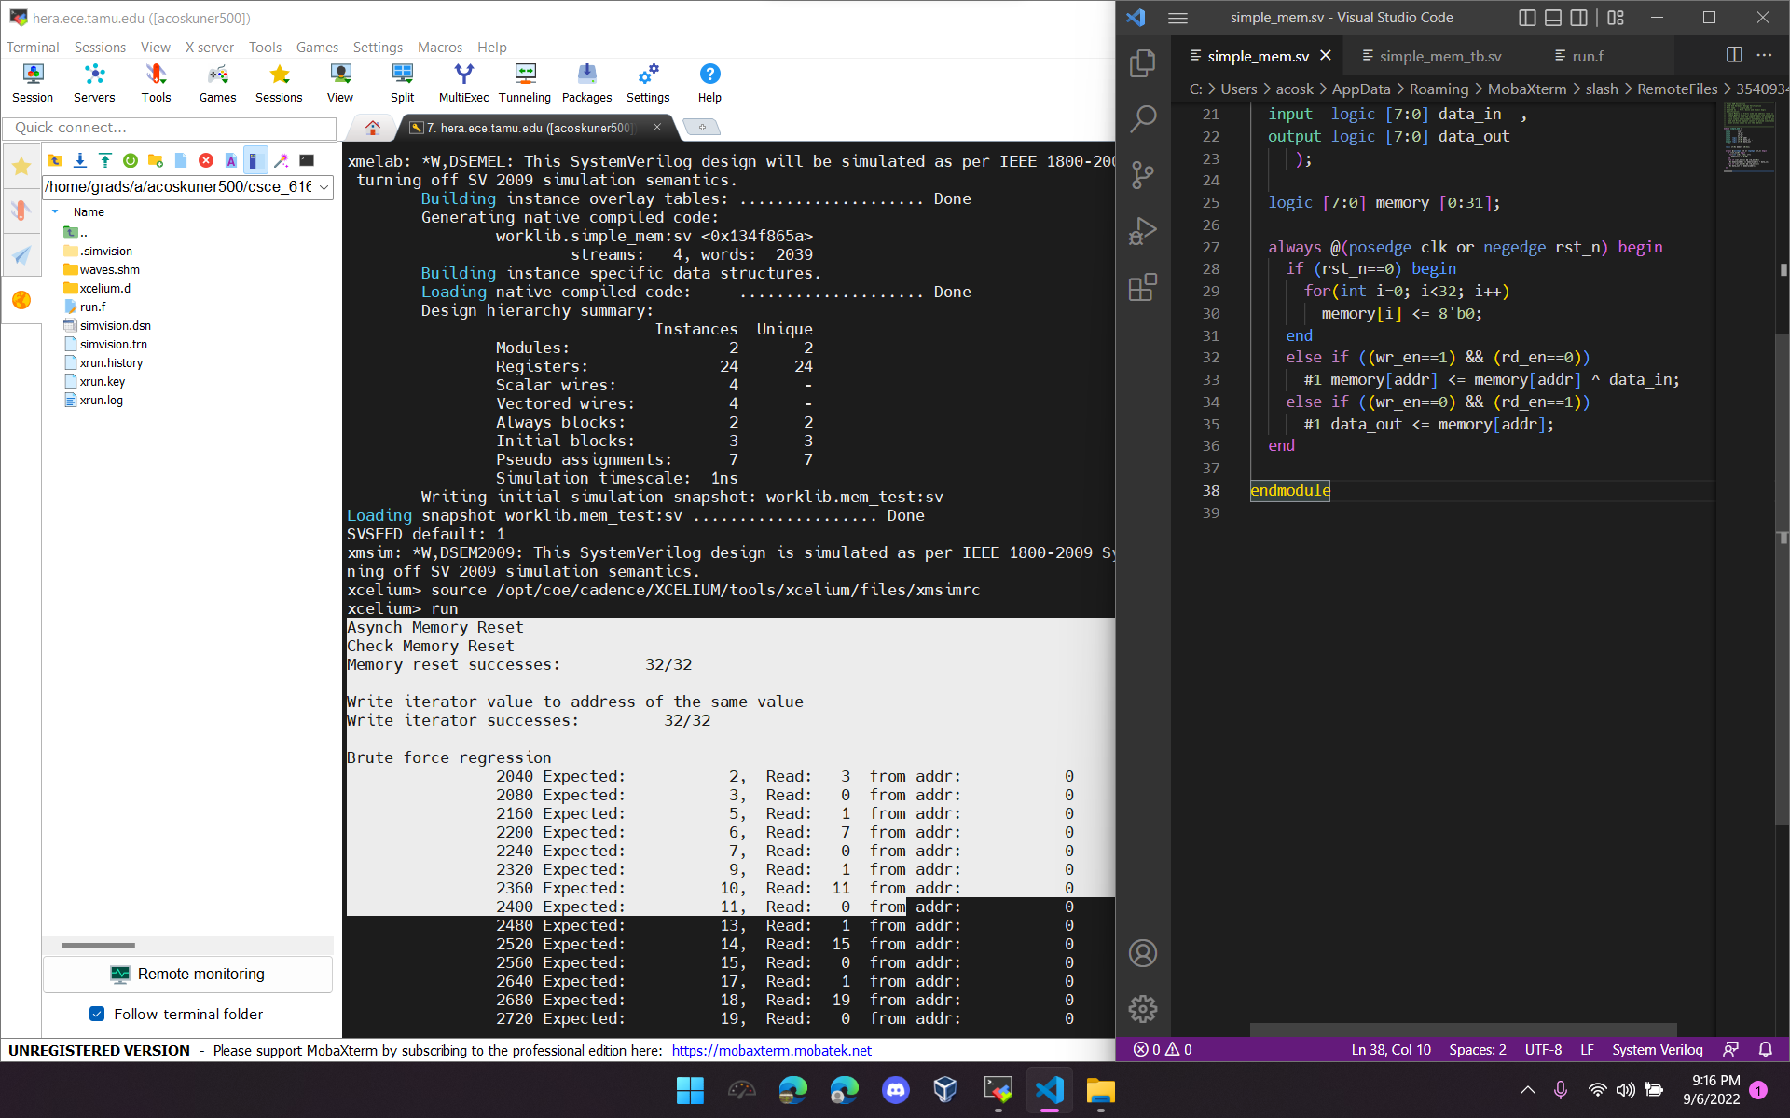

Figure 3. Simulation with HDL bug fixed. 100% success for reset, iterator value, brute force, and random